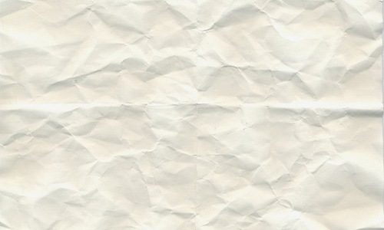

Bien, R. (2010). *40+ High Quality Free Paper Patterns and Textures.*Available: http://www.ucreative.com/resources/40-plus-various-high-quality-free-paper-patterns-and-textures/. Last accessed 11/11/2016.

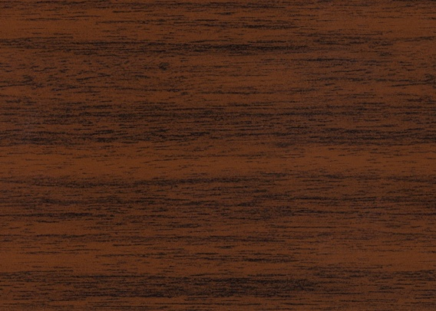

CPS Resources Inc.. (2016). *WOODGRAIN FOIL DESIGNS.* Available: http://www.cpsresources.com/woodgrain-foil-designs/. Last accessed 11/11/2016.



Todd. (2014). *57 images for Open Book Clip Art Template.* Available: http://www.clipartpanda.com/categories/open-book-clip-art-template. Last accessed 11/11/2016.