Group 17 - 28/01/2017 -

Hours: 2:30

Research:

**Helicopter:**

**Mechanics**:

gravity, Avoid colliding with objects and the ground/ceiling.

**End Goal**: Get the best score possible, by travelling the furthest.

This game is never ending, It gained fame on the internet due to its addictiveness and simple gameplay, This game could be run on any device.

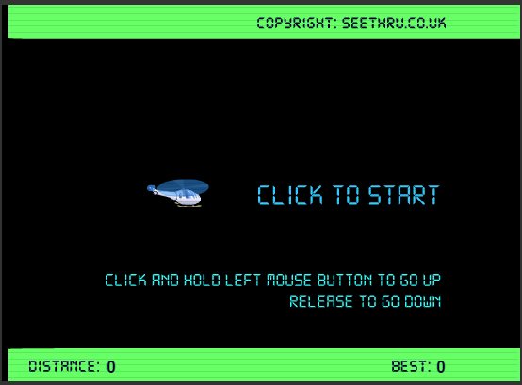

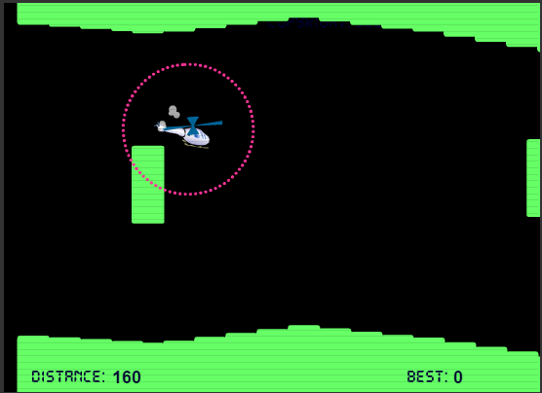

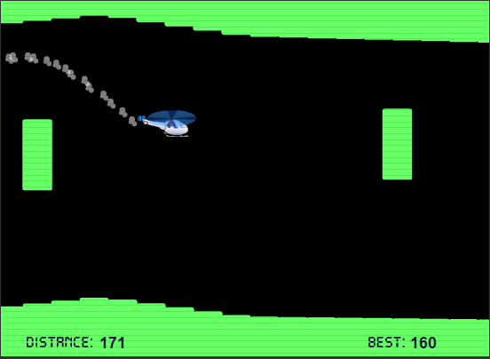

Gravity Guy:

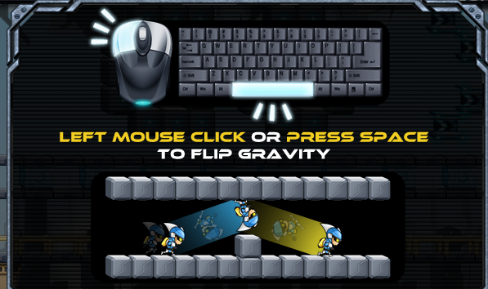

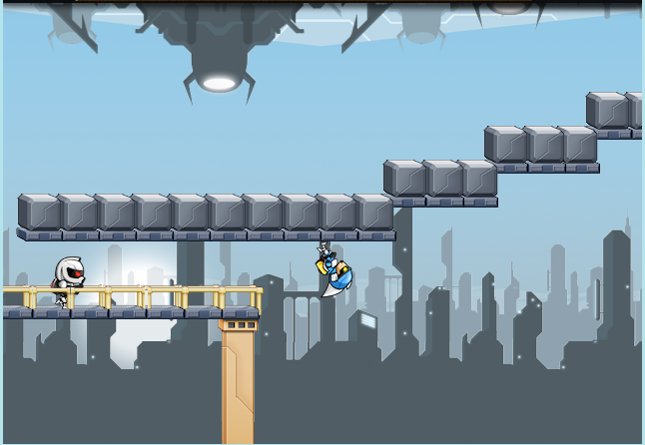

Mechanics: Racing, Gravity Reversal

This game can be single player or multiplayer, the aim of the game is to outrun the AI or your opponent, traversing the game map by timing the reversal of gravity using the space bar, if used at the same time this will loose the game.

This is lots of fun, highly addictive, its very fast paced and can get very frustrating, But this is another adaption on gravity that could be useful.

I think we should focus on a game that does not have a ending, More a challenge to keep going, Like pinball or the helicopter game above.

**Prototype 1:**

Very Similar with the helicopter game, But have Two players start at the same time, The goal of the game would be to have somebody last the longest and travel the furthest. Both players can collide with each other, So this leaves two different types of gameplay that could happen, the first being that they go out against each other to try and beat the other, trying to squeeze through gaps at the same time/before their opponent. This will cause more accidents to happen and the players to make mistakes, But it will bring the competitive side of the players out, the second type of gameplay could be the players could actually work together and take turns going through small gaps. In turn both players would get further in the game rather than pitting out against each other, Of course one player is bound to make a mistake and collide with an object and in turn their opponent will still win. But it would give multiple types of gameplay types within the multiplayer aspect of the game.

**Mechanics**: Gravity, Collisions with objects

**Multiplayer** aspect to have two "characters" start at the same time.

**End Goal**: get Furthest or Highest score

**Controls**: WASD/ Arrow Keys

**Prototype 2:**

**Mechanics:** Players Dodging falling Debris, Knocking your opponent into Falling debris

**Multiplayer:** Both players playing in Real-time against each other

**End Goal:** To survive longer than your opponent, or knocking your opponent into debris without colliding with objects.

**Controls:** WASD, Arrow Keys

This game will have the screen moving upwards, The players will both be on the screen in real time. Colliding with each other will not end in either death, But will allow players to "knock" each other into objects. The Game will have Random sized objects falling from the top of the screen, each player has to dodge and survive longer than their opponent.

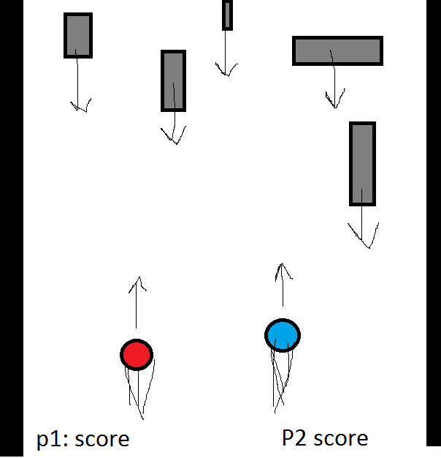

**Prototype 3:**

This is a complete wild card.

Two player Versus Tetris like game, Where each person controls a Tetris block that is coming down and has to beat their opponent to spots, and if they complete a line they get the points. It would work of gravity and slightly lean towards racing, But it would be a whole different game at the same time.

Each player would have to strategically plan where they want to go and if it is better to let the other player get the spot, The pieces would move like normal, Apart from there would be two blocks at the same time, controlled by each player.

