**Research**

First I began looking into other games using prominent physics based mechanics and mechanics using friction similar to our game, I read articles such as physics based games on Gamasutra and complied images of worth researching video games into a mood board to look at art styles, typography and colour schemes they either have in common or make them stand out in the market.

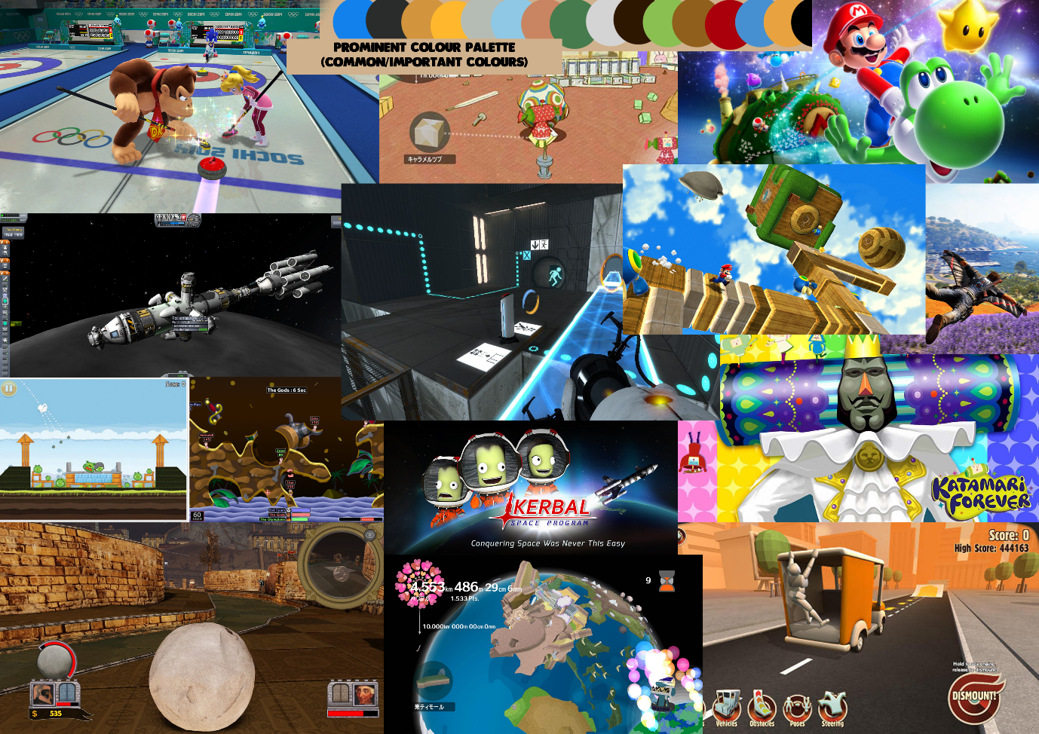The mood board is shown here;

In my search I managed to find the prominent or most used colours and some elements of typography and design choices, I will discuss some of the most interesting ones here, first I will talk about the Katamari series.

**Katamari.**

The katamari games have been well known for their outlandish design choices and mechanics, with the games core mechanic being rolling a ball to pick up items to increase the balls size and to thus be able to pick up larger items, for example, the ball could start at the size of 10cm’s and you can only pick up items smaller than that, but when the ball reaches 100m’s you can now pick up any item under that size, think of the possibilities.

These games use very pastel yet colourful pallets with upbeat chirpy music and cartoonish character designs to appeal to a young or either quirky audience as each element of its design falls into the category of “a Japanese game” with other examples such as project rub.

Other design choices I noticed is that the game does not focus on a selected colour palette using many colours on lots of items early on, but as the game begins to expand, certain levels contain different colour schemes to reflect their levels such as a brown black and white palette for levels involving cows and bears and black and white for levels held in the past or using light (In which where the colour yellow is added to use light over black and white) Colour in this game is almost used to convey emotions related to the level, with of course most of them being vibrant.

The shapes used are also very polygonal and although using sharp edges appear soft due to colour and use of polys.

**Portal and Kerbal space program.**

These two games both share very similar design choices, both their mechanics use physics very heavily, with kerbal using a lot of force and gravity, whilst Portal using gravity and basic physics that can be applied through the player taking a step back to think.

Both games colour palettes include lots of greys of different shades, with key colours over the top to either use as iconography towards mechanics such as in portals case with the blue and orange portals and the different colour gel, and with the green skin Kerbals (the player character and main character) helping to distinctively itself as so does portal do.

Other design choices they contain are things such as slanted typography possibly related to their technological themes.

**Super Mario & Sonic and Mario at the winter Olympic Games.**

The colour style for both these games are the same, with strong bright colours prominent on each individual character with blues and greens used as background setting colours as blue has been found to be easy on the eye, this helps the main characters to stand out nicely over the chosen background colours.

The shapes used in the game have very round edges mainly circles are used and if squares are used, for example with platforms and planets they have round edges, only using hard edges to help define architecture.

The mechanic I am focusing from Sonic and Mario at the Olympic Games is the curling mini-gamps sliding mechanic which uses friction. The sliding mechanic uses iconography of a target marker for the end goal, and arrows directing what the player should do to increase or decrease friction.

Super Mario galaxy uses a friction/physics mechanic similar to the Katamari games in which certain levels require rolling a ball to the end of the level, this is also similar to the game “Rock of Ages” which I have included as well.