**Overworld Design**

**Non-Income Progression**

**Progression Based Upon Level Completion**

Players could be able to progress through our game based upon completing levels. We should be able to display to the players how well they are performing and how close they are to unlocking the next area. From here we could either limit player progression to unlocking zones by requiring a total attained amount of stars or by only unlocking the next area after all levels in the previous area have been completed.

**Layout Concept**

The Overworld will give players different viewing options. We can display a overall view of the town and a detailed view of a zone. Whilst, it will require removing the drag/pan mechanic and the freedom that comes with that it will allow us to show town sections with greater detail, within our limited resources on mobile. Additionally, it could help reduce confusion to the player as they will be guided to levels far easier.

Below is a concept of an overworld ‘zoomed’ out view displaying all of the sections which contains puzzles

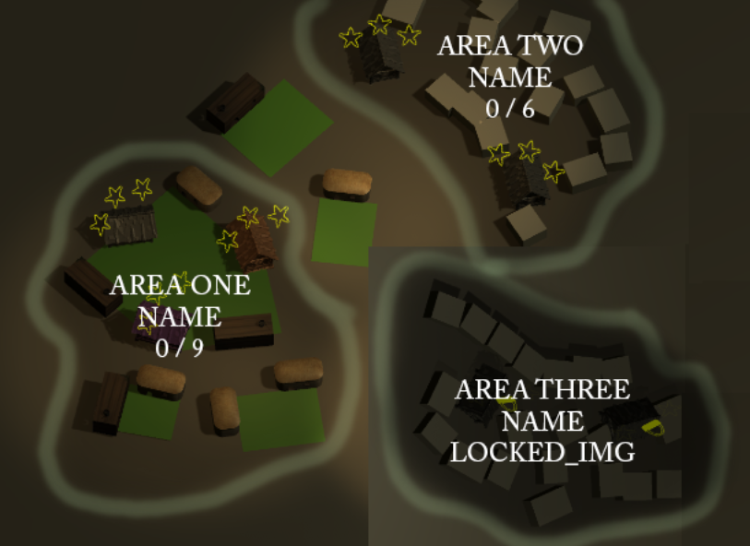

Below here is a second concept of how a ‘zoomed’ in section could look to the player.

