# Screen Mockups

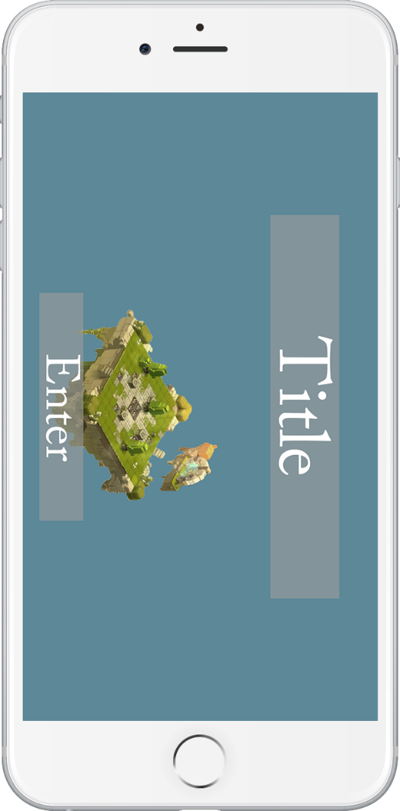All the screen mocks up are done in **1334 x 750 resolution** at **a 16:9 aspect ratio**. Our game will also be locked in the **landscape view**. Any art or colors used is purely for concept representation and not an indication thematic direction.

## Opening Screen

This screen will be the screen that players will land on **after** their first game launch. On the first game launch players could be put straight into the game.

**[2]**

**[1]**

**[3]**

[1] Game Title

* The game title will be displayed at the top of the screen.
* When the main game loads in the title could fade out the camera pan in past it.

[2] Background

* The background will be a zoomed-out view of our player’s world. Once the player starts playing it could pan in and make objects interactable.

[3] Enter Button

* This could be animated indicating the player should press here at which point the game will start.
* The could be optional, instead on the game load the title screen will pop up then it will automatically be removed.

## Overworld Screens

The overworld is the metagame progression of our game. The overworld will contain an upgradable environment for the player to interact with.

### Entry Overworld Screen

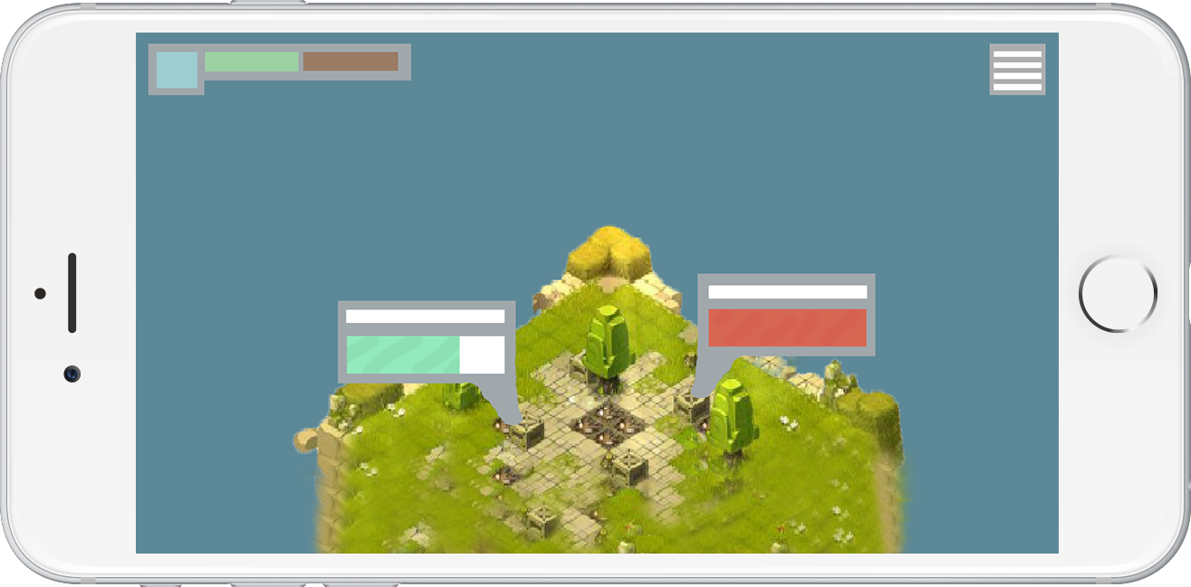This screen will be the first view on the world after the opening screen has finished loading in.

**[1]**

**[2A]**

**[2B]**

**[4]**

**[3]**

[1] Player Stats

* This area will be reserved for player stats.
* Player stats could include:
  + Player level
  + Player experience
  + Player resources
  + Player income (per hour)

[2] Factory Collection

* This box will be clickable to receive the offline income once the app is closed.
* There can be different representations of the box seen in 2A and 2B. The factory under 2A has not met its offline income cap, whereas the factory on 2B has.
* At the top a factory name can be placed, or information about the production of the factory.
* As the player scrolls past factories the opacity of the collection boxes will decrease.

[3] Menu Button

* This will open an options menu
* The options menu will overlay the screen.
* It can present some gameplay options
  + music volume
  + Effect volume
  + Hints toggle
  + Saving options (cloud)
  + Social media settings

[4] World layout

* The world will lay isometrically underneath the camera.
* Factories will be placed on the available land
* The world will scroll vertically
* Areas of the world will unlock as the player gains levels giving them access to more materials

### Overworld Screen – Menu

**[2]**

**[1]**

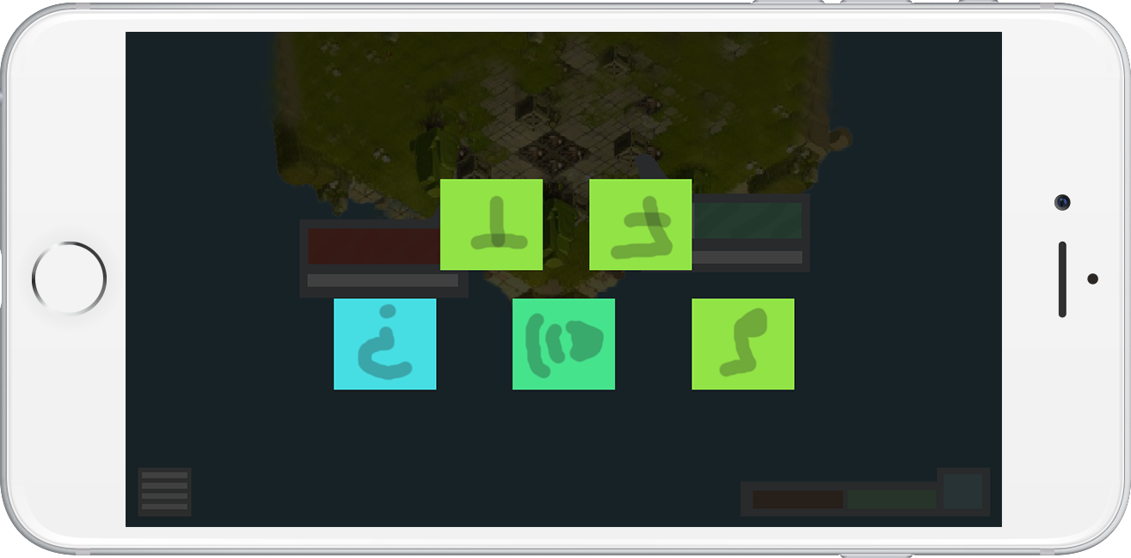

[1] Background Dim

* A dim will be applied to the background.

[2] Icons

* Icons without text will represent the player options
* When pressed, or held tooltip text can pop-up.

## Overworld Screen – Factory Selection

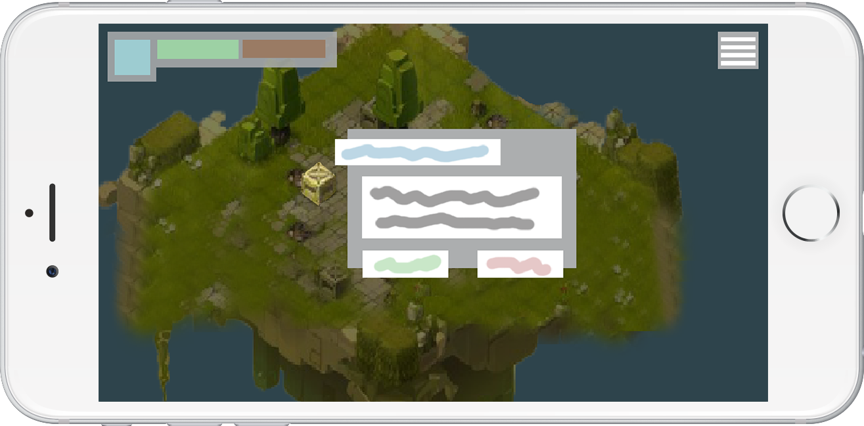

**[6]**

**[5]**

**[4]**

**[3]**

**[2]**

**[1]**

[1] Factory Highlight

# Player Flow

**New Factory Screen**

**Existing Factory Screen**

**Overworld Menu**

**Opening (Splash Screen)**

**Entry Point**

**Default Overworld**

**Selection Overworld Screen**