**Machine usage**

Preliminary:

**Ratio:**

Any machine with a greater number of inputs than outputs will work with any number of inputs up to the specified amount.

For example: A 2:1 machine can work 1:1 or 2:1. A 3:1 machine can work 1:1, 2:1 or 3:1.

**Processing time per ingredient:**

We can add extra complexity by requiring the machine to take an additional tick if more ingredients are supplied instead of one:

1 Ingredient: 1 tick processing time.  
2 ingredients: 2 tick processing time.  
3 ingredients: 3 tick processing time.

Oven:

**Design:**

Ovens should be designed as a 1:1 machine.

**Justification:**

By having a 1:1 machine, we are able to add difficulty to the timing of the production line. Ovens can be giving a “cooking” time which means they require more than 1 tick to process. This means we can introduce an added level of complexity when working with other machines alongside ovens.

An oven should be responsible for cooking one ingredient at a time, and the current design of the oven is also very suggestive of a 1:1 ratio.

Grinder:

**Design:**

Grinders should be designed as a 2:1 machine.

**Justification:**

Grinders can be responsible for grinding ingredients together. Having two 1:1 machines removes a level of complexity we can add to routing as this would leave us with only one machine with a ratio greater than 1:1.

A grinder can be designed in such a way that it is intuitive for the grinder to be a 2:1 machine:

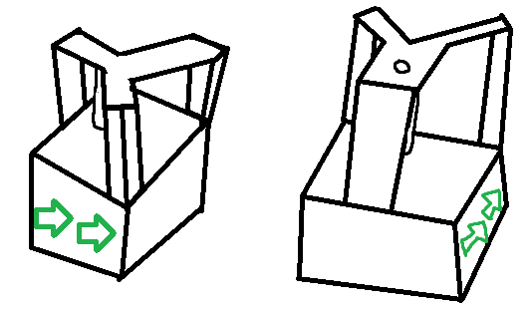

Brewer:

**Design:**

Brewers should be designed as a 3:1 machine.

**Justification:**

Potions can be made from a varying number of ingredients; some potions are simple and some are more complex. It therefore makes sense for a brewer to be able to take up to the maximum number of ingredients at once, however still be able to take less ingredients on earlier levels which feature simpler potions.

Brewers can take ingredients from the left, back and right and will produce a potion from the front in the appropriate number of ticks.