**1 - Research:**

Infinifactory has one “main” tutorial at the beginning of the game which teaches the main mechanics:

* Placing conveyers
* Rotating conveyer
* Getting item from A->B

This is all done in one linear level which teaches the player the core fundamentals of how to interact with the puzzles. There is absolutely zero challenge at this stage.

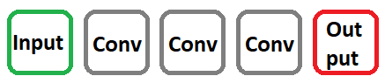

Once the player has finished the tutorial, the game splits off into sections. Each section introduces a new mechanic. Once the player has had some time to learn, practise and master this mechanic, the mechanics are used together.

* Section 1
  + Level 1
    - Introduce welder block
    - No challenge
  + Level 2, 3
    - Learn, practise, master
    - Challenge
* Section 2
  + Level 1
    - Introduce piston block
    - No challenge
  + Level 2, 3
    - Learn, practise, master
    - Challenge
  + Level 3, 4
    - Welder + piston block
    - Challenge

This trend continues of introducing how the machine works without letting the player fail. After the player has learnt the mechanic, difficulty is introduced.

**2 - Suggested layout:**

I propose an initial tutorial that takes place before the first town section is unlocked. This could be “Town section 0” which teaches the player *how to play the game* before we start getting the player to solve puzzles.

These are based on Blake’s suggestions of a 3-level minimum (5 recommended) levels per new machine:

**Initial tutorial:**

* Part 1:
  + Inputter and Output are in a straight line
  + Inputter already contains ingredient
  + Player must place conveyers
* Part 2:
  + Inputter and Output are in a straight line
  + Player must select ingredient
  + Player must place conveyers
* Part 3:
  + Inputter and Output do not line up
  + Player must select ingredient
  + Player must place conveyers
  + Player must rotate conveyer

**Town section 1 – Oven:**

* Level 1:
  + Oven in place
  + Player places Conveyers
* Level 2:
  + Player must place down Oven + Conveyers
  + Straight line
* Level 3:
  + Player must place down Oven + Conveyers
  + Player must go around a corner

**Town section 2 – Grinder:**

* Level 1:
  + Grinder in place
  + Player places conveyers
* Level 2, 3:
  + Player must place down Grinder + Conveyers
* Level 4:
  + Oven is in place
  + Player must place down Grinder and conveyers
* Level 5:
  + Player must place down Oven, Grinder, Conveyers

**Town section 3 – Brewer:**

* Level 1:
  + Brewer is in place
  + Player places down conveyers
* Level 2, 3:
  + Player has to place down Brewer, + Conveyers
* Level 4, 5:
  + Introduce all machines
  + Player has to place down Oven, Grinder, Brewer, Conveyers

**Town section 4 – Slow conveyers:**

* Level 1:
  + Inputters don’t sync up
  + All machines already in place
  + The slow conveyer is already in place
  + Player just connects everything with regular conveyers
* Level 2, 3:
  + Player has to place down their own slow conveyers
  + All machines already in place
* Level 4, 5:
  + Inputter and Outputs don’t sync up
  + Player has to place down machines and conveyers

**Town section 5 – Rotating conveyers:**

* Level 1:
  + 1 Inputter
  + 2 machines need same ingredient
  + All conveyers in place apart from rotating conveyer
  + Player places down rotating conveyer
  + Gets to see it rotate when they press play
  + 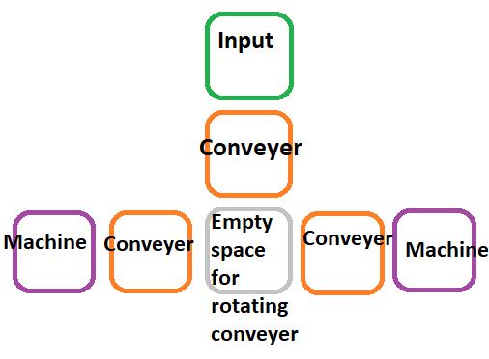
* Level 2, 3:
  + Player must place down their own slow conveyers
  + All machines already in place
* Level 4, 5:
  + Inputter and Outputs don’t sync up
  + Player has to place down machines and conveyers