**Machine Concepts**

**Design Consistency**

A big problem we have is introducing the players to our game. We need the players to understand the mechanics of our game, while this can’t be done entirely intuitively I think with some intelligent machine design we can really improve the user experience.

**Direction**

The addition of arrows to all machines. If all of the machines were to have arrows along the bottoms of them the player will always know which direction the ingredients will be flowing. We will teach them once about the arrows then they will always understand this concept.

*A conveyor into a grinder above.*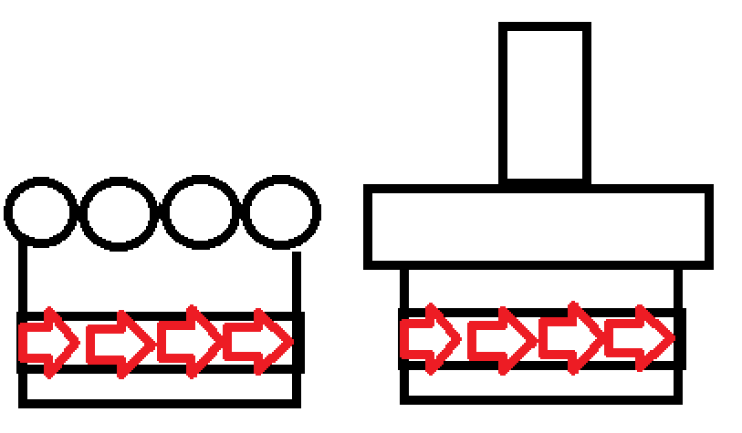

The arrows will appear consistent and show a nice flow of direction to the player.

**Color**

A bit of an oversight is color, I think color can be of a great use in indicating to the player the speed of a machine. While this is a little more subtle, I think alongside a indicator we will be able to teach the player the meanings of the colors.

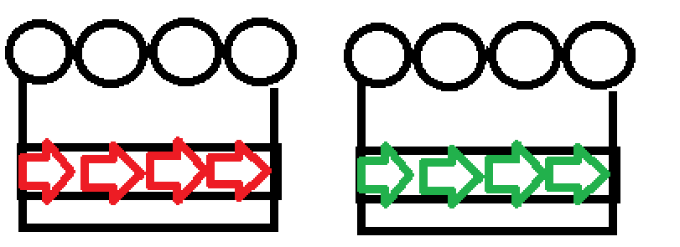

The red arrows will indicate slow 2 tick machines and green as 1 tick machines. We could also introduce yellow and have 1 to 3 tick variance in machine length.

**Machine Models**

This doesn’t follow the idea of teaching the player once, but will give the players a better chance at understand the machines without needing instruction. I think by adding shape to model of machines we show the players how these machines will need to be used. This sounds vague, but i’ll give an example. The crushers while we didn’t flesh this idea out entirely if we were to change the crusher to be a one input one output machine we could do the following: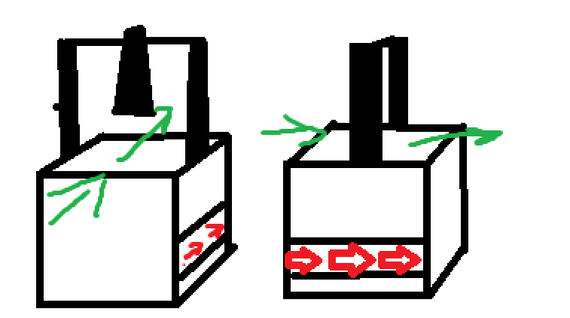

Above is two angles of the crusher.

The model indicates that input can only be passed into the machine one of the sides. With some more thought we could probably do this all of our machines thus saving us having to teach the player how many inputs and outputs a machine has.