**Hamsterdam Font Research**

**Articles:**

**Choosing / Designing the right fonts**

* [**http://blog.kongregate.com/choosing-fonts-for-your-game/**](http://blog.kongregate.com/choosing-fonts-for-your-game/)
* [**https://www.gamasutra.com/blogs/CarolMertz/20150513/243306/Down_to_the_Letter_The_Importance_of_Typography_in_Video_Games.php**](https://www.gamasutra.com/blogs/CarolMertz/20150513/243306/Down_to_the_Letter_The_Importance_of_Typography_in_Video_Games.php)
* [**https://www.gamasutra.com/blogs/DaveBleja/20141201/231207/Designing_an_Alien_Alphabet.php**](https://www.gamasutra.com/blogs/DaveBleja/20141201/231207/Designing_an_Alien_Alphabet.php)

**Color theory both inside and outside of fonts:**

* [**https://www.gamasutra.com/blogs/DougStewart/20170411/295806/Color_in_Video_Games_How_to_Choose_a_Palette.php**](https://www.gamasutra.com/blogs/DougStewart/20170411/295806/Color_in_Video_Games_How_to_Choose_a_Palette.php)
* [**https://www.gamasutra.com/view/news/315345/Art_Design_Deep_Dive_Giving_back_colors_to_cryptic_worlds_in_Dead_Cells.php**](https://www.gamasutra.com/view/news/315345/Art_Design_Deep_Dive_Giving_back_colors_to_cryptic_worlds_in_Dead_Cells.php)

**Potential Fonts**

**Another day in Paradise**

<https://www.dafont.com/another-day-in-paradise.font> 

**Summary**

* The Cursive style script font at the cost of some clarity adds flavor to the in game text.
* Smoothed edges promotes the cute aesthetic throughout the game.
* Consistent line height, and for the most part consistent letter width.
* Letter spacing is a little on the low side, reducing some of the clarity when reading it at small sizes
* High dpi, so it has no problems with scaling up or down inside of unity itself.

**Optimal Solutions**

<https://www.dafont.com/optimal-solutions.font> 

**Summary**

* The fully Cursive style would push forward the homeward, cosy feel of the game.
* Whilst been less curlicued than you’d expect for a script font the joins present a handwritten feel to the font.
* The line height remains constant, but the letter width changes really bringing forth a handwritten feel.
* Issues will come out when trying to resize this as it is a low dpi.

**Dani's Handwriting**

<https://www.dafont.com/danis-handwriting.font> 

**Summary:**

* A handwritten script font could pulls out the charm of the game whilst remain legible.
* Soft edges and imperfect curves shines through showing the handwritten style promoting the cute side of our game.
* Width spacing is quite low so the letters merge into each other in places making somewhat difficult to read.
* The dpi is fairly good, but due to the disparity in the letter spacing the font has to remain quite small.

**Pop Rum Cute**

[**https://www.freejapanesefont.com/pop-rum-cute-download/**](https://www.freejapanesefont.com/pop-rum-cute-download/)



**Summary:**

* A gothic styled script font which has been adapted to remove any harsh edges with curves promotes a cute style, but is quite hard to read.
* Script font with consistent line height and letter width helps with the readability.
* High dpi and consistent spacing allows it to scale very well to all sizes.

**HonyaJi Re**

<https://www.freejapanesefont.com/honyaji-re-download/>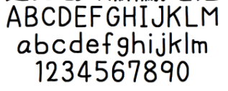

**Summary**

* A simplistic script font with a few blemishes to pull apart the perfections that comes with a sans style.
* Curvy without any harsh turns.

**Reference fonts:**

**Finurlig**

<http://www.1001fonts.com/finurlig-demo-font.html>

**Uechi**

<http://www.1001fonts.com/uechi-font.html#styles>

**Spring is coming**

[**http://www.1001fonts.com/spring-is-coming-font.html**](http://www.1001fonts.com/spring-is-coming-font.html)

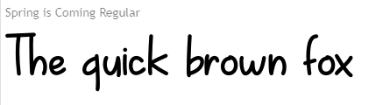

**Metamorphous**

[**http://www.1001fonts.com/metamorphous-font.html**](http://www.1001fonts.com/metamorphous-font.html)

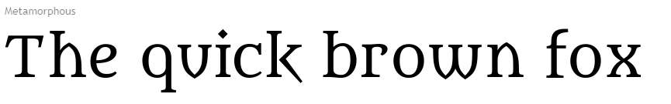

**Magnificent**

[**https://www.dafont.com/magnificent-2.font**](https://www.dafont.com/magnificent-2.font)



**Cardinal**

[**https://www.dafont.com/cardinal.font**](https://www.dafont.com/cardinal.font)

**Sweet Sensations**

[**http://www.fontspace.com/billy-argel/sweet-sensations-personal-use**](http://www.fontspace.com/billy-argel/sweet-sensations-personal-use)

