# Game Progression in Emergent Games

I read a few articles and tried out a few games to look for some approaches to our game progression.

## Approach

After reading an article by Jesper Juul titled “The Open and the Closed: Games of Emergence and Games of Progression.” (Juul, 2002). I realized the **importance of not limiting the player’s options by progression**. If we leave many of the games ‘tools’ locked behind a progress requirement many players may leave the game before they have the intended experience.

I next read a blog post by Josh Bycer on Gamasutra titled “The Procession of Progression in Game Design” (Bycer, 2013). Bycer talks about the **progression being split into two categories the player and the game**. The **player progression** outlines how the **player becomes more skillful** at the game where the **game progression** outlines how the game provides **better resources** for the player to use. The ideal experience would be to present the player with a **multi-system system progression** where both player progression and game progression interact. Bycer add a nice graph explain showing how the progress through a game can look.

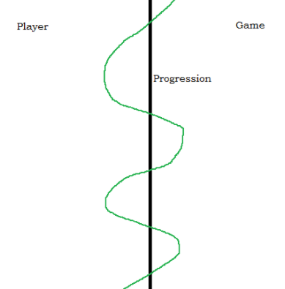(Bycer, 2012)

Above you can see the green representing the player progression. It both advanced by player progress on the left and game progress on the right. A good example of this multi-system progression is binding of Isaac whereby playing can unlocked additional items for the player to master. However, after completing the game a few times the difficulty of the game will ramp up. To sum up Bycer’s post he states, “games that feature different forms of progression can lead to richer gameplay experiences”. Which is something we should aim for in our game.

## Ideas & Examples

**Factorio (2016)**

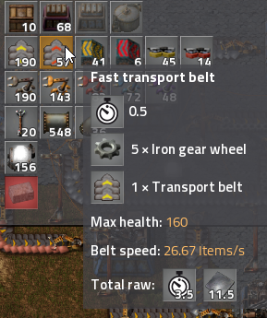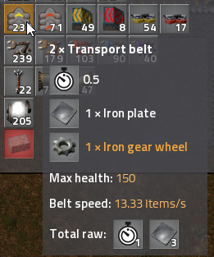Factorio is an industrial sandbox game where is player’s goal is to setup a factory and progress through the tehcnology.

(Wube Software, 2016)

Above shows two available ways of transporting goods. The first transport belt on the left takes less items to build but it slower, and on the right is more expensive but its faster. However to unlock the belt on the right you need to advance down a technology tree.

Technology advancement unlocks both additional buildings and upgrades to current **core** buildings. This is done by building and supplying research labs with materials. So, a ramp up on player skill is required to speed research as well as making use of the newly researched tech. This progression appears to be a multi-system progression using both the player skills and game advancement.

# Bibliography

Juul, J. (2002). The Open and the Closed: Games of Emergence and Games of Progression. In: *Proceedings of Computer Games and Digital Cultures Conference.* Copenhagen: Tempere University Press, pp.232-329.

<https://www.gamasutra.com/blogs/JoshBycer/20130523/192906/The_Procession_of_Progression_in_Game_Design.php>

<http://store.steampowered.com/app/427520/Factorio/>