John Dorman

Group 8

03.10.2017

**Game Research**

**Portal (Valve) 2007**

Puzzle-Platformer

**Objective**

To complete each level the player must move their character from A to B

**Means**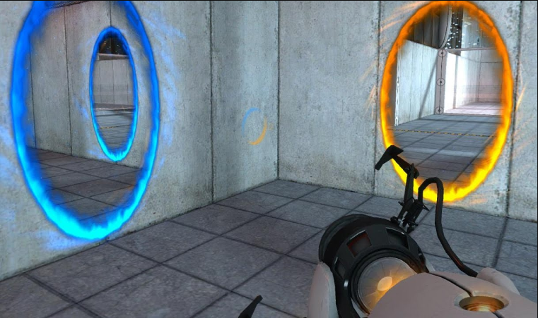

Portal Gun.

* Can launch two portals onto walls, floors, or ceilings. Entering the portal will cause the player character or any object they to be teleported to the other portal.

**Modifiers**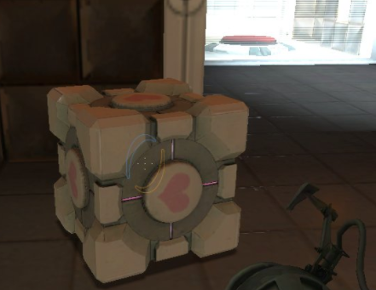

Companion Cubes.

* Can be used for climbing or weighing down a pressure plate.
* Can be spawned into the level a few different ways, but usually by a button pressed by the player.
* Can be destroyed by lava pits and certain ‘fields’ which surround the level.

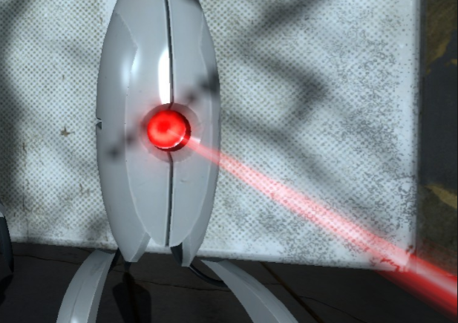

Enemies.

* Usually stationary will damage or kill the player’s character if encountered inappropriately
* Can be used to kill other enemies.

Hazards.

* Can be placed both on the floor and can moving around the room

**NaissanceE (Limasse Five) 2014**

Puzzle-Platformer

Adventure

Indie

**Objective**

* To complete each ‘level’ the player must move their character from A to B.
* The levels flow into each other and are not clearly defined.

**Means**

* The player’s character can sprint, jump, and can interact with light orbs which has many uses.

**Modifiers**

* Maze like levels.
  + The levels are completely open, but are vast mazes which can resemble doolin’s artwork.
* Light
  + Areas of the map can be shrouded in darkness the player will need to interact with a light orb in order to pass them.

**Similar Games**

**Disoriented -** <http://store.steampowered.com/app/556240/Disoriented/>

**Trine Trilogy (Frozenbyte) Various years**

Puzzle-Platformer

Adventure

**Objective**

* There can be a few ways to complete a level
  + Moving the character/s to a desired location
  + Escorting a character or object
  + Killing a boss

**Means**

* The player is given control of three characters a warrior, wizard, and archer type.
* The Warrior
  + Can smash broken walls
  + Can reflect projectiles
  + Can glide instead of fall
* The Archer
  + Can swing on ropes
  + Can use ropes to pull objects
* The Wizard
  + Can create boxes, and planes
  + Can move objects with telekinesis

**Modifiers**

* Enemies/Bosses
  + Various enemies will be scattered across levels and usually the player can fight them in various ways with the three characters
  + Bosses will be at the end of levels and will need to be encountered in a specific way.
* Hazards
  + Spikes and other various objects can be placed on any surface
  + Fireballs

**Comments & Ideas:**

**Immersive Gameplay**

* Give the player an explanation to why they are solving these 'puzzles'.
  + The player falling into the first puzzle area.
  + The player is taken for a job interview they are put into a room and locked in they have to escape from here
  + *Movies like Cube (1997) & Exam (2009)*

* Levels are not explicitly defined one will merge into the next.
  + Use mechanics like falling to block of backtracking where we don’t want it.
  + If we want to include analytics they could be provided after a complete playthrough along with a level select.
* Sound
  + If we have a player character include things like heavy breathing during sprinting, and footsteps on certain surfaces.
    - This also seconds as information to the player for things like run limits.

**Mechanics**

* Physics
  + The laws of physics could be changed from level to level.
    - If the main mechanic is driven by carrying an object from A to B, then suddenly what if solid objects became liquid and liquid became solids
    - Gravity variance
    - Light given mass
* Timing
  + Switches stay switched for durations.
  + Platforms that move on intervals
* Sound
  + (3d only) Sound location to spark players interest into crucial areas.
* Light & Color
  + By lighting an object with a certain color it will react in a certain way.
  + Levels without ambient light, so the player’s vision is obscured without a nearby light source.
* Size
  + Player size can be manipulated
* Air
  + Wind that pushes objects or the player

**Bibliography**

Portal (2007). <http://store.steampowered.com/app/400/Portal/>

NaissanceE (2014) <http://store.steampowered.com/app/265690/NaissanceE/>

Trine Trilogy (Various years). <http://store.steampowered.com/bundle/721/Trinelogy/>

Cube (1997) <http://www.imdb.com/title/tt0123755/>

Exam (2009). [www.imdb.com/title/tt1258197/?ref_=tt_rec_tti](http://www.imdb.com/title/tt1258197/?ref_=tt_rec_tti)