**Final Group Project Design Document v.00**

**[Name To Be Confirmed]**

**Introduction**

**Objective of the Game**

This game is a combination of fitness game, snack game and augmented reality pet simulator. A large componenent of caring for the pet is taking it for a walk or run in real life.

**Gameplay Description**

**Mechanics**

* Walking
* Progression system (upgrades for the pet).
* Rewards schedules
* Step counter
* Augmented realtiy capability to see the pet.

**Dynamics**

The game will challenge players with a gradual incline in difficulty and increase the required amount of walking in order to progress.

The player must care for their pet by feeding and walking it. Walking the pet will take place in real life, making use of real life maps where players can find other pets and collectables. The more a player cares for their pet the more the pet will level up, and the more collectables and interactions with the pet the player can unlock. Ideally there would be some element of PvP, though this could take the form of battling the pets, or the pets preforming tricks and receiving scores on how well those tricks are preformed.

**Aesthetics**

**Themes**

Below are some examples of themes that could fit with the current design decisions. [Anonymous: N.D].

* Darkness and Light
* Life and Death
* Empowerment
* Destruction of beauty
* Fading beauty
* Facing darkness
* Rebirth
* Reunion
* Self reliance
* Temporary nature of physical beauty
* Temptation and destruction
* Vanity as downfall
* Circle of life
* Creation
* Technology as a downfall

**Player Experience**

This game would focus on a **care for pet, fight, rewards** game loop. The player experience would focus on creating empathy for the pet, competition, mastery and progression scheduals. Hard fun (possibly people fun).

**Reward Systems (Player Retention)**

* Using the hook model to keep players engaged in the game.
* Progression of the pets abilities and items.
* Accomplishment/mastery of mechanics.
* False rewards to act as a tool for learning the game. Doesn’t offer any spatial progression and is seen as a false reward. The reward comes through learning the games interaction system. [Gazzard, A : 2011]

**Demographics**

Using Bart Stewarts Unified Model [Stewarts, B : 2011] to narrow down our player type.

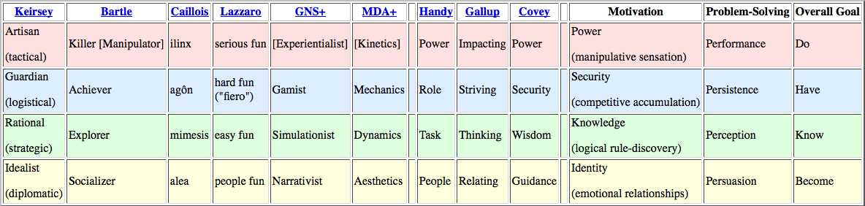

Socializer, Achievers and Explorers are the demographic of players who will enjoy playin this game.

Socializers enjoy: chatting, roleplaying, storytelling, cooperation, decorating, pets, social events.

Acheivers enjoy: competition, collections, manufacturing, high scores, levels, clear objectives, guild membership, min-maxing.

Explorers enjoy: puzzles, creative building, world-lore, systems analysis, theorizing, surprise.

**Time Required To Play**

The game will technically have no end, and its sole purpose is to keep people playing as long as possible. However because it is a mobile game it must adhere to snack game rules – players will likely only play for 15-30 minute intervals. First impressions are vital in this game as they will decide if a player even plays the game or if they close the app and delete it immediately.

**The Rules**

**Artistic Style Outline**

**Game Assets**

**Suggested Game Flow Diagram**

**Additional Ideas And Possibilities**

**Bibliography**

Freeman, T. (1997) *Creating A Great Design Document* [Online] Accessed On [29/02/2016]. Available At: <http://www.gamasutra.com/view/feature/131632/creating_a_great_design_document.php>

Ryan, T. (1999) *The Anatomy of a Design Document, Part 1: Documentation Guidelines for the Game Concept and Proposal* [Online] Accessed On [29/02/16]. Available At: <http://www.gamasutra.com/view/feature/131791/the_anatomy_of_a_design_document_.php?page=3>

Bakker, J. (2009) *A GDD Template for the Indie Developer* [Online] Accessed on [29/02/16] Available at: <http://www.gamasutra.com/blogs/JasonBakker/20090604/84211/A_GDD_Template_for_the_Indie_Developer.php>

**Demographics**

Stewart, B (2011) *Personality and Play Styles: A Unified Model.* [Online] Accessed On: 28/07/17. Available At: <http://www.gamasutra.com/view/feature/134842/personality_and_play_styles_a_.php>

Einhorn, A (2015) *Four Step Puzzle Design* [Online] Accessed On [26/07/17] Available At: <http://www.gamasutra.com/blogs/AsherEinhorn/20150528/244577/Fourstep_puzzle_design.php>

Kockar, A (2016) *On Puzzle Design And Fabric* [Online] Accessed On [26/07/17] Available At: <http://www.gamasutra.com/blogs/AtilKockar/20161026/284098/On_Puzzle_Design_and_Fabric.php>

Luban, P (2002) *Designing and Integrating Puzzles In Action-Adventure Games* [Online] Accessed On (26/07/17) Available At: <http://www.gamasutra.com/view/feature/131326/designing_and_integrating_puzzles_.php>

Sala, T (2013) *Game Design Theory Applied: The Flow Channel* [Online] Accessed On (26/07/17) Available At: <http://www.gamasutra.com/blogs/ToniSala/20131208/206535/Game_Design_Theory_Applied_The_Flow_Channel.php>

<http://www.gamasutra.com/blogs/ToniSala/20140102/207665/Game_Design_Theory_Applied_the_puzzle_of_designing_a_puzzle_game.php>

Kantilaftis, H (2015) *Learning From The Best: Action Adventure Games.* [Online] Viewed On: 28/07/17. Available At: <https://www.nyfa.edu/student-resources/learning-from-the-best-action-adventure-games/>

**Combat System Research**

**Ruiz, B (2013) *Anatomy Of A Successful Attack (2.0)* [Online] Viewed On: 28/07/17. Available At:** [**https://aztez.com/blog/2014/01/06/anatomy-of-a-successful-attack/**](https://aztez.com/blog/2014/01/06/anatomy-of-a-successful-attack/)

**Anonymous (2016) *About Combat System Design* [Online] Viewed On: 28/07/17. Available At:** [**https://breadcrumbsinteractive.com/about-combat-system-design/**](https://breadcrumbsinteractive.com/about-combat-system-design/)

**Anonymous (N.D) *A Huge List Of Common Themes* [Online] Viewed On: 28/07/17. Available At:** [**https://literarydevices.net/a-huge-list-of-common-themes/**](https://literarydevices.net/a-huge-list-of-common-themes/)

**Rewards**

Gazzard, A. (2011) *Unlocking The Gameworld: The Rewards Of Space and Time in Video Games.* [Online] Viewed On 28/07/17. Available At: <http://gamestudies.org/1101/articles/gazzard_alison>

Sala, T (2013) *Game Design Theory Applied: A Layered Rewards System.* [Online] Viewed On 28/07/17. Available At: <http://www.gamasutra.com/blogs/ToniSala/20131215/207064/Game_Design_Theory_Applied_A_Layered_Rewards_System.php>