**Final Group Project Design Document v.00**

**[Name To Be Confirmed]**

**Introduction**

**Objective of the Game**

As the protagonist you must traverse a dark environment with only a light source to guide your way to ward of enemies (potentially) and solve puzzles. The game will either be a Classical Adventure Game (investigation), Action-Adventure games. [Luban, P : 2002]

**Gameplay Description**

**Mechanics**

* Walking
* Light source
* Oils for light source (light source against different enemies)
* Timer for oils to wear off
* Enemies

**Dynamics**

The game will challenge players with a gradual incline in difficulty.

The puzzles discusses so far are:

* Refracting beams of light using mirrors to hit a specific point/create a shape
* Directing a shadow using a sun dial.
* Timing and precision puzzles (could also double as the combat to “repel” enemies)
* Matching the lamp/lamps and oil colours to objects/enemies in the room in the correct sequence. Scaled difficulty with multiple colours on a single object.
* Matching colours to specific trees/plants to make them grow in such a way that they avoid hazards (that must be burned down or incinerated with concentrated light).

Each puzzle will adhere to be sure that it: (Einhorn, A : 2015)

* The player understands the objective
* The player discovers the puzzle
* The player works out a solution in their head.

Due to the presence of enemies there will be action elements to the adventure game, meaning emphasis must be placed on combat and the enemies themselves. The combat could be achieved in several different ways.

* The player does not directly “attack” enemies, but adds a specific oil to change the colour of their lamp, which then repels the enemies or kills them.
* The player can “shoot” beams of light at enemies which do damage within a certain radius. The oils still would be for specific enemies.
* There are inanimate objects in the environment that the player can use as checkpoints and do repel/kill enemies. Otherwise the player must keep their lantern lit and avoid enemies.

Regardless all enemy combat must contain these things [Ruiz, B: 2013]:

* Attack Animation to build anticipation (usually 6 frames).
* Struck Animation which is fast and over the top to sell the pain of the enemy. Flash the struck character a colour to visual show something has happened.
* Weapon swing effects which should be big and flashy, fast and follow a smooth linear line.
* Hit effect must also be big and flashy with quick fire. Similar to explosions.
* Screen shake to sell the impact.
* Animation freeze when a hit connects for a few frames.

Optional combat effects:

* Weapon impact effect.
* Blood.
* Attacker ground dust.

**Aesthetics**

**Themes**

Below are some examples of themes that could fit with the current design decisions. [Anonymous: N.D].

* Darkness and Light
* Life and Death
* Empowerment
* Destruction of beauty
* Fading beauty
* Facing darkness
* Rebirth
* Reunion
* Self reliance
* Temporary nature of physical beauty
* Temptation and destruction
* Vanity as downfall
* Circle of life
* Creation
* Technology as a downfall

**Player Experience**

The game will be a puzzle game primarily, so curiosity and challenge are essential. The puzzles will get gradually more complex, but with little or no punishment or lost progress to keep frustration low.

The game will focus on trying to achieve Flow by focusing on the factors; Challenge VS Skill, Anxiety VS Boredom, Difficulty or Difficulty Balance. In an attempt to balance these elements and keep the player within the Flow Channel, the puzzles should follow a pattern such as outlined below.

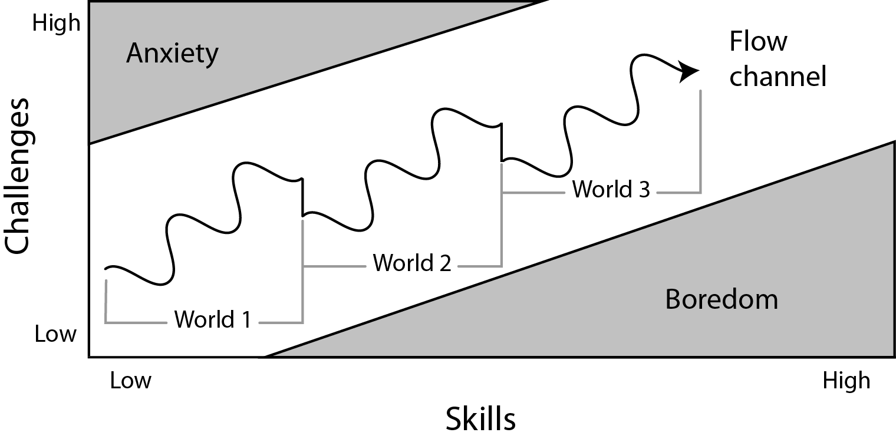

In the above diagram the player is increasing skill and challenge in a wave pattern, with dips in difficulty at the start of each new puzzle, section, world, mechanic etc. The intention of creating game play following this diagram is that there is variation in the gameplay between the difficulty, not just between sections but within each section. [Sala, T: 2013]

There will be visual incremental progress, to show the player they are getting closer to their destination or not. The puzzles should force players to think about the mechanics in a different way by being offered multiple choices but only a select few (or one) solution. [Kockar, A : 2016]

**Reward Systems (Player Retention)**

* Spatial rewards to avoid obstacles with new areas and spaces to explore/puzzles to solve
* Accomplishment/mastery of mechanics.
* Penalties in the form of restart section on death (frequent checkpoints).
* False rewards to act as a tool for learning the game. Doesn’t offer any spatial progression and is seen as a false reward. The reward comes through learning the games interaction system. [Gazzard, A : 2011]

**Demographics**

Using Bart Stewarts Unified Model [Stewarts, B : 2011] to narrow down our player type.

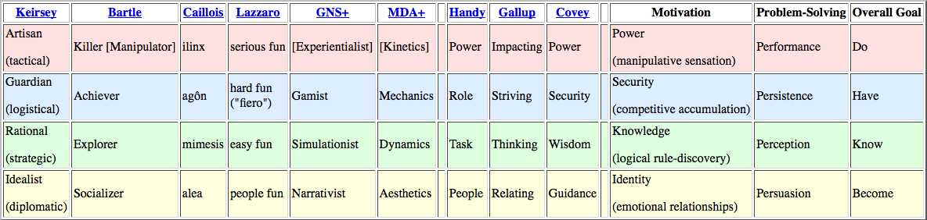

Achiever/Explorer seems to fit with the players of Action Adventure games best. That means our player will be likely to enjoy: action, vertigo, tool-use, vehicle use, horror, gambling, speedruns, exploits as a Killer. As a Explorer the player will enjoy: puzzles, creative building, world-lore, systems analysis, theorizing, surprise.

**Time Required To Play**

**The Rules**

**Artistic Style Outline**

**Game Assets**

**Suggested Game Flow Diagram**

**Additional Ideas And Possibilities**

**Bibliography**

Freeman, T. (1997) *Creating A Great Design Document* [Online] Accessed On [29/02/2016]. Available At: <http://www.gamasutra.com/view/feature/131632/creating_a_great_design_document.php>

Ryan, T. (1999) *The Anatomy of a Design Document, Part 1: Documentation Guidelines for the Game Concept and Proposal* [Online] Accessed On [29/02/16]. Available At: <http://www.gamasutra.com/view/feature/131791/the_anatomy_of_a_design_document_.php?page=3>

Bakker, J. (2009) *A GDD Template for the Indie Developer* [Online] Accessed on [29/02/16] Available at: <http://www.gamasutra.com/blogs/JasonBakker/20090604/84211/A_GDD_Template_for_the_Indie_Developer.php>

**Demographics**

Stewart, B (2011) *Personality and Play Styles: A Unified Model.* [Online] Accessed On: 28/07/17. Available At: <http://www.gamasutra.com/view/feature/134842/personality_and_play_styles_a_.php>

Einhorn, A (2015) *Four Step Puzzle Design* [Online] Accessed On [26/07/17] Available At: <http://www.gamasutra.com/blogs/AsherEinhorn/20150528/244577/Fourstep_puzzle_design.php>

Kockar, A (2016) *On Puzzle Design And Fabric* [Online] Accessed On [26/07/17] Available At: <http://www.gamasutra.com/blogs/AtilKockar/20161026/284098/On_Puzzle_Design_and_Fabric.php>

Luban, P (2002) *Designing and Integrating Puzzles In Action-Adventure Games* [Online] Accessed On (26/07/17) Available At: <http://www.gamasutra.com/view/feature/131326/designing_and_integrating_puzzles_.php>

Sala, T (2013) *Game Design Theory Applied: The Flow Channel* [Online] Accessed On (26/07/17) Available At: <http://www.gamasutra.com/blogs/ToniSala/20131208/206535/Game_Design_Theory_Applied_The_Flow_Channel.php>

<http://www.gamasutra.com/blogs/ToniSala/20140102/207665/Game_Design_Theory_Applied_the_puzzle_of_designing_a_puzzle_game.php>

Kantilaftis, H (2015) *Learning From The Best: Action Adventure Games.* [Online] Viewed On: 28/07/17. Available At: <https://www.nyfa.edu/student-resources/learning-from-the-best-action-adventure-games/>

**Combat System Research**

**Ruiz, B (2013) *Anatomy Of A Successful Attack (2.0)* [Online] Viewed On: 28/07/17. Available At:** [**https://aztez.com/blog/2014/01/06/anatomy-of-a-successful-attack/**](https://aztez.com/blog/2014/01/06/anatomy-of-a-successful-attack/)

**Anonymous (2016) *About Combat System Design* [Online] Viewed On: 28/07/17. Available At:** [**https://breadcrumbsinteractive.com/about-combat-system-design/**](https://breadcrumbsinteractive.com/about-combat-system-design/)

**Anonymous (N.D) *A Huge List Of Common Themes* [Online] Viewed On: 28/07/17. Available At:** [**https://literarydevices.net/a-huge-list-of-common-themes/**](https://literarydevices.net/a-huge-list-of-common-themes/)

**Rewards**

Gazzard, A. (2011) *Unlocking The Gameworld: The Rewards Of Space and Time in Video Games.* [Online] Viewed On 28/07/17. Available At: <http://gamestudies.org/1101/articles/gazzard_alison>

Sala, T (2013) *Game Design Theory Applied: A Layered Rewards System.* [Online] Viewed On 28/07/17. Available At: <http://www.gamasutra.com/blogs/ToniSala/20131215/207064/Game_Design_Theory_Applied_A_Layered_Rewards_System.php>