<https://www.ancient.eu/Mictlantecuhtli/>

[Mictlantecuhtli](https://www.ancient.eu/Mictlantecuhtli/) (pron. Mict-lan-te-cuht-li) or ‘Lord of the Land of the Dead’ was the [Aztec](https://www.ancient.eu/Aztec/) god of death and worshipped across Mesoamerica. He ruled the underworld (Mictlán) with his wife Mictecacíhuatl. The god was the ruler of the 10th day Itzcuintli (Dog), the 5th Lord of the Night and the 6th (or 11th) Lord of the Day. He was the equivalent of the [Maya](https://www.ancient.eu/Maya/) god Yum Cimil, the [Zapotec](https://www.ancient.eu/Zapotec/) god Kedo and the Tarascan god Tihuime. Mictlantecuhtli was closely associated with owls, spiders and bats and the direction south.

### Mictlàn

Mictlantecuhtli was such an important god in the Aztec pantheon because, as ruler of Mictlán, all souls would one day meet him face to face, for it was believed that only those who suffered a violent death, women who died in childbirth or people killed by storms or floods avoided the underworld in the afterlife. The Aztecs did not believe in a special paradise reserved only for the righteous but, rather, that all people shared the same destiny after death, regardless of the kind of life they had led. Souls would descend the nine layers of the underworld in an arduous four-year journey until eventually reaching extinction in the deepest part - Mictlan Opochcalocan. Mictlantecuhtli was particularly worshipped in the Aztec month of Tititl where, at the [temple](https://www.ancient.eu/temple/) of Tlalxicco, an impersonator of the god was sacrificed and incense was burned in his honour.

**[[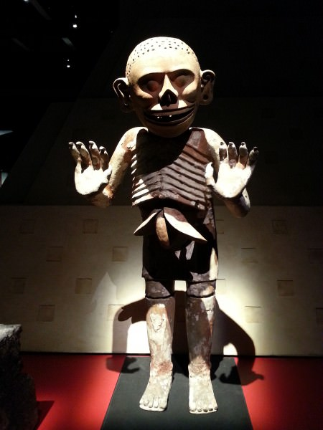](https://www.ancient.eu/image/4009/)](https://www.ancient.eu/image/4009/)**

[Mictlantecuhtli](https://www.ancient.eu/image/4009/)

### Representation in Art

Mictlantecuhtli is usually portrayed in art as a skeleton or covered in bones with red spots representing blood. He may also wear a skull mask, bone ear plugs, a costume of owl feathers and even a necklace of eyeballs. He has curly black hair and powerful eyes which allow him to penetrate the gloom of the underworld. On occasion he can be wearing clothes and a conical hat made from bark-paper.

<https://www.thoughtco.com/mictecacihuatl-aztec-goddess-of-death-248587>

### **Symbols, Iconography, and Art**

Aztecs depicted Mictecacihuatl with a skull face, a skirt made from serpents, and sagging breasts.

### **Mictecacihuatl is Goddess of**

Death  
Underworld

### **Story and Origin of Mictecacihuatl**

The basic job which Mictecacihuatl has is to watch over the bones of the dead. Because of the bones of the dead from past worlds were used to create the first humans of this world, it's possible the bones of people form this world will at some point be needed to create the people in some future world.

This is why they would have to be carefully guarded — but, like the bones from past worlds, they will probably have to be stolen in order to be used.

### **Family Tree and Relationships of Mictecacihuatl**

Wife of Mictecacihuatl

### **Temples, Worship, and Rituals of Mictecacihuatl**

The Aztecs believed that Mictecacihuatl presided over their festivals in honor of the dead. Those celebrations evolved with the incorporation of Christianity and are now represented in the Day of the Dead.

### **Mythology and Legends of Mictecacihuatl**

Mictecacihuatl is also sometimes called the Lady of the Dead because, in some legends, she is depicted as having died in childbirth.

<https://en.wikipedia.org/wiki/Mictlan>

Mitclan is the Aztec underworld. Most people who died went to Mictlan, although other possibilities existed (see "Other Destinations," below).[[1]](https://en.wikipedia.org/wiki/Mictlan#cite_note-Smith2009p207-1) Mictlan consisted of nine distinct levels.[[1]](https://en.wikipedia.org/wiki/Mictlan#cite_note-Smith2009p207-1)

The journey from the first level to the ninth was difficult and took four years, but the dead were aided by the [psychopomp](https://en.wikipedia.org/wiki/Psychopomp), [Xolotl](https://en.wikipedia.org/wiki/Xolotl). The dead had to pass many challenges, such as crossing a mountain range where the mountains crashed into each other, a field with wind that blew flesh-scraping knives, and a river of blood with fearsome jaguars.[*[citation needed](https://en.wikipedia.org/wiki/Wikipedia:Citation_needed" \o "Wikipedia:Citation needed)*]

Mictlan also features in the Aztec creation myth. Mictlantecuhtli set a pit to trap Quetzalcoatl. When Quetzalcoatl entered Mictlan, Mictlantecuhtli was waiting. He asked Quetzalcoatl to travel around Mictlan four times blowing a conch shell with no holes. Quetzalcoatl eventually put some bees in the conch shell to make sound. Fooled, Mictlantecuhtli showed Quetzalcoatl to the bones. But Quetzalcoatl fell into the pit and some of the bones broke. The Aztecs believed this is why people's height are different.

Mictlan was ruled by King [Mictlantecuhtli](https://en.wikipedia.org/wiki/Mictlantecuhtli) ("Lord of the Underworld")[[2]](https://en.wikipedia.org/wiki/Mictlan#cite_note-Smith2009p206-2) and his wife, [Mictecacihuatl](https://en.wikipedia.org/wiki/Mictecacihuatl) ("Lady of the Underworld").[[3]](https://en.wikipedia.org/wiki/Mictlan#cite_note-3)

Other deities in Mictlan included [Cihuacoatl](https://en.wikipedia.org/wiki/Cihuacoatl_(goddess)) (who commanded Mictlan spirits called [Cihuateteo](https://en.wikipedia.org/wiki/Cihuateteo)), [Acolmiztli](https://en.wikipedia.org/wiki/Acolnahuacatl_(deity)), [Chalmecacihuilt](https://en.wikipedia.org/wiki/Chalmecacihuilt), [Chalmecatl](https://en.wikipedia.org/wiki/Chalmecatl) and [Acolnahuacatl](https://en.wikipedia.org/wiki/Acolnahuacatl_(deity)).[[*citation needed*](https://en.wikipedia.org/wiki/Wikipedia:Citation_needed)]

<http://www.mexicolore.co.uk/aztecs/ask-us/13-heavens-and-9-underworlds>

‘Under the celestial column of the gods, forces, colors, and dualities floated the four-quartered Earth in the sacred waters. Below the terrestrial level were the nine levels of the underworld, realms that the souls of the dead had to cross: the place for crossing the water, the place where the hills are found, the obsidian mountain, the place of the obsidian wind, the place where banners are raised, the place where people are pierced with arrows, the place where people’s hearts are devoured, the obsidian place of the dead, the finally, the place where smoke has no outlet (Mictlan).’

<https://en.wikipedia.org/wiki/Mictlan>