**Final Group Project Design Document v.00**

**[Name To Be Confirmed]**

**Introduction**

**Objective of the Game**

A dungeon crawler that focuses of memory puzzles. The objective is to get to the end of the game by choosing your own path and solving all the puzzles on the way. This game focuses on a learn practise master core gameplay loop.

**Gameplay Description**

**Mechanics**

* Walking
* Progression system (upgrades for the pet).
* Rewards schedules
* Step counter
* Augmented realtiy capability to see the pet.

**Dynamics**

This game would incorporate spatial memory, were the player would remember where they had travelled and what direction they needed to go in. They choose to go down corridor A or B, and once they have made their choice the other option is rendered null. Each corridor will present different obstacles, an easy path or a hard path. This is to make use of risk/reward mechanics.

There would also be enviromental puzzles as a gating technique. The player would remember a sequence, and then repeat the sequence by some environmental input (a button, levers etc). If successful the player can progress, if not they must try again. These puzzles could be colour, sound or object based. This game would focus on a Learn Practise Master loop and inciting fiero in the player through hard fun.

**Aesthetics**

**Themes**

Below are some examples of themes that could fit with the current design decisions. [Anonymous: N.D].

* Empowerment
* Reunion
* Self reliance
* Vanity as downfall
* Circle of life
* Creation
* Technology as a downfall

**Player Experience**

This game would focus on a **learn practice master** loop in which the player travels through a dungeon and finds the end through exploration and problem solving.

**Reward Systems (Player Retention)**

* Accomplishment/mastery of mechanics.
* Rewards to aid players in their exploration, and help them choose which corridors to travel down with more information.
* False rewards to act as a tool for learning the game. Doesn’t offer any spatial progression and is seen as a false reward. The reward comes through learning the games interaction system. [Gazzard, A : 2011]

**Demographics**

Using Bart Stewarts Unified Model [Stewarts, B : 2011] to narrow down our player type.

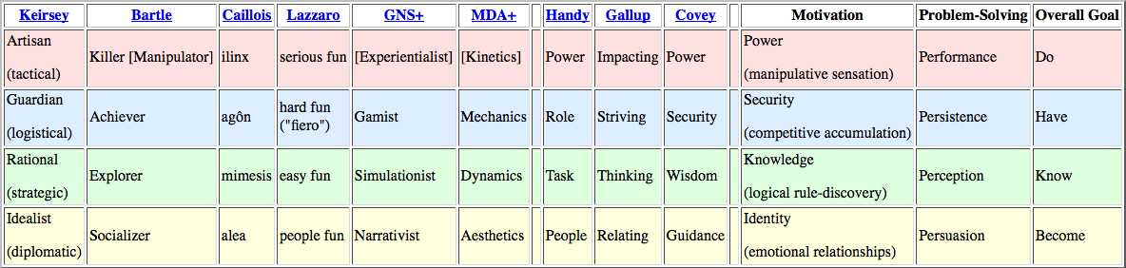

Achievers and Explorers are the demographic of players who will enjoy playin this game.

Acheivers enjoy: competition, collections, manufacturing, high scores, levels, clear objectives, guild membership, min-maxing.

Explorers enjoy: puzzles, creative building, world-lore, systems analysis, theorizing, surprise.

**Time Required To Play**

The game will take 20-30 minutes to complete a normal paced play session.

**The Rules**

**Artistic Style Outline**

**Game Assets**

**Suggested Game Flow Diagram**

**Additional Ideas And Possibilities**

**Bibliography**

Freeman, T. (1997) *Creating A Great Design Document* [Online] Accessed On [29/02/2016]. Available At: <http://www.gamasutra.com/view/feature/131632/creating_a_great_design_document.php>

Ryan, T. (1999) *The Anatomy of a Design Document, Part 1: Documentation Guidelines for the Game Concept and Proposal* [Online] Accessed On [29/02/16]. Available At: <http://www.gamasutra.com/view/feature/131791/the_anatomy_of_a_design_document_.php?page=3>

Bakker, J. (2009) *A GDD Template for the Indie Developer* [Online] Accessed on [29/02/16] Available at: <http://www.gamasutra.com/blogs/JasonBakker/20090604/84211/A_GDD_Template_for_the_Indie_Developer.php>

**Demographics**

Stewart, B (2011) *Personality and Play Styles: A Unified Model.* [Online] Accessed On: 28/07/17. Available At: <http://www.gamasutra.com/view/feature/134842/personality_and_play_styles_a_.php>

Einhorn, A (2015) *Four Step Puzzle Design* [Online] Accessed On [26/07/17] Available At: <http://www.gamasutra.com/blogs/AsherEinhorn/20150528/244577/Fourstep_puzzle_design.php>

Kockar, A (2016) *On Puzzle Design And Fabric* [Online] Accessed On [26/07/17] Available At: <http://www.gamasutra.com/blogs/AtilKockar/20161026/284098/On_Puzzle_Design_and_Fabric.php>

Luban, P (2002) *Designing and Integrating Puzzles In Action-Adventure Games* [Online] Accessed On (26/07/17) Available At: <http://www.gamasutra.com/view/feature/131326/designing_and_integrating_puzzles_.php>

Sala, T (2013) *Game Design Theory Applied: The Flow Channel* [Online] Accessed On (26/07/17) Available At: <http://www.gamasutra.com/blogs/ToniSala/20131208/206535/Game_Design_Theory_Applied_The_Flow_Channel.php>

<http://www.gamasutra.com/blogs/ToniSala/20140102/207665/Game_Design_Theory_Applied_the_puzzle_of_designing_a_puzzle_game.php>

Kantilaftis, H (2015) *Learning From The Best: Action Adventure Games.* [Online] Viewed On: 28/07/17. Available At: <https://www.nyfa.edu/student-resources/learning-from-the-best-action-adventure-games/>

**Combat System Research**

**Ruiz, B (2013) *Anatomy Of A Successful Attack (2.0)* [Online] Viewed On: 28/07/17. Available At:** [**https://aztez.com/blog/2014/01/06/anatomy-of-a-successful-attack/**](https://aztez.com/blog/2014/01/06/anatomy-of-a-successful-attack/)

**Anonymous (2016) *About Combat System Design* [Online] Viewed On: 28/07/17. Available At:** [**https://breadcrumbsinteractive.com/about-combat-system-design/**](https://breadcrumbsinteractive.com/about-combat-system-design/)

**Anonymous (N.D) *A Huge List Of Common Themes* [Online] Viewed On: 28/07/17. Available At:** [**https://literarydevices.net/a-huge-list-of-common-themes/**](https://literarydevices.net/a-huge-list-of-common-themes/)

**Rewards**

Gazzard, A. (2011) *Unlocking The Gameworld: The Rewards Of Space and Time in Video Games.* [Online] Viewed On 28/07/17. Available At: <http://gamestudies.org/1101/articles/gazzard_alison>

Sala, T (2013) *Game Design Theory Applied: A Layered Rewards System.* [Online] Viewed On 28/07/17. Available At: <http://www.gamasutra.com/blogs/ToniSala/20131215/207064/Game_Design_Theory_Applied_A_Layered_Rewards_System.php>