**Final Group Project Design Document v.00**

**[Name To Be Confirmed]**

**Introduction**

**Objective of the Game**

An diablo style RPG that features dark (and sometimes ridiculous) humour. Featuring enemies and dungeons for players to fight and explore.

The brief for this game would be a focus on comedy and storytelling, whilst turning common RPG themes and elements on their head.

**Gameplay Description**

**Mechanics**

* Walking
* Progression system.
* Rewards schedules
* Combat
* Class System
* Skills
* Repair system
* Conversation system
* Quest system
* Scaling difficulty

**Dynamics**

This game would be a mix of easy fun and hard fun. Exploration, combat all provide the player with experience points which they use to level up and modify their class weapons and skills. The world will be a small sandbox full of quests, side quests and encounters to give the impression of a living world.

The game would be story driven, meaning a lot of emphasis is placed on the quests and NPC’s and how the player interacts with them and the consequences of those actions.

The player will play as an antagonists, however this will not be revealed until the end in a big Reversal for maximum emotional impact.

**Aesthetics**

**Themes**

**Player Experience**

This game would focus on a **learn practice master** loop, but also a **choose quest, combat/exploration, reward, upgrade** loop.

One consideration of the player experience is that it will be narrative driven. This immediately presents challenges due to our team size and time constraints. Below are some ways we have considered to tell the story;

* Dialog/Conversation system (Non branching).
* Narrator
* Using Mystery and Misdirection
* Character Design
* Environmental Design
* Cut scenes (either animation or static images).

**Reward Systems**

**Demographics**

Using Bart Stewarts Unified Model [Stewarts, B : 2011] to narrow down our player type.

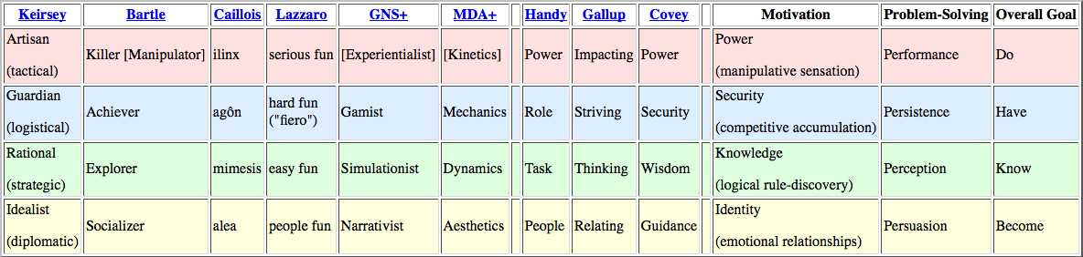

Acheivers and Explorers are the demographic of players who will enjoy playin this game.

Acheivers enjoy: competition, collections, manufacturing, high scores, levels, clear objectives, guild membership, min-maxing.

Explorers enjoy: puzzles, creative building, world-lore, systems analysis, theorizing, surprise.

**Time Required To Play**

The game will take 20-30 minutes to complete a normal paced play session.

**The Rules**

**Artistic Style Outline**

**Game Assets**

**Suggested Game Flow Diagram**

**Additional Ideas And Possibilities**

**Challenges During Development**

* Telling the story without breaking immersion or players missing the story entirely.
* Scale and size of the project.
* There are a lot of mechanics that can go wrong.
* Balancing so many mechanics will be challenging.

**Bibliography**

Freeman, T. (1997) *Creating A Great Design Document* [Online] Accessed On [29/02/2016]. Available At: <http://www.gamasutra.com/view/feature/131632/creating_a_great_design_document.php>

Ryan, T. (1999) *The Anatomy of a Design Document, Part 1: Documentation Guidelines for the Game Concept and Proposal* [Online] Accessed On [29/02/16]. Available At: <http://www.gamasutra.com/view/feature/131791/the_anatomy_of_a_design_document_.php?page=3>

Bakker, J. (2009) *A GDD Template for the Indie Developer* [Online] Accessed on [29/02/16] Available at: <http://www.gamasutra.com/blogs/JasonBakker/20090604/84211/A_GDD_Template_for_the_Indie_Developer.php>

**Demographics**

Stewart, B (2011) *Personality and Play Styles: A Unified Model.* [Online] Accessed On: 28/07/17. Available At: <http://www.gamasutra.com/view/feature/134842/personality_and_play_styles_a_.php>

Einhorn, A (2015) *Four Step Puzzle Design* [Online] Accessed On [26/07/17] Available At: <http://www.gamasutra.com/blogs/AsherEinhorn/20150528/244577/Fourstep_puzzle_design.php>

Kockar, A (2016) *On Puzzle Design And Fabric* [Online] Accessed On [26/07/17] Available At: <http://www.gamasutra.com/blogs/AtilKockar/20161026/284098/On_Puzzle_Design_and_Fabric.php>

Luban, P (2002) *Designing and Integrating Puzzles In Action-Adventure Games* [Online] Accessed On (26/07/17) Available At: <http://www.gamasutra.com/view/feature/131326/designing_and_integrating_puzzles_.php>

Sala, T (2013) *Game Design Theory Applied: The Flow Channel* [Online] Accessed On (26/07/17) Available At: <http://www.gamasutra.com/blogs/ToniSala/20131208/206535/Game_Design_Theory_Applied_The_Flow_Channel.php>

<http://www.gamasutra.com/blogs/ToniSala/20140102/207665/Game_Design_Theory_Applied_the_puzzle_of_designing_a_puzzle_game.php>

Kantilaftis, H (2015) *Learning From The Best: Action Adventure Games.* [Online] Viewed On: 28/07/17. Available At: <https://www.nyfa.edu/student-resources/learning-from-the-best-action-adventure-games/>

**Combat System Research**

**Ruiz, B (2013) *Anatomy Of A Successful Attack (2.0)* [Online] Viewed On: 28/07/17. Available At:** [**https://aztez.com/blog/2014/01/06/anatomy-of-a-successful-attack/**](https://aztez.com/blog/2014/01/06/anatomy-of-a-successful-attack/)

**Anonymous (2016) *About Combat System Design* [Online] Viewed On: 28/07/17. Available At:** [**https://breadcrumbsinteractive.com/about-combat-system-design/**](https://breadcrumbsinteractive.com/about-combat-system-design/)

**Anonymous (N.D) *A Huge List Of Common Themes* [Online] Viewed On: 28/07/17. Available At:** [**https://literarydevices.net/a-huge-list-of-common-themes/**](https://literarydevices.net/a-huge-list-of-common-themes/)

**Rewards**

Gazzard, A. (2011) *Unlocking The Gameworld: The Rewards Of Space and Time in Video Games.* [Online] Viewed On 28/07/17. Available At: <http://gamestudies.org/1101/articles/gazzard_alison>

Sala, T (2013) *Game Design Theory Applied: A Layered Rewards System.* [Online] Viewed On 28/07/17. Available At: <http://www.gamasutra.com/blogs/ToniSala/20131215/207064/Game_Design_Theory_Applied_A_Layered_Rewards_System.php>