**Final Group Project Design Document v.00**

**[Name To Be Confirmed]**

**Introduction**

**Objective of the Game**

This game is a simulation game focusing on God game and base building elements. In this game you manage a small settlement that you must expand and improve whilst also maintaining a plague that is coming in from the ports and ravaging your people. (Possibly a dancing plague).

The brief for this game is about creating empathy and making players care about the people in their settlement.

**Gameplay Description**

**Mechanics**

* Resource Management
* Technology Tree
* Time
* AI
* Point and Click

**Dynamics**

This game will focus on a gameplay loop of **manage resources, spend resources, punishment/reward.** Players must balance their resources of religion, disease and wealth to keep all of their people safe and happy. The peoples needs will vary depending on their wealth.

There will also be a religious faction system, with each religion constantly fighting for terriroty and upsetting the balance of the settlement.

The settlement will start small and increase with size and complexity, centring around a sea port and the main import and export of goods.

**Aesthetics**

**Themes**

**Player Experience**

The player experience would focus on creating empathy for the people the player is looking after, and hard fun for the strategy and spinning plates. Easy fun for the curiosity, awe, wonder.

**Reward Systems**

**Demographics**

Using Bart Stewarts Unified Model [Stewarts, B : 2011] to narrow down our player type.

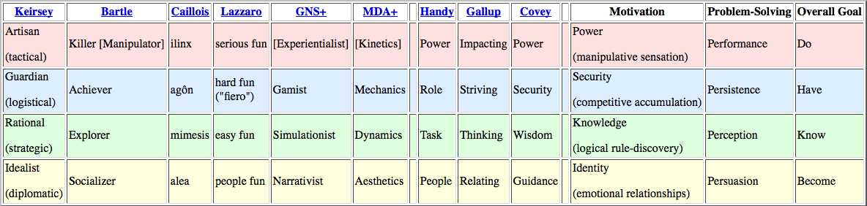

Achievers and Explorers are the demographic of players who will enjoy playing this game.

Acheivers enjoy: competition, collections, manufacturing, high scores, levels, clear objectives, guild membership, min-maxing.

Explorers enjoy: puzzles, creative building, world-lore, systems analysis, theorizing, surprise.

**Time Required To Play**

30 mins.

**The Rules**

**Artistic Style Outline**

**Game Assets**

**Suggested Game Flow Diagram**

**Additional Ideas And Possibilities**

**Bibliography**

Freeman, T. (1997) *Creating A Great Design Document* [Online] Accessed On [29/02/2016]. Available At: <http://www.gamasutra.com/view/feature/131632/creating_a_great_design_document.php>

Ryan, T. (1999) *The Anatomy of a Design Document, Part 1: Documentation Guidelines for the Game Concept and Proposal* [Online] Accessed On [29/02/16]. Available At: <http://www.gamasutra.com/view/feature/131791/the_anatomy_of_a_design_document_.php?page=3>

Bakker, J. (2009) *A GDD Template for the Indie Developer* [Online] Accessed on [29/02/16] Available at: <http://www.gamasutra.com/blogs/JasonBakker/20090604/84211/A_GDD_Template_for_the_Indie_Developer.php>

**Demographics**

Stewart, B (2011) *Personality and Play Styles: A Unified Model.* [Online] Accessed On: 28/07/17. Available At: <http://www.gamasutra.com/view/feature/134842/personality_and_play_styles_a_.php>

Einhorn, A (2015) *Four Step Puzzle Design* [Online] Accessed On [26/07/17] Available At: <http://www.gamasutra.com/blogs/AsherEinhorn/20150528/244577/Fourstep_puzzle_design.php>

Kockar, A (2016) *On Puzzle Design And Fabric* [Online] Accessed On [26/07/17] Available At: <http://www.gamasutra.com/blogs/AtilKockar/20161026/284098/On_Puzzle_Design_and_Fabric.php>

Luban, P (2002) *Designing and Integrating Puzzles In Action-Adventure Games* [Online] Accessed On (26/07/17) Available At: <http://www.gamasutra.com/view/feature/131326/designing_and_integrating_puzzles_.php>

Sala, T (2013) *Game Design Theory Applied: The Flow Channel* [Online] Accessed On (26/07/17) Available At: <http://www.gamasutra.com/blogs/ToniSala/20131208/206535/Game_Design_Theory_Applied_The_Flow_Channel.php>

<http://www.gamasutra.com/blogs/ToniSala/20140102/207665/Game_Design_Theory_Applied_the_puzzle_of_designing_a_puzzle_game.php>

Kantilaftis, H (2015) *Learning From The Best: Action Adventure Games.* [Online] Viewed On: 28/07/17. Available At: <https://www.nyfa.edu/student-resources/learning-from-the-best-action-adventure-games/>

**Combat System Research**

**Ruiz, B (2013) *Anatomy Of A Successful Attack (2.0)* [Online] Viewed On: 28/07/17. Available At:** [**https://aztez.com/blog/2014/01/06/anatomy-of-a-successful-attack/**](https://aztez.com/blog/2014/01/06/anatomy-of-a-successful-attack/)

**Anonymous (2016) *About Combat System Design* [Online] Viewed On: 28/07/17. Available At:** [**https://breadcrumbsinteractive.com/about-combat-system-design/**](https://breadcrumbsinteractive.com/about-combat-system-design/)

**Anonymous (N.D) *A Huge List Of Common Themes* [Online] Viewed On: 28/07/17. Available At:** [**https://literarydevices.net/a-huge-list-of-common-themes/**](https://literarydevices.net/a-huge-list-of-common-themes/)

**Rewards**

Gazzard, A. (2011) *Unlocking The Gameworld: The Rewards Of Space and Time in Video Games.* [Online] Viewed On 28/07/17. Available At: <http://gamestudies.org/1101/articles/gazzard_alison>

Sala, T (2013) *Game Design Theory Applied: A Layered Rewards System.* [Online] Viewed On 28/07/17. Available At: <http://www.gamasutra.com/blogs/ToniSala/20131215/207064/Game_Design_Theory_Applied_A_Layered_Rewards_System.php>