Notes

Target Audience:

* **Killers:** Players driven by their passion for competition want to beat other players. They expect to take it to the competition with a big stick. They enjoy winning in peer-to-peer competition. They like ranking, recognition, and well published leader boards.
* **Achievers:** These players like proofs of success: points, possessions, or prizes. They want rewards and prestige with or without advancement in gameplay.
* **Explorers:** Some players just like the thrill of discovery. They like to dig down and find something new or unknown. Secret pathways and rare finds excite them.
* **Socializers:** For others, the social interaction counts more than the game strategy. Relationships are their reward.

Core game loop:

[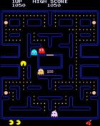](https://i2.wp.com/jerrymomoda.com/wp-content/uploads/2013/11/Pac-Man.jpg)[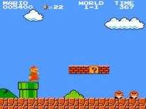](https://i1.wp.com/jerrymomoda.com/wp-content/uploads/2013/11/Super-Mario-Bros.jpg)

Games with abstract core loops like Pac Man (Namco), Donkey Kong (Nintendo) Tempest (Atari), Frogger (Konami), Q-Bert (Gottlieb) and Super Mario (Nintendo) are timeless in their ability to engage players.

The F2P business model of today prioritizes key performance indicators (KPIs) that measure engagement (time on game), retention (lifetime on game) and conversion (in-app purchase). The thought is that engaging players for extended periods of time will eventually drive players to spend money. By this definition players could be bored out of their skull, but if still playing they are thought to be engaged.

[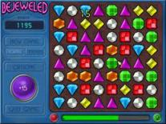](https://i0.wp.com/jerrymomoda.com/wp-content/uploads/2013/11/Bejeweled.jpg)

In 2001, PopCap released [Bejeweled](http://www.popcap.com/games/bejeweled/home), the original “match three” game. It’s core loop: move tiles to create rows of 3. It’s simple to learn and play, but hard to master. Especially against a clock. For more than a decade it was hugely popular because anyone could play it.

[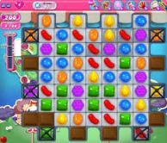](https://i1.wp.com/jerrymomoda.com/wp-content/uploads/2013/11/Candy-Crush-Saga.jpg)

In late 2012, King introduced [Candy Crush Saga](http://www.king.com/games/puzzle-games/candy-crush/). Taking the same core loop and creatively injecting depth and variety, it revived what had become a stale genre. Candy Crush Saga became one of the highest revenue generating franchises ever.

[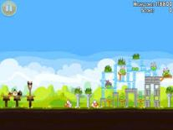](https://i2.wp.com/jerrymomoda.com/wp-content/uploads/2013/11/Angry-Birds.jpg)Another example of a simple yet effective core loop is Rovio’s [Angry Birds](http://www.angrybirds.com/). The core mechanic is to fling birds from a slingshot towards a structure. The goal is to knockdown the structure.  It’s as basic as throwing softballs at bowling pins at a carnival. So basic and intuitive, even young children can play.

Designing virality and monetization mechanics into the core loop are also key to them being effective. It’s important that they feel like extensions of the core loop and not like afterthoughts only to separate money from players.

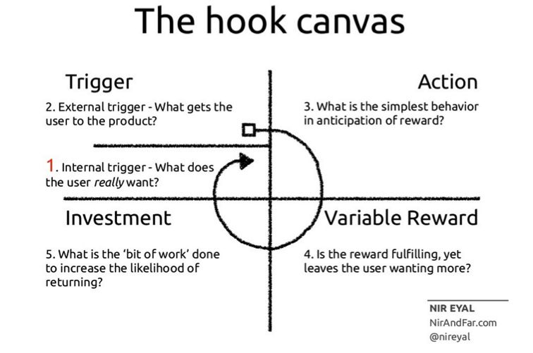

**Compulsion Loop** – a habitual, designed chain of activities that will be repeated to gain a neurochemical reward: a feeling of pleasure and/or a relief from pain. [[7](https://www.gamasutra.com/blogs/IgorMatrofailo/20160107/263164/5_Criteria_of_a_Successful_Mobile_Game.php#references)]. Here is example (from [Candy Crush Saga](http://candycrushsaga.com/)): “Play (full energy) -> Match Candies -> Random reward (on the last turn, missing candies of required color appear on the board what allow player complete mission) -> Complete Mission -> Wait (recharge energy)”.