Each player has a dedicated section for their power ups. A sacrifice of the background for a clearer UI should make the game more accessible for the players.

The colours chosen are to match Frasers colour scheme from the main menu and buttons.

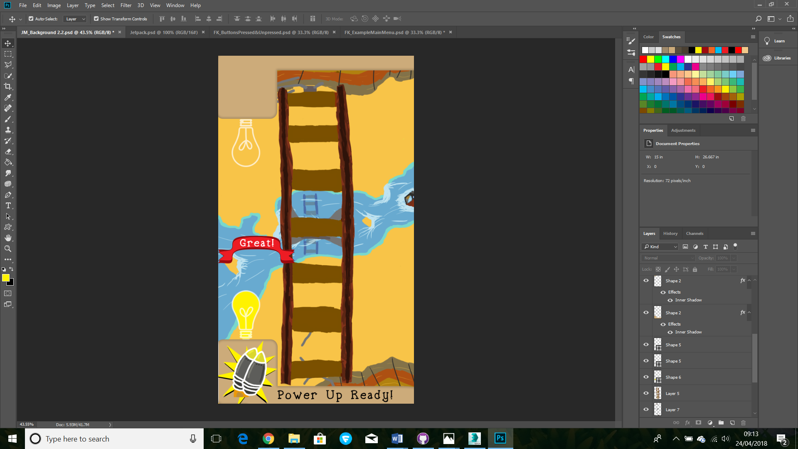

Power ups and a notification are displayed here.

Red banners appear when the player has scored on the timer bar with white text.

The light bulb is an idea to exemplify when the power up is ready. An extra visual aid to show the players the status of their power ups.

* When no power ups are available the bulb is unlit.
* When power ups are available the bulb is lit.

Perhaps an audible sound like a microwave “Ting!” could be added when a power up is gained?

The new font (spellstone) is still playful and charming but I found it reads much easier.

I decided to change the font to the example shown in Frasers button samples, with the old text at the top. and the new one displayed below it

Your Text Here

Your text here