**Implementing feedback loops into our game**

**Idea #1 – Accelerating the conveyer belts based on amount of customers.**

The more customers the player has, the faster the speed at which the conveyor belt is moving. That way, if the player is leading by a lot, then their conveyor belt will move much faster than for the opposite player, making it harder for the winning player to land perfect taps and may cause them to occasionally miss. This way, the losing player who will have the slower belt can use that to steal customers from the winning player, as they have the better chance at landing the perfect taps.

This makes it so that if both players have a fairly equal number of customers there will not be much change in the speed, but once one gets a larger number of customers, then it will be harder for them to obtain more and easier to lose customers.

This could prolong the games, especially if the players keep switching the sides on whoever has the most number of customers. This however could be eliminated with a time limit, and instead would perhaps create a tense scenario where both players are on fairly equal ground of winning the game, and the final decision will decide the winner.

**Idea #2 – Reducing the range in which the tap can occur based on amount of customers.**

Similar to the first idea, though instead of modifying the acceleration of the conveyor belts, the range in which the player can tap the node to register as the tap would be reduced based on how many customers the player has.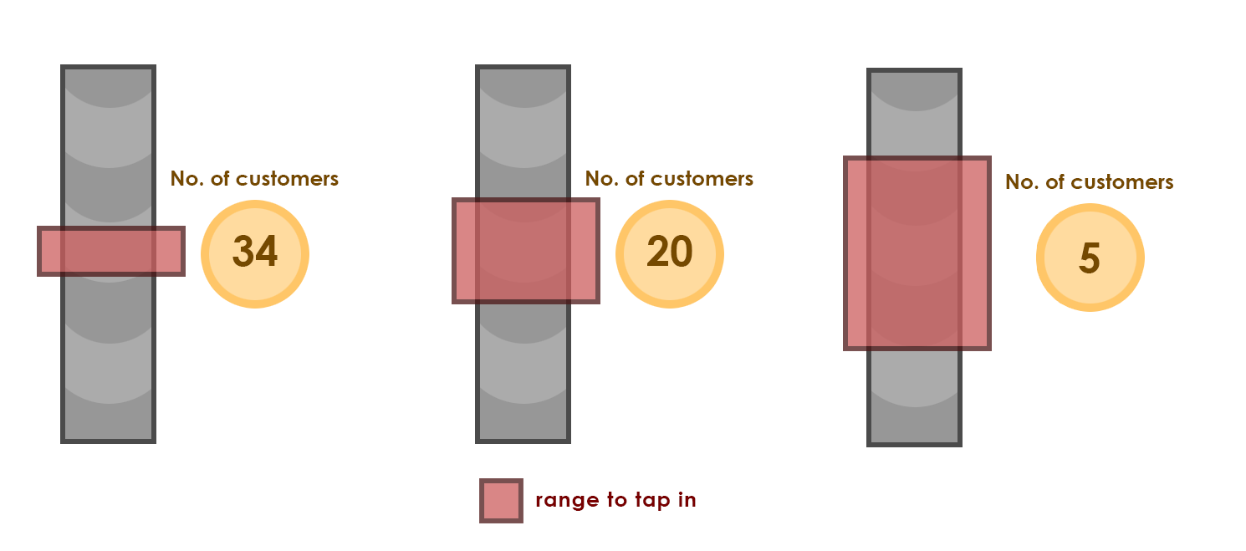

**Fig. 1**

So as shown on the image above (Fig. 1), the range to tap in increases based on how many customers the player has. The area to tap in is still relative to the position of the customer that called out for the sushi, but the size of the area is dynamic and changes based on how the player is doing.

As with idea 1, if both players have a fairly equal spread of customers, than they both have the equal chances to score the perfect tap, but once one player gets more customers, the winning player will have the harder time trying to get the perfect tap or to hit the tap at all, once the losing player will have a better chance at tapping the perfect tap and lesser chance to miss the tap.

Just like with idea 1, this could also prolong the games.

**Idea #3 – A bar fight.**

The bar fight is a scenario in which two customers decide to fight together for some reason (probably annoyed with waiting). Not entirely sure whether a bar fight should be randomly occurring event, or perhaps something that the opposite player could trigger (perhaps by moving the phone up during player 1’s turn or simply select customers to fight). Or perhaps something that the player does triggers the fight, perhaps misses the sushi few times in a row. The player that has more customers has a higher chance of a bar fight to occur.

If a bar fight does begin, then the player will need to either decide to stop the fight or tap the sushi. If they tap the sushi, the bar continues, and more customers will be pulled into the fight. If they tap the fight, then the player will miss the sushi and probably lose a customer but will be able to keep the other customers from leaving their bar. If the bar fight goes for more than 1 turn, any following customers that are pulled into it will be lost to the opposite player.

So, as an example, the fight starts on player 1’s turn. There are two people fighting.

Player 1 decided to tap the sushi and keeps the customer, the fight pulls in 2 more customers, there are now 4 customers fighting.

Player 2 does their turn.

Player 1 now decides to stop the fight by tapping the fight. They will miss the sushi, so 1 customer leaves. The customers that were fighting are taken away from the bars and never comeback. So, if before the fight was stopped the customer spread was 27:13 (40 in total), after the fight is stopped the spread will be 23:13 (36 in total).

One major problem that I see with it is that it is really disadvantageous to the player that gets the fight, as either way they will need to lose a customer to stop the fight and will lose at least three customers would they stop the fight immediately. I was going with the idea that the bar fight would help the losing player, as the winning player would need to worry about calming the fight down, rather than about distributing sushi. Though I am not exactly sure that is what I have achieved with it here, as if anything, it helps both players in the longer run, as they need less customers for the total, but regardless the losing player is not pulled in closer towards the winning player.

Any input on this idea is welcome.

**Idea #4 – Knife throw.**

A losing player will have an option to throw a knife to the winning player’s bar. This will happen during the turn of the winning player. This will make the winning player’s conveyor belt to stop moving, preventing them from tapping the sushi and giving the losing player a chance to steal a customer. However, the losing player will have a difficulty next round, where if they manage to miss the sushi, then they will lose the double number of customers that the winning player lost.

This is supposed to act as a high risk, high reward event. After all the losing player guarantees that the winning player loses their turn and loses customers. However, they then must make sure they don’t miss the sushi themselves or they will lose even more customers and only help the other player more.

Players should not be able to abuse that ability however, and definitely should not be possible for the other player to throw the knife if the opposite player threw the knife the round before.

**Idea #5 – Fake customer.**

A losing player can create a fake customer and send them to the winning player’s bar to get more customers. Basically, the way the idea works, is that the losing player will need to select whether the next customer will be a fake customer. They will then need to miss sushi, and in return lose the customer. That customer will then call out the food from the winning player’s bar and will ‘fake’ it’s reaction saying the food is bad. This is supposed to cause other customers from the winning player’s bar to leave to the losing player.

To make this idea balanced, I think there should be a way to tell whether a customer is a fake, that way perhaps if the winning player misses the sushi, that customer would be exposed, and the losing player would lose customers instead.

Another high risk, high rewards event that the losing player can use to bring themselves back closer to the winning player. Though if the winning player sees through what the losing one is planning, the plan may backfire and cause even greater losses for the losing player.