**The coloured sushi bars**

**1st concepts**

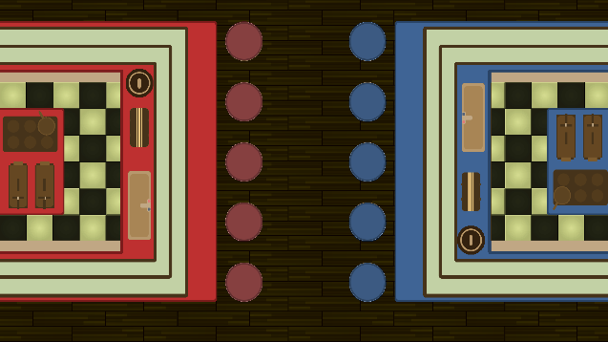 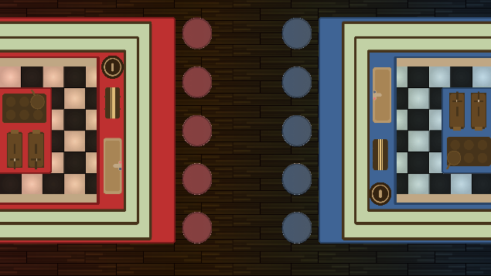

With the above concepts (the left one is without the floor tint, and the right one is with the floor tint), I have decided to make the bars represent their colours, by having the actual wooden/stone flat surfaces be the corresponding colours. Whilst the appliances and the sushi bar, remained their original colour. I did that to show that despite being on different teams, both sushi bars use the same equipment and so it is a far battle.

**2nd concepts**

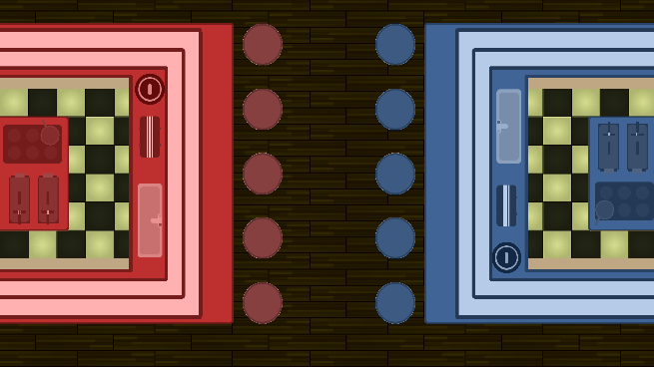 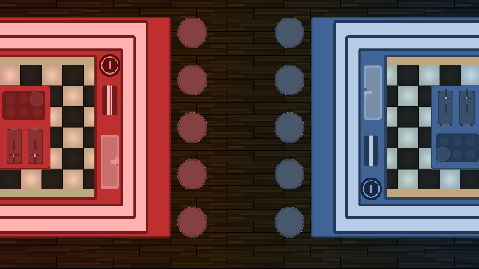

With these concepts, I decided to make the whole sushi bar, both the flat surfaces and the equipment be coloured in the respective colour of the team. This I think will highlight the competitive nature of the game, as both players can clearly see what side they are fighting for.

**3rd concepts**

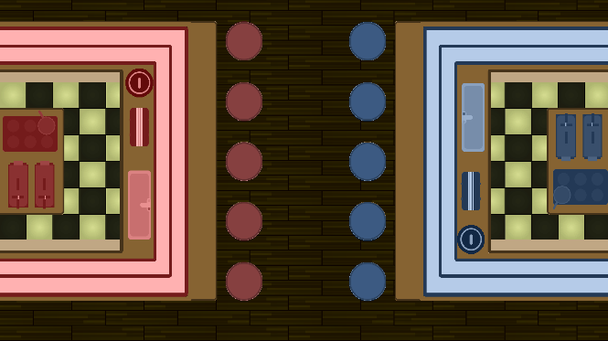 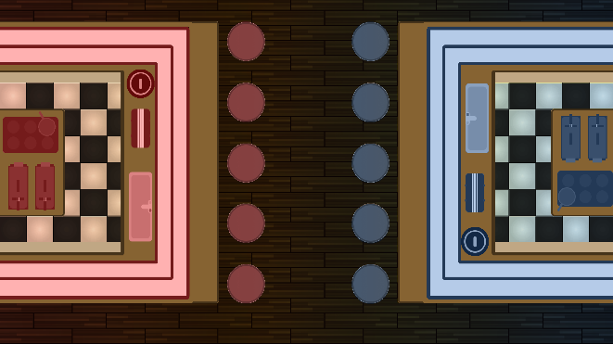

These concepts are the opposite of the first concept. Now the flat surfaces stayed with the original colour, whilst the equipment became coloured.

**4th concepts**

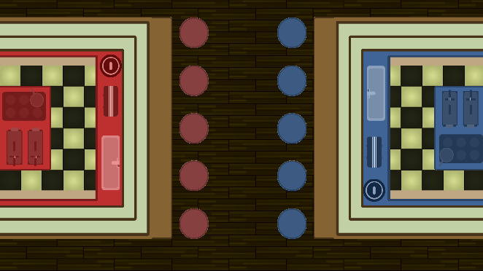 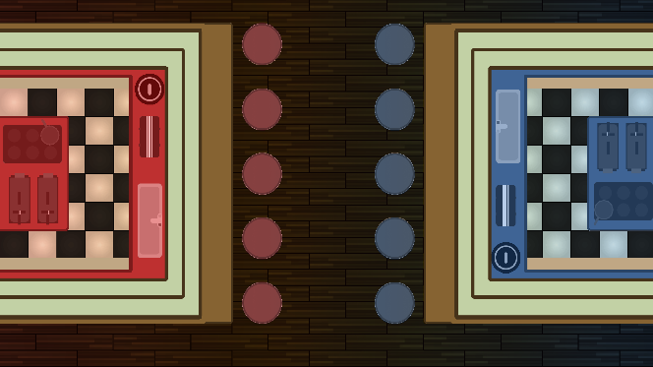

These concepts borrow from the second set of concepts, but they only include the inner part of the bar. I think that this way, the kitchens show which bar is owned by which player, without necessarily making the bar feel out of place, when compared to the floor and the clients.

**5th concepts**

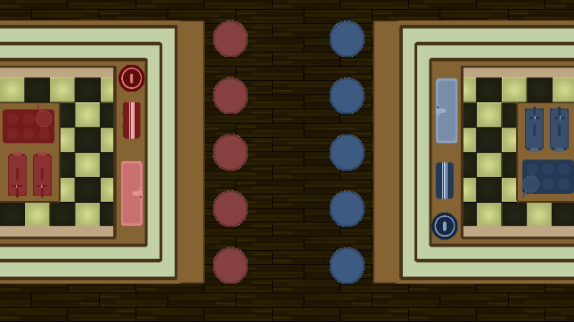 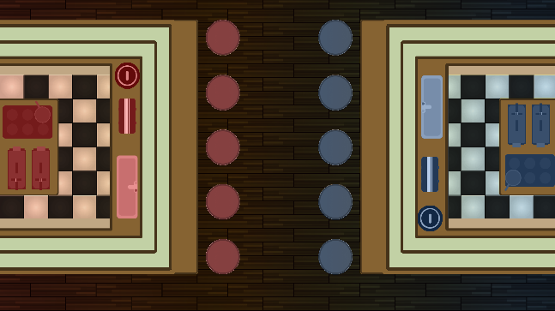

These concept is similar to the fourth one, as it only concerns the inner kitchen, though this time, only the equipment is coloured. It keeps the original aesthetic of the bar, whilst making brief highlights to which player owns which bar.