**Key Stage 2 Research**

Key Stage 2: includes ages 7-11

|  |  |  |  |  |
| --- | --- | --- | --- | --- |
| School Year | 3 | 4 | 5 | 6 |
| Addition | Two one digit numbers | Two numbers up to three digits | Up to four digits (column method)  Adding fractions with the same denominators | Up to four digits (column method)  Adding fractions with different denominators |
| Subtraction | Two one digit numbers | Up to three digits | Up to four digits (column method)  Subtracting fractions with the same denominators | Up to four digits (column method)  Subtracting fractions with different denominators |
| Multiplication | 1-8 time table | 1-12 times table | Up to four digits X`s by a two-digit number  Multiplying whole numbers & decimals by 10,100 and 1000 | Up to four digits X`s by a two-digit number  Multiplying a one-digit number with two decimal places by a whole number.  Multiplying fractions by a whole number |

Key Stage 2: includes ages 7-11 (example questions)

|  |  |  |  |  |
| --- | --- | --- | --- | --- |
| School Year | 3 | 4 | 5 | 6 |
| Addition | 3+7 | 111+214 | 1445+1223 $$\frac{1}{4}±\frac{2}{4}$$ | 6712+1215 $$\frac{2}{4}±\frac{3}{12}$$ |
| Subtraction | 8-4 | 300-150 | 1600-1237 $$\frac{3}{9}±\frac{4}{9}$$ | 8120-2352 |
| Multiplication | 3x4 | 9x9 | 1614x12  0.7*100 | 1250x17  3.22x7 $$\frac{3}{7}×6$$ |

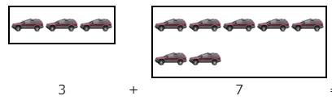

Year 3

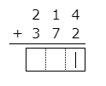

Year 4

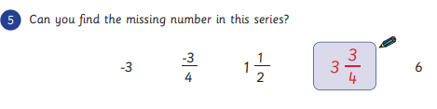

Year 5

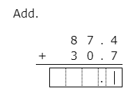

Year 6

Sources

Bbc.co.uk. (2019). *BBC - Schools Parents - The National Curriculum and Key Stages in England*. [online] Available at: http://www.bbc.co.uk/schools/parents/national_curriculum_key_stages/ [Accessed 20 Feb. 2019].

#### TheSchoolRun. (2019). *TheSchoolRun*. [online] Available at: https://www.theschoolrun.com/ [Accessed 20 Feb. 2019].