Date of Meeting: 14/11/2018

Time of Meeting: 13:38

Attendees: Thomas McCarthy, Elliot Chester, George Heath-Collins and Thomas McLaren

**Item One: Post-mortem of previous sprint**

We got written feedback from our presentation. In the meeting we went through them and talked about what we can do to fix the issues and respond to the suggestions that were brought up. Below are the main points that were made and how we plan to respond to them:

* “Much of the application of ‘theory’ was nonsensical and wildly inaccurate”
* We talked about some research we have used in our game; however, we didn’t talk much about the sources of our research or how we plan to use them in our game, meaning that while we have done research, we didn’t show if any of it was actually relevant research.

For example, we mention that we would use string instruments which doesn’t actually mean much because different string instruments create different moods. The example used in the feedback was Jaws, which is definitely not the mood we would like to create for our game. While we know what mood we are trying to create, and we understand how different music will effect that. We should have been more specific in the presentation.

* “I have no idea how the team intends to sustain a player’s engagement for any more than a few minutes.”
* While we talked about the changes we have made to the core game loop, we did not talk about what the player will be doing at different stages of the game. We have done research on this however, and we have a clear vision on what we plan to do, we need to work on showing that within our game and in the presentations.
* “If the team intends to pursue the *Tranzfuser* initiative, they will need to give consideration to monetisation tactics. If the game is intended to become a long-term persistent experience, the team will need to think in terms of months and years rather than ten hours, and they will need to gate the content accordingly.”
* We have talked about monetisation in the past but we’ve never really thought of it as a core part of the game, we were wrong however, it is something that will effect the some of the progression. Some items will be locked behind monetizable methods, because of this we will create a task dedicated to researching different monetisation techniques. And how they can be applied to our game. When we have a good idea of the techniques we can use, we will work on how we will implement them into our game and how it will affect the players experience and progression.
* “You have plenty of product but now you must make absolutely sure you are drilling down on all aspects so the game works as seamless whole.”
* This is very true, we keep thinking of features we can add, instead of thinking about how all of our features work together. To fix this, this sprints tasks will be mainly focused on responding to feedback we have received from play testing at Game Anglia and our presentation. And we will not be adding any more features unless we think they are absolutely necessary to making the experience better. Future sprints will be spent making sure that every interaction the player makes, makes sense, and making the experience as intuitive and user friendly as possible.
* “Why would your psychographic want an ‘agility’ stat?”
* This is feedback we also received during the questions after the presentation, to respond to this a task was set last sprint to come up with new names for the different stats. To get new stats we looked up what our demographic looks for in their friends. The new stats we have chosen from this are, sweetness, silliness, sport, style and smarts. In terms of technical gameplay changing these won’t make a difference, the game will still work in the same way, however the user will hopefully find the new stats more relatable and engaging. We will find this out for sure with playtesting.

All group members finished all tasks on time and uploaded their work this week.

All of the trees and fruit that we plan to have are now in the game, this is good because it brings us a lot closer to being able to test the core game loop as now all of the decisions surrounding feeding and planting can now be tested.

Based on feedback we received, Assets have been created by tom McCarthy that will give visual feedback for feeding the creature and the creature breeding. this was requested at game Anglia because people were confused about what feeding the creatures will actually do, using these new assets we can add particle effects to the creatures to show that their stats have been upgraded and that they have been made happier, this will help the player understand what their actions are affecting.

George created different stages of plant pots that will be used to show the different levels of trees. higher level trees will produce fruit faster and we feel that this will be essential to increasing the life span of the game as it allows users to choose between boosting productivity on a single island or have the same type of tree on different islands, this is an important decision because fruit will not be transferable between islands so you will need to pick the right fruit to use to keep your creatures happy and level them up.

George also made a mock-up of how the new feeding mechanic will work, currently in the game, the way feeding works is, you tap a tree, and the fruit will fall to the floor, then the closest creature will move to it and eat it. We found from feedback at Game Anglia, that players didn’t like this mechanic, they wanted to be able to choose which pet they give specific fruits to, so the way we have decided to improve the feeding system, is that each island has a storage item, current ideas are a chest or basket, when trees are tapped the giant will pick the fruit and place it in the storage item, the player can then tap on a creature and they will be able to choose what fruit they want to feed it from there. 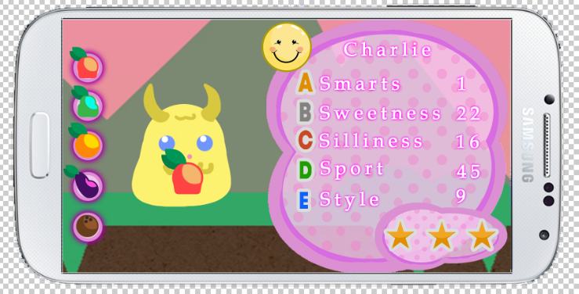(screen mock-up below)

Here you can see the fruit, this fruit will be dragged to the creature, the pet will hold and eat the fruit, this is to allow the player to see visual feedback of the pet eating the fruit, when the creature has eaten the fruit you will see the visual feedback we talked about earlier to let the user know what effect they have had on the pets happiness and stats.

Fruit Selection (Left), Stat Screen (Right)

In the meeting we discussed the current UI for the inventory and the stats screens. We decided that while we like the colours more than the old stat screen, the bubbliness and textures of it don’t match the rest of our game. What we have decided to do about that is take our old stat UI and give it different colours, we can then choose the best of these. The inventory UI will also be reworked by George, he will create different styles of inventory panel that we can all review and pick between, this will allow us do playtesting with each style to see what the players find easiest to use.

Inventory UI

A major piece of feedback we received from playtesting is that the giant is always very annoying when it is walking around because a lot of the time it is accidentally moved and gets in the way of the rest of the items on the island, to improve this we have decided that the giant will only move when it is needed for an interaction, this means that he will be stationary on a specific part of the island until he is needed. We can possibly use this area as a place the player can customise, the giant can also have little interaction that he will do automatically, this will be discussed in more detail in a future meeting as it is not essential to the experience now.

**Tasks for this sprint**

**Tom McLaren**

Research different customisation options for the game 1h

Mock up a customisation screen 1h

Mock up examples of the different kinds of customisation 1h

Research and document when creatures should evolve based on their level 1h

Mock up different ways the creatures could evolve 2h

Mock up the journal screen in landscape mode 2h

**Tom McCarthy**

* Mock up the island selection screen and the animations associated with it 3h
* Research different methods of monetization that we can use 2h
* create the sprites that will be used for the visual feedback given when the pets eat fruit 1h30m
* mock up the new title screen that will incorporate our new design 1h30m

**George**

* Create some artwork that will be used as a container for fruit 1h
* create new different coloured versions of the stat window 1h
* mock up a redesigned UI to fit the style of the game 2h
* Create different coloured versions of the inventory UI 1h
* Create different sprites that can be used for the confetti particle effect 1h
* Create 2 new updated fruits 30m
* Create the UI that will be used to show the level of my tree is currently

**Elliot**

* implement the new feeding screen to the prototype 2h
* implement the ability to leave the stat screen by pinching to zoom out 30m
* add the animation that will be used when creatures are eating 1h
* add the animation that will be played when the user taps a gift into the prototype 1h
* implement breeding into the prototype 1h30m
* implement more tutorial features that can be added together in the future to complete the tutorial 2h

**Meeting Ended: 14:26**

**Minute Taker: Elliot Chester**