**Customisation System Examples Research**

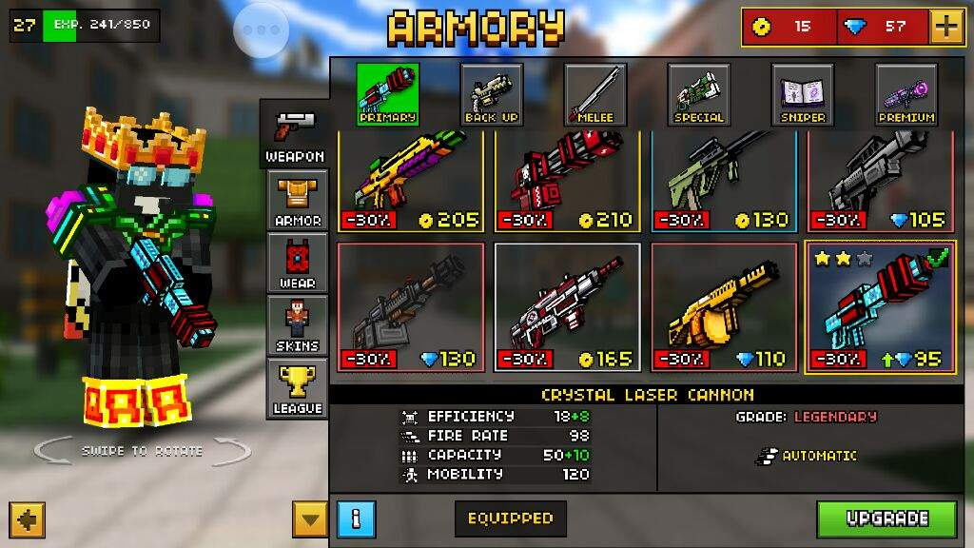

A weapon customisation system for when our pets verse each other during contests. However, this would not fit our psychographic as a result instead of having weapons it would be spells, songs or dances. This would then increase pet’s stats during contests.

Video Games | aminoapps.com. (2018). *My top 5 Favorite Mobile Games | Video Games Amino*. [online] Available at: https://aminoapps.com/c/video-games/page/blog/my-top-5-favorite-mobile-games/kRSG_ugq7g64BonNYV62nEz3zRd8jr [Accessed 16 Nov. 2018].

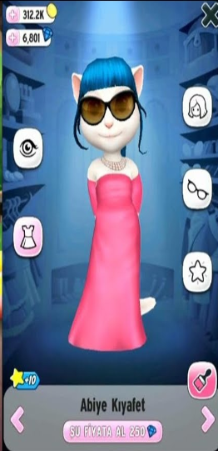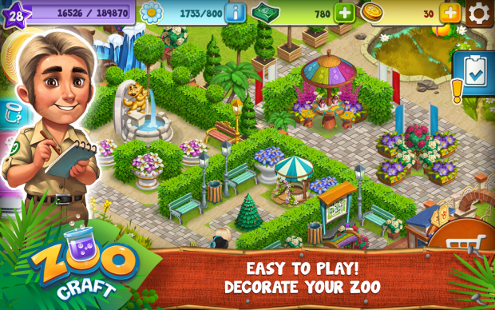 _

An apparel customisation system. Where additional wearable items such as hats for the pets can be unlocked and worn. Giving the player no advantage within the game, just purely cosmetic. But making them more personal to them and can show off to their friends.

#### Homesecurity.press. (2018). *My Talking Tom Wallpaper*. [online] Available at: https://homesecurity.press/quotes/my-talking-tom-wallpaper.html [Accessed 16 Nov. 2018].

An environmental customisation system. Where you can add cosmetic environmental assets, which would not affect gameplay. However, like an apparel customisation system, it would make your world more personal to you. Plus, you can show your design and layout to your friends.

#### Mod DB. (2017). *Image 2 - ZooCraft*. [online] Available at: https://www.moddb.com/games/zoocraft/images/image-2 [Accessed 16 Nov. 2018].