**Gaia Social Integration**

Facebook Leader board

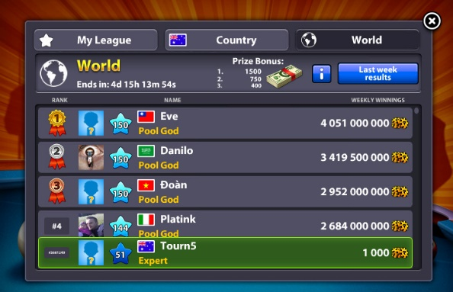

Facebook Friend Invites - Players will receive a small incentive for inviting a Facebook friend to play

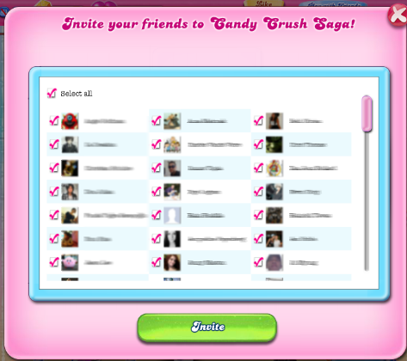

Send & receive rewards from Facebook friends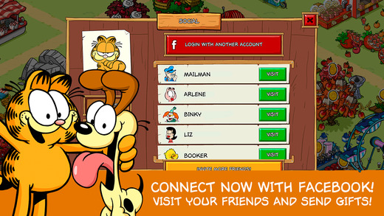

Take a snapshot of your Island or creatures, which you can share to friends or onto your own Facebook wall

