**Monetisation (In game-currency)**

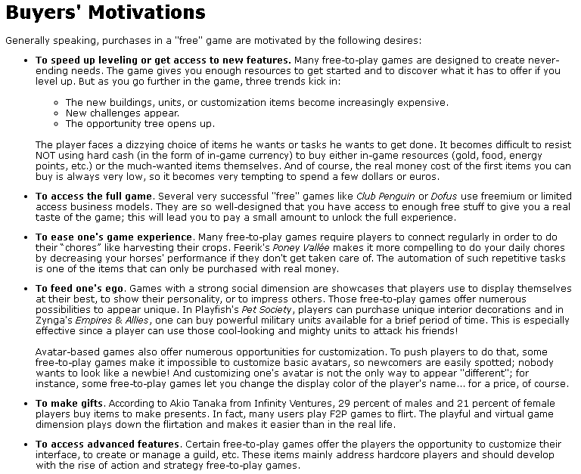Before researching in-game currency, I decided to look at the reasons behind why players might actual buy the currency. I found out many different reasons why below, also ways I didn’t even think of. For example, to buy an item for real money and gift it to a player in game. This can be for a friendly gesture or a flirtatious one.

**Single currency model**: It is good for games which feature gameplay that doesn’t revolve around the balancing of an in-game economy. You can give out small amounts of the currency as a daily reward and over time it shouldn’t devalue as there is no alternative currency against which it competes.  This single currency system can be used to get the player used to making frequent trips to the store to make a purchase, thereby increasing the likelihood of them dropping real money in the game.

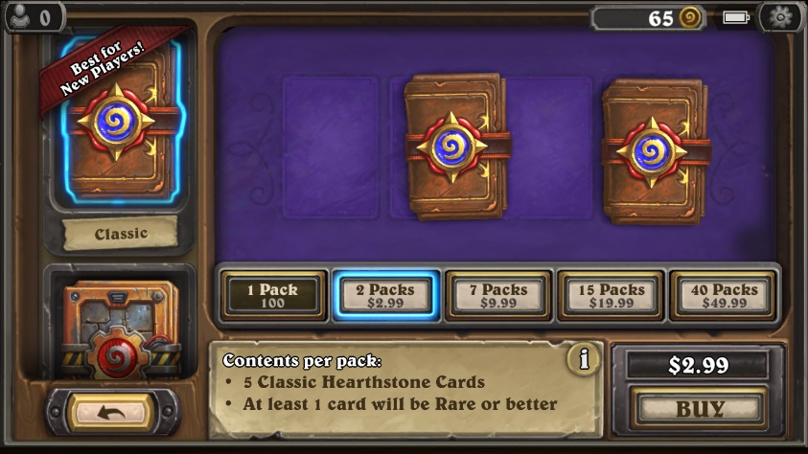

**Multiple currency model:** This all stems from the initial formula used with early free to play games that featured a dual currency system. One “Soft Currency” that players earn through gameplay and one “Hard Currency” that can only be purchased through an IAP. These days a lot of free to play games have more complex economies than this, but the principle remains the same: players can play a lot for free and earn the Soft Currency, or trade money for time and acquire the more valuable “Hard” currency to speed up in game progression.

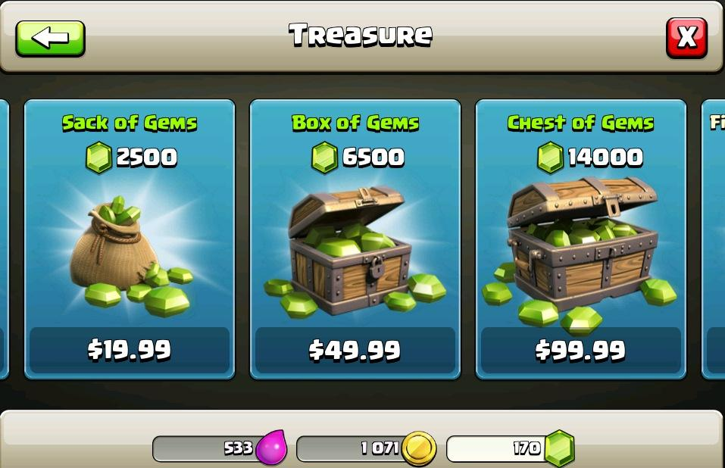

**Sunk Cost effect**: It is when not losing money in a losing proposition becomes the main reason to throw in more money. Leaving unspent Premium Currency is the “losing proposition” and the player, having already invested money into the game, is inclined to spend more to acquire additional premium currency and use the unspent currency sitting in their accounts effectively, thus in the mind reducing the initial loss.

**References**

Gamasutra.com. (2018). *Gamasutra - The Design of Free-to-Play Games, Part 2*. [online] Available at: https://www.gamasutra.com/view/feature/134959/the_design_of_freetoplay_games_.php?print=1 [Accessed 27 Nov. 2018].

#### Anon, (2018). *In-Game Currency as Means to Build Smart Mobile Game Economy*. [online] Available at: http://r-stylelab.weebly.com/blog/in-game-currency-as-means-to-build-smart-mobile-game-economy [Accessed 27 Nov. 2018].