Character Ideas

Following my previous research regarding different themes that could fit our game, I’ve come up with a few main character ideas as well as some basic enemies. In this research I will mainly focus the main characters, trying to provide some basic mechanics and background story. Please note that the following pictures are some rough sketches and they do not represent the final product.

**1. Ancient spirit**

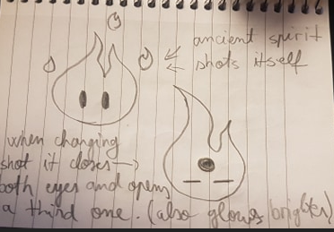

In the previous research I proposed a theme where the main character is an ancient spirit that wakes up after 15 billion years with the mission to observe the current state of the universe and decide whether it is going on the right way or it needs to be eradicated, allowing a new universe to be born and forge its new path. The spirit could be a simple blue flame with eyes and some outer glow. Thinking about the slingshot mechanic that we are going to use, I suggest that we can incorporate it into the character itself. We could have at least 2 sprites, one for when the character is idling and one for when the character is charging the shot. When the character is charging, it could close its eyes and open his third eye. Being an ancient spirit, I think that this method fits the theme, since it is all-knowing and all-seeing, and it could easily move by its own will, not requiring an additional slingshot. Our spirit could be travelling in the universe and observe the planets / solar systems from above, without interacting with anyone but receiving a quite detailed report about the planet’s inhabitants, their mindset and what they accomplished so far. Depending on the planets / solar systems the player chooses to visit, each one will contribute negatively or positively to a “that’s the right way” bar. Depending if the bar gets filled over 50%, one of the two endings could be triggered at the end of the game.

**2. Robot with a heart**

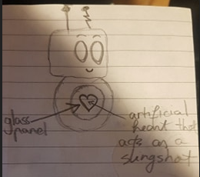

This character that could be named L0_V3 or something similar is the first robot with feelings that was created on planet Earth while scientists researched deeper into Artificial Intelligence. The goal of the project was to create a robot that could understand people’s feelings and replace psychologists. Since the final product was not what they desired, the robot had its memory erased and was thrown in a junkyard. The storyline of the game would be focused on love and how a robot made entirely of electronic parts has a bigger heart than most of the humans on Earth. After the robot wakes up with its heart glowing, it will set up on a quest to discover why the humans thrown him away and why he was considered a reject. Throughout the game the robot could become friend to a human that understands him and helps him complete his quest.

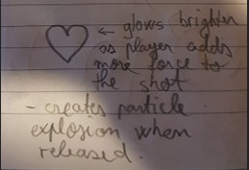

Like our previous character, I think that the robot could move without using a slingshot, using the power of love / the power of its heart. The heart could be located beneath a glass panel, so the player can see it and it could glow brighter when channelling a throw, causing a particle explosion when released. I think that this character has the best chance to create a bond with the player.

**3. Just a circle**

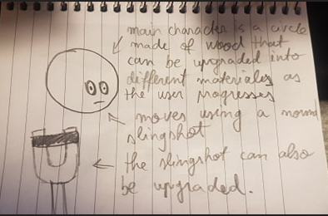

In this particular idea I refer to the theme where the main character is a circle that lives on a square-populated planet, unable to do the things he desires / follow his path / etc. For the character sprite I suggest some basic circles with eyes made from different materials (starting with wood or something similar and evolving until it reaches a very hard / expensive material). The same thing would apply to the slingshot that could be upgraded in the same time as the circle, as if they come in a package. Another idea would be to have certain known or unknown requirement to complete the next level, making the player think twice about what it should upgrade next. Even though the character is so simple, I think it could grow on the player’s heart when combining it with the story. The circle’s goal would be to evolve as a “person” after so much time in which it wasn’t able to follow his dreams and create a place for his few brethren that remained on a planet to live in peace.

**4. Ancient Octopus Spirit**

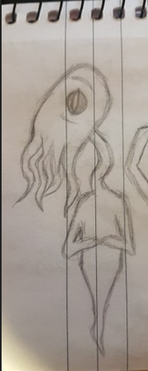 This character would fit into the universe theme, behaving as the Ancient Spirit but with a few different characteristics. I chose an octopus since they are highly intelligent creatures and they could fit the “overseer” character. The character would have 2 forms: the idle one that is present in the sketch and the “travelling” form that would be just the head. Moving with only the head would represent the capacity of the spirit to travel without using his body, like an out-of-body experience. The storyline would be approximately the same as the one presented with the first character.

**5. Meatball**

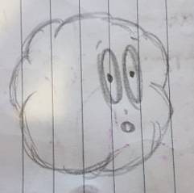The meatball would be the character that fits into the food themed game, where our main guy must reach a prisoner that is the “meatball chief’s” best friend. The slingshot could be 2 of the chef’s fingers. This game’s main goal would be to amuse the player since it doesn’t have a touching story or objective.

**Enemies**

The following enemies are just some random sketches I drew while thinking about the main characters and could probably fit in one of the themes selected.

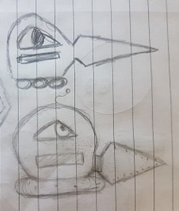This is a basic mech that could patrol and damage the main character when colliding with it.

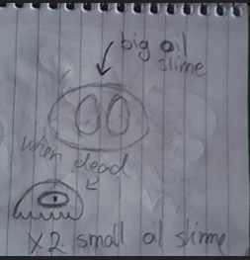This is a basic slime that could patrol while jumping. When killed it could split into 2 smaller and weaker slimes.

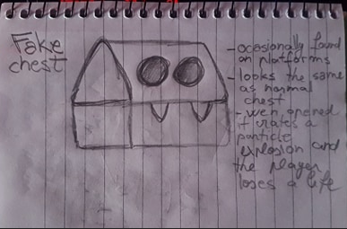This enemy could fit into a game that has chests scattered around the levels. A fake chest could look the same as a normal chest when idling but will change the appearance when the player tries to open it, channelling an explosion that the player can avoid if it is fast enough.

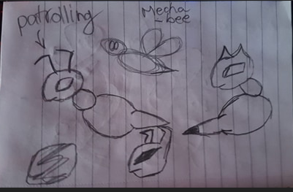This is a mech bee that could be a basic airborne enemy. This bee could have 2 stances: patrolling and attacking. When attacking, the lower-body will detach, revealing a gun that will shoot towards the main character.