**Independent Research**

By studying various platformer games, I have selected three games that I consider to be some of the best games of this genre at the moment. The three games are Limbo (Fig. 1), Ori and the Blind Forest (Fig. 2), and Hollow Knight (Fig. 3), all of them being award-winning games that have lots of various unique mechanics and design elements that could be integrated in our game.

**Limbo**

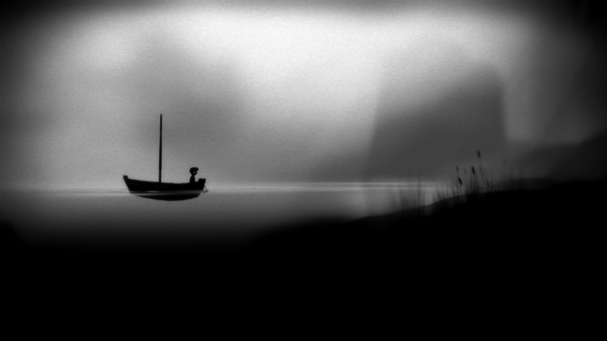 (Fig. 1)

**Ori and the Blind Forest**

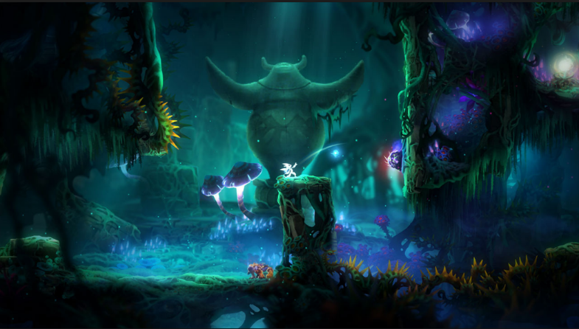 (Fig. 2)

**Hollow Knight**

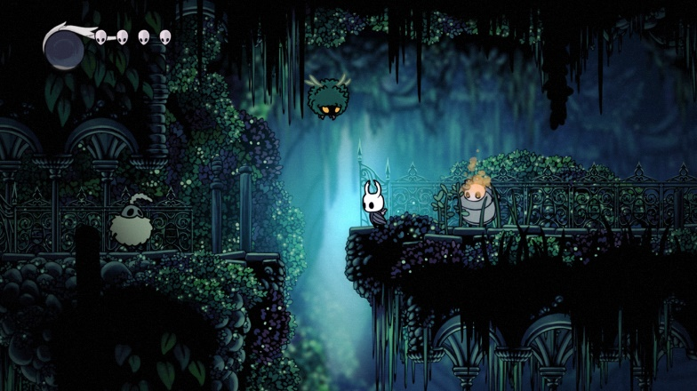 (Fig. 3)

At first glance, each of the three games has a rather unique design style, making it easy to get immersed into the surreal worlds. *Limbo* is a 2D Side-Scrolling Platformer game in which you play as a young boy that wakes up in a forest. The game has no indications, no dialogue, no cutscenes or loading screen, resulting in a good chance for the player to be swept away by the disturbing world. The game is entirely black and white with a high contrast, resulting in a mysterious and horrific feeling that persists over the whole gameplay.

*Ori and the Blind Forest* is my second favourite game from the list, with a style turned 180 degrees compared to *Limbo’s*. With a hand-drawn style, this game has a brilliant, colourful and luminous world, deceiving the player into thinking the game is going to be nice and friendly. *Ori*, just like *Limbo*, is one enormous scrolling map with a complex combat system and a rather high difficulty level that rewards the player with challenging puzzles, traversing complex landscapes and the surprisingly affecting story. *Ori* also has an interesting system where you wake up weakened and as you progress you unlock new and more powerful attacks and powers. By researching deeper into the game, I strongly believe that at least some good ideas could be found, including movement and combat mechanics.

*Hollow Knight* is by far the best game from the list in my opinion. This game has the biggest attention to details, with the art, music, colour tone, sound and many more that combine creating a perfect harmony that fits the game’s theme. Being an unforgivable and unashamedly challenging game, it still does a good job of silent-teaching how to play, even if you’re still going to die a lot. The game borrowed and modified some elements from some triple A titles, such as *Dark Souls III*. With a similar difficulty level, having to navigate to the place where you died to recover the currency and other various ways to hinder the player’s progress, like having to search for a map-seller in each area to keep track of where you’ve been and the dozens of different bosses, the gameplay has to be strategic, the player has to learn when it’s safe to attack and heal and how to get better every time after being defeated. The design style is once again hand-drawn, surrealistic, with high contrast and colourful areas.

By combining the best elements from the three games, I think that we should use a similar hand drawn style with colourful and high contrast elements and a cute main character with a touching story, creating a strong bond between it and the player and making it easier to trigger strong emotions in the player through the character. By using surreal elements, we could amaze the player, and the music and sound effects must fit the theme and the action phase. By replacing the movement mechanic, we could increase the difficulty level, making the game more challenging. Also, making strong enemies that have observable movement and combat patterns that can be learned will contribute to the game’s difficulty, requiring the player to concentrate and fail multiple times until he reaches the next checkpoint / level / etc, but rewarding him with a bigger sense of accomplishment. I will include a gameplay video and a link for each game mentioned above.

*Gameplay Videos:*

* Limbo: <https://youtu.be/N9icdJ1dk9U>
* Ori and the Blind Forest: <https://www.youtube.com/watch?v=Wh6gBjfXKxw>
* Hollow Knight: <https://www.youtube.com/watch?v=U8Wz-VwX5dw>

*Game Reviews:*

* Limbo: IGN. (2019). Limbo Review - IGN. [online] Available at: [https://uk.ign.com/articles/2011/08/02/limbo-review-2](https://uk.ign.com/articles/2011/08/02/limbo-review-2%20) [Accessed 5 Feb. 2019].
* Ori and the Blind Forest: IGN. (2019). Ori and the Blind Forest Review - IGN. [online] Available at: <https://uk.ign.com/articles/2015/03/10/ori-and-the-blind-forest-review> [Accessed 5 Feb. 2019].
* Hollow Knight: IGN. (2019). Hollow Knight Review - IGN. [online] Available at: [https://uk.ign.com/articles/2018/06/22/hollow-knight-review](https://uk.ign.com/articles/2018/06/22/hollow-knight-review%20) [Accessed 5 Feb. 2019].

*Steam Store:*

* Limbo: <https://store.steampowered.com/app/48000/LIMBO/>
* Ori and the Blind Forest: <https://store.steampowered.com/app/261570/Ori_and_the_Blind_Forest/>
* Hollow Knight: <https://store.steampowered.com/app/367520/Hollow_Knight/>