I suggest using a pixel art design style since it is pretty easy to create basically any type of character or building. Also, by using pixel art we have the option to use modular tile-sets (See Fig. 1), making the level design much easier. In the following screenshots (see Fig. 2 and Fig. 3) we can notice two platformer levels made using just a few tiles.

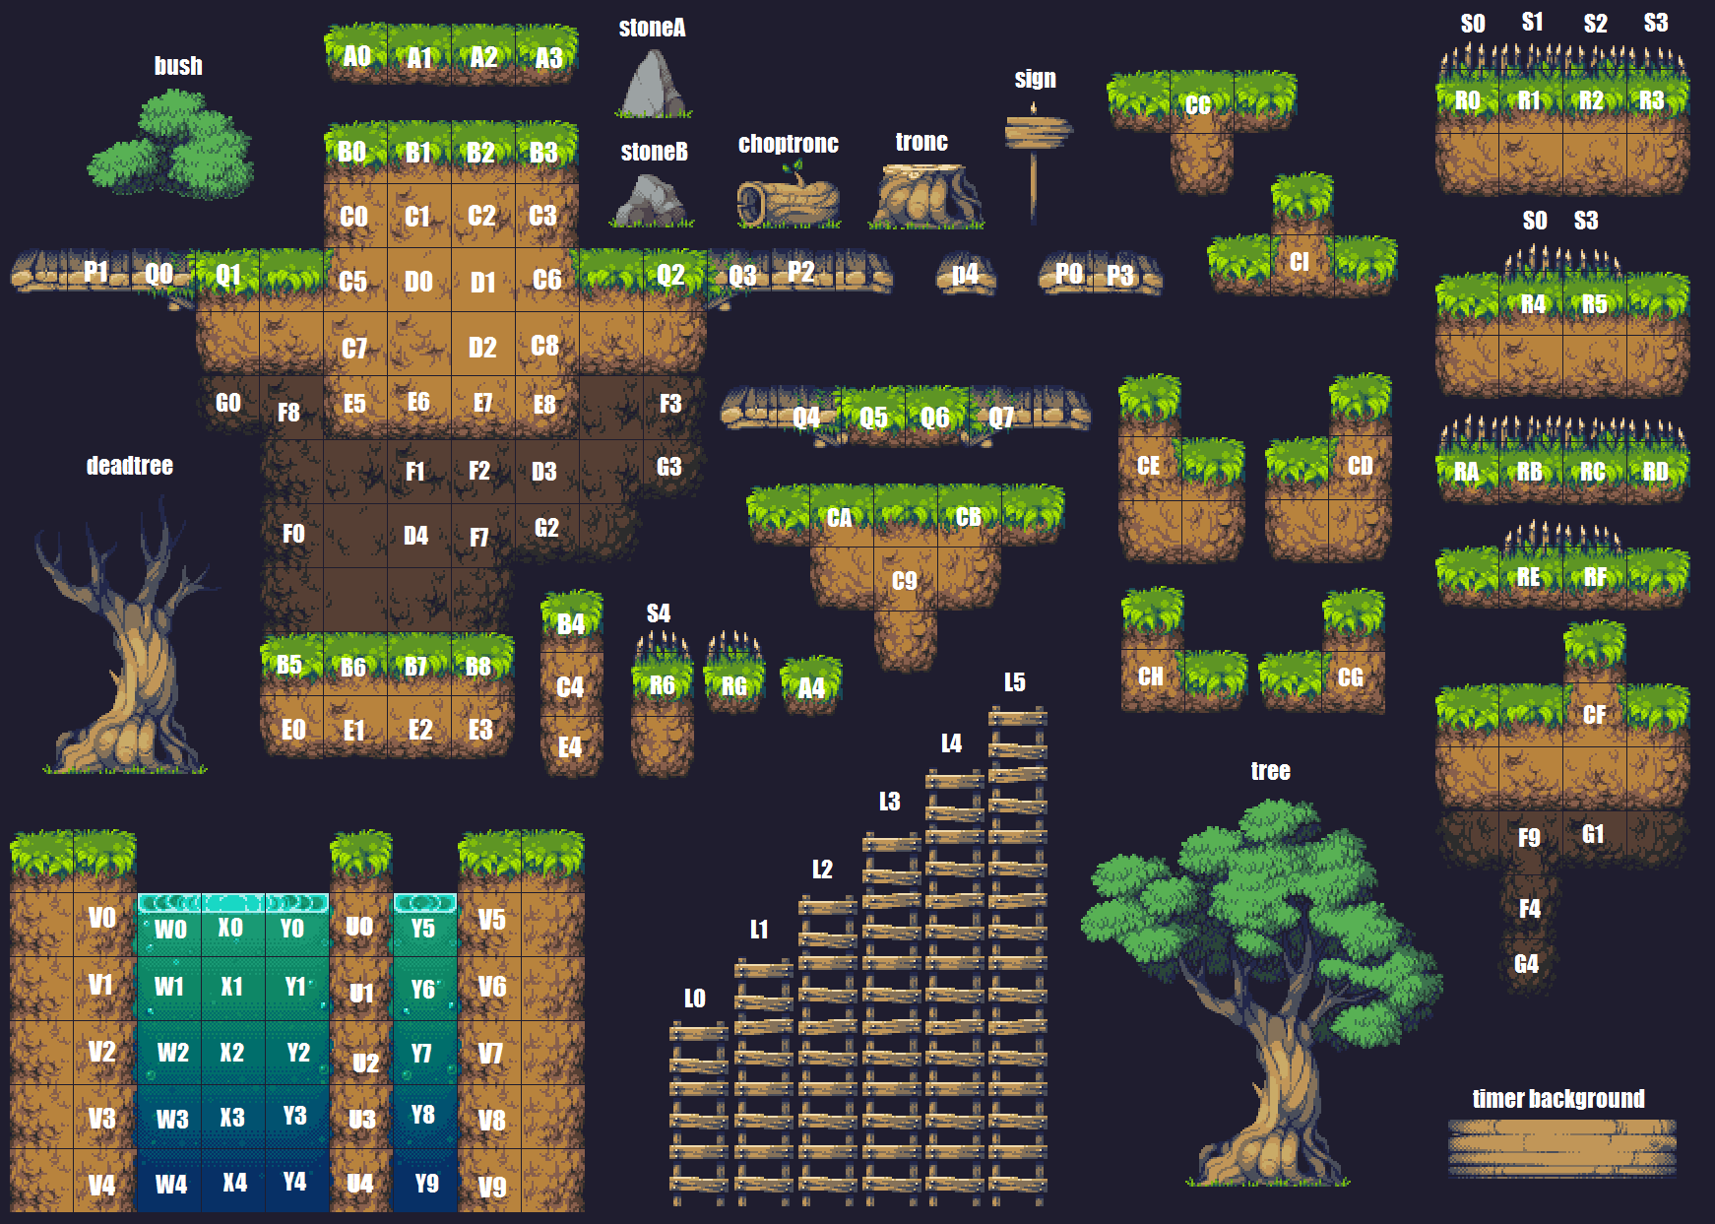 (Fig. 1)

(Fig. 2) (Fig. 2)

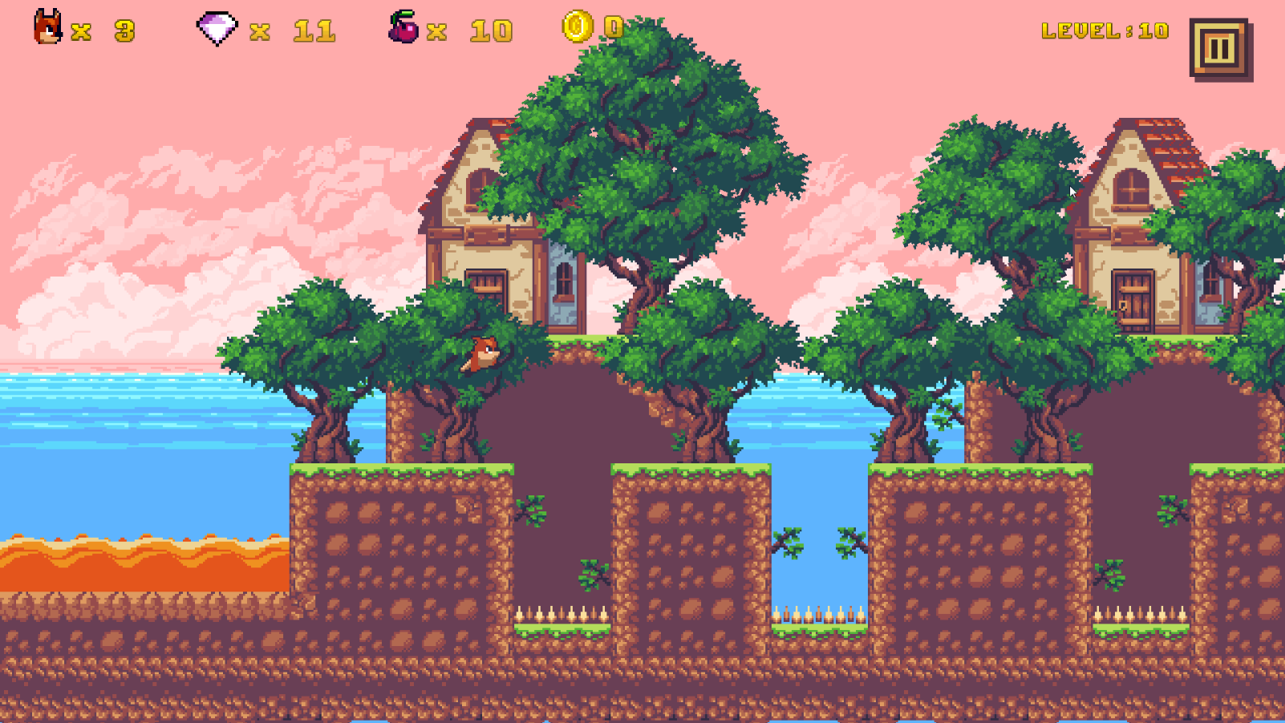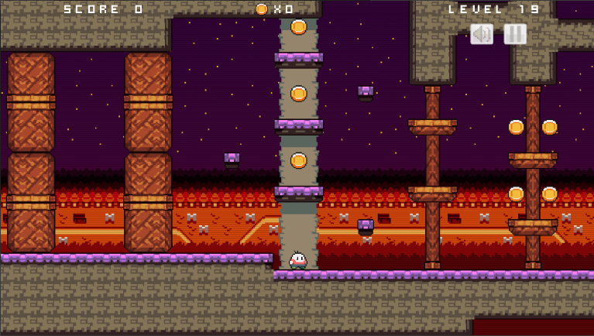

Since the platformer genre is so old (the first 2D platformers appeared in the early 1980s), the market is already filled with an enormous amount of games, most of them being free. So, in order to create something good it has to be pretty unique. Finding a theme can be pretty hard with that in mind. My main suggestion would be to use 32x32 pixel tiles, with the character about twice the height and the same width. The character (I suggest a big head with big eyes and a small body) has to have human characteristics so it will be easier for a bond between them to be made.

Themes:

* The main character is a meatball (or other food) that starts its journey inside different environments like forests and beaches and its objective is to reach a prison that is located on the other side of the environment. The meatball is being thrown by the prisoner’s best friend that tries to keep his comrade healthy during his sentence. The enemies could be some food ingredients that would make the meatballs taste weird or do not follow the healthy recipe. This would be a game where the main goal would be to amuse the player.
* The main character is a circle that lives on a square-populated world, where everything is square shaped and moves using the principle of magnetism. The circle is sad and lonely and decides to set on a journey to accomplish something in this unfair world. The main objective of the game would be to explore abandoned areas from the era before the squares and populate them, creating a world for the circles scattered across the world. In this game, the main thing would be the storyline that would cause the player to “feel” for our character.
* The main character is the first robot with feelings that was built on earth, stamped as a reject and thrown away. Imagine the robot as a being purer and spiritual than any human on earth, with no ego, with a big “heart”. The robot would wake up in a far-away electronics dumpsite with only the core (imagine a futuristic looking ball) and “the brain” (the head) working. It will set up on a journey to reveal his past and his story and the humans’ story and why the people that created him thrown him away. The robot would discover how the humanity turned in the wrong direction since money appeared and how he was considered just a product that wouldn’t be able to produce enough revenue for his company. Since the robot doesn’t have any parts left, he is able to move with the help of a slingshot. Throughout the game, the robot will unlock different new parts that can be added to the core, unlocking new attacks or abilities.
* The main character would be a “god”, an energy-spiritual-whatever bubble that was programmed to “wake up” 15 billion years after the universe was born, and its task is to review the way in which the life forms all around the universe evolved and then to decide whether the current universe is going in the right direction or it needs to be eradicated with another big-bang. The game will be organized in increasingly difficult levels with different life-form from different places around the universe. In (universe age) year 15 billion, the humans are the most advanced civilization, controlling over half the universe, and they are going to be the final boss. The game could have 2 endings, where the universe is saved and where the universe is destroyed by humans. The slingshot could be a string of energy that is pulled backwards by our character’s “third eye”, a circular shape assembling our character’s eyes, with a more mystical feel to it. This could suggest that our character’s third eye is always open, allowing it to travel freely in space and time. After the character is thrown, the eye could go back into the forehead for the duration of the jump.