Style guide

A combination of 3D models and 2D sprites.

**3D section**

The beginning of the game will be set in a low-poly, stylised setting, a bar with few streets and buildings around, creating a closed-off space.

**The Inside/The Bar**

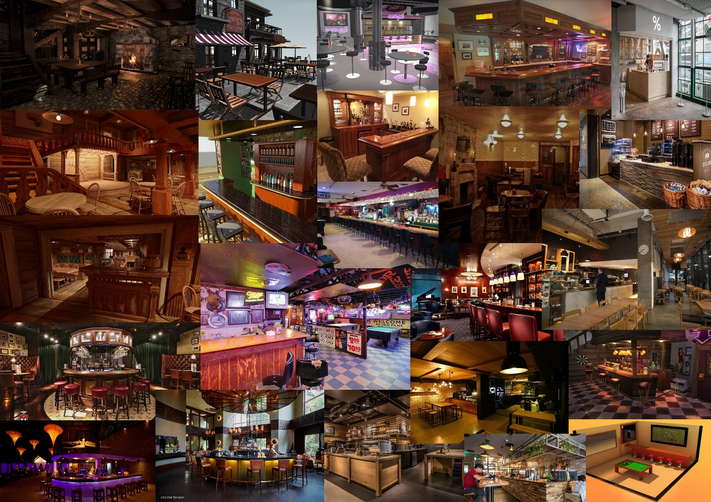

Modern, compact, local. Mostly warm lighting and colour palettes, so yellows, oranges and browns. A mix between, bricks, wood and stone for the bar materials, and possibly glass, wood and leather for other props, like chairs, tables and glasses.

**The Outside**

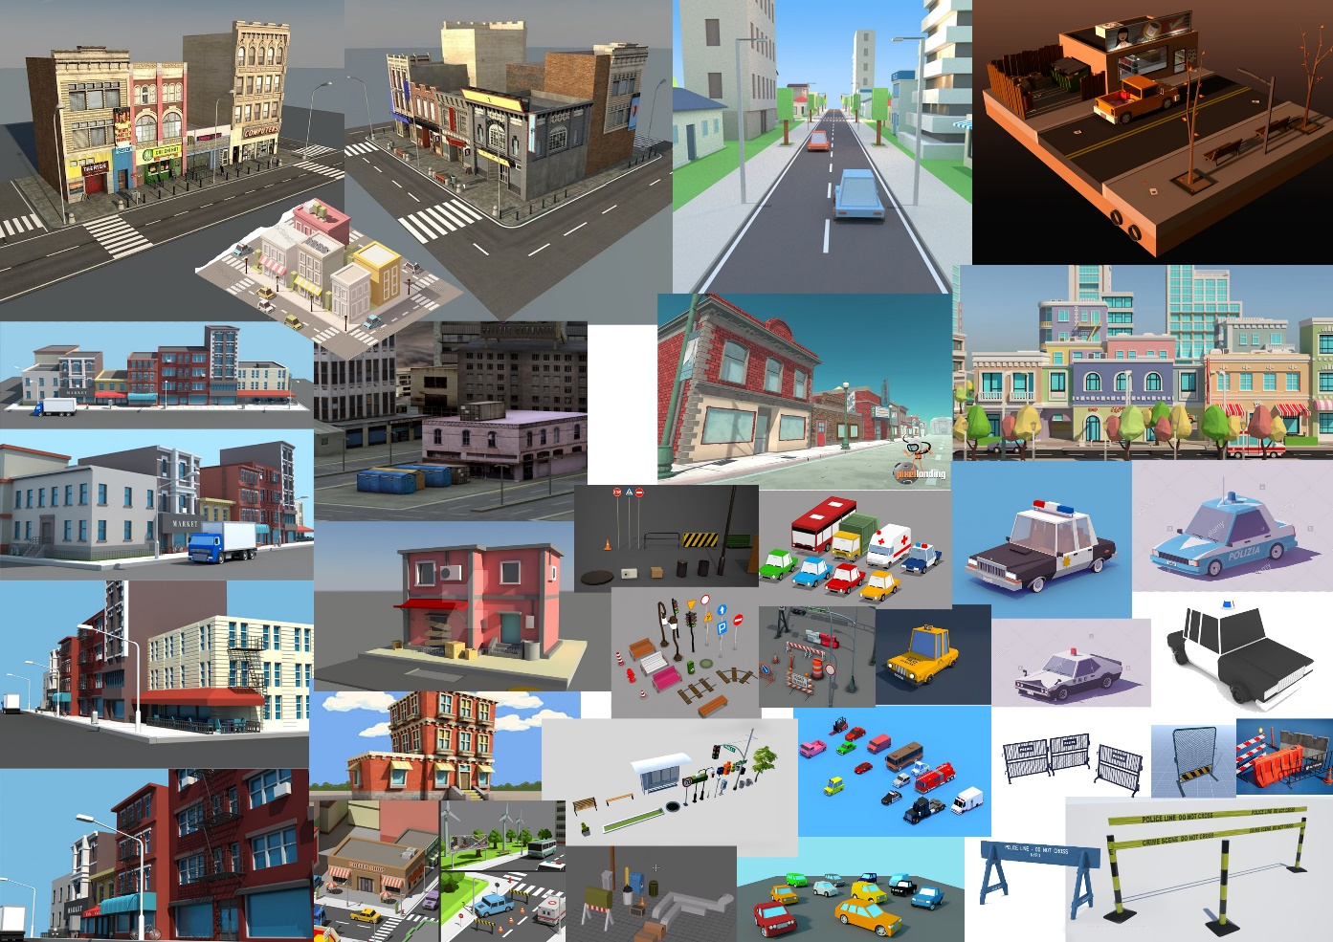

Modern, calm, small-city area. Mostly warm lighting with cold colour palette, so grays, blues, greens, oranges and browns. Similar to the bar, the city will mostly be composed of stone, wood and bricks, alongside with metals and glass materials. The area should appear as it is a part of a bigger city, however the possibility of exploration is limited. The player will be closed in with police barricades and police cars, preventing them to go further out. Lots of city-based props, like trash bins, cars, trees, lamp posts, benches and more.

Both the bar and the outside, should offer enough space for the player to move around without constantly bumping into objects.

**2D section**

Once the actual gameplay begins, the player’s perspective will be shifted from the low-poly 3D world, into a more cartoonish, stylized 2D world. The 2D world will take place in a 3D space of the bar and the city. The 2D effect will mostly cover the enemy/neutral characters and particle effects.

**Characters**

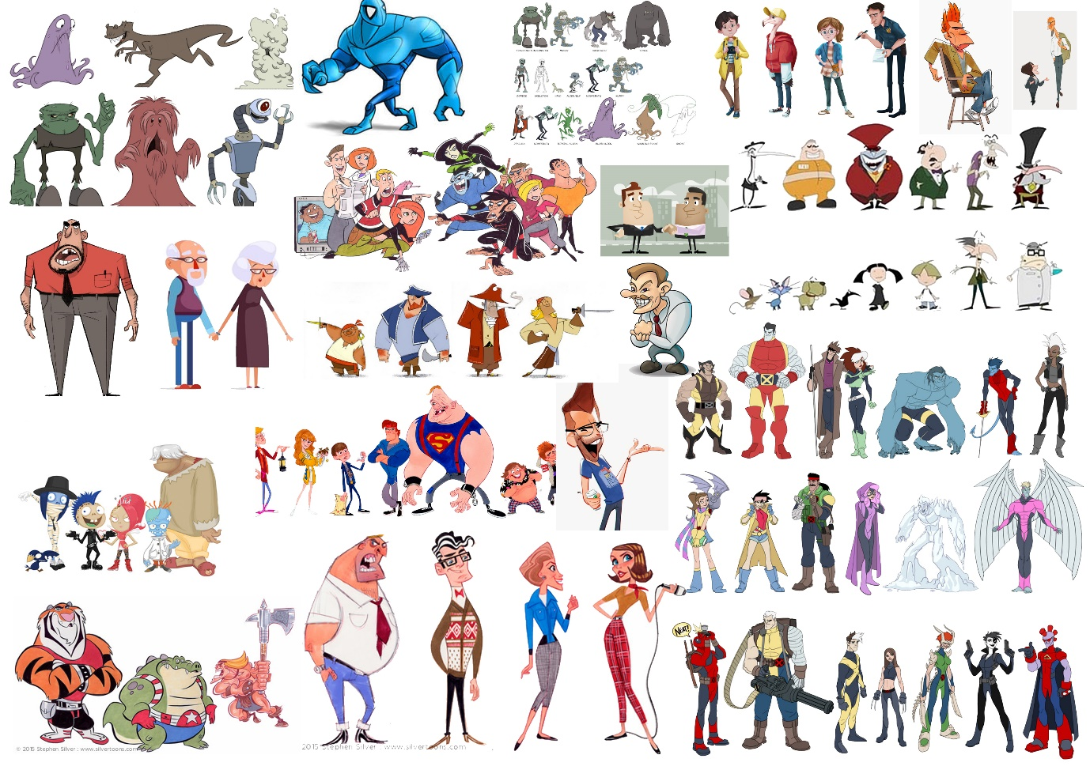

The neutral characters will come in variety of shapes and colours. The ‘drunken’ view will cause the characters to look monstrous and demonic, as well as it will exaggerate various features for a more comedic effect. The neutral characters will mostly run away from the player; thus most animations would have to be animated from the back.

The police-based characters’ will be similar to the neutral character in terms of shape variety, however their costume will mostly consist of the blue uniform, which will indicate these enemies are tougher. Unlike neutral characters, police will also face forward the player and will hold weapons, therefore they will most likely require few movement-based animations, as well as a shooting animation.

**Particle effects**

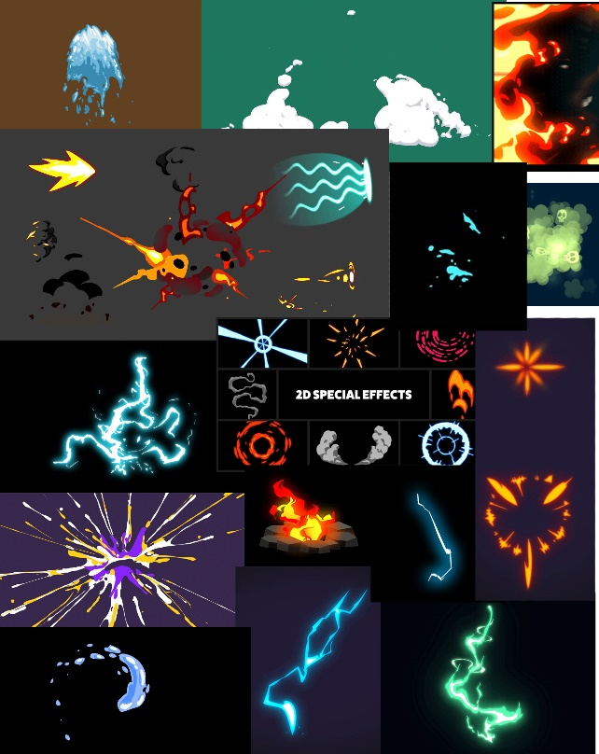The particle effects will follow the style of the characters, so big, flashy and exaggerated. They will also be bright and will compose of lots of different colours. Since the view will be “drunken”, the particles will also be affected. So for example stuff like blood, could be replaced with paint splatters, or perhaps bubbles, or smoke clouds.