## Preproduction Blueprint

Room 1 – The classroom

1. What do we want to create?

-Recreate an unpleasant memory / dream, taking place in a classroom

1. Why?

-purpose

-introduction to the game mechanics

-allowing the player to get to know the environment and what he can and can’t do in it

-features / elements that we want to include in this particular environment, what is the thing that we want to include which would make it stand out?

(for example: Assassins creed- Black flag

* Loot underwater shipwrecks
* Assassinate Templars in blossoming cities
* Hunt for rare animals in untamed jungles
* Search for treasure in lost ruins
* Escape to hidden coves

-the unique way of navigating around and interacting with objects

1. Where exactly it takes place, narrow it down

-a specific city, where the character is from

1. Collecting photo references:

- environment and location preferences



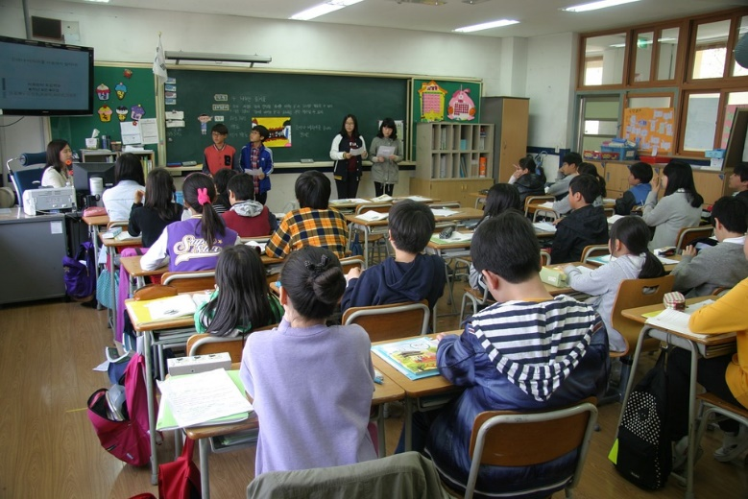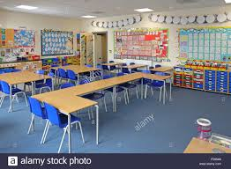

- design and props

Create a table 3D model

Create chair 3D model

Create desk 3D model

Create shelves 3D model

Create Blackboard / board 3D model

Create light bulb/ source 3D model

Create decoration, such as: sponge, pencils, chalk, books etc.

- lightning and style

Not relevant to us as the character can’t quite see

1. Narrative
   * What happened in the environment prior to the player getting there?

-depends on the story

* + How did the player come to that environment, what is he doing there?

-depends on the story (was he drunk, tired etc. what is the thing which made him remember/ dream about this particular moment?

1. Create objectives, obstacles and set pieces (scripted events)

▲Objective

-Find your backpack (the class is about to start soon, and you need to find where it is)

▲Obstacles

-You can’t clearly see around you (you need to use the ball to complete the objective)

▲Events

-In video games, a scripted sequence is a pre-defined series of events that occur when triggered by player location or actions that play out in the game’s engine. We need to decide that together as for example when or if at all the player will trigger a sound effect for example.

1. Top down view of the level
   * Where the obstacles are going to be
   * Where the plot points within the story will unfold
   * Where the objective is
   * Player’s path
   * If there are any cinematics where and at which point are they going to show up

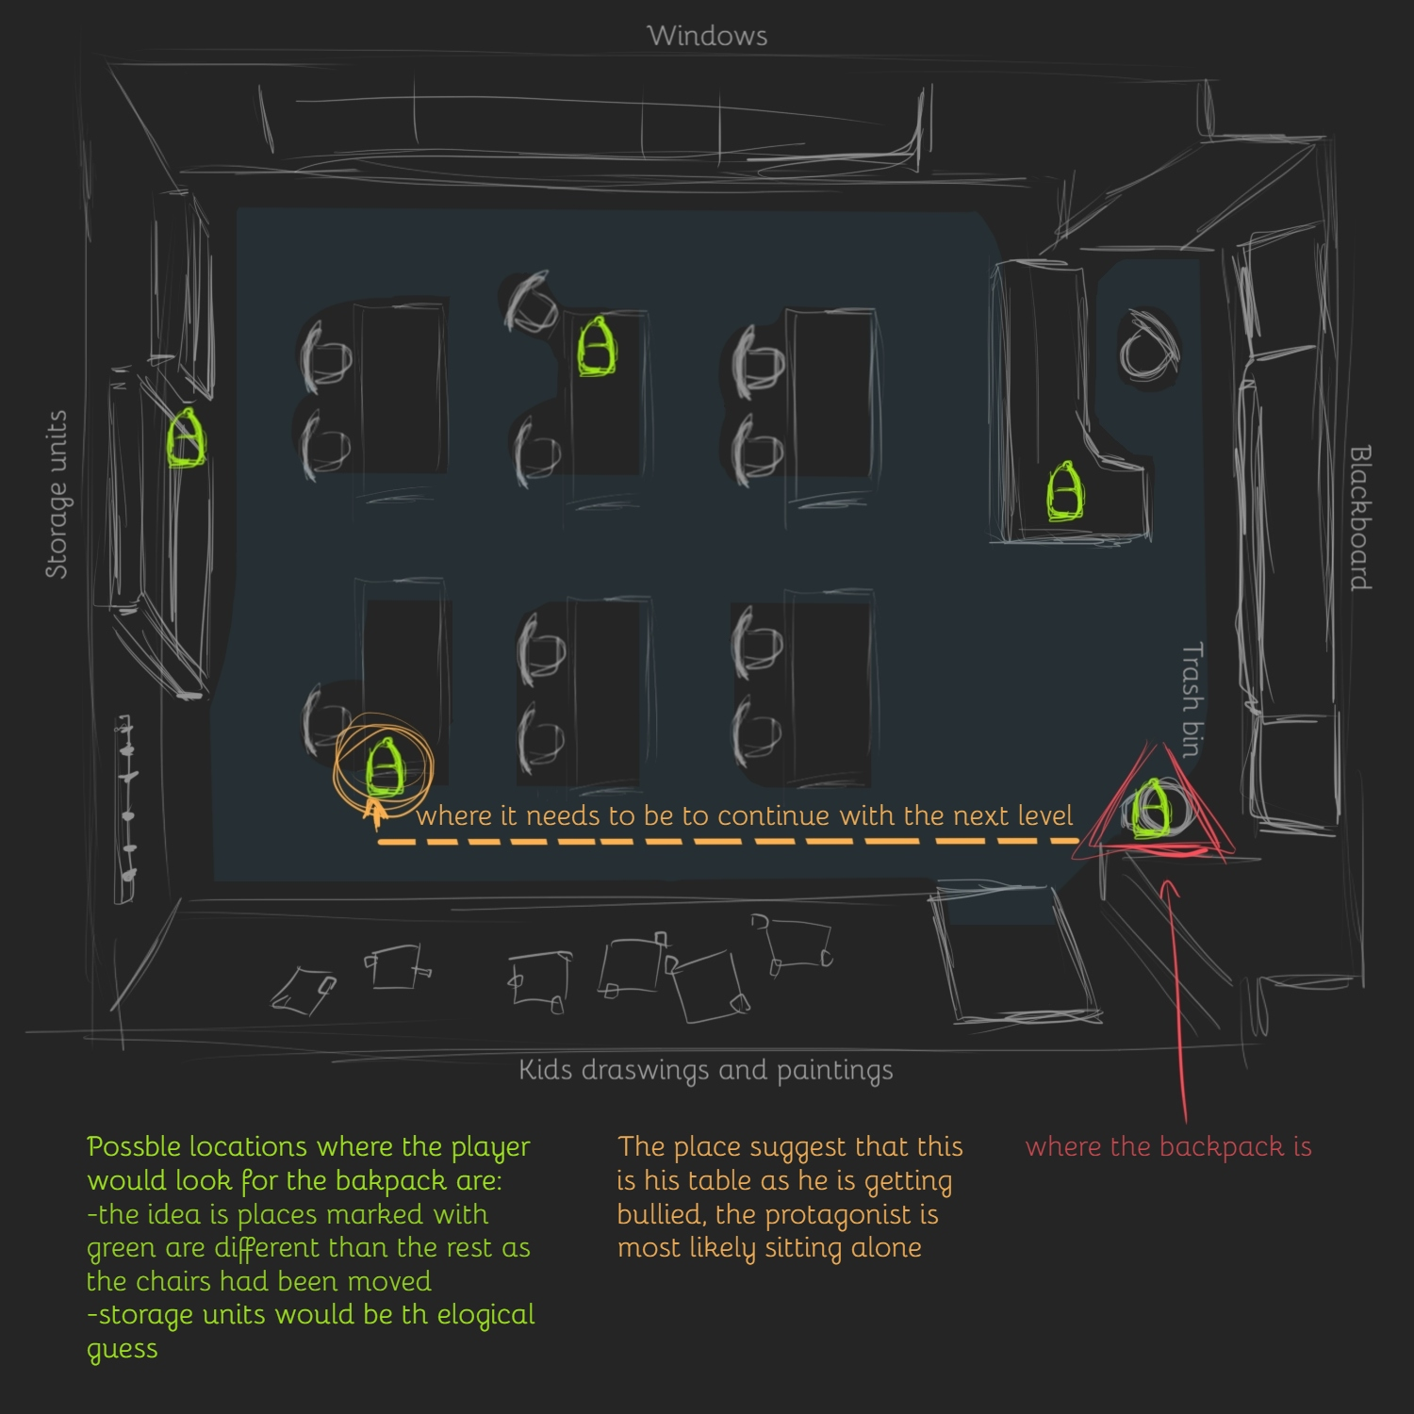

1. Creating focal point for the player to easily navigate in the environment

-doorways, stairs, hatches ↑

1. Creating concept art, to get the best idea possible about how your environment is going to look

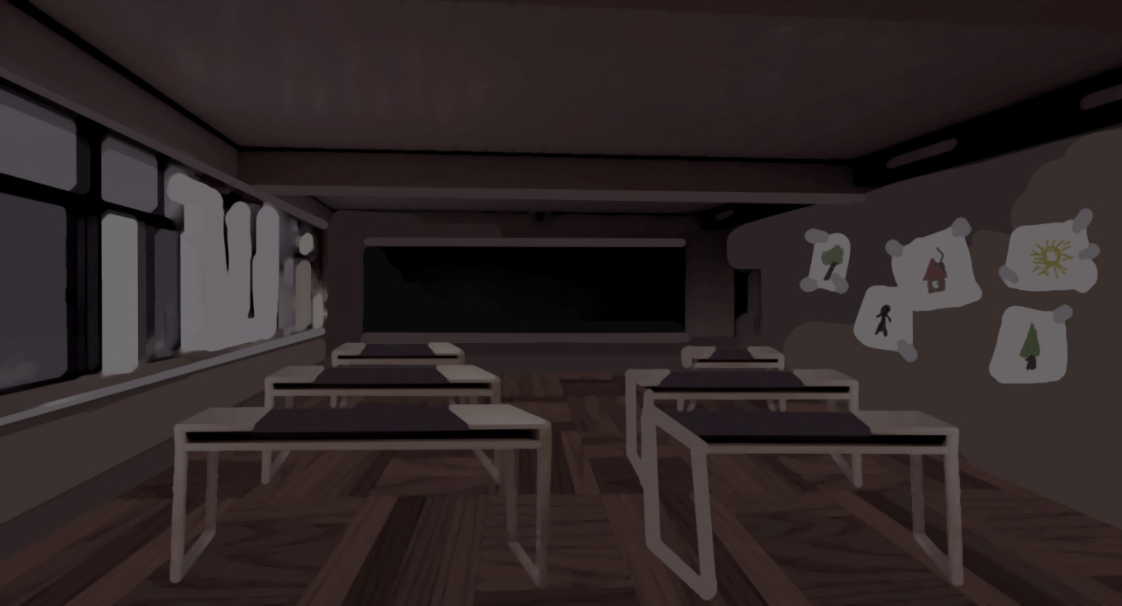

1. Creating the level

Soon 😊

Sources: https://www.worldofleveldesign.com/store/preproductionblueprint.php