Statistics:

Based on interviews with 4,000 UK residents, the research asserts that women now account for 52% of the gaming audience, up from 49% three years ago. The study, which was commissioned by the Internet Advertising Bureau, also revealed there are now more people over 44 years old playing games (27% of the audience) than children or teenagers (22%). The gamer audience reportedly stands at 33.5 million Britons – 69% of the population.

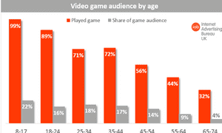

We chose adventure/puzzle/horror as statistics show they are some of the favorite genres of all ages ↓

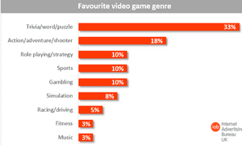

While “hardcore” gaming is clearly still rooted in its traditional user base (playing games is considered the most entertaining media amongst males aged 16-24), what the study shows is a widening audience who are exploring games through new platforms, thanks to the proliferation of new platforms. The suggestion that a quarter of all gamers are now over 45-years-old may well have interesting ramifications for game design going forward.

But according to the IAB, one of the most interesting discoveries through the 4,000 surveys and 20 in-depth interviews that contributed to the findings, was the immersive nature of the medium. Researchers found that, when UK gamers are playing, they give their full attention.

**Overview: Who is Playing?**

The average age of gamers: 35  
The average age of game purchasers: 38  
Households that own a device used for playing video games: 65%  
Households that own a device exclusively for playing video games: 48%  
The average number of years gamers have been playing: 13

The average age of gamers held steady this year, indicating that more up and coming gamers are joining in as us older gamers gained another year on our birthdays. The average number of years gamers have been playing also held steady this year. Is this an indication that some gamers are aging out just a bit?

**What are people playing?**

Gamers who play social games: 48%

**Devices the most frequent gamers are playing on:**  
PC: 56%, dedicated game console: 53%, smartphone: 36%, wireless device: 31%, dedicated handheld system: 17%

**Playing Video Games as a social outlet**

54% of the most frequent gamers play with others  
53% of the most frequent game players feel video games help them connect with friends  
42% of the most frequent game players feel video games help them spend time with family  
Hours per week spent playing with others online: 6.5  
Hours per week spent playing with others in person: 4.5

**Who are they playing with?**  
40% friend  
21% Family members  
17% Parent(s)  
15% Spouse/Partner

Sources:

<https://www.wepc.com/news/video-game-statistics/>

<https://www.statista.com/topics/1763/gaming-in-the-united-kingdom/>

<https://www.theguardian.com/technology/2014/sep/17/women-video-games-iab>

<https://www.bigfishgames.com/blog/2017-video-game-trends-and-statistics-whos-playing-what-and-why/>