Research on similar games

**Narcosis** / action adventure, survival, horror (5/10 IGN Rating)

*(On paper,***Narcosis***sounds exactly like what the horror genre needed. A first-person survival story where you’re stuck in a heavy, high-tech suit deep down in the sea?*)

-Unfortunately, Narcosis is only good on paper. The writing and voice acting are the standouts here, as everything else sinks in execution. It’s very much a game of what-ifs and missed opportunities.

-The game is also too dark

-There are numerous sections where you’re stumbling around in the dark for significant periods of time and you actually ask yourself why did you pay a lot of money to watch a black screen, it’s frustrating to navigate around as you bump from one lull to the next. These clunky movements and lack of fluidity are aggravating to the point where you don’t feel rewarded when you’ve finally figured out how to get around.

-I felt in suspense through my entire playthrough not really knowing what the game is going to throw at me next.   
I do have quite a few issues with this game.   
I felt like the overall experience was more stressful than it was enjoyable scary. it could just be because of the setting and the whole under water base thing that I automatically don’t like… but I didn’t enjoy exploring these areas. I don’t have a solution for make space station like areas enjoyable to explore. but they’re just not for me. they stress me out.

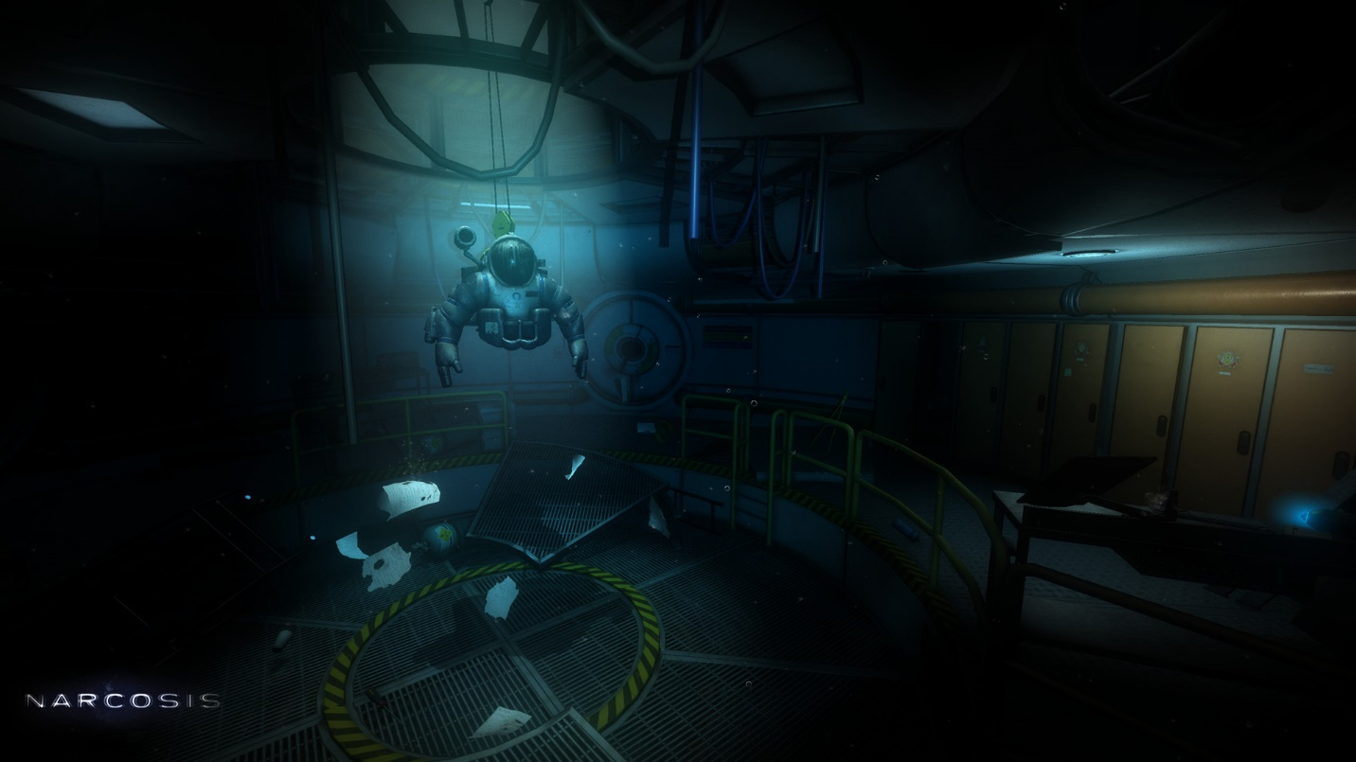

**Get Even** / action adventure, shooter, arcade (7/10 IGN Rating)

*(In the game’s prologue, Black finds himself tracking down a missing girl. When he finds her strapped to a chair with a bomb strapped to her chest, things go south, and he is knocked unconscious. Shortly after that, he wakes up outside an abandoned asylum and he becomes trapped there when he explores the mysterious building in front of him. His only way out is to cooperate with a mysterious character behind a screen, known only as Red, who gives Black the VR-like device called The Pandora which allows the user to relive memories and even change them (although it doesn’t really affect the present, it’s not a time machine, it’s a simulation). The goal is to remember why you were trying to find the girl, who orchestrated her kidnapping, and any other pieces of information that may be relevant.)*

- **A unique, well-written tale of regret filled with twists and turns.** While some twists may be a bit predictable (I was able to predict various things hours before they happened), there are a few elements that really caught me off guard. It goes to some dark places, but it manages to tell a very compelling story with emotion, especially towards the end of the game.

-The story is amazing, mature and intelligently written. A mystery so fragmented it makes you use your brain and keeps you curious only to blow your mind with some unexpected plot twists near the end.   
-The voice acting is out of this world, I can't remember the last time I've seen such honest and heartfelt character portrayals in a game.   
-Not only is the music chill inducing but it's implemented in such a way that it plays in rhythm with things happening on screen and dynamically changing in response to different situations.

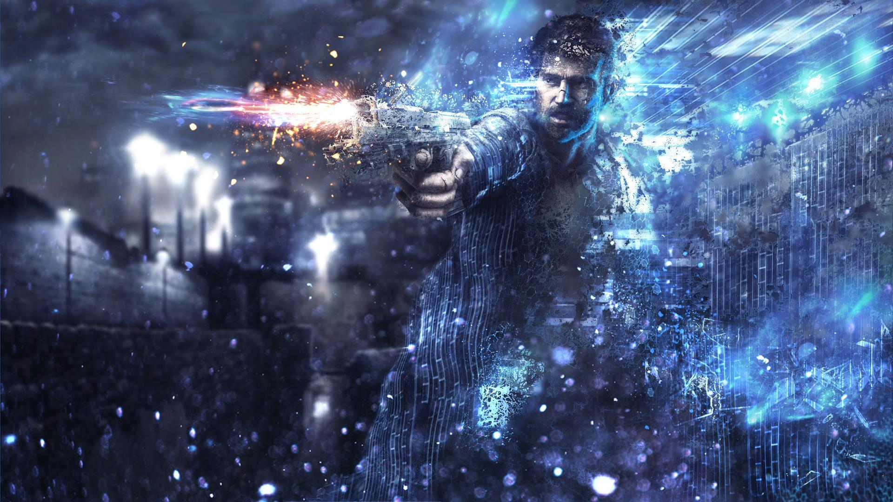

**Inside /** action, platformer(10/10 IGN Rating)

*(The player controls a boy in a dystopic world, solving environmental puzzles and avoiding death.)*

-The first 10 minutes of Inside, swing between being beautiful, haunting, and terrifying. Sometimes it is all three at the exact same time. From there, it adds intrigue, wonder, and shock on top of those and never lets up.

-Even though it is mechanically a 2D puzzle-platformer, Inside is quite simply one of the most beautiful and subtly detailed games I’ve ever played. Every frame appears to have been meticulously crafted and polished several times over, from dust particles hovering in smoky air to raindrops splashing down in a bog to golden sunlight beaming onto your unnamed, red-shirted boy avatar through a window.

-Gray paints a lot of the scenery but splashes of color – often red – are used as a bold contrast that draws your eye where the designers want it to go.

-Camera work is also laudable; the perspective only ever shifts slightly, but from scene to scene you’re always in the optimal viewing position for what’s happening on screen, and there’s always a visual reward anytime the camera moves closer in, pulls further out, or changes angle.

- “Genius game, incredibly minimalistic and although that great fun.   
The atmosphere is genius, very dark and depressive. The light and shadow elements made some scenes very beautiful, good graphic engine.   
The atmosphere fits perfectly to the story, which is an art, you don’t get any intro, not text, you understand the story just by looking at your surroundings.   
Gameplay is very simple: run, jump, grab. Just like the whole game, it is very minimalistic. But with such few possibilities you get many interesting puzzles. “

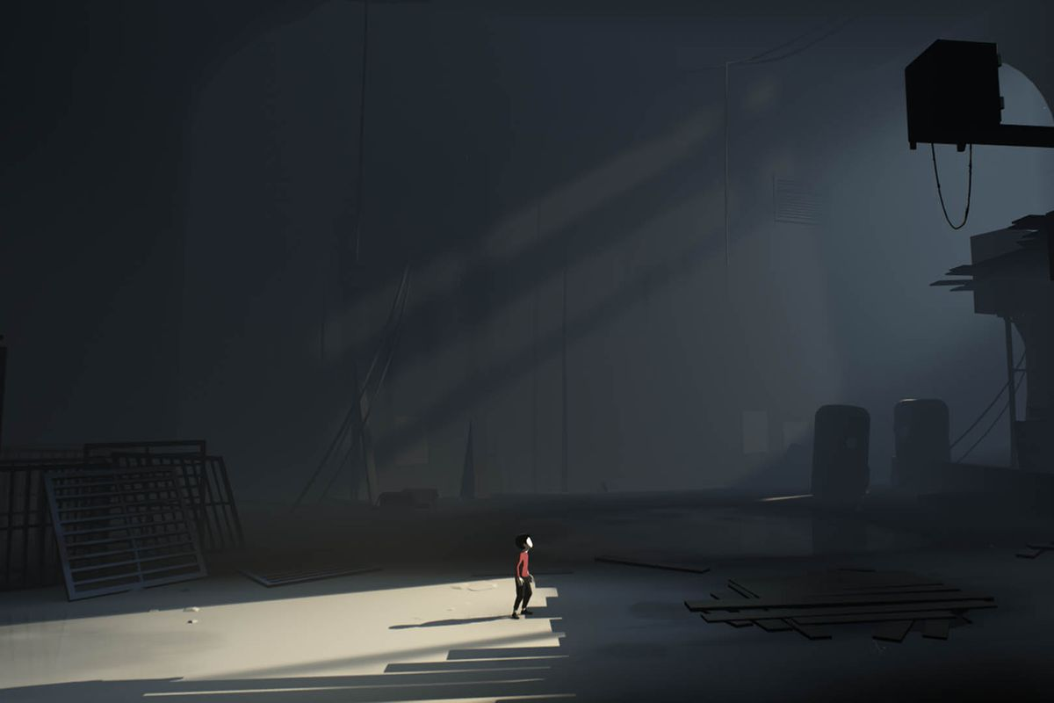 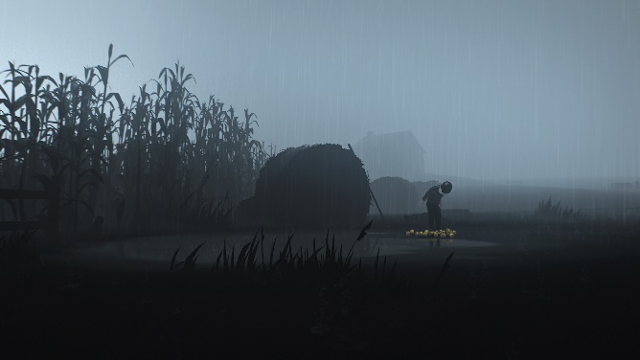

**Silent hill 3** / action adventure, survival, horror (8/10 IGN Rating)

-Silent Hill 3 isn't so much about gameplay as it is about creating a disturbing world and immersing you in it, which is something it does very well.

-This game also has quite a bit of replay ability to, with 3 different endings to see, and additional scenes to be seen on replay. My only qualm with this game is that it’s too short, at only 5 hours on your first play through and maybe half that each additional time.

-The game's biggest weakness is the lack of any levity or humor to counterpoint the story's overwhelmingly serious tone.

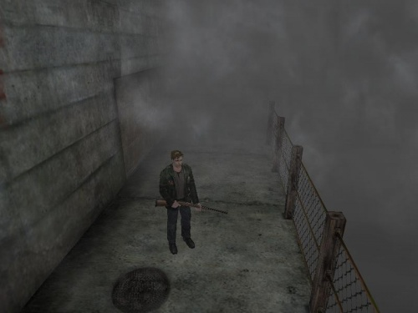 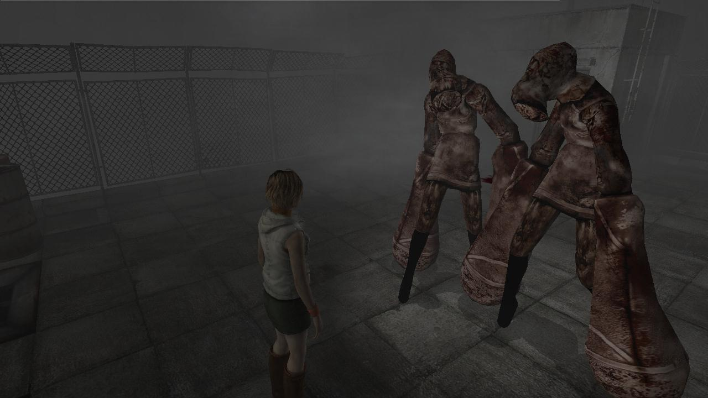

**SOMA** / action adventure, survival, horror (8/10 IGN Rating)

-For me Soma is a good sci-fi interactive novel that tries to answer - or at least explore - the ramifications of deep questions about what it is to be human

- Man, what an incredible game this was. I don’t think the gaming community has really shouted about this game enough. This has easily one of the best written stories’ in this medium. It's super deep and makes you think and question your very existence. Game should be getting a lot more acclaim. Must play.

- SOMA is smart and scary science fiction. Not all of its ideas work, but it's worth playing for the story alone.In terms of plot and ideas, SOMA is fascinating, but when it comes to the moment-to-moment gameplay it has fewer original ideas. Ultimately, it’s built upon the framework of a fairly standard ‘peak-em-up’.

- SOMA is a sustained exploration of an original and thought-provoking idea. The concept of artificial intelligence has been explored by lots of science fiction, so it isn’t unique in that regard, but it makes particularly intelligent use of video game conventions to present those familiar ideas in new and surprising ways. At 12 hours long, the story feels a little stretched, especially when so much of its gameplay feels less original than its ideas. That’s not to say it’s scares aren’t effective or intense, but I found myself drawn to its quiet moments in which its philosophical, yet unpretentious storytelling is allowed to breathe without interference from unintuitive puzzles and monsters that can’t be manipulated.

