Hdoop command:

$ hdfs dfs –copyFromLocal input.txt /WordCountFiles

$ hadoop jar ./WordCount.jar WordCount /WordCountFiles/input.txt /WordCountFiles/output

Application Scene:

* OTA
* Mobile Data
* E-Commerce
* Energy Mining
* Save Energy
* Base Framework Regulation
* Image Processing
* Cheating inspection
* Medical

Why Hadoop

* Scalability
* Efficiency
* Flexibility

How Hadoop runs a MapReduce job

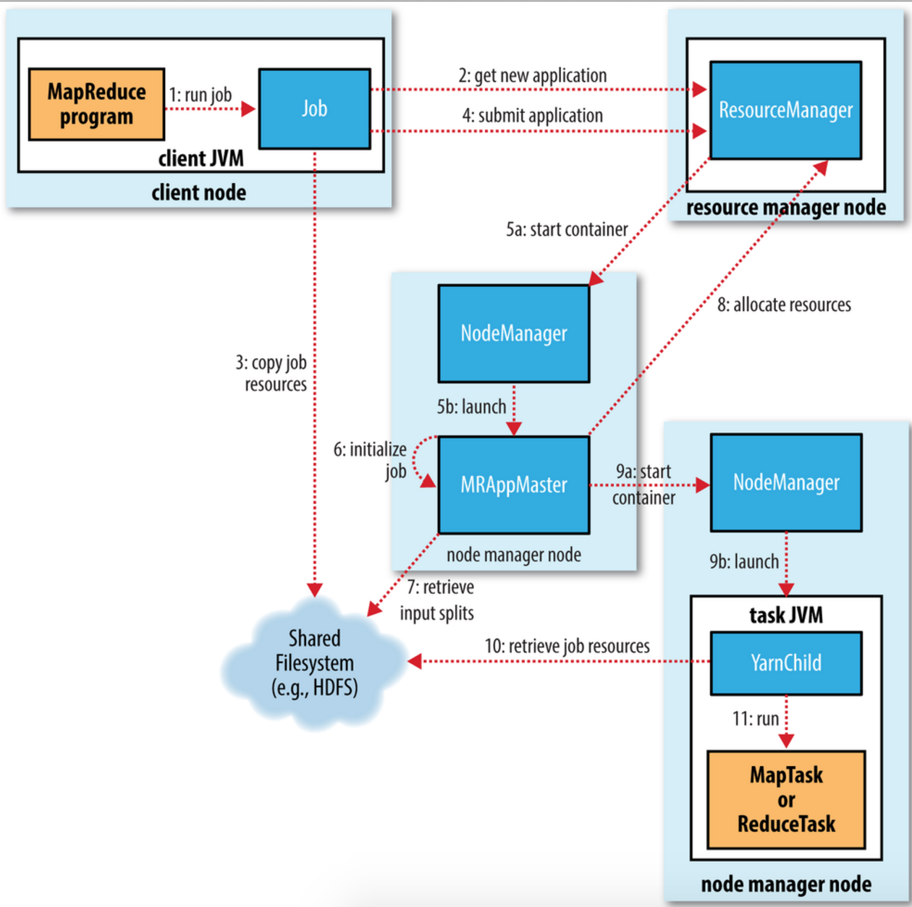

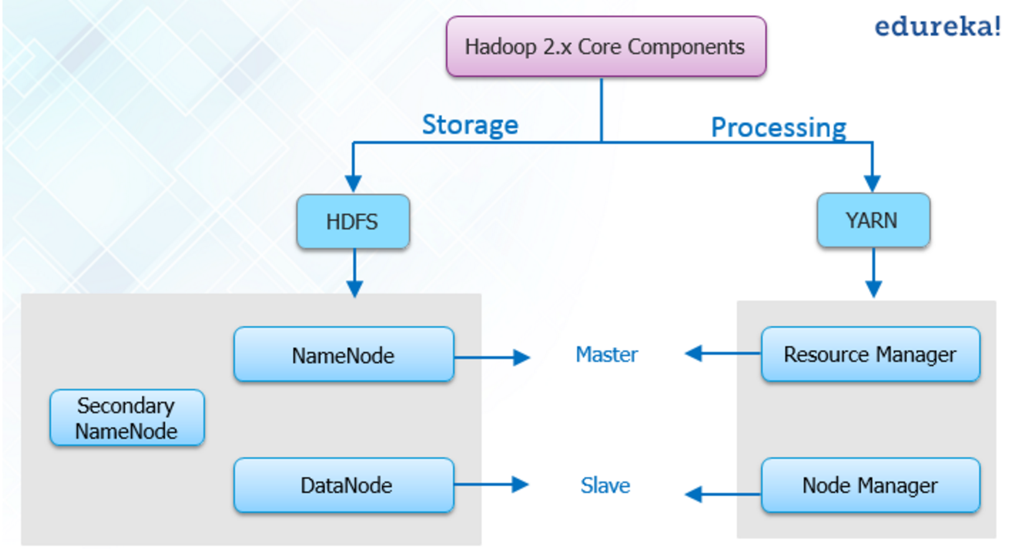

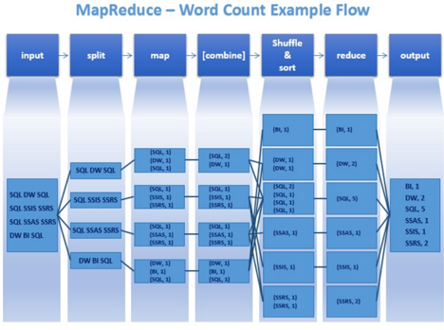

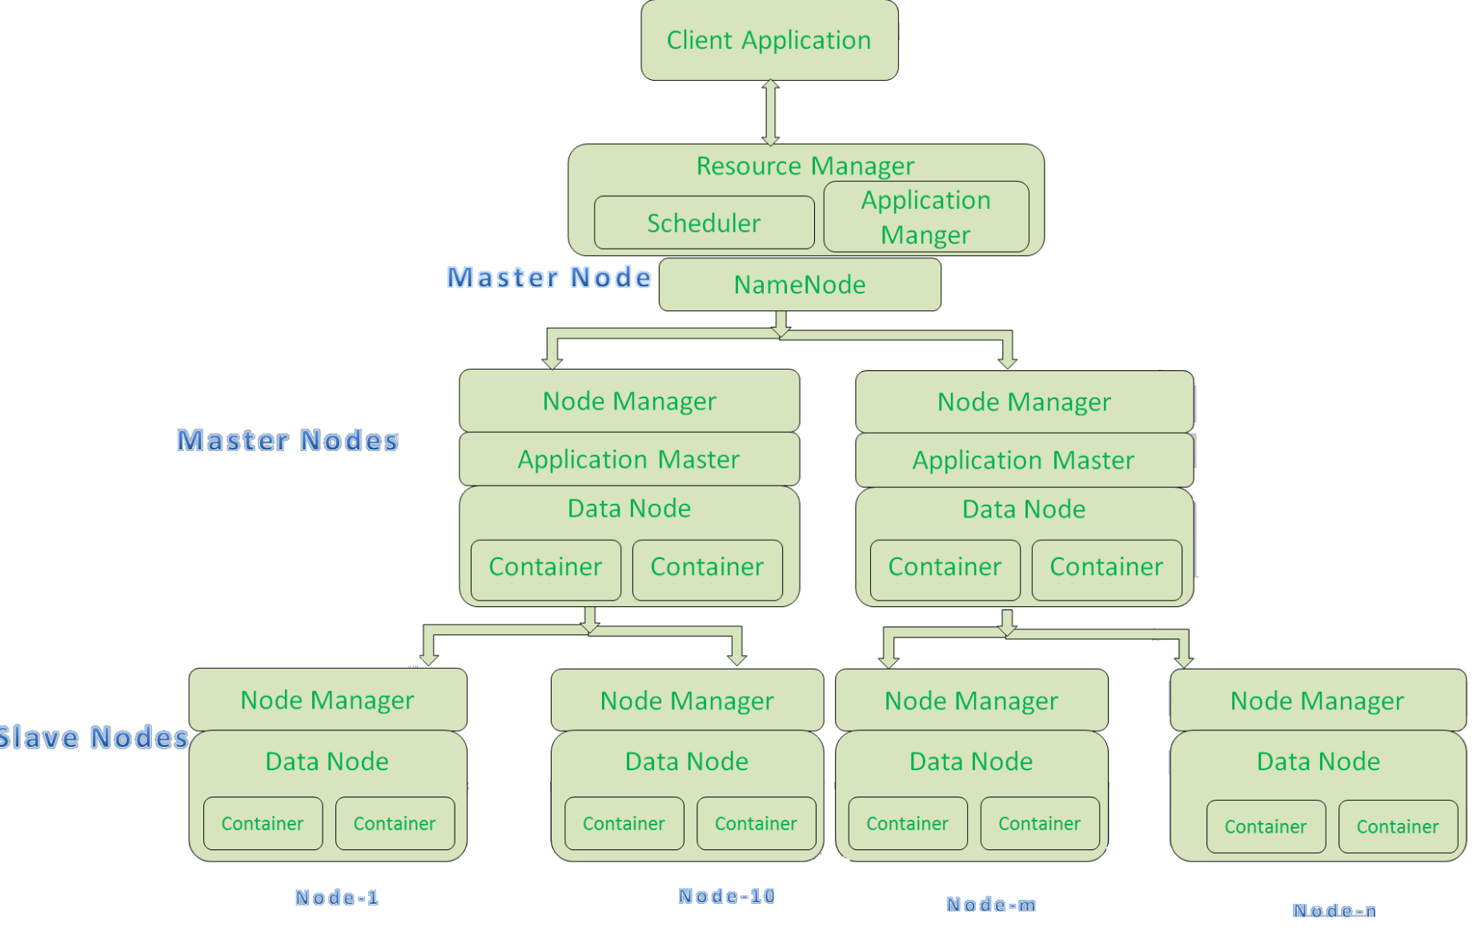

Problem Solving

* DataNode cannot run:

Plan 1:

1. Stop dfs
2. Open hdfs-site.xml
3. Remove the data.dir and name.dir properties from hdfs-site.xml and -format namenode again.
4. Then remove the hadoopdata directory and add the data.dir and name.dir in hdfs-site.xml and again format namenode.
5. Then start dfs again.

**Plan 2:**

* 1. Delete dfs/data
* DataNode cannot show in webpage:

1. Check localhost

Hadoop Cluster Installation