COMP 1900
Software Setup Instructions
(Combined installation of BlueJ and JDK)

- If you are a Windows user, simply visit bluej.org in your web browser and click on “BlueJ Installer
with Java 8 JDK.” When the download is finished, run it. You should be able to accept the defaults (i.e., simply click Next about 4 times), then click Install, then Finish. That’s it. You’re done. There are pictures of the process below, but you probably don’t need them.

- If you are a Mac user, I hope you are using OS X version 10.7.3 or newer. If so, then simply visit bluej.org in your web browser, scroll down to the Mac OS X Apple section, and click on “BlueJ Installer with Java 8 JDK.” After the download is finished, you should be able to run it and accept the defaults. That’s it. You’re done.

- If you are a Mac user, and you are using OS X version 10.7.2 or older, then proceed as follows. Simply visit bluej.org in your web browser, scroll down to the Mac OS X Apple section, and click on “BlueJ Installer.” After the download is finished, you should be able to run it and accept the defaults. That’s it. You’re done.

Pictures of the installation process for Windows users

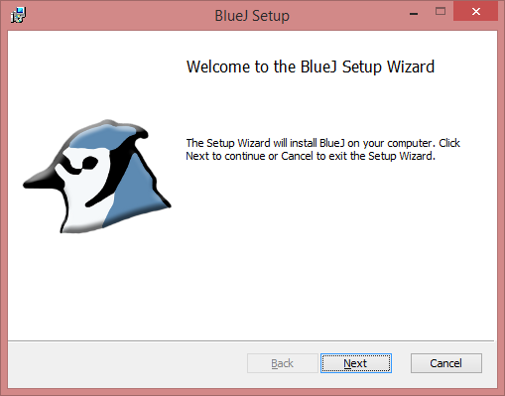
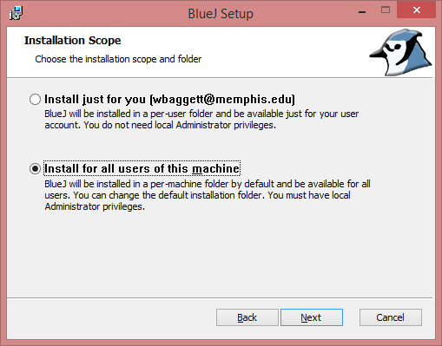

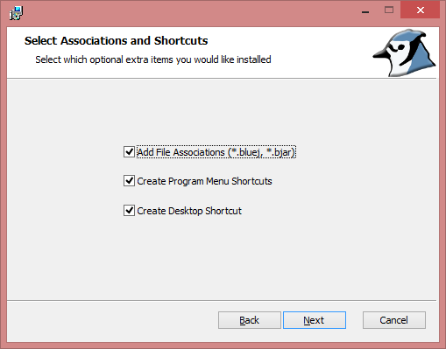
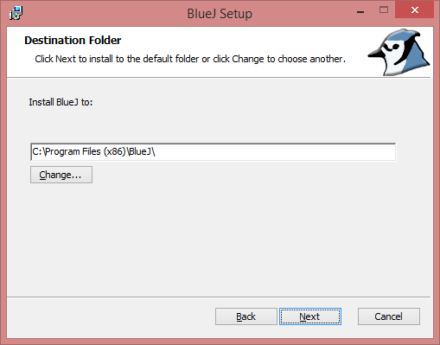

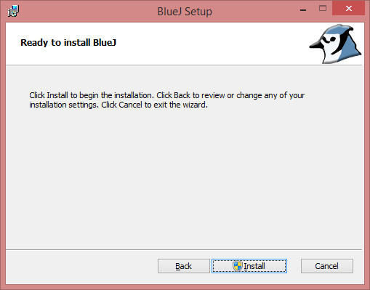
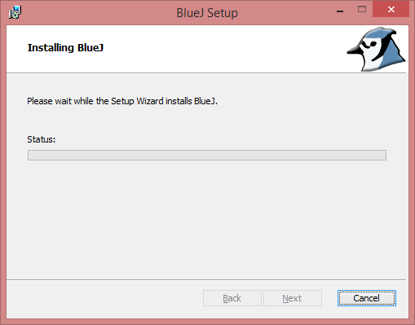

If you are asked, “Do you want to allow the following program from an unknown program to make changes to this computer?” then Select Yes.

