**Using the TFT controller**

**Acknowledgement**

The controller used in this tutorial is provided by the Xilinx IP catalog.

**Goal**

* Use IP integrator to connect and configure TFT controller with the MicroBlaze system
* Communicate to video memory using the TFT controller
* Be able to use a C program in SDK to interact with the TFT controller

**Requirements**

* Xilinx Vivado software
* Xilinx SDK software
* Xilinx Nexys 4 board and a programming cable
* Enough disk space for the project files

**Background**

Before using the AXI TFT controller, it is important to note that that this controller has both a master and a slave axi interface. In this tutorial, the TFT controller is connected as a slavof them te on the AXI bus for the purpose of allowing the MicroBlaze processor write to the controller's internal registers. It is also a master as well, because it needs to access video memory through the same bus.

The controller must be connected as a slave to the axi bus because we need to initialize its address register and control registers to tell the controller where to read from the memory. We can do this using the MicroBlaze.

The slave port can be connected to the axi peripheral output of the AXI-interconnect.

The master port must be connected to the axi peripheral slave input in a similar way to how the MicroBlaze is connected.

**1. Import the Board Package**

1. Invoke the Vivado IDE

2. Bring up the Tcl Console at the bottom of the window and enter:

**set_param board.repoPaths <path-to-board-files>/board_files/**

3. Create a **New Project** specifying the **Nexys 4 DDR** board and leaving the rest of the settings as default

**2. MicroBlaze Processor**

1. From Navigator > IP Integrator, select **Create Block Diagram**

2. Right click anywhere in the Diagram and select Add IP and add a MicroBlaze block to the design

3. Double-click the MicroBlaze Processor Diagram to open the Re-customize IP dialog box.

4. Leave everything in page 1 as default,and click **Next**.

5. On page 2 of the Re-customize IP dialog box:

• Check the **Enable Barrel Shifter** option.

• From the pulldown menu, in option **Enable Floating Point Unit** select **BASIC**.

• From the pulldown menu, in option **Enable Integer Multiplier** select **MUL32** (32-bit).

• Check the **Enable Integer Divide** option.

• Check the **Enable Branch Target Cache** option.

• Click **Next**.

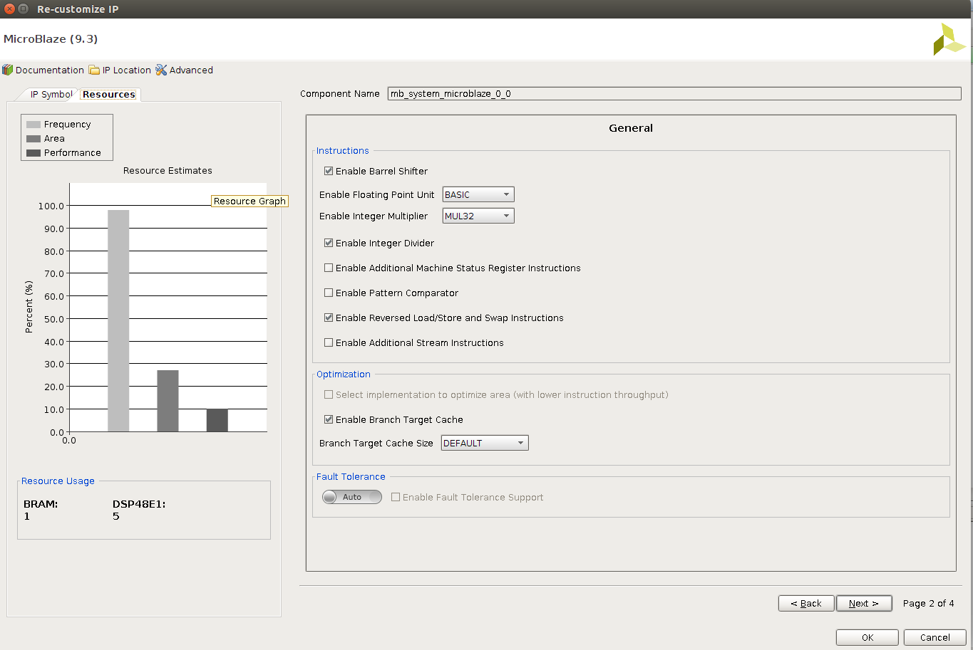

6. On Page 3 of the Re-customize IP dialog box, ensure that the **MicroBlaze Debug Module is en**abled

(i.e. BASIC), and click Next.

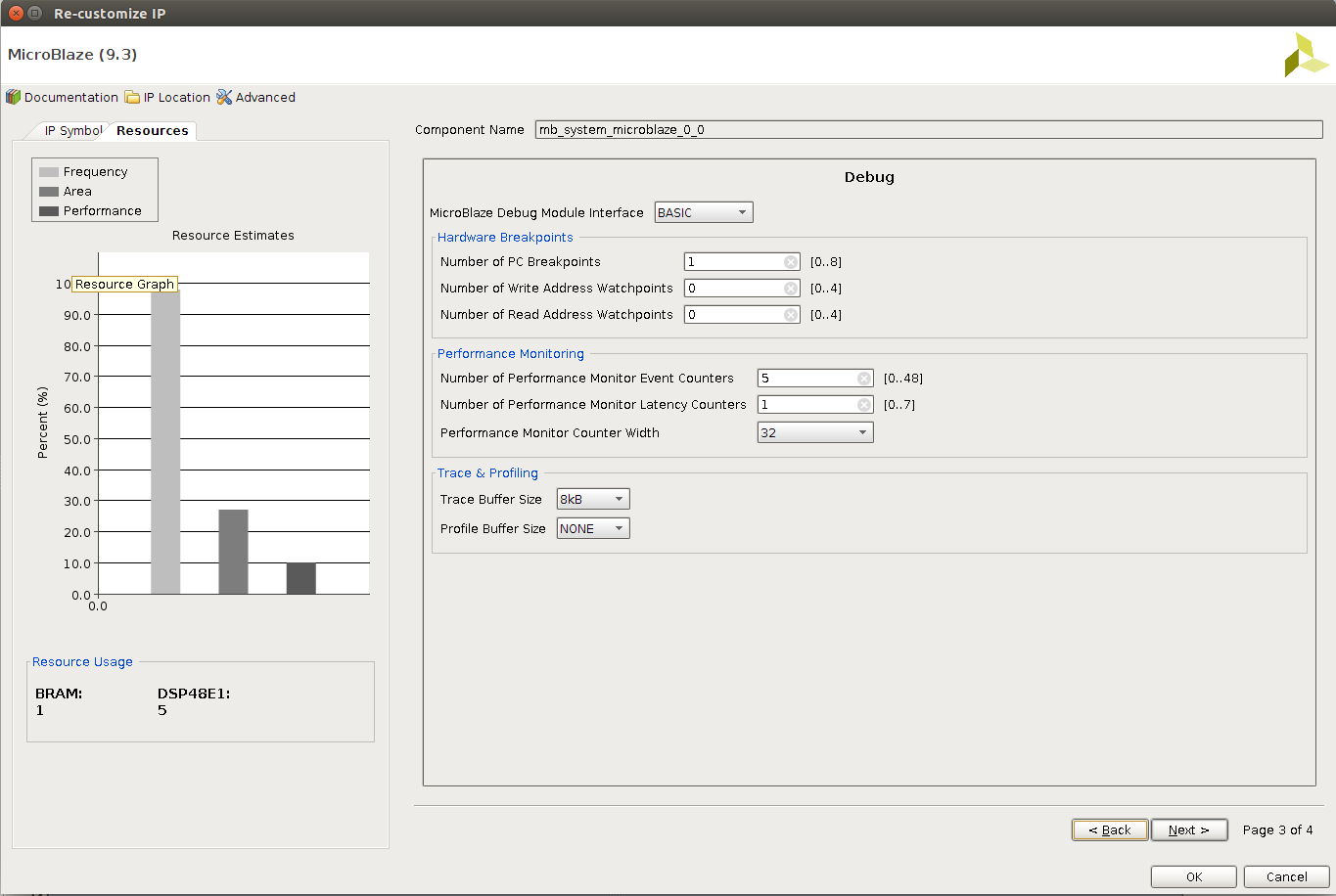

7. On Page 4 of the Re-customize IP dialog box, ensure that the **Enable Peripheral AXI Data Interface**

option is checked, and click OK to re-configure the MicroBlaze processor

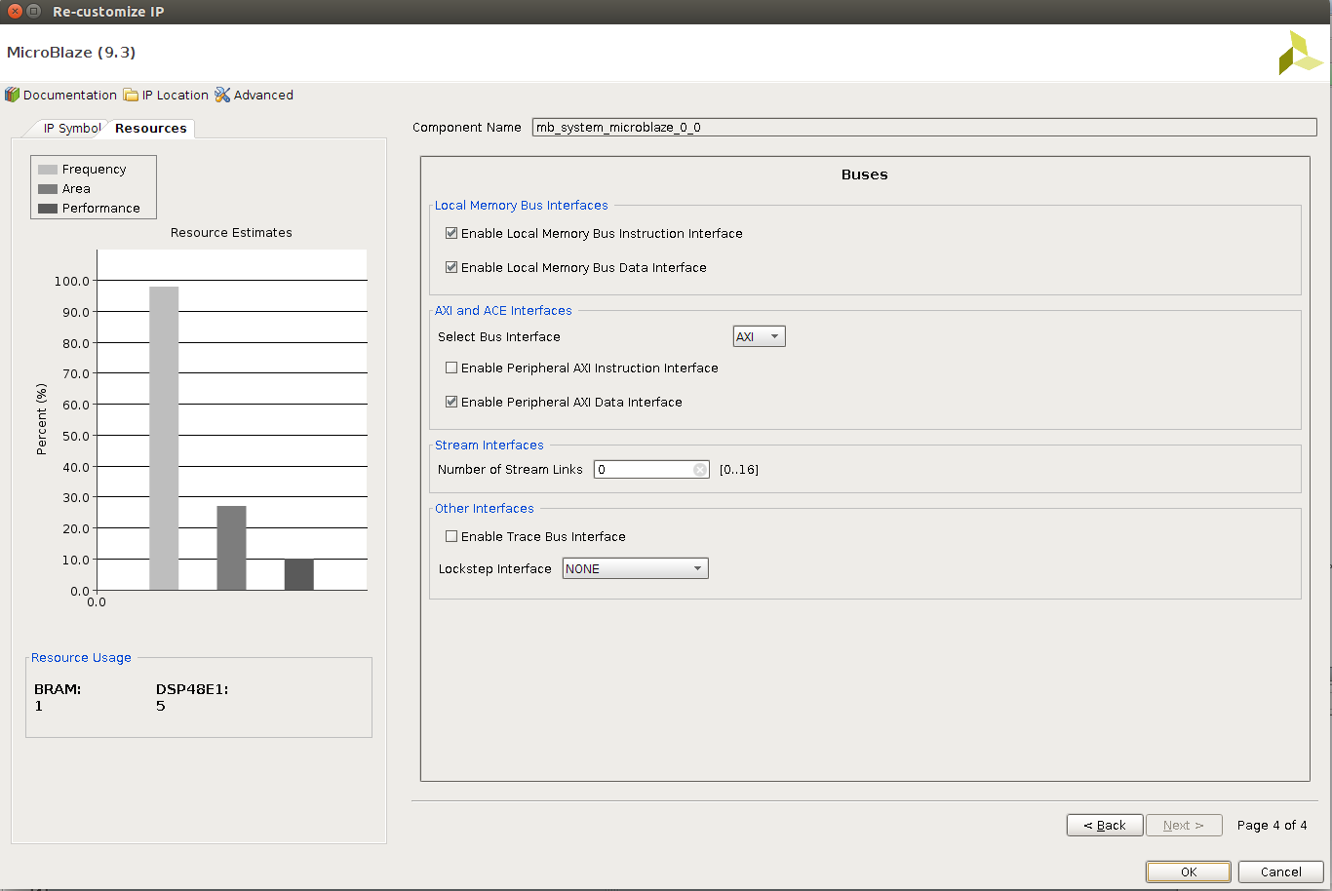

8. **Run Block Automation** for the MicroBlaze with **Local Memory** set to 32KB and **Interrupt Controller** enabled.

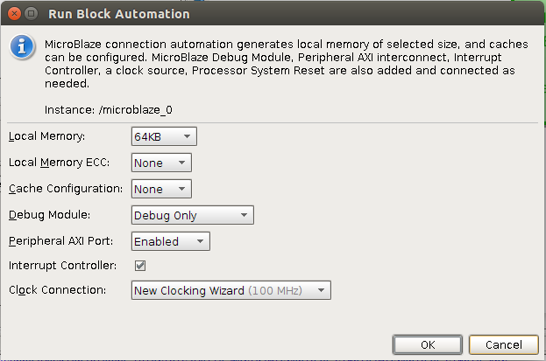

**3. Clock Customization**

The processing system will operate at 100 MHz, but the memory controller requires a 200 MHz input

clock to generate the appropriate clock for the external DRAM. Additionally, the pixel clock of the TFT controller requires a frequency of 25MHZ to operate a 640 by 480 display.

1. Double click the **Clock Wizard** (clk_wiz_1) block to re-customize it.

2. Under the **Board** tab, use the Board Interface pull-down menu for IP interface CLK_IN1 and select sys clock.

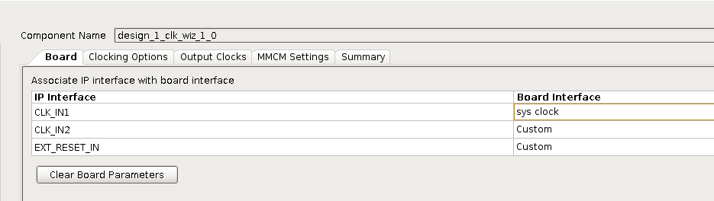

3. Under the **Output Clocks** tab, check the radio box for Output Clock clk_out2 and enter a requested clock frequency of 200 MHz.

4. Repeat the process and check the radio box for Output Clock clk_out3 and enter a requested clock frequency of 25 MHz.

5. While in Output Clocks tab, change the Reset Type to Active Low.

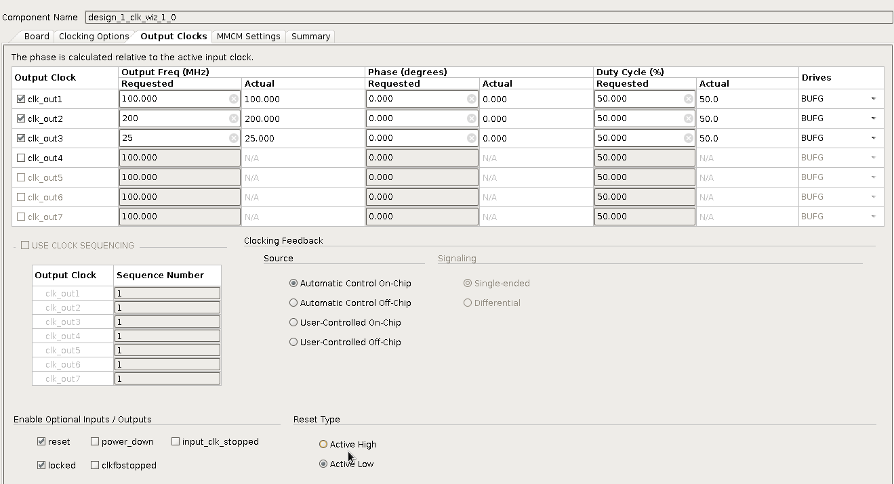

**4. DDR2 Memory Block**

In this section, you will be creating an external memory on the Nexys 4 DDR board that will be used as the video memory for the AXI TFT controller.

1. Right click anywhere in the Diagram and select Add IP and add an AXI Uartlite block to the desgin.

2. Repeat the process to search and add a Memory Interface Generator (MIG 7) peripheral.

3. Run Block Automation for the Memory Interface Generator. There may be an error during the process, you may ignore that and move on.

4. Run Connection Automation and selection all connections.

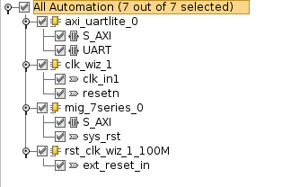

5. Manually connect clk_out2 from clk_wiz_1 to the Memory Interface Generator sys_clk_i

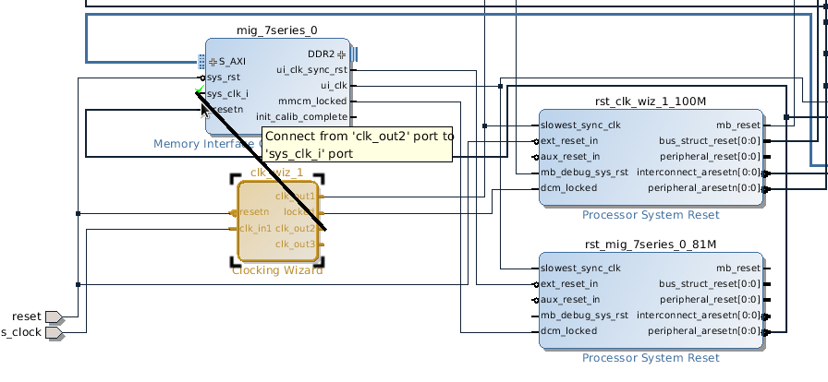

6. Right click **DDR2** in the Memory Interface Generator and make it **external**.

**5. Connecting the TFT Controller**

1. Add IP > AXI TFT Controller

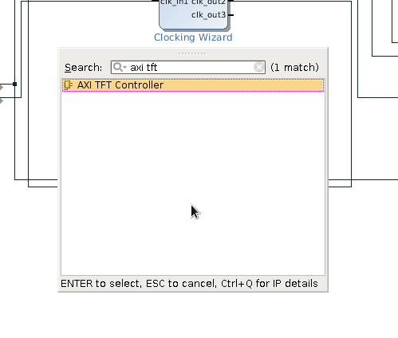

2. Double Click the TFT controller and customize it as in the figure below. Set **TFT Interface** to VGA. Set **base address** to 0x44A00000. Set **data width** to 32 bits and **burst length** to 32.

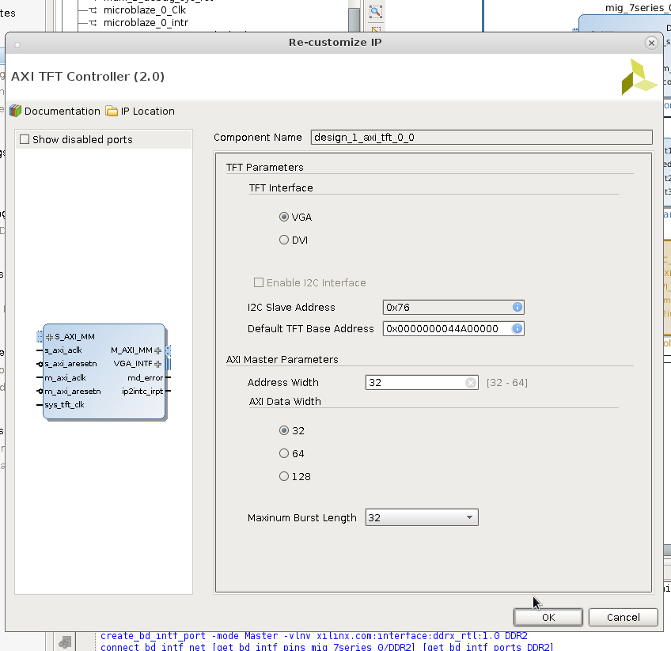

3. Run **Connection Automation** for all connections.

4. Connect **sys_tft_clk** to **clk_out3**, which is 25MHz.

SYS_TFT_CLK – this is essentially the pixel clock of the controller. For operating a 640 by 480 display the clock should have a frequency of 25Mhz.

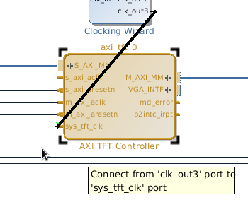

5. Connect interrupts. Connect Uartlite Interrupt to In0. Connect ip2intc_irpt to In1 on Concat.

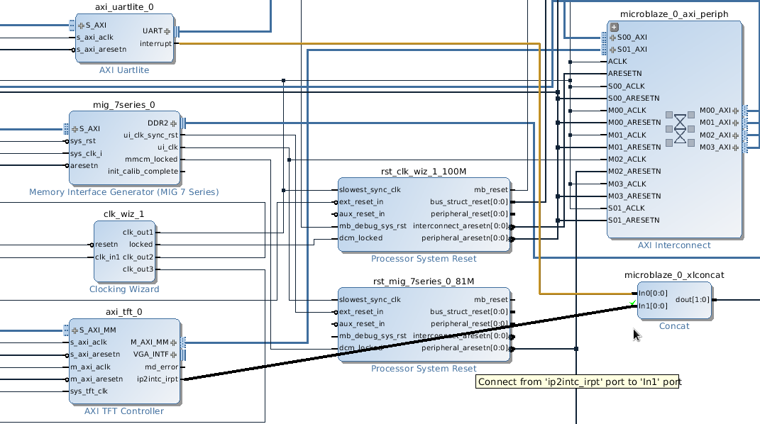

6. You will need to truncate the 2 least significant bits of each of the pixel colour output ports because the board only supports up to 12 bit RGB (4 bits for R, 4 bits for B, 4 bits for G). Search for **Slice** in the **Add IP** pop-up. Add three to the block diagram. Use it to truncate the 2 least significant bits of each pixel colour output port. Right click on the slice output and select make port – name them accordingly. Do the same for all R, G, and B.

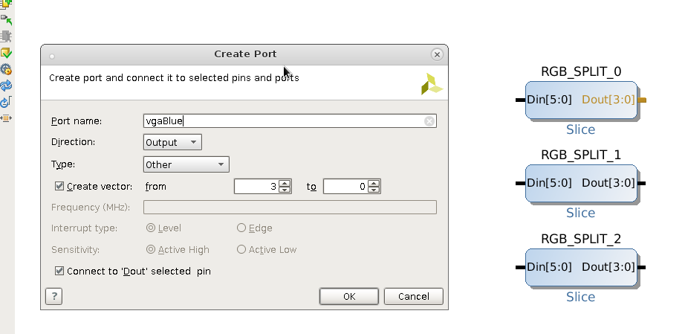

7. Expand VGA_INTF and connect the wires accordingly. Right click tft_vsync and tft_hsync and select make external.

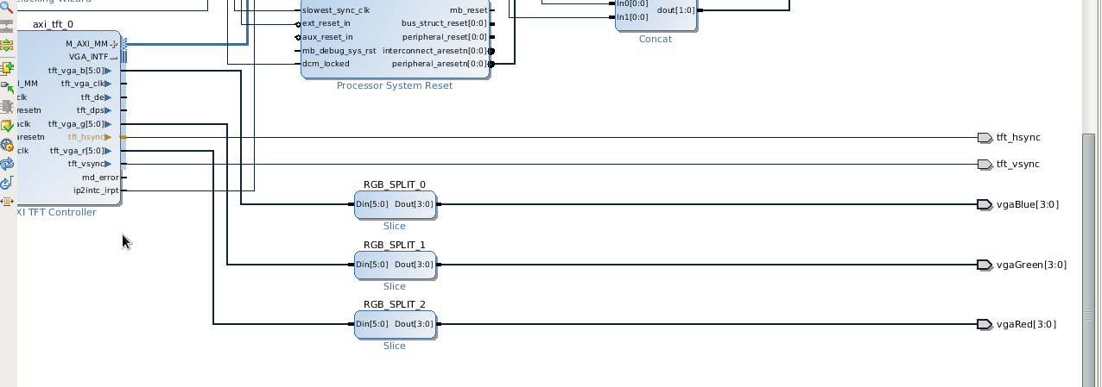

8. Click **Validate Design**. The complete design should look like:

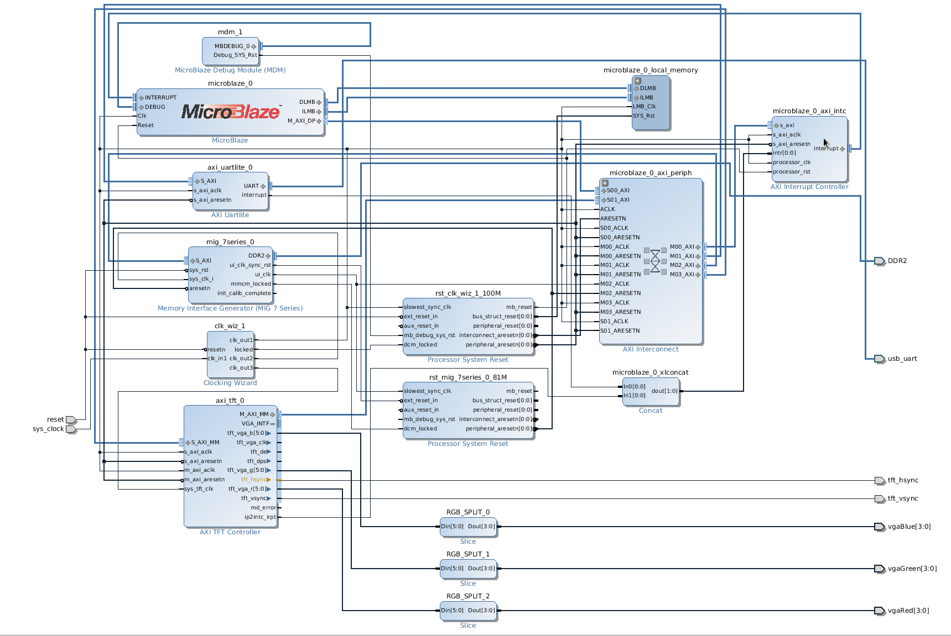

The Address Map should look like:

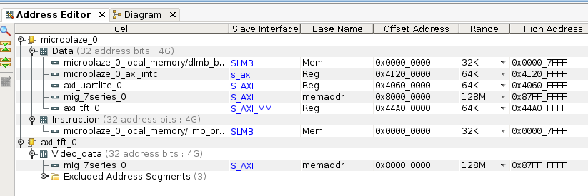

9. Create a new constraint file and enter the following port assignments. Also note to modify the external port names based on your design.

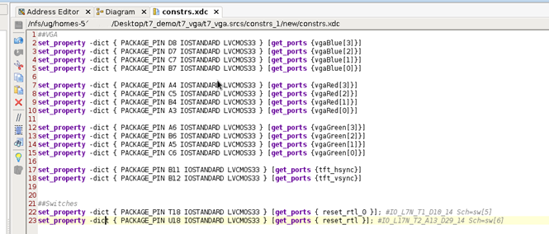

10. Create **HDL wrapper**.

11. **Generate** **bitstream**.

12. Export hardware – **include bitstream**. And then, launch SDK. Now, we finally finished the hardware setup and move to the software design, which is also very interesting.

**6. SDK Configuration**

1. Open SDK and create a new project (Xilinx Application). Make sure it is an **empty** application.

2. Right click the new project to create a new C source file and name it **main.c**.

3. Copy and paste the provided code into **main.c**. Try to understand the code. Make sure that the **TFT base address** and the **DDR2 base address** are matching to your hardware address.

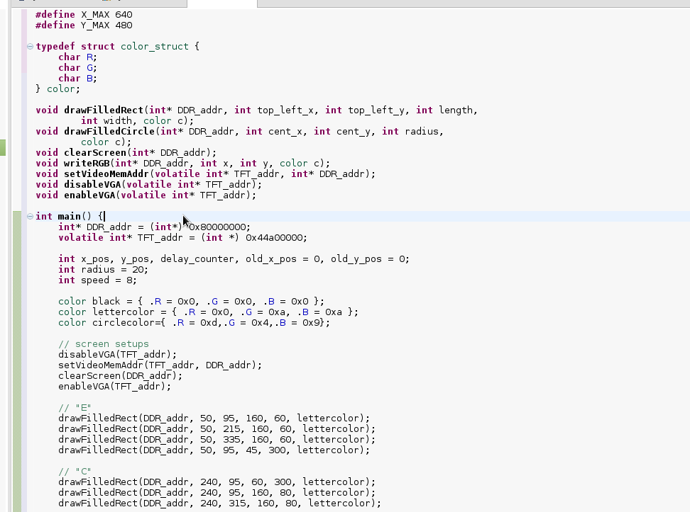

4. Open the **lscript.ld** (linker script) under src – change all Memory Region Mapping to local memory as shown.

5. Save the main.c and the linker file and build the program.

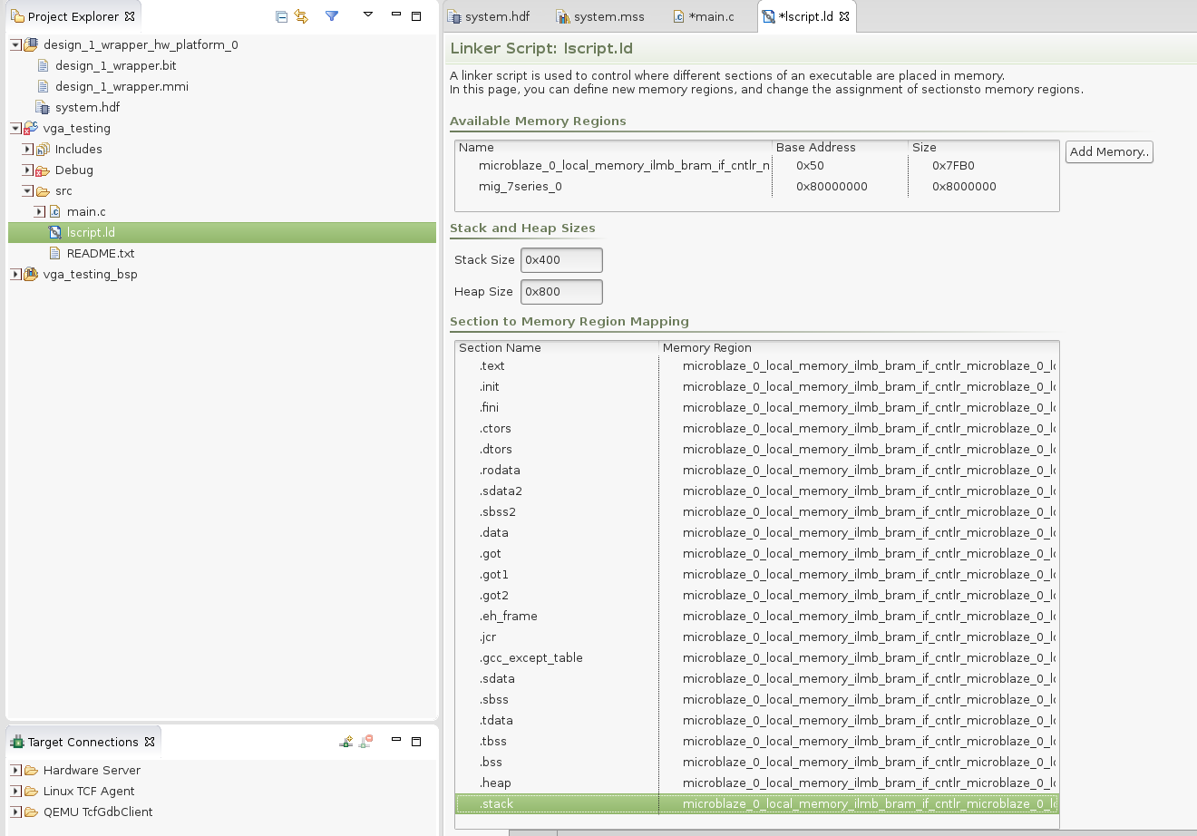

6. Program FPGA to load the hardware into the board.

7. Under Run, click Run configuration. Make SW5 active high or else the CPU will be in reset mode.

8. In **Target Setup**, search for your bitstream file. Choose **wrapper.bit** and click Ok.

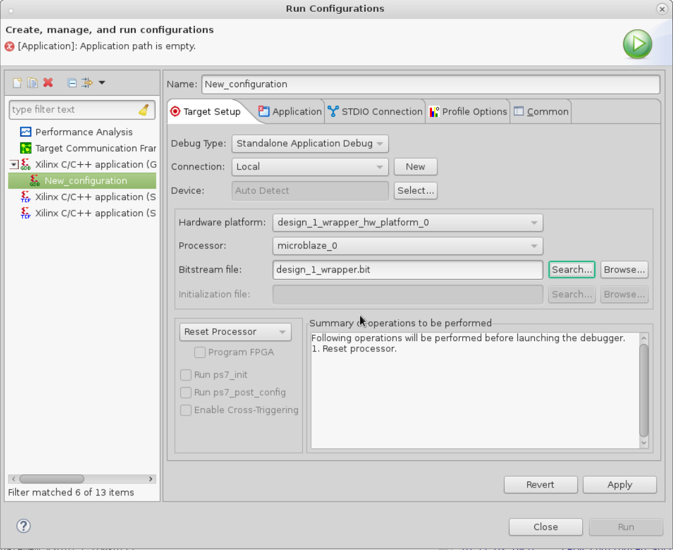

8. In **Application**, browse the Project Name and choose your project. In this example it is vga_testing. The Application file should be selected automatically under the Debug folder.

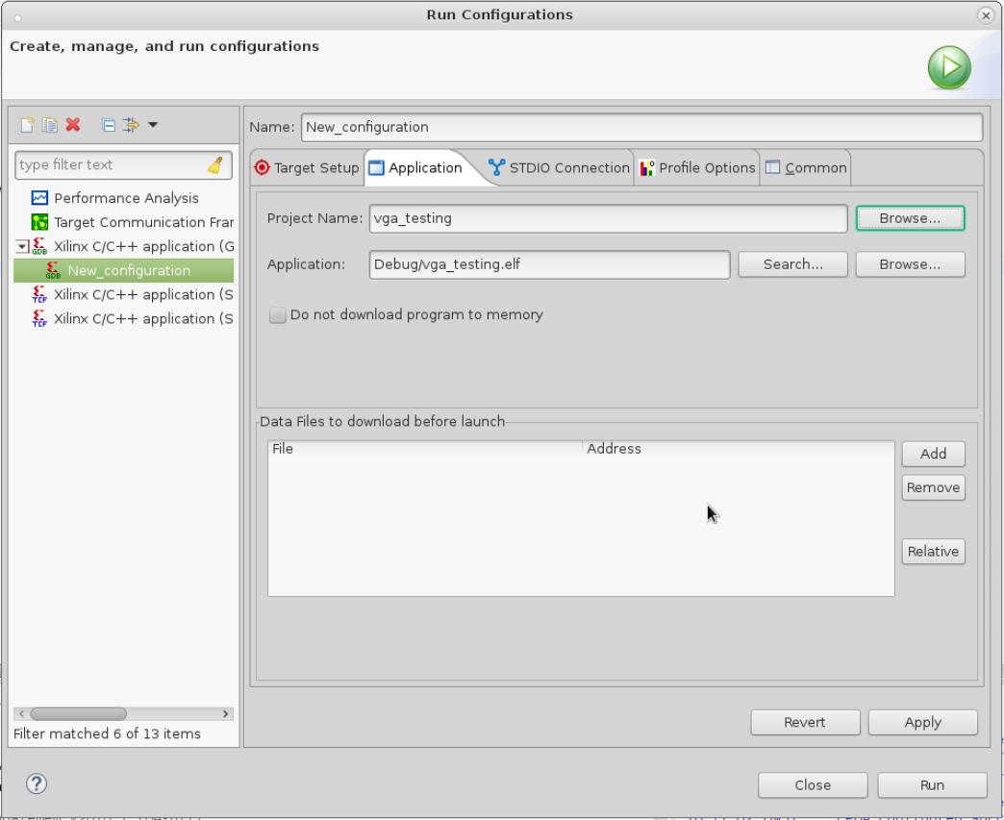

9. Go through the given source code (**main.c**) and try to draw some other shapes on the screen.

**Further notes on the AXI TFT CONTROLLER**

There are three registers that you must write to in order to configure the AXI TFT controller. The first is the address register, which is offset 0x00 from the address of the controller. Here you write the address of the memory space that the video memory is located. This is to allow the controller to access the video memory. Only the eleven most significant bits matter (but the memory space must be aligned to a 2M boundary)

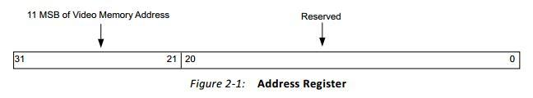

The other register is the TFT control register. Only the least two significant bits of this register are used to set the controller. Bit 0 is called the TDE bit. Writing ‘1’ to this location will enable the TFT display, while writing ‘0’ will disable it. Bit 1 is called the DPS bit. Writing ‘1’ to this location will case the scan direction of the screen to be reversed (rotates the screen by 180 degrees).Writing ‘0’ in this location will cause the normal display to be shown.

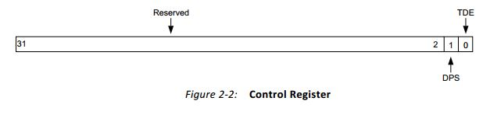

The last register that can be configured for use is the interrupt enable and status register (IESR). This register contains the VSYNC interrupt enable bit as well as the status bit. These two bits work together to switch frames after the current frame is already displayed. If the VSYNC interrupt is enabled, the core generates an interrupt for the VSYNC pulse of every frame. For every rising edge of the VSYNC pulse, the core sets status bit to indicate that the core has displayed the current frame completely and accepted the new address from the AR.

