Simulation Tutorial

Acknowledgement
This module is derived from a Xilinx lab on Xilinx website.

Goal
- Use Vivado simulator to perform behavioral, functional, or timing simulations
- Be able to use a C program in SDK to interact with the processor.
- Use some software debugging tools in an embedded processor environment.

Requirements
- Xilinx Vivado software
- Enough disk space for the project files

Source Files
For the purpose of this tutorial, all source files are provided

1. Create a Project
1. Choose RTL Project in Project Type box
2. Click Add Directories in Add Source dialog box and add the following
- <Extract_Dir>/sources
- <Extract_Dir>/sim
3. Set the Target Language to Verilog and Simulator Language to Mixed
4. Choose Nexys 4 board
5. Finish creating the projects

2. Adding IP from the IP Catalog
1. Click the '+' character in the Sources window to expand the folers as shown below
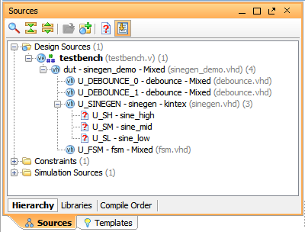

Notice that the Sine wave generator (sinegen.vhd) references cells that are not found in the current design sources. In the Sources window, the missing design sources are marked by the missing source icon.
You will now add the sine_high, sine_mid, and sine_low modules to the project from the
Xilinx IP Catalog.
Adding Sine High
1. In the Flow Navigator, select the IP Catalog button.
2. In the search field of the IP Catalog, type DDS.
The Vivado IDE highlights the DDS Compilers in the IP catalog.
3. Under any category, double-click the DDS Compiler.
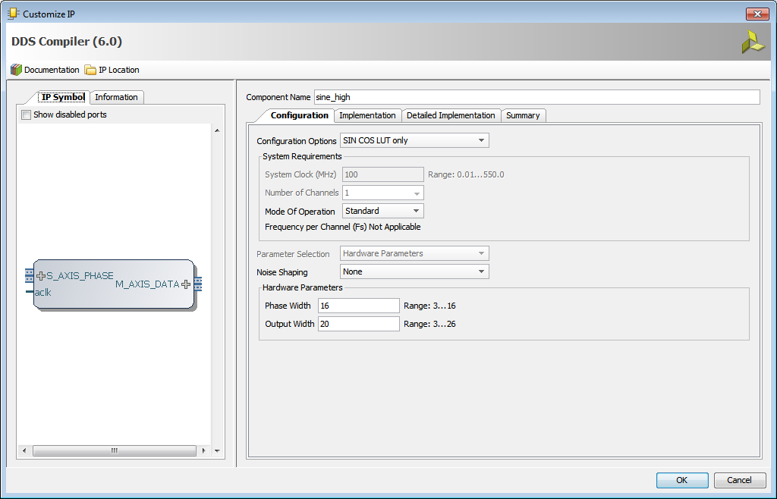
The Customize IP wizard opens.
4. In the IP Symbol on the left, ensure that Show Disabled Ports is unchecked.
5. Specify the following on the Configuration tab:
- Component Name: sine_high
- Configuration Options: SIN COS LUT only
- Noise Shaping: None
- Under Hardware Parameters, set Phase Width: 16, and Output Width: 20
6. On the Implementation tab, set Output Selection: Sine
7. On the Detailed Implementation tab, set Control Signals: ARESETn (active-Low)
8. Select the Summary tab, review the settings and click OK.
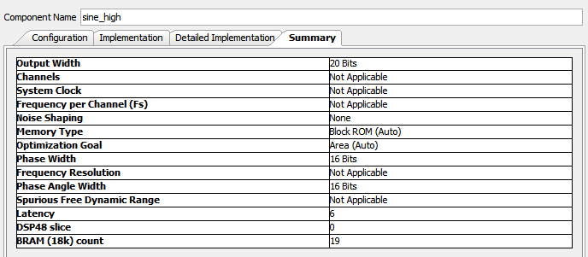
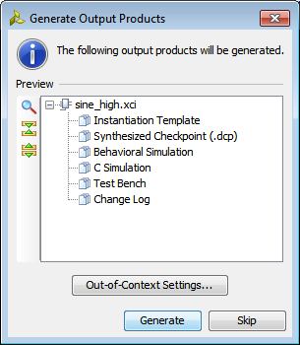
When the sine_high IP core is added to the design, the output products required to support the IP in the design must be generated. The Generate Output Products dialog box displays, as shown below.

9. ClickGenerate to generate the default output products for sine_high.

Adding Sine Mid
1. In the IP catalog, double-click the DDS Compiler IP a second time.
2. Specify the following on the Configuration tab:
- Component Name: sine_mid
- Configuration Options: SIN COS LUT only
- Noise Shaping: None
- Under Hardware Parameters, set Phase Width: 8, and Output Width: 18
3. On the Implementation tab, set Output Selection: Sine
4. On the Detailed Implementation tab, set Control Signals: ARESETn (active-Low)
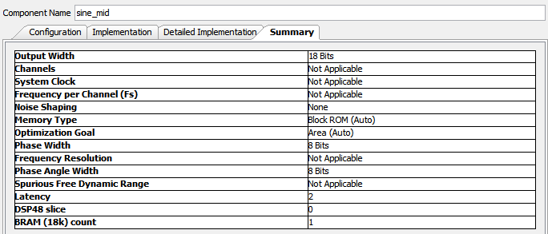
5. Select the Summary tab, review the settings and click OK.

When the sine_mid IP core is added to the design, the Generate Output Products dialog box displays to generate the output products required to support the IP in the design.
6. Click Generate to generate the default output products for sine_mid.

Adding Sine Low
1. In the IP catalog, double-click the DDS Compiler IP, for the third time.
2. Specify the following on the Configuration tab:
- Component Name: sine_low
- Configuration Options: SIN COS LUT only
- Noise Shaping: None
- Under Hardware Parameters, set Phase Width: 6, and Output Width: 16
3. On the Implementation tab, set Output Selection: Sine
4. On the Detailed Implementation tab, set Control Signals: ARESETn (active-Low)
5. Select the Summary tab, review the settings as seen below, and click OK.
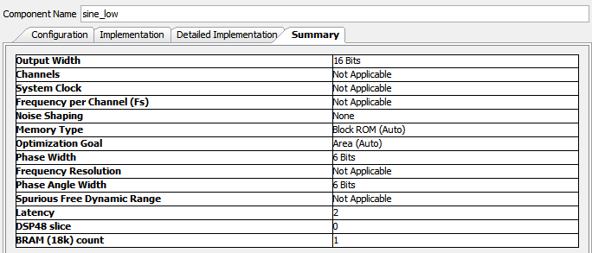

When the sine_low IP core is added to the design, the Generate Output Products dialog box displays to generate the output products required to support the IP in the design.
6. Click Generate to generate the default output products for sine_low.

3: Running Behavioral Simulation
After you have created a Vivado project for the tutorial design, you set up and launch Vivado simulator to run behavioral simulation. Set the behavioral simulation properties in Vivado:
1. In the Flow Navigator, click Simulation Settings. The following defaults are automatically set:
- Simulation set: sim_1
- Simulation top-module name: testbench
2. In the Compilation tab, ensure that the debug level is set to typical, which is the default value.
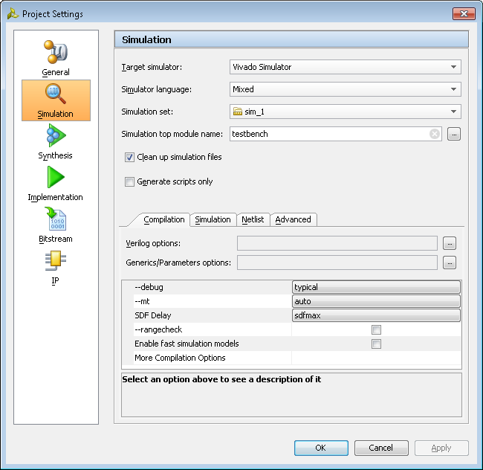

3. In the Simulation tab, observe that the Simulation Run Time is 1000ns.
4. Click OK.
With the simulation settings properly configured, you can launch Vivado simulator to
perform a behavioral simulation of the design.
5. In the Flow Navigator, click Run Simulation >Run Behavioral Simulation.

Functional and timing simulations are available post-synthesis and post-implementation.
Those simulations are outside the scope of this tutorial.
When you launch the Run Behavioral Simulation command, the Vivado tool runs xelab in
the background to elaborate and compile the design into a simulation snapshot, which the Vivado simulator can run. When that process is complete, the Vivado tool launches xsim to run the simulation.
In the Vivado IDE, the simulator GUI opens after successfully parsing and compiling the design. By default, the top-level HDL objects display in the Waveform window.
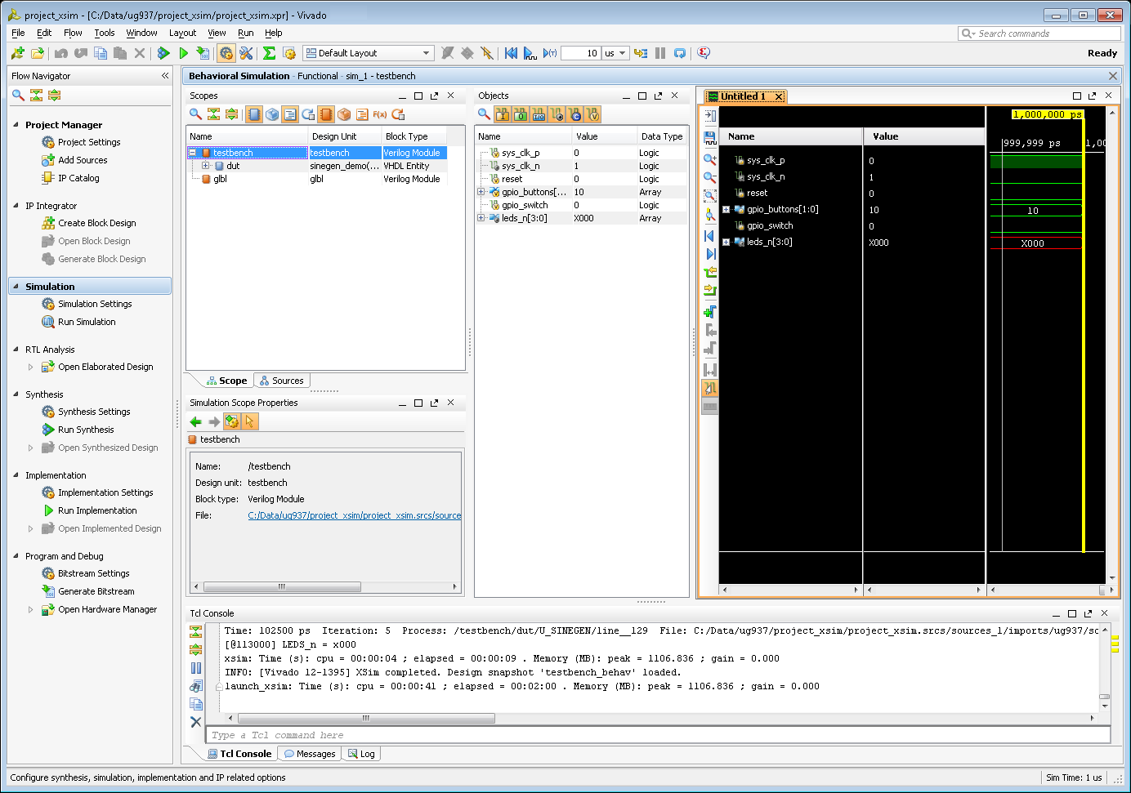

Debugging the Project

1: Opening the Project
1. click File > Open Recent Project and select the project_xsim project you saved in Lab #1.
2. After the project has opened, from the Flow Navigator click Run Simulation > Run Behavioral Simulation.
The Vivado simulator compiles your design and loads the simulation snapshot.

2: Displaying Signal Waveforms
In this section, you examine features of the Vivado simulator GUI that help you monitor signals and analyze simulation results, including:
• Running and restarting the simulation to review the design functionality, using signals in the Waveform window, and messages from the testbench shown in the Tcl console.
• Adding signals from the testbench and other design units to the Waveform window so you can monitor their status.
• Adding groups and dividers to better identify signals in the Waveform window.
• Changing signal and wave properties to better interpret and review the signals in the Waveform window.
• Using markers and cursors to highlight key events in the simulation and to perform zoom and time measurement features.
• Using multiple waveform configurations.
Add and Monitor Signals
The focus of the tutorial design is to generate sine waves with different frequencies. To observe the function of the circuit, you will monitor a few signals from the design. Before running simulation for a specified time, you can add signals to the wave window to observe the signals as they transition to different states over the course of the simulation. By default, the Vivado simulator adds simulation objects from the testbench to the Waveform window. In the case of this tutorial, the following testbench signals load automatically:
• Differential clock signals: sys_clk_p and sys_clk_n: This is a 200 MHz clock generated by the testbench, and is the input clock for the complete design.
• Reset signal (reset): Provides control to reset the circuit.
• GPIO buttons (gpio_buttons[1:0]): Provides control signals to select different frequency sine waves.
• GPIO switch (gpio_switch): Provides a control switch to enable or disable debouncer logic.
• LEDs (leds_n[3:0]): A place holder bus to display the results of the simulation. You will add some new signals to this list to monitor those signals as well.
1. In the Scopes window, click the ‘+’ sign to expand the testbench.
An HDL scope, or scope, is defined by a declarative region in the HDL code such as a module, function, task, process, or begin-end blocks in Verilog. VHDL scopes include entity/architecture definitions, block, function, procedure, and process blocks.
2. In the Scopes window, click to select the dut object. The current scope of the simulation changes from the whole testbench to the selected object. The Objects window updates with all the signals and constants of the selected scope.
3. From the Objects window, select signals sineSel[1:0] and sine[19:0] and add them
into Wave Configuration window using one of the following methods:
• Drag and drop the selected signals into the Waveform window.
• Right-click on the signal to open the popup menu, and select Add to Wave Window.
Note: You can select multiple signals by holding down the CTRL key during selection.
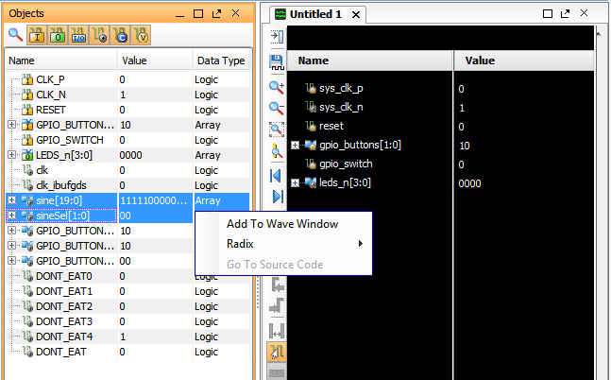

Step 3: Using the Analog Wave Viewer
The sine[19:0] signals you are monitoring are analog signals, which you can view better in Analog wave mode. You can choose to display a given signal as Digital or Analog in the Waveform window.
1. In the Waveform window, select the sine[19:0] signal.
2. Right click to open the popup menu, and select Waveform Style > Analog.
3. Right click to open the popup menu again, and set Radix > Signed Decimal.
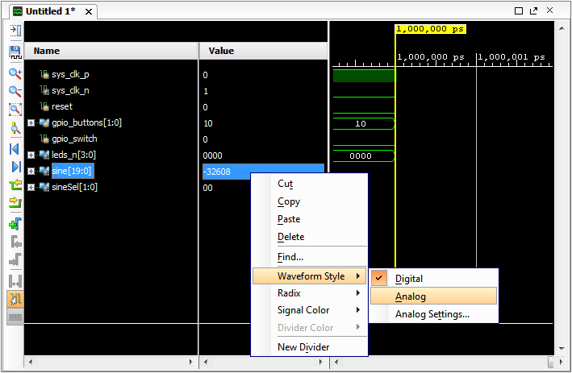

Logging Waveforms for Debugging
The Waveform window lets you review the state of multiple signals as the simulation runs. However, due to its limited size, the number of signals you can effectively monitor in the Waveform window is limited. To identify design failures during debugging, you might need to trace more signals and objects than can be practically displayed in the Waveform window. You can log the waveforms for signals that are not displayed in the Waveform window, by writing them to the simulation waveform database (WDB). After simulation, you can review the transitions on all signals captured in the waveform database file.
1. Enable logging of the waveform for the specified HDL objects by entering the following command in the Tcl console:
log_wave [get_objects /testbench/dut/*] [get_objects /testbench/dut/U_SINEGEN/*]
This command enables signal dumping for the specified HDL objects, /testbench/dut/* and /testbench/dut/U_SINEGEN/*.

The log_wave command writes the specified signals to a waveform database, which is written to the simulation folder of the current project:
<project_name>/<project_name>.sim/sim_1/behav

4: Working with the Waveform Window
Now that you have configured the simulator to display and to log signals of interest in the
waveform database, you are ready to run the simulator again.
1. Run the simulation by clicking the Run All button.
Observe the sine signal output in the waveform. The Wave Window can be undocked from Main window layout to view it as standalone.
2. Click the Float icon in the left top corner of the waveform configuration window.
3. Display the whole time spectrum in the Waveform window, by clicking the Zoom Fit button.
Notice that the low frequency sine output is incorrect. You can view the waveform in detail by zooming into the Waveform window. When you are zoomed into the waveform, you can use the horizontal and vertical scroll bars to pan down the full waveform.
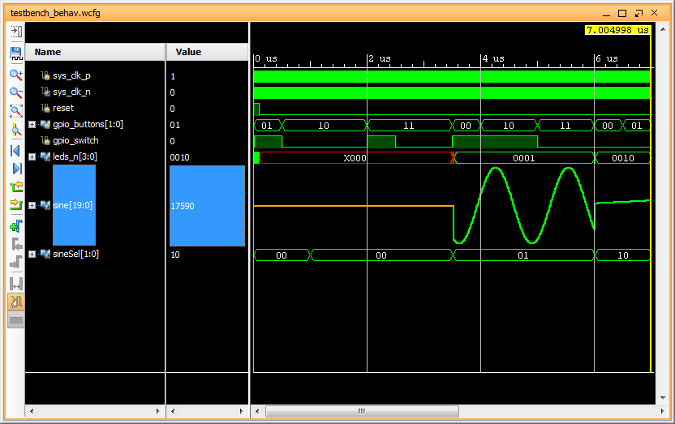

When the value of sineSel is 00, which indicates a low frequency sine selection, the analog sine[19:0] output is not a proper sine wave, indicating a problem in the design or testbench.
Grouping Signals
Now you will add signals from other design units to better analyze the functionality of the whole design. When you add signals to the Waveform window, the limited size of the window makes it difficult to display all signals at the same time. Reviewing all signals would require the use of the vertical scroll bar, making the review process difficult.
You can group related signals together to make viewing them easier. With a group, you can display or hide associated signals to make the Waveform window less cluttered, and easier to understand.
1. In the Waveform window, select all signals in the testbench unit: sys_clk_p, sys_clk_n, reset, gpio_buttons, gpio_switch, and leds_n.
Note: Press and hold the Ctrl key, or Shift key, to select multiple signals.
2. With the signals selected right-click to open the popup menu and select New Group. The Name dialog box opens to let you specify the name of the signal group to create.
3. Type TB Signals as the name of this signal group, and click OK.
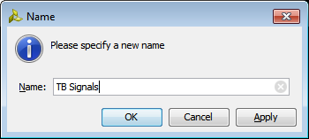

Vivado simulator creates a collapsed group in the waveform configuration window. To expand the group, click the ‘+’ to the left of the group name.
4. Create another signal group called DUT Signals to group signals sine[19:0] and
sine_sel[1:0].
You can add signals to a group, or remove signals from a group as needed. Cut and paste signals from the list of signals in the Waveform window, or drag and drop a signal from one group into another. You can also drag and drop a signal from the Objects Window into the Waveform window, or into a group.
You can ungroup all signals, thereby eliminating the group. Select a group, right-click to
open the popup menu, and select Ungroup. To better visualize which signals belong to which design units, add dividers to separate the signals by design unit.

Adding Dividers
Dividers let you create visual breaks between signals, or groups of signals, to more easily identify related objects.
1. In the Waveform window, right-click to open the popup menu and select New Divider.
The Name dialog box opens to let you name the divider you are adding to the Waveform window.
2. Add two dividers named:
- Testbench
- SineGen
3. Click and drag the Testbench divider above the TB Signals group.
4. Move the SineGen divider above the DUT Signals group.
Adding Signals from Sub-modules
You can also add signals from different levels of the design hierarchy to study the interactions between these modules and the testbench. The easiest way to add signals from a sub-module is to filter objects and then select the signals to add to the Waveform view.
You will add signals from the instantiated sine_gen_demo module (DUT), and the sinegen module (U_SINEGEN).
1. In the Scopes window, select and expand the testbench, then select and expand DUT. Simulation objects associated with the currently selected scope display in the Objects window.
By default, all types of simulation objects display in the Objects window. However, you can limit the types of objects displayed by selecting the object filters at the top of the Objects window. The figure below shows the Objects window with the Input and Output port objects enabled, and the other object types are disabled. Move the cursor to hover over a button to see the tooltip for the object type.
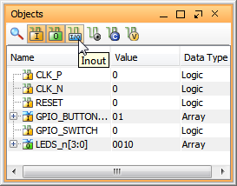

2. Use the Objects window toolbar to enable and disable the different object types.
The types of objects that can be filtered in the Objects window include Input, Output, Inout ports, Internal Signals, Constants, and Variables.
3. In the Scopes window, select the U_SINEGEN design unit.
4. In the Waveform window, right-click beneath the SineGen divider, and use the New Group command to create three new groups called Inputs, Outputs, and Internal Signals.
5. In the Objects window, select the Input filter to display the Input objects.
6. Select the Input objects in the Objects window, and drag and drop them onto the Input group you created in the Waveform window.
7. Repeat step 5 and 6 above to filter the Output objects and drag them onto the Output group, and filter the Internal Signals and drag them onto the Internal Signals group.
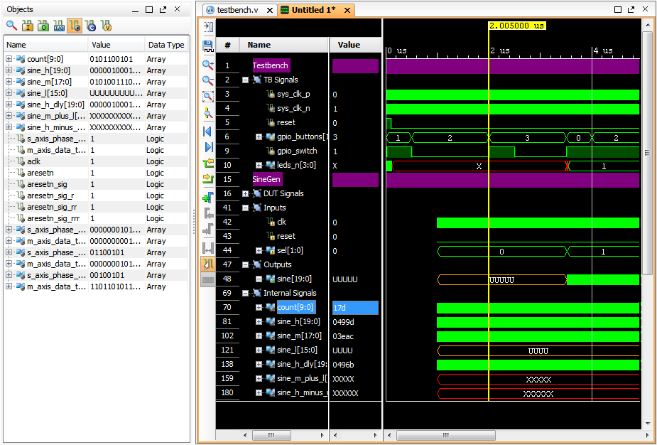

Step 5: Changing Signal Properties
You can also change the properties of some of the signals shown in the Waveform window to better visualize the simulation results.
Viewing Hierarchical Signal Names
By default, the Vivado simulator adds signals to the waveform configuration using a short name with the hierarchy reference removed. For some signals, it is important to know to which module they belong.
1. In the Waveform window, hold Ctrl and click to select the sine[19:0] and sineSel[1:0] signals listed in the DUT group, under the SineGen divider.

2. Hold Ctrl, and click to select the sine[19:0] signals listed in the Outputs group, under the SineGen divider.
3. Right-click in the Waveform window to open the popup menu, and select the Name > Long command.
The displayed name changes to include the hierarchical path of the signal. You can now see by looking that the sine[19:0] signals under the DUT Signals group refers to different objects in the design hierarchy than the sine[19:0] signals listed under the Outputs group.
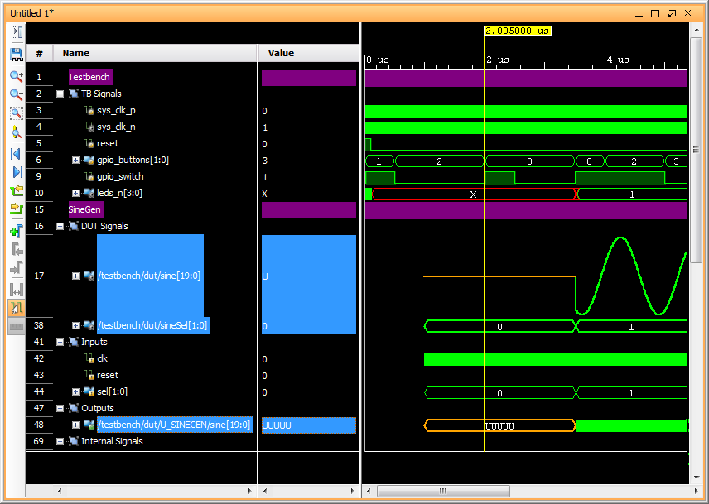

Viewing Signal Values
You can understand some signal values more clearly, if they display in a different radix format than the default, for instance, hexadecimal values instead of binary values. The default radix is binary, unless you override the radix for a specific object.
Supported radix values are default, binary, hexadecimal, octal, ASCII, signed and unsigned decimal, and real.
1. In the Waveform window select the following signals:
s_axis_phase_tdata_sine_high, s_axis_phase_tdata_sine_mid and
s_axis_phase_tdata_sine_low.
2. Right-click to open the popup menu, and select Radix > Hexadecimal.
The values on these signals now display using the specified radix.

Step 6: Saving the Waveform Configuration
You can customize the look and feel of the Waveform window, and then save the Waveform configuration to reuse in future simulation runs. The Waveform configuration file defines the displayed signals, and the display characteristics of those signals.
1. In the Waveform window, click the Options button on the sidebar menu. The Waveform Options dialog box opens to the General tab.
2. Ensure the Default Radix is set to Binary. This defines the default number format for all signals in the Waveform window. The radix can also be set for individual objects in the Waveform window to override the default.
3. Select the Draw Waveform Shadow to enable or disable the shading under the signal waveform.
By default, a waveform is shaded under the high transitions to make it easier to recognize the transitions and states in the Waveform window.
You can also enable or disable signal indices, so that each signal or group of signals is identified with an index number in the Waveform window.
4. Check or uncheck the Show Signal Indices checkbox to enable or disable the signal list numbering.
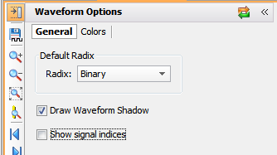

5. In the Waveform Options dialog box, select the Colors view.
Examine the Waveform Color Options dialog box. You can configure the coloring for elements of the Waveform window to customize the look and feel. You can specify custom colors to display waveforms of certain values, so you can quickly identify signals in an unknown state, or an uninitialized state. With the Waveform window configures with your preferences, you can save the current waveform configuration so it is available for use in future Vivado simulation sessions.
By default, the Vivado simulator saves the current waveform configuration setting as testbench_behav.wcfg.
6. In the Waveform window sidebar menu, select the Save Wave Configuration button.
7. Save the Wave Configuration into the project folder with the filename tutorial_1.wcfg.

When saving the waveform configuration file, you are prompted to add this file to your
current project, as seen below.
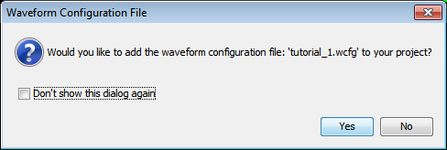

8. Click Yes, the file is added to the project simulation fileset, sim_1, for archive purposes.

7: Re-Simulating the Design
With the various signals, signal groups, dividers, and attributes you have added to the Waveform window, you are now ready to simulate the design again.
1. Click the Restart button to reset the circuit to its initial state.
2. Click the Run All button.
The simulation runs for about 705ns. If you do not Restart the simulator prior to Run All, the simulator will run continuously until interrupted.
3. After the simulation is complete, click the Zoom Fit button to see the whole simulation timeline in the Waveform window.
The following shows the current simulation results.
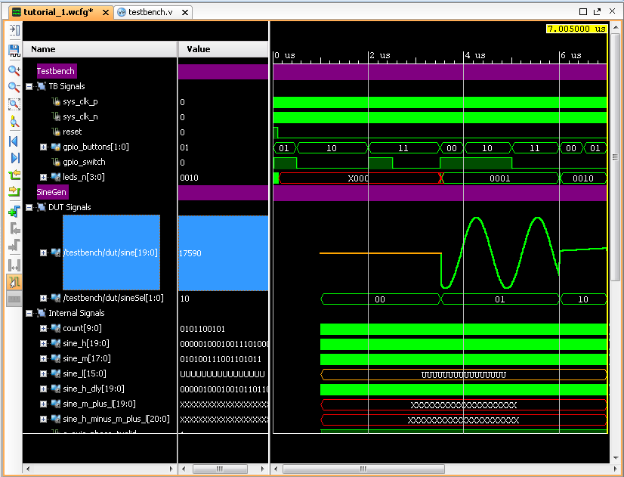

8: Using Cursors, Markers, and Measuring Time
The Finite State Machine (U_FSM) module used in the top-level of the design generates three different sine-wave select signals for specific outputs of the SineGen block. You can identify these different wave selections better using Markers to highlight them.
1. In the Waveform window select the /testbench/dut/sineSel[1:0] signal.
2. In the waveform sidebar menu, click the Go to Time 0 button.
The current marker moves to the start of the simulation run.
3. Enable the Snap to Transition button to snap the cursor to transition edges.
4. From the waveform sidebar menu, click the Next Transition button.
The current marker moves to the first value change of the selected sineSel[1:0] signal, at 1 microsecond.
5. Click the Next Transition button again and the marker moves to 3.5225 microseconds.
6. Click the Add Marker button
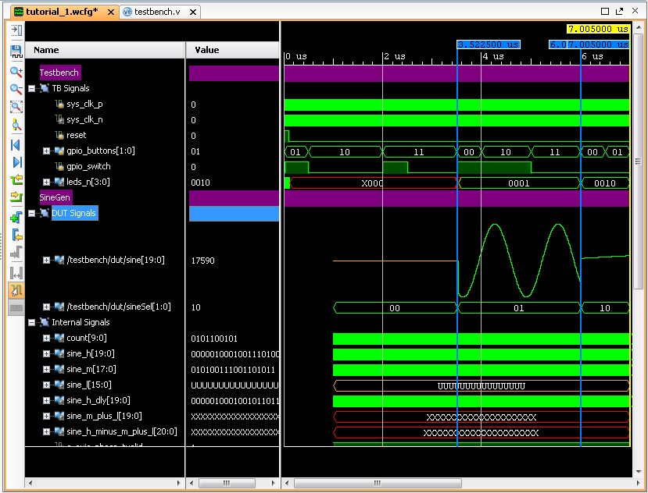

7. Search for all transitions on the sineSel signal, and add markers at each one. With markers identifying the transitions on sineSel, the Waveform window should look similar to the figure. As previously observed, the low frequency signals are incorrect when the sinSel signal value is 00. You can also use the main Waveform window cursor to navigate to different simulation times, or locate value changes. In the next steps, you use this cursor to zoom into the Waveform window when the sineSel is 00, to review the status of the output signal, sine[19:0], and identify where the incorrect behavior initiates. You will also use the cursor to measure the period of low frequency wave control.
8. In the Waveform window, click and drag the cursor from time 0 to zoom into the beginning of the simulation run.
9. Continue to zoom in the Waveform window as needed, until you can see the reset signal asserted low, and you can see the waveform of the clock signals, sys_clk_p and sys_clk_n, as seen below.
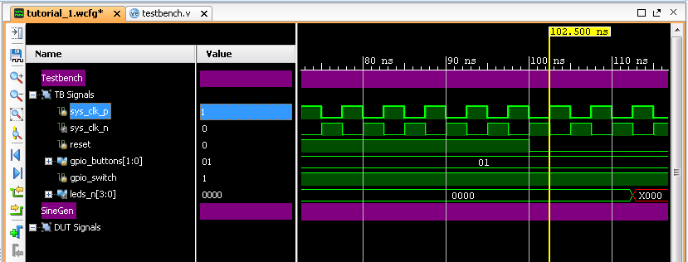

You can also zoom in to view the waveform more closely by repeatedly clicking the Zoom In button until you achieve the zoom needed to see the details of the signal. The Waveform window zooms in or out around the area centered on the cursor.
10. Place the main Waveform window cursor on the area by clicking at a specific time or point in the waveform.
You can also click on the main cursor, and drag it to the desired time.
11. Because 00 is the initial or default FSM output, move the cursor to the first posedge of sys_clk_p after reset is asserted low, at time 102.5 ns. You can use the Waveform window to measure time between two points on the timeline.
12. Place a marker at the time of interest, 102.5 ns, by clicking the Add Marker button.
13. Click to select the marker.
The Floating Ruler button displays a ruler at the bottom of the Waveform window useful for measuring time between two points. Use the floating ruler to measure the sineSel control signal period, and the corresponding output_sine[19:0] values during this time frame.
When you select the marker, a floating ruler opens at the bottom of the Waveform window, with time 0 on the ruler positioned at the selected marker. As you move the cursor along the timeline, the ruler measures the time difference between the cursor and the marker.
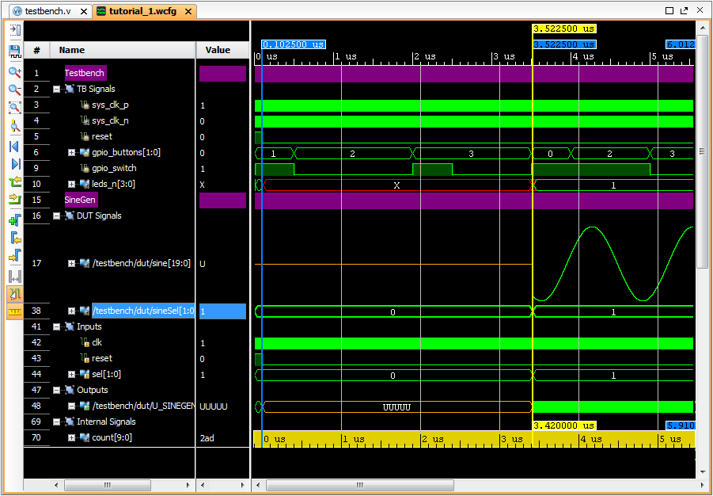
You can move the cursor along the timeline in a number of ways. You can scroll the horizontal scroll bar at the bottom of the Waveform window. You can zoom out, or zoom fit to view more of the time line, reposition the cursor as needed, and then zoom in for greater detail.
14. Select sineSel from the list of signals in the Waveform window, and use the Next Transition command to move to the specific transition of interest.
As shown in the figure, the ruler measures a time period of 3.420 ns as the period that FSM selected the low frequency output.

9: Debugging with Breakpoints
You have examined the design using cursors, markers, and multiple Waveform windows. Now you will use Vivado simulator debugging features, such as breakpoints, and line stepping, to debug the design and identify the cause of the incorrect output.
First, open the tutorial design testbench to learn how the simulator generates each design input.
1. Open the testbench.v file by double-clicking on the file in the Sources window, if it is not already open.
The source file opens in the Vivado IDE Text Editor.
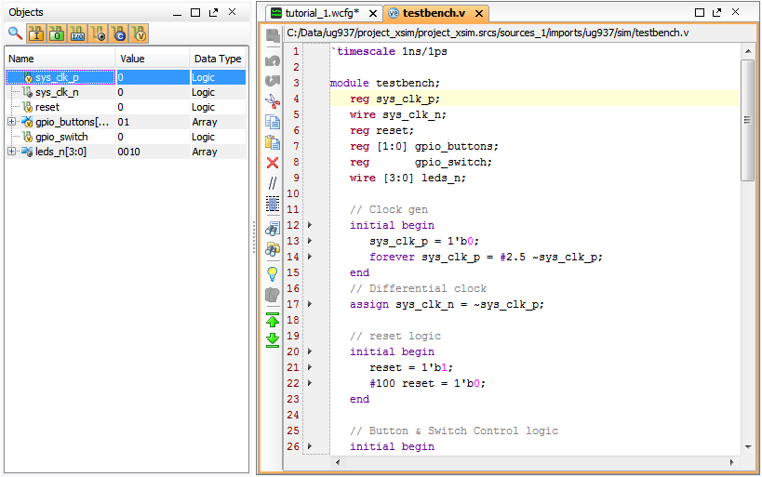

Note: You can also use File > Open File from the main menu, or Open File from the popup menu in the Sources window. You can also select an appropriate design object in the Scopes window or Objects window, right-click and select Go to Source Code.

Using Breakpoints
A breakpoint is a user-determined stopping point in the source code used for debugging the design. When simulating a design with set breakpoints, simulation of the design stops at each breakpoint to verify the design behavior. After the simulation stops, an indicator shows in the text editor next to the line in the source file where the breakpoint was set, so you can compare the Wave window results with a particular event in the HDL source.
You will use breakpoints to debug the error with the low frequency signal output that you previously observed. The erroneous sine[19:0] output is driven from the sineGen VHDL block. Start your debugging with this block.
Select the U_SINEGEN 1. scope in the Scopes window, to list the objects of that scope in the Objects window.
2. In the Objects window, right-click on sine[19:0], and use Go to Source Code to open the sinegen.vhd source file in the Text Editor.
Looking through the HDL code, the clk, reset, and sel inputs are correct as expected. Set your first breakpoint after the reset asserts low at line 137.
3. Scroll to line 137 in the file. Add a breakpoint at line 137 in sinegen.vhd. Note that the breakpoint can be set only on the executable lines. Vivado simulator marks the executable lines using an arrowhead symbol on the left hand margin in the Text Editor, along with the line numbers. Setting a breakpoint causes the simulator to stop at that point, every time the simulator processes that code, or every time the counter is incremented by one.
4. Click the arrowhead in the left margin, to set a breakpoint. Observe that the symbol changes to a to indicate that a breakpoint is set on this line.
You can remove a breakpoint by clicking on the red dot to revert it to an arrowhead.
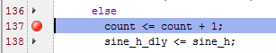
Note: To delete all breakpoints in the file, right-click on one of the breakpoints, and select Delete All Breakpoints. Debugging in the Vivado simulator, with breakpoints and line stepping, works best when
you can view the Tcl Console, the Waveform window, and the HDL source file at the same time.
5. Resize the windows, and use the window Float command, or the New Vertical Group command, to arrange the various windows so that you can see them all.
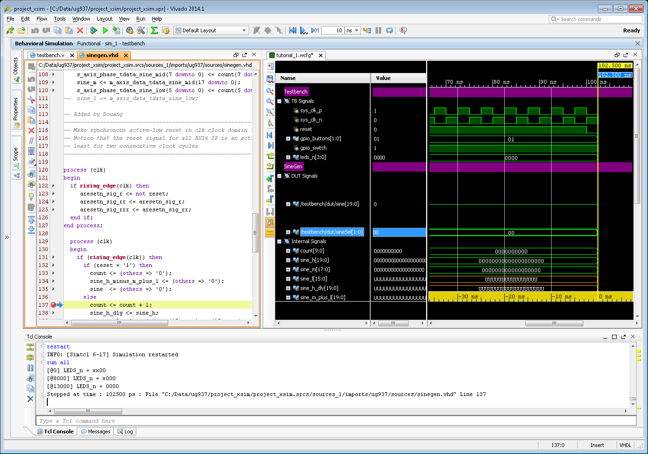
6. Click the Restart button to restart the simulation from time 0.
7. Run the simulation by clicking the Run All button.
The simulation runs to time 102.5 ns, or near the start of first counting, and stops at the breakpoint at line 137. The focus within the Vivado IDE changes to the Text Editor, where it shows the breakpoint indicator and highlights the line.
A message also displays in the Tcl console to indicate that the simulator has stopped at a specific time, displayed as picoseconds, indicating the line of source code last executed by the simulator.
8. Continue the simulation by clicking the Run All button.
The simulation stops again at the breakpoint. Take a moment to examine the values in the Waveform window. Notice that the sine[19:0] signals in the Outputs group are uninitialized, as are the sine_l[15:0] signals in the Internal signals group.
9. In the Text Editor, add another breakpoint at line 144 of the sinegen.vhd source file.
This line of code runs when the value of sel is 00. This code assigns, with bit extension, the low frequency signal, sine_l, to the output, sine.
10. In the Waveform window, select sine_l[15:0] in the Internal Signals group, and holding Ctrl, select sine[19:0] in the Outputs group. These selected signals are highlighted in the Waveform window, making them easier for you to monitor.
11. Run the simulation by clicking the Run All button.
Once again, the simulation stops at the breakpoint, this time at line 144.
Stepping Through Source Code
Another useful Vivado simulator debug tool is the Line Stepping feature. With line stepping, you can run the simulator one-simulation unit (line, process, task) at a time. This is helpful if you are interested in learning how each line of your source code affects the results in simulation.
Step through the source code line-by-line, and examine how the low frequency wave is selected, and whether the DDS compiler output is correct.
1. On the Vivado simulator toolbar menu, click the Step button.
The simulation steps forward to the next executable line, in this case in another source file. The fsm.vdh file is opened in the Text Editor. You may need to relocate the Text Editor to let you see all the windows as previously arranged.
Note: You can also type the step command at the Tcl prompt.
2. Continue to Step through the design, until the code returns to line 144 of sinegen.vhd. You have stepped through one complete cycle of the circuit. Notice in the Waveform window that while sel is 00, signal sine_l is assigned as a low frequency sine wave to the output sine. Also notice that sine_l remains uninitialized.
3. For debug purposes, initialize the value of sine_l by entering the following add_force command in the Tcl console:
add_force /testbench/dut/U_SINEGEN/sine_l 0110011011001010
This command will force the value of sine_l into a specific known condition, and can provide a repeating set of values to exercise the signal more vigorously if needed.
4. Continue the simulation by clicking the Run All button a few more times.
In the Waveform window notice that the value of sine_l[15:0] is now set to the value specified by the add_force command, and this value is assigned to the output signal sine[19:0], since the value of sel is still 00. Trace the sine_l signal in the HDL source files, and identify the input for sine_l.
5. In the Text Editor, use the Find in files button to search for sine_l.
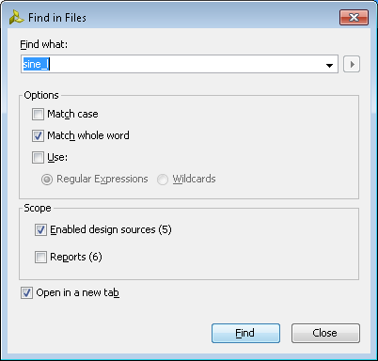
6. Select the Match whole word checkbox, and Enabled design sources, and click OK.

The Find in Files results display at the bottom of the Vivado IDE, with all occurrences of sine_l found in sinegen.vhd.
7. Expand the Find in Files results to view the results in the sinegen.vhd file.
The second result, on line 111, identifies the problem with the design. At line 111 in the sinegen.vhd file, the m_axis_data_tdata_sine_low signal is assigned to sine_l. Since line 111 is commented out, the sine_l signal is not connected to the low frequency DDS compiler output, or any other input.
8. Uncomment line 111 in the sinegen.vhd file, and click the Save File button.
9. In the Tcl Console, remove the force on sine_l: remove_forces -all

10: Re-launch Simulation
By using breakpoints and line stepping, you identified the problem with the low frequency output of the design, and corrected it.
Since you modified the source files associated with the design, you must recompile the HDL source and build new simulation snapshot. Not just restarting the simulation at time 0 in this case, but rebuilding the simulation from scratch.
1. In sinegen.vhd, select one of the breakpoints, right-click and select Delete All Breakpoints.
2. Click the Re-launch button on the main toolbar menu. The Vivado IDE prompts you to confirm re-launching the simulator.
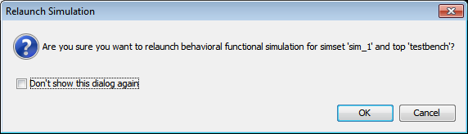

3. Click OK to continue.
Note: If prompted to save the Wave Config file, click yes. The Vivado simulator recompiles the source files with xelab, and re-creates the simulation snapshot. Now you are ready to simulate with the corrected design files.
4. Click the Run All button to run the simulation.
Observe the sine[19:0], the final sine wave output signal in the waveform configuration.
The low frequency sine wave looks as expected.
The Tcl console results are:
[@3518000] LEDS_n = 0100
[@3523000] LEDS_n = 0001
[@3523000] LEDS_n = 0001
[@6008000] LEDS_n = 0101
[@6013000] LEDS_n = 0010
[@6013000] LEDS_n = 0010
$finish called at time : 7005 ns : File "ug937/sim/testbench.v" Line 63
