Using the Embedded MicroBlaze Processor
Acknowledgement
This module is derived from labs developed by Xilinx.
Goal
- Use the Vivado tool to build a basic MicroBlaze system. This will consist of a MicroBlaze processor, on-chip memory, GPIO, and a UART.
- Be able to use a C program in the SDK to interact with the processor.
- Use some software debugging tools in an embedded processor environment.

Requirements
- Xilinx Vivado software
- Xilinx SDK software
- Xilinx Nexys 4 DDR board and a programming cable
- Enough disk space for the project files

Background
Soft processors, such as MicroBlaze, are implemented using programmable logic (FPGA LUTs and registers) and can be custom configured to suit the software application they run. In contrast, hard processors, such as the Intel i7 CPU, are implemented as application-specific integrated circuits (ASICs), and their functions are fixed after manufacture. Soft processors are common in embedded systems built with FPGAs, and they usually provide high-level control logic for the system. They can be quickly and easily programmed with a C-based language, and have the advantage of customization. For example, the user can choose between various instruction and data caches, as well as choose to include custom instructions for faster execution of an application.

Introduction
In this tutorial you will create a simple MicroBlaze system for an Artix-7 FPGA using the Vivado IP integrator.
The MicroBlaze system includes native Xilinx IP such as the:
- MicroBlaze processor
- AXI Timer
- UARTLite
- Debug Module (MDM)
- Proc Sys Reset
- Interrupt Controller
- Local memory bus (LMB)
These are the basic building blocks used in a typical MicroBlaze system.
In addition to creating the system described above, this tutorial also describes the development of a small application that you develop in the Xilinx Software Development Kit (SDK) in the Vivado Design Suite. The application code developed in the SDK prints “Hello World” on a terminal.
This tutorial targets the Xilinx Nexys 4 DDR FPGA Evaluation Board, and uses the 2016.2 version of Vivado Design Suite.

1. Create a Project
1. Invoke the Vivado IDE
2. From the Getting Started page, select Create New Project
3. In the Project Name dialog box, type the project name and location.
4. In the Project Type dialog box, select RTL Project.
5. In the Add Sources dialog box, ensure that the Target language is set to Verilog.
6. Click Next in the Add Constrains and Add Existing IP dialog box
7. Choose xc7a100tcsg324-1 in the Default Part dialog box.
8. Click Finish to finish creating the project.

2. Create an IP Integrator Design
1. From Navigator > IP Integrator, select Create Block Design
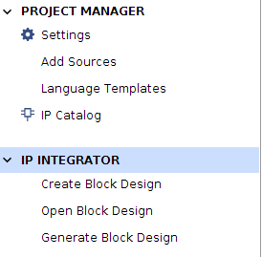

2. Specify the design name and click OK.
3. Right click anywhere in the Diagram and select Add IP.
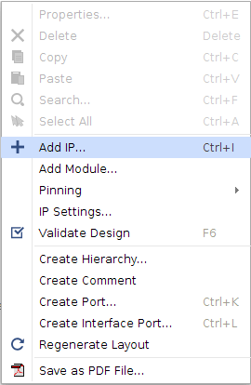

4. In the Search field, type microblaze to find the MicroBlaze IP, then click Enter.
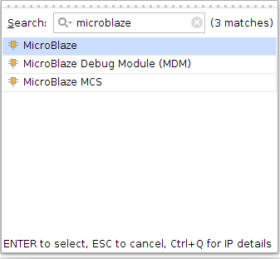

Customize the MicroBlaze Processor
1. In the Diagram view, click the Run Block Automation link beside Designer Assistance available
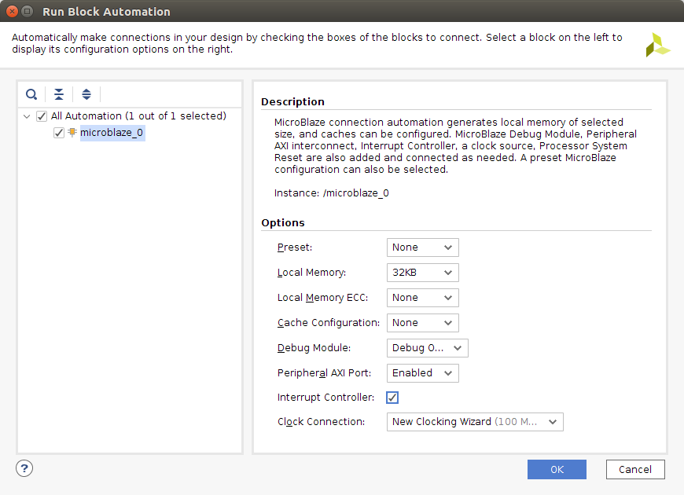

2. From the pulldown menu, set Local Memory to 32 KB.
3. Leave the Debug Module option to its default state Debug Only.
4. Leave the Peripheral AXI Port option as Enabled.
5. Check the Interrupt Controller option.
6. Select the Clock Connection option of New Clocking Wizard (100 Mhz). This will create a clock signal in the block design.
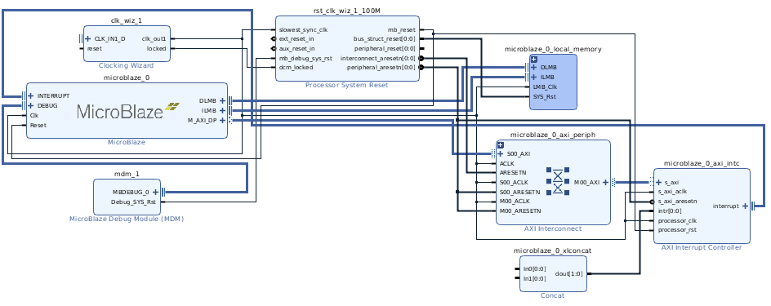
The generated basic MicroBlaze system should look like the following:

Add peripherals: AXI Uartlite, GPIOs
1. Right click anywhere in the block diagram, Add IP and search for and select the AXI Uartlite.
2. Repeat step 1 but search for AXI GPIO.
3. Repeat step 2 so that you have two GPIO blocks in your design. The reason why there are two GPIO blocks is that one of them is for switches and another one is for LEDs so that you can control the LEDs using the switches.
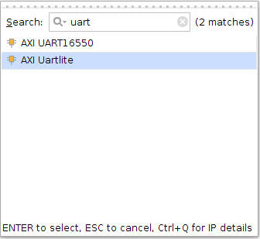
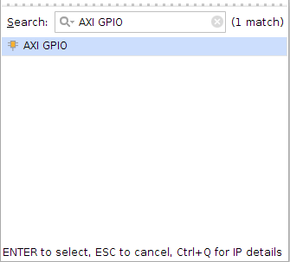

4. Right click one of the GPIO block and click Block Properties. Change the name to gpio_led.
5. Right click the other GPIO block and click Block Properties. Change the name to gpio_switch.
Block Configurations and Connections:
Interrupts
1. Connect the interrupt signal of the AXI Uartlite to the ln0 signal of Concat, which connects to the interrupt input of the interrupt controller. Concat is used to concatenate individual signals into a bus signal.
Move the mouse to the interrupt signal and left click on it, drag it to ln0 and release the mouse. You'll see a green check mark when you do it. That means you can make the connection.
Note that there is one input of the Concat block that is not connected and there is no other input to connect to the block. Leaving the unconnected input open will result in critical warnings and ultimately an error when you reach the SDK. There are several ways to deal with this particular situation. To reduce the number of ports, double click on the Concat block and change the number of ports to 1 in the Re-customize IP window. Click OK.

Clock Wizard:
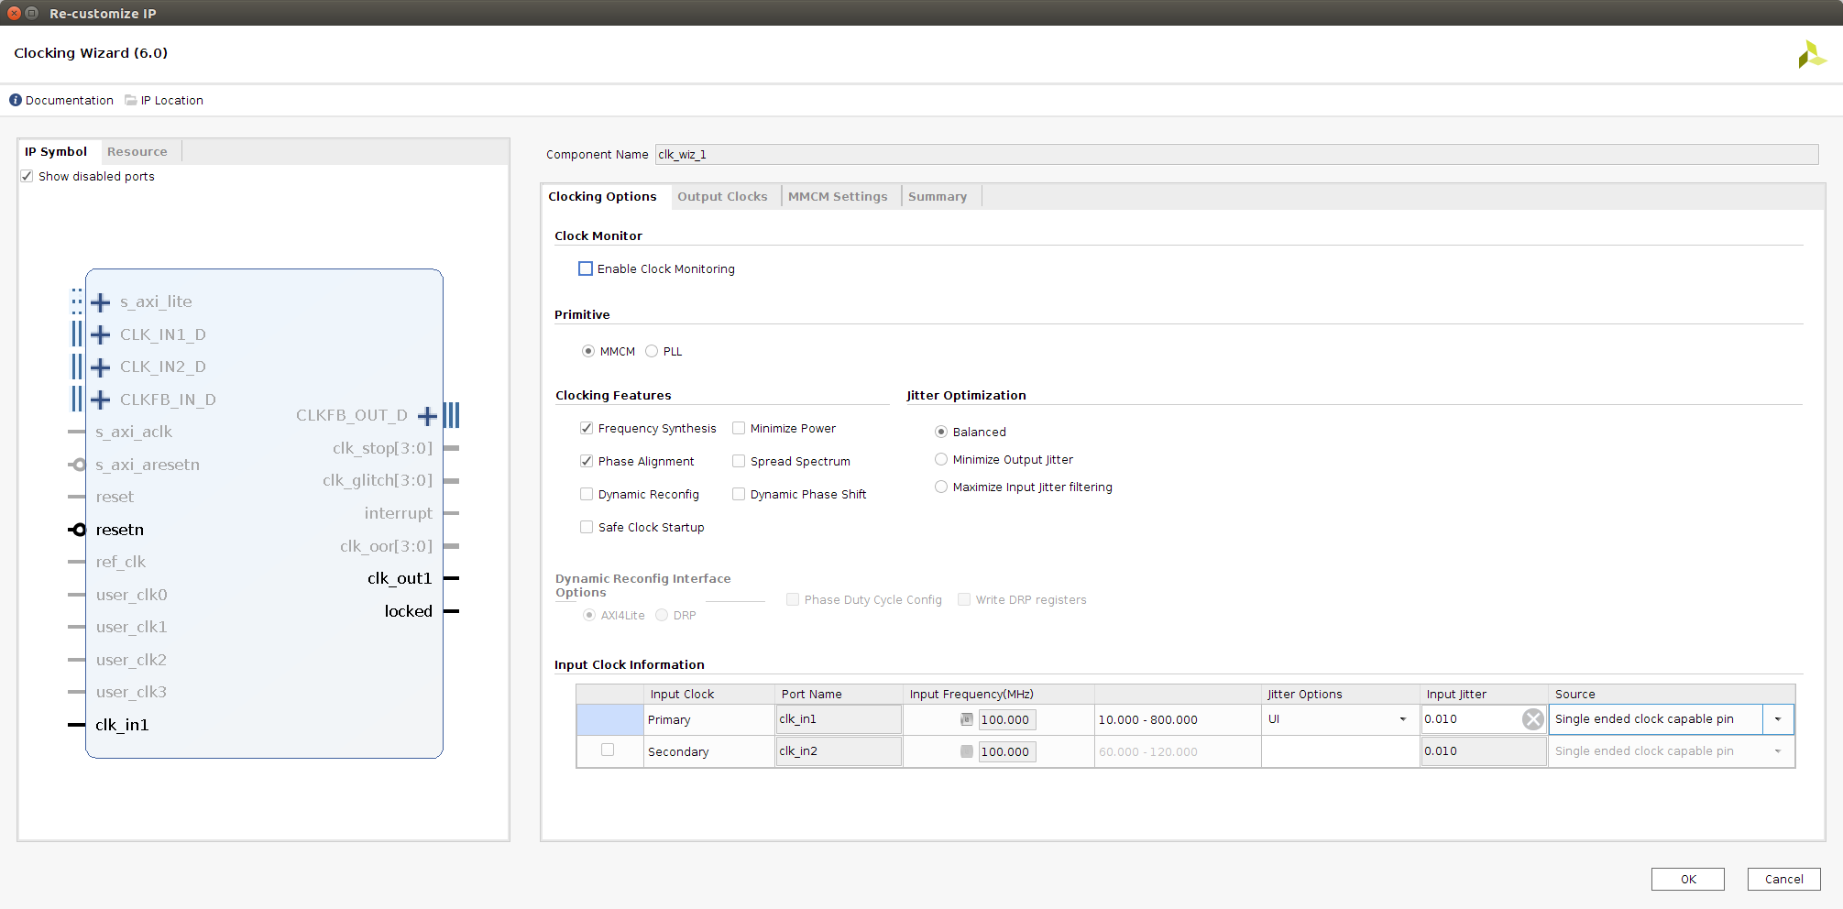
2. Double click the Clocking Wizard and change the Source of Primary clock input to Single ended clock capable pin. The clock supplied to the FPGA will use a single wire instead of a differential signal requiring two wires, which is more often used for very high speed clocks.
In the Output Clocks tab, change the Reset Type to Active Low and Press OK.
Reset Connections:
1. Click on Run Connection Automation and choose clk_wiz_1/resetn. Make the clock reset active low and press OK. This will generate a new reset_rtl pin in the block diagram.
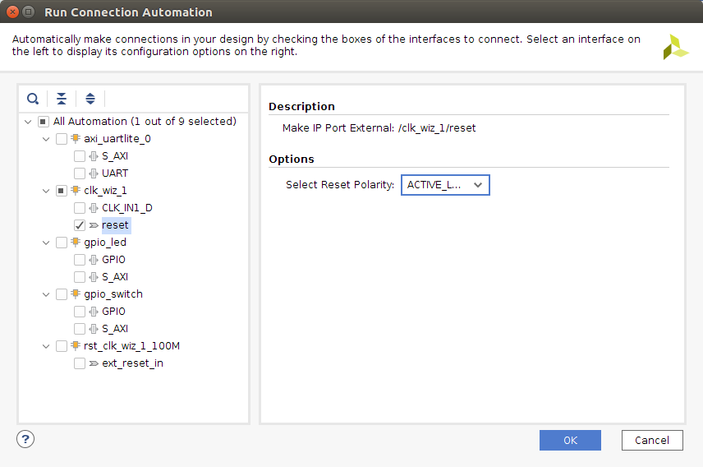

2. Connect the ext_reset_in pin of the Processor System Reset block to the reset_rtl pin.
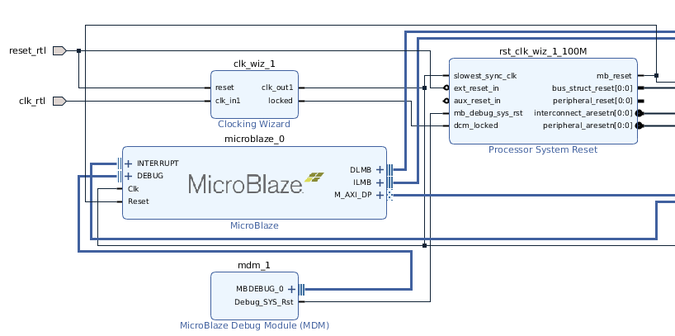
GPIO Configuration:
Double click on gpio_led to bring up the configuration window. Check the All Outputs and change the GPIO Width to 2 as we only need to use 2 LEDs for this lab. If you need more LEDs, you can change the width to the value you wish.
Double click on gpio_switch block and configure the block to accept two inputs in a similar manner.
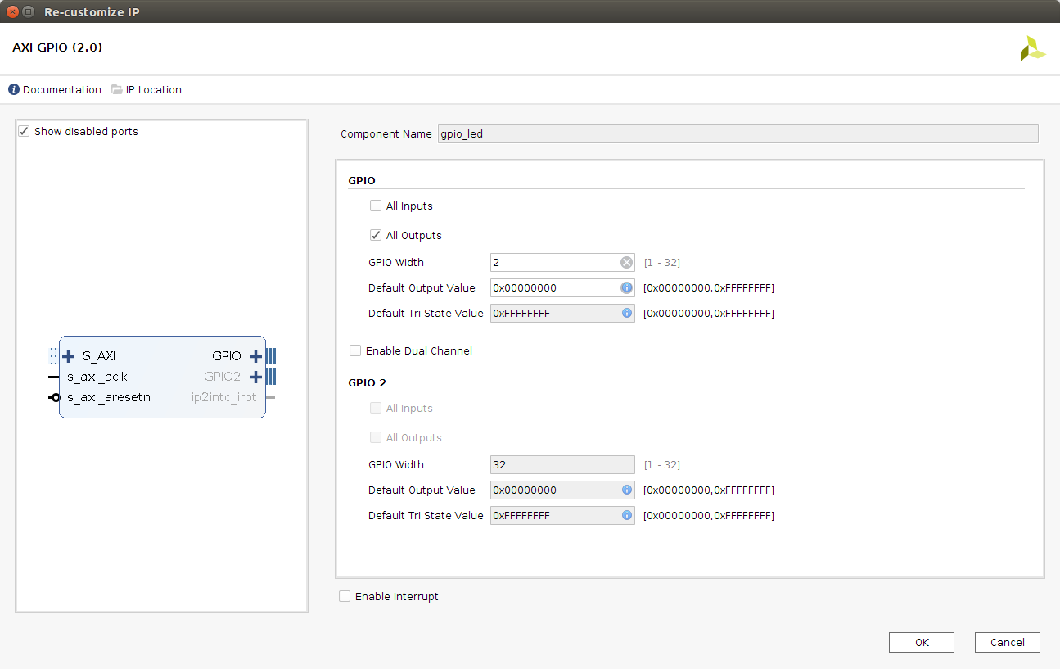
Create GPIO Ports:
Expand the GPIO port on gpio_switch by clicking the plus sign. Right click on gpio_io_i and choose make external.
Expand the GPIO port on gpio_led by clicking the plus sign. Right click on gpio_io_o and choose make external.

AXI and Clock Connections:
To handle the remaining connections we will use connection automation. Click on Run Connection Automation and select All Automation. This will connect the GPIO and UART controllers to the AXI Interconnect and create an external pin for the clock source.
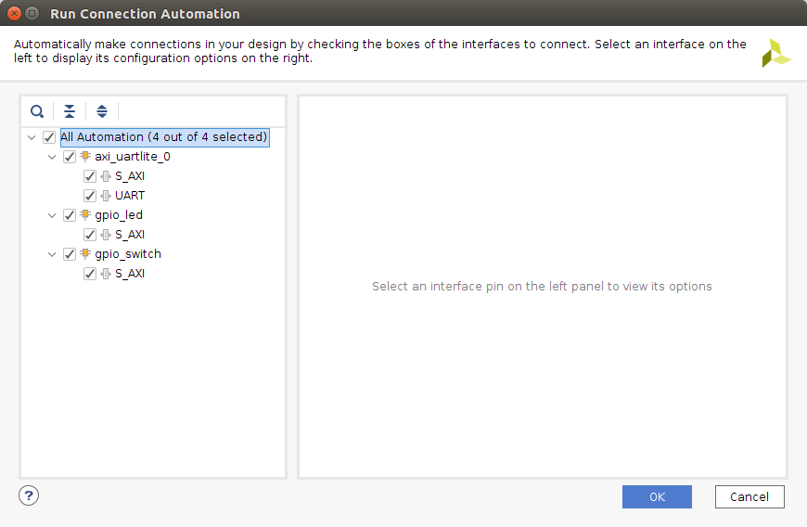
You should now have the following complete system with a MicroBlaze processor, three AXI peripherals, interrupt controller, local memory, debug module and clock and reset generators. Ensure you can identify the function of each block in your design.

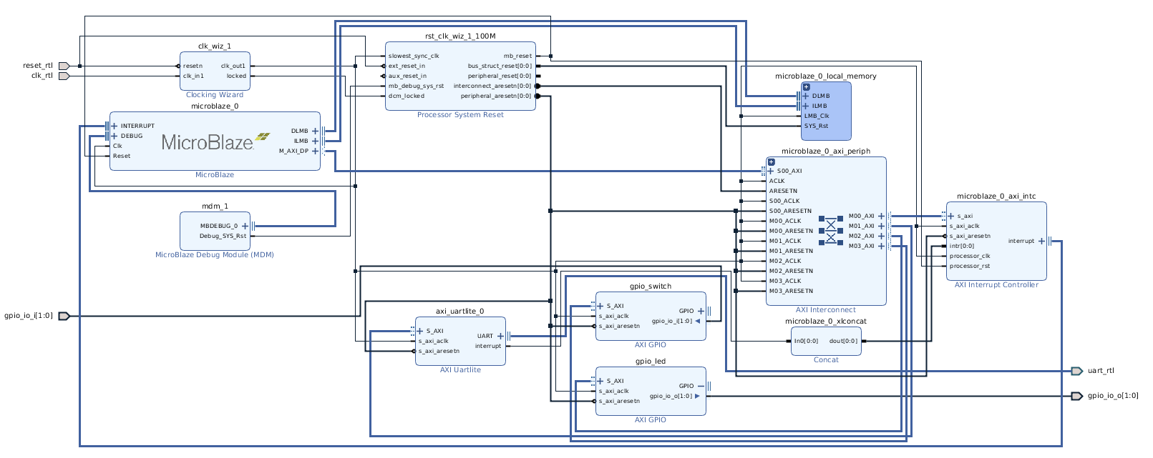
Select Tools > Validate Design. Or simply just press F6. If you followed every step above, it should say validation successful.

Memory-Mapping
Click on Address Editor to examine the Address Map. This table shows how different peripherals are mapped into the address spaces of different bus masters. In this design, the master is the MicroBlaze soft processor. For instance, notice below that the gpio switch peripheral can be accessed starting from the address 0x4001_0000 from the Data port of the MicroBlaze.
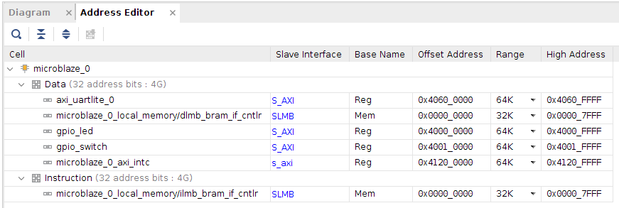
Creating Constraints
1. Click on Add Sources in the Flow Navigator box and choose Add or Create Constraints then click Next.
2. Click on Create File and give it a name. Click OK and then Finish.
3. Open up the constraint file you just created and copy the code below, then save it. You can find the file in the Sources tab under Constraints. Double click on the file name to edit it. Note that the reset signal is the CPU RESET button on the board. You can also import the XDC file packaged with this tutorial.
## Clock signal
set_property -dict { PACKAGE_PIN E3 IOSTANDARD LVCMOS33 } [get_ports { clk_rtl }];
create_clock -add -name sys_clk_pin -period 10.00 -waveform {0 5} [get_ports {clk_rtl}];

## Reset (CPU_RESET)
set_property -dict { PACKAGE_PIN C12 IOSTANDARD LVCMOS33 } [get_ports { reset_rtl }];

##Switches
set_property -dict { PACKAGE_PIN J15 IOSTANDARD LVCMOS33 } [get_ports { gpio_io_i[0] }];
set_property -dict { PACKAGE_PIN L16 IOSTANDARD LVCMOS33 } [get_ports { gpio_io_i[1] }];

## LEDs
set_property -dict { PACKAGE_PIN H17 IOSTANDARD LVCMOS33 } [get_ports { gpio_io_o[0] }];
set_property -dict { PACKAGE_PIN K15 IOSTANDARD LVCMOS33 } [get_ports { gpio_io_o[1] }];

##USB-RS232 Interface
set_property -dict { PACKAGE_PIN C4 IOSTANDARD LVCMOS33 } [get_ports { uart_rtl_rxd }];
set_property -dict { PACKAGE_PIN D4 IOSTANDARD LVCMOS33 } [get_ports { uart_rtl_txd }];
Wrap and build the design
1. In the Sources box, click Design Sources. Right click your design and choose Create HDL Wrapper to wrap your design. In this example, the design is called mb_system so right click on mb_system.
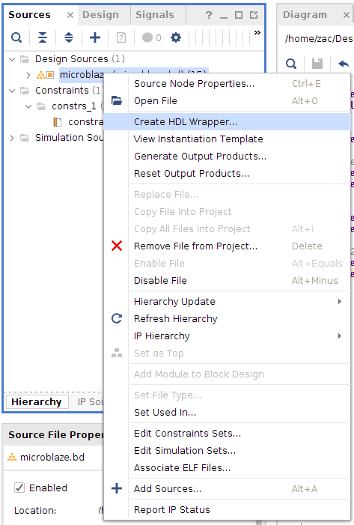

2. A window pops up as shown below. Leave the options as default then click OK.
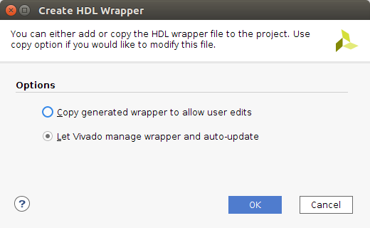

3. Navigate through the hierarchy of the design in the Hierarchy tab. You will notice that a top-level verilog file is created by the HDL wrapper. As the design flow continues, HDL files will be generated for each block in the IP Integrator design.
4. Click on Run Synthesis.
5. Click on Run Implementation.
6. Click on Generate Bitstream.

3. Export to SDK
After generating the bitstream, click on File on the top and choose Export, then choose Export Hardware. Make sure you check Include bitstream. If the option is gray, simply open your Implemented Design under Implementation in the Flow Navigator and do the export again. Click on File on the top and choose Launch SDK so that after export, the SDK program will launch.
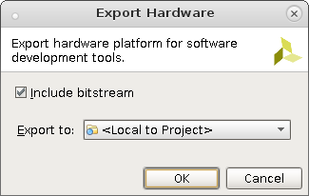

After the SDK first launches, double click system.hdf and you should see a description of the peripherals connected to the MicroBlaze processor.
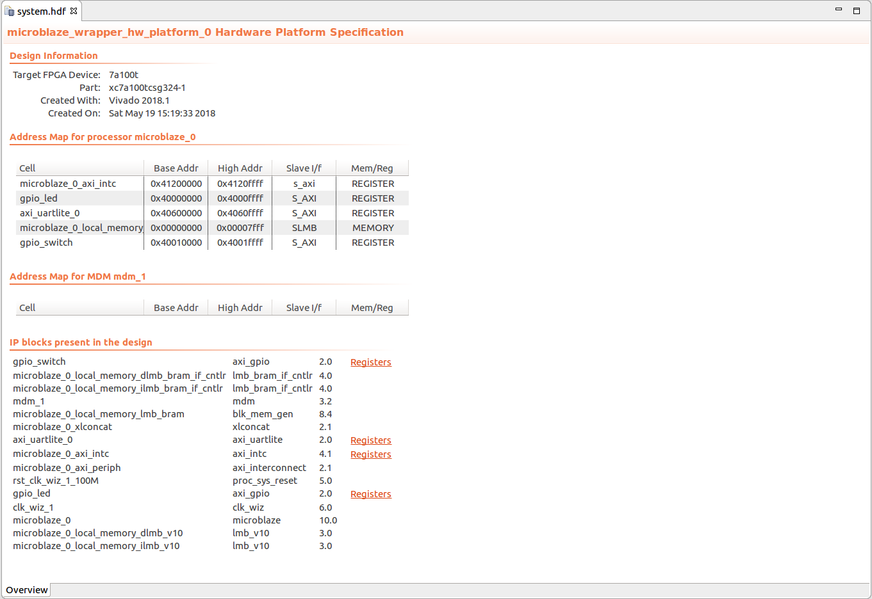
Creating a Hello World program
1. Select File > New > Application Project
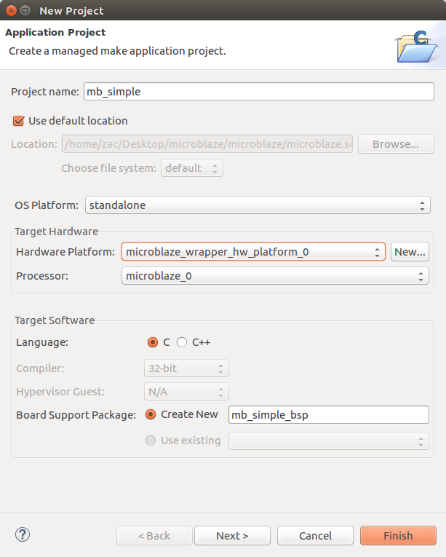
2. Enter the Project name and choose the OS Platform to be standalone. Click Next.

3. Choose Hello World as your template. Click Finish.
4. Connect your board to the computer and turn it on.

5. Click Xilinx Tools at the top -> Program FPGA to program your board.
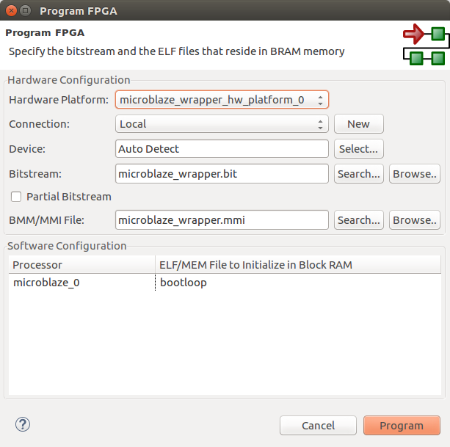

Run the C Program
1. Click on Run on the top -> Run Configurations to create a new run session.
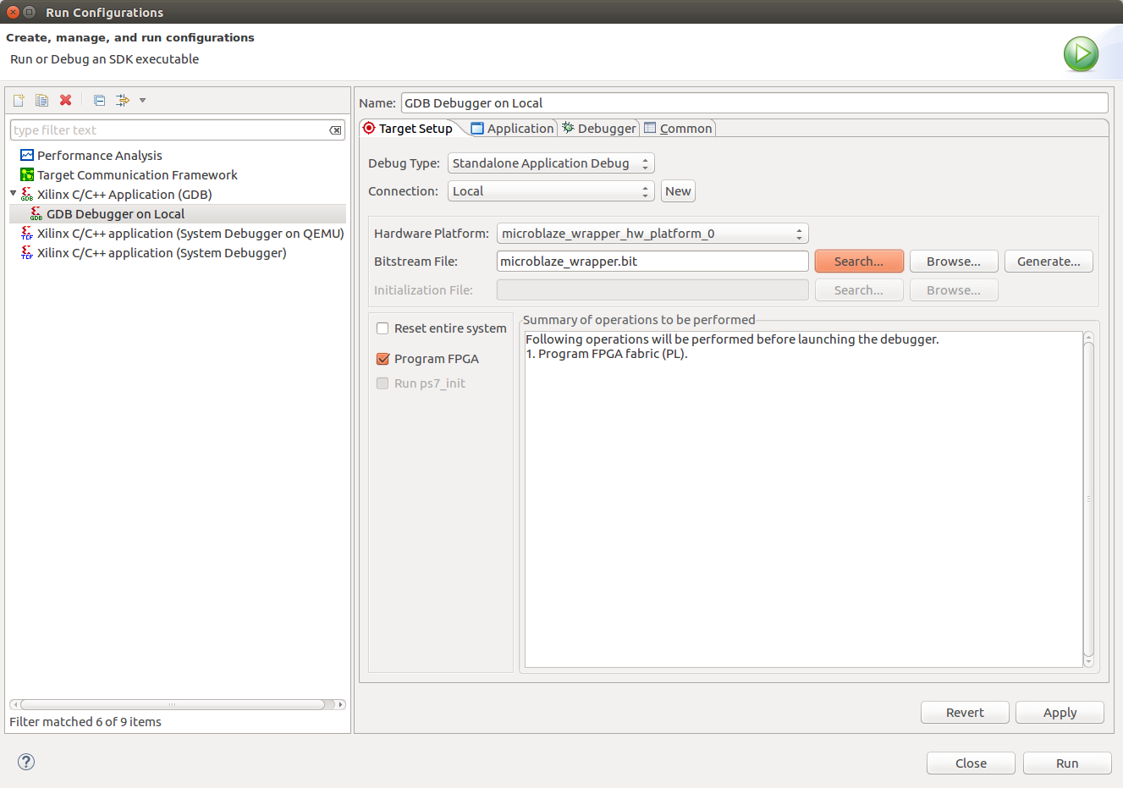
2. Choose Xilinx C/C++ application(GDB) and click new on the top left corner to create a new launch.
3. In Application, browse the Project Name and choose your project. In this example, it is mb_simple. You will notice that the Application file is automatically selected under Debug folder.
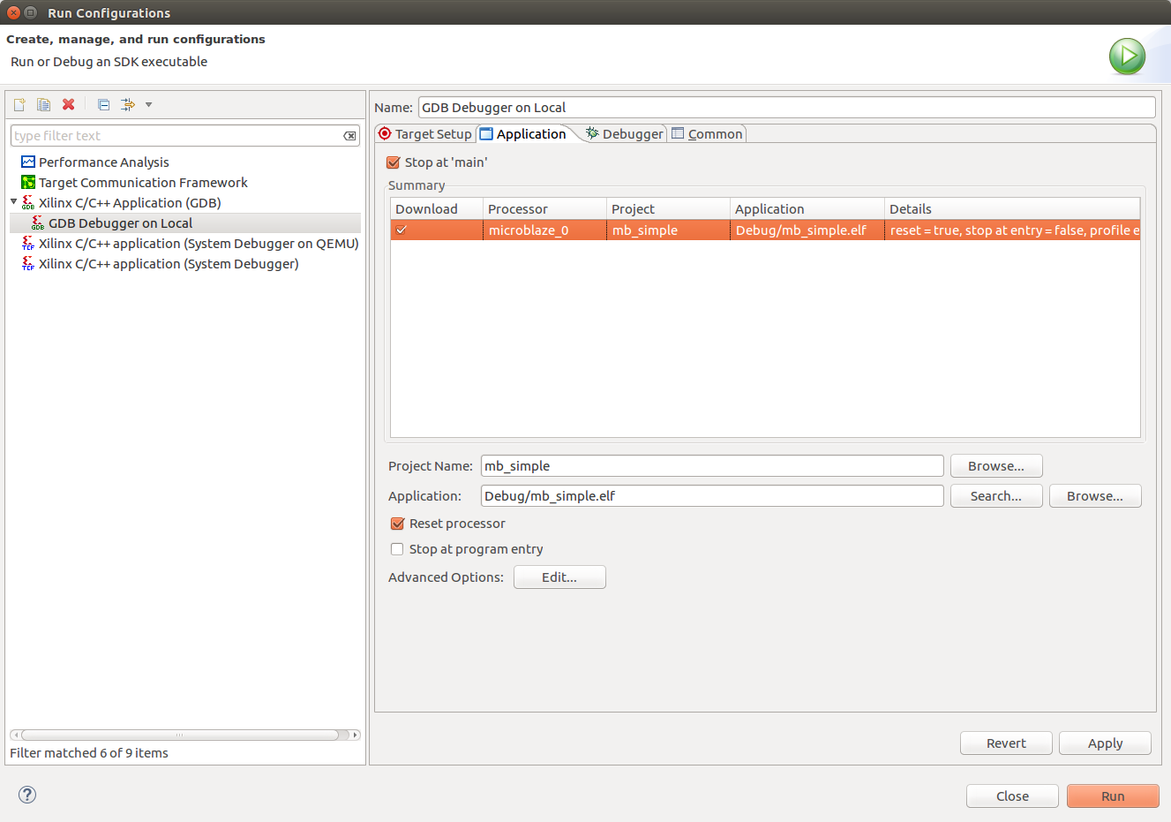
4. In SDK Terminal, check + and enter /dev/ttyUSBx while x is the port number board connected to. Change the BAUD Rate at 9600. Leave everything else as default and click Run. (Add yourself to dialout group on personal machine before doing the above step)
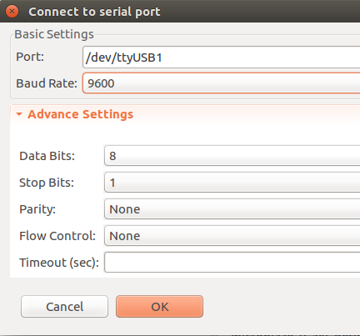
You will see Hello World is printed in the SDK Terminal.
Controlling LEDs using Switches
1. Open up your helloworld.c file under source file
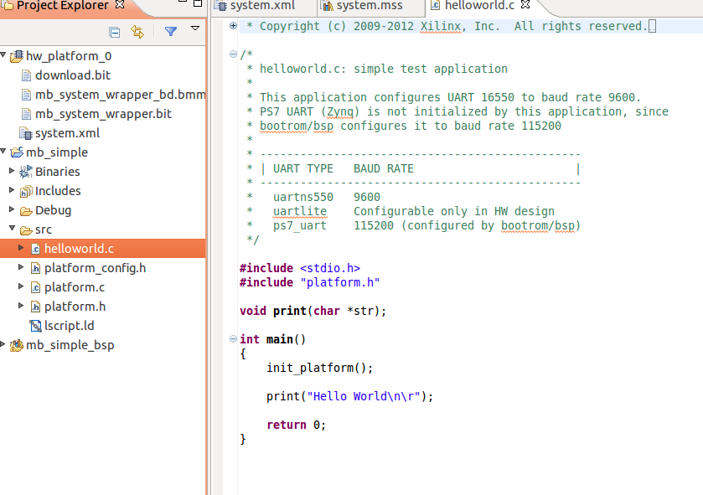

2. Copy the following code to helloworld.c
#include <stdio.h>
#include "platform.h"

volatile unsigned int * led = (unsigned int *)0x40000000;
volatile unsigned int * swt = (unsigned int *)0x40010000;

int main()
{
init_platform();
print("Hello World\n\r");

while(1)
*led = *swt;
return 0;
}

In this example, the base address of the LED controller is 0x40000000 and the base address for the switches is 0x40010000. The infinite while loop keeps checking the value of the switches and assigns them to the LEDs. This way you can control the LEDs from the switches. Double check the addresses of your GPIO peripherals either by double clicking system.hdf in SDK or by looking at the Address Editor in the IP Integrator tool in Vivado.

3. Click Run.

4. Change the value of the switches and see the changes of leds.

Experiment with the program and block design to implement different logic between the LEDs and switches.

