Supplementary Information: How’s the Air Out There? Using a National Air Quality Database to Introduce First Year Students to the Fundamentals of Data Analysis

David Hall and Jessica D’eon (Corresponding Author)

19/03/2021

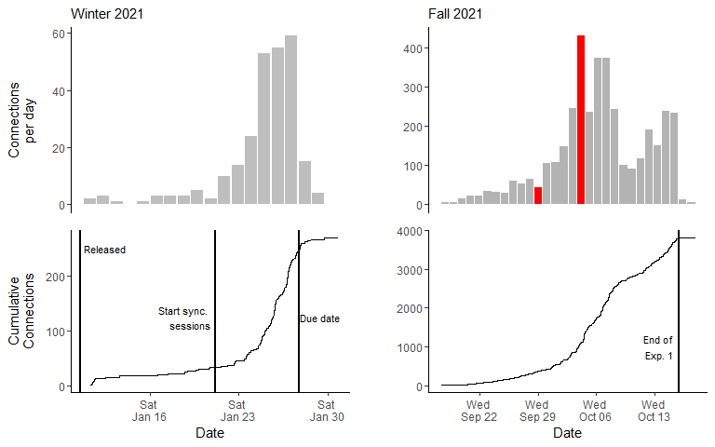

Figure 1: Connections to Air Quality app per day (top) and cummulative connections over time (bottom) for the Winter and Fall 2021 sessions. Red bars denote days when the app crashed and required resetting and expansion of number of allowable connections. Note discrepency of y-axis between Winter and Fall 2021 sessions.