

# Project Two Title: A Brand New Project!

**Team Number: One**

**Team Name: Immigration Advocacy**

## Team Members:

| **Name** | **Email Contact** |
| --- | --- |
| Eleonore Caclard |  |
| Nerin Kaur | [nerinkaur2@gmail.com](mailto:nerinkaur2@gmail.com) |
| Siyan Guo | [syg9345@gmail.com](mailto:syg9345@gmail.com) |
| Ha Damon |  |
| Abrar Chowdhry | [abrarchowdhry44@gmail.com](mailto:abrarchowdhry44@gmail.com) |

## Logo

**{Create a logo and place it here}**

## Project Board Website Link and Screenshots

**{Please place your link to your GitHub or Trello Project Board here}**

**{Place a baseline screenshot of your project board with your initial tasks }**

## 

## Project Description (High Level):

The purpose of this project is to allow newcomers and immigrants that choose to immigrate to Canada a brief overview of

### Motivation

{ Describe why the team feels that the project idea can be an important commodity or service }

## User Story

{Describe below using the “As a [persona], I [want to], so that [outcome] “, to define the user story - see information for example at <https://www.atlassian.com/agile/project-management/user-stories> and detail the acceptance tests for the user story “Given…when…then” as described in <http://bit.ly/given-when-then> }

Example…

USER STORY

AS a LEARNER

I WANT to efficiently remember facts in a gamified way

SO THAT I can consistently recall facts at will

ACCEPTANCE TEST FOR USER STORY

GIVEN sets of decks to study from

WHEN I select a deck

THEN the game loads this deck's contents to be reviewed

WHEN a flashcard shows up

THEN I can select an answer from three possible options

WHEN I select an incorrect answer

THEN the card will show more frequently in the future

WHEN I select a correct answer

THEN the card will show less frequently in the future

WHEN I complete a game (of 15 cards)

THEN I get a summary of how much points I have earned in this session

WHEN I do particularly well in each game

THEN more cards from the deck will be added to the pool

WHEN my score reaches certain milestones

THEN I will have earned a badge to show off on my profile

GIVEN my competitive nature in this gamified environment

WHEN I open my profile page

THEN I see my avatar, cumulative score, and badges I have earned

WHEN I open the leaderboard page

THEN I can see how my score compares with other players

WHEN I click on another player's profile

THEN I can see their avatar, cumulative score, and badges

NOTE: You may have more than one user story (or feature) to describe as part of your application.

## APIs to be Used:

{list the Names, descriptions and URLs of the APIs being used for your project below, along with the reasons on why you are using it }

| Resource | URL | HTTP Verb (GET, POST) | Action | Used For |
| --- | --- | --- | --- | --- |
|  |  |  |  |  |
|  |  |  |  |  |
|  |  |  |  |  |

## Libraries to be Used:

{List client-side CSS and JavaScript Libraries being used in this project. List the names, descriptions and URLs for these libraries, along with the reason to use it . Examples include JQuery, Materials UI}

## Packages Required:

{Not Applicable for Project One}

## Minimum Viable Product (MVP) Requirements

{Describe here your minimum features that are required to make your project functional and presentable}

## Stretch Goals

{Describe here what features you would like to see if there is time permitting in your project period of development, or post-presentation, outline features that you would like to add for future development}

## Breakdown of Tasks (Ownership by Group Member):

{List who will be doing what}

Sam: Front-end design and development.

Jules: Game design and asset creation.

Kim: Back-end management, and integration with front-end.

Pat: Back-end management, schema creation, git repository management

Richie: Back-end design and development.

Kris: Front-end design and development.

Eddy: Back-end design, development, and integration with front-end.

Max: Game design and asset creation.

## Schedule for Completion of Tasks:

{Use a calendar to forecast estimated completion of stories and tasks, once they are defined. Have your teammates commit to it.}

| **Date** | **Task** | **Notes** |
| --- | --- | --- |
| **08/05** | Idea generation |  |
| **14/05** | Static pages for Main page, avatar, game, login/sign up page | Due on |
| **15/05** | Sample data - Main page, avatar, login/signup | Dynamic pages due on |
| **15/05** | Finalize and test GameSession class functionality | Due on |
| **16/05** | Game session | Dynamic pages due on & passed on for integration |
| **17/05** | Connect game logic to IndexedDB and graphql | Due on |
| **…** | … | **…** |
|  |  |  |
|  |  |  |
|  |  |  |
|  |  |  |
|  | READY MVP |  |
|  |  |  |
|  |  |  |
|  | PROJECT POLISH |  |

## Schema

{ Describe your organization of your data used in the website, either in diagrams or text }

Example:

| Model | Properties / Fields | Type | Details |
| --- | --- | --- | --- |
|  |  |  |  |
| User | firstName | String |  |
|  | lastName | String |  |
|  | email | String |  |
|  | password | String (scrambled) |  |
|  |  |  |  |
| UserList | User (many) | Array (list) |  |
|  |  |  |  |
| Product | Name | String |  |
|  | Description | String |  |
|  | Price | Number |  |
|  | SKU | Number |  |
|  | ID | String |  |

Etc.

## Associations:

Example:

* A userList has many users
* ProductCategories has a list of individual Product Category information
* A Product Category has one or more products

Etc.

## Validations:

{Describe what forms will require validations, what fields within a form are being validated, and what type of validation is required}

Example:

New User Form

* Required Fields
  + First Name (text)
  + Last Name (text)
  + Email (valid email address)
  + Password (minimum, maximum, character type)

Search on Map Form

* Required Fields
  + City (text)
  + Province / State / District (text)
  + Country (text)

Etc.

## Migrations and Seed Information

{Describe here any initial data that you might need to initially apply (populate) before your website will work. For example , a list of “default users” }

| User | firstName | lastName | email | password | status |
| --- | --- | --- | --- | --- | --- |
|  | John | Doe | [john@doe.com](mailto:john@doe.com) | P@$$w0rd! | Active |
|  | Sally | Smith | [sally@smith.com](mailto:sally@smith.com) | T1geR_1IlY | Inactive |
| … | … | … | … | … | … |

## Wireframes:

{ A set of DETAILED screen-by-screen design layouts with annotations describing all UI/UX components and all data relevant to the screen}

Acceptable formats:

* Scanned or photographed, neat and clean sketches, or
* UX/UI images created from tools such as balsamiq (<https://balsamiq.com>) , Lucidchart, PowerPoint, word, mockplus, Draftium etc.

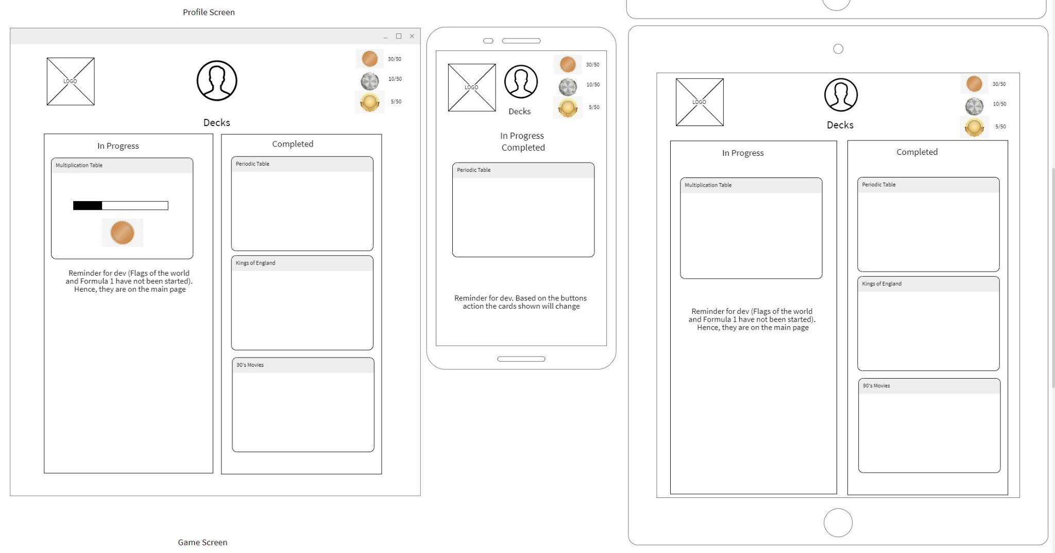

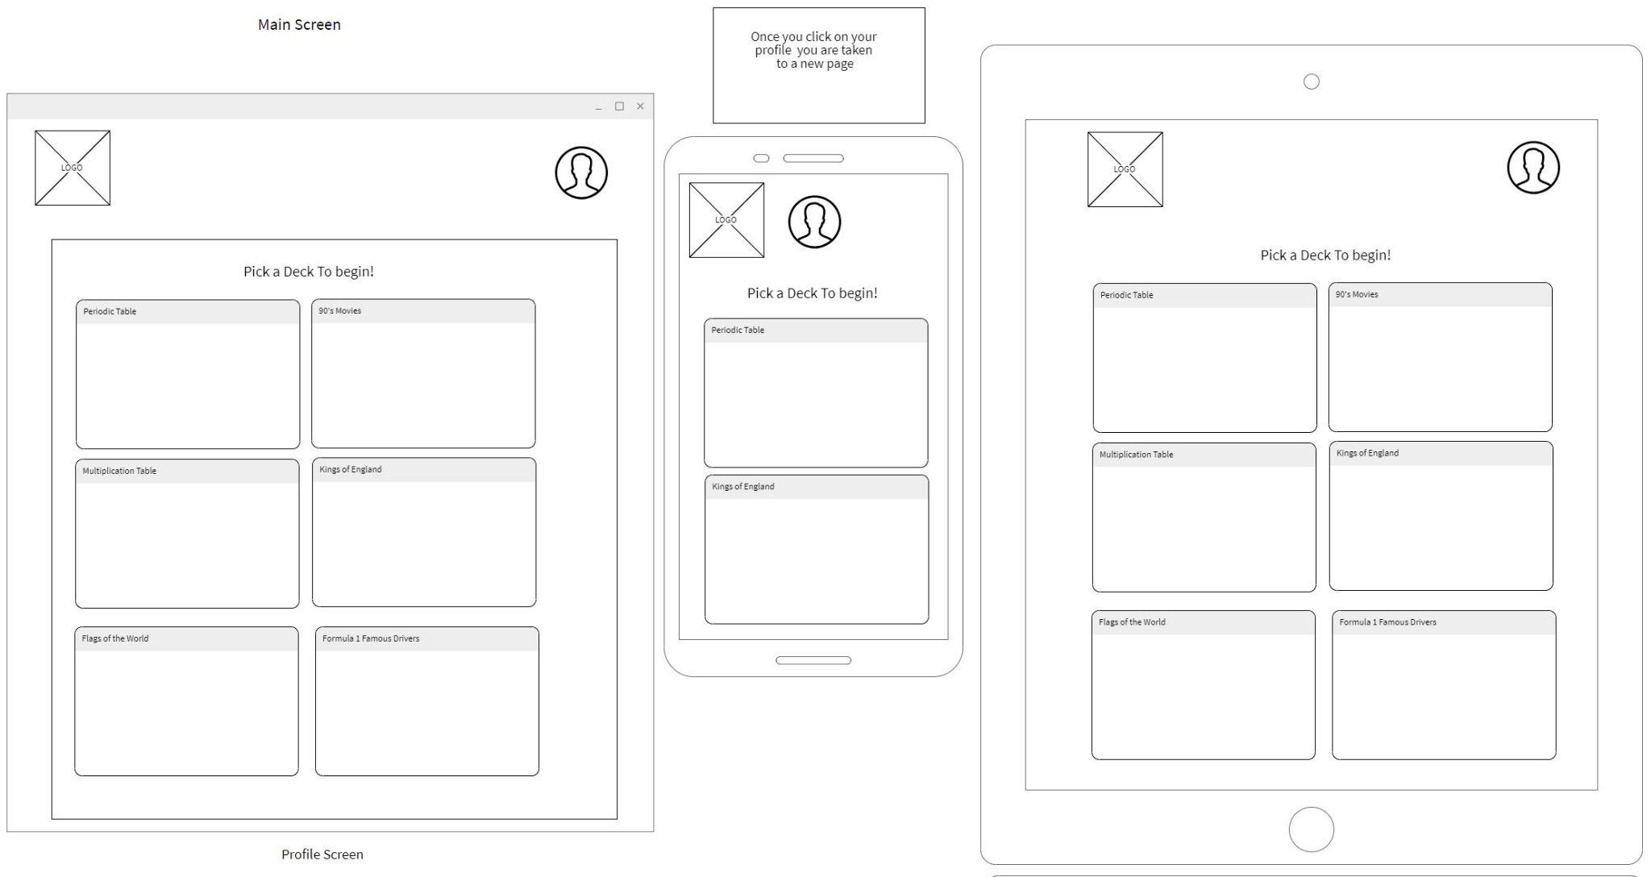

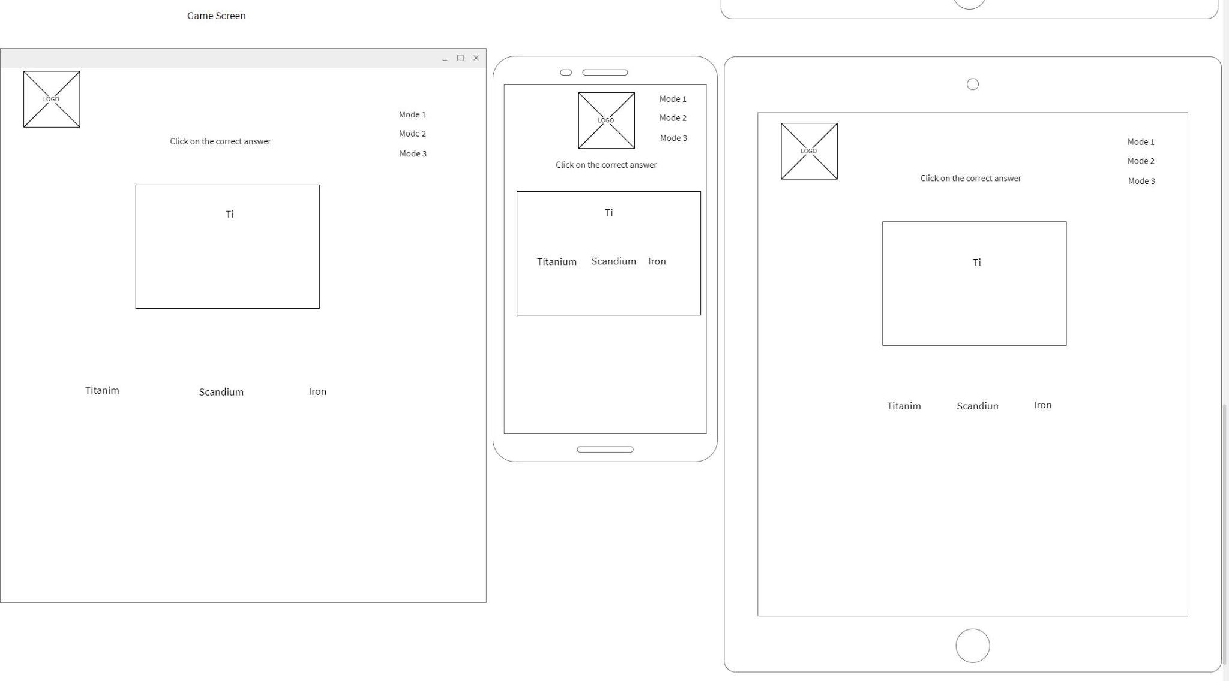

## Website “Components” and/or “Sections”

{ Based on your wireframes, describe the common components on the website “navigation”, “forms”, “headers”, “footers” either with images / and or content and describe the intention / usage of the components. In addition, describe the primary “views” or “sections” that your project will have, for example “About Us”, “Products and Services”, etc.

}

## Git Workflow, Website Directory Structure:

{describe your workflow and methodology that all team members will abide by when using Git, AND describe in text or imagery the directories and filenames and their descriptions that will be used for the project}

Example:

### GIT Workflow

Production Branch Name: Main

Development Branch Name: develop

All developers will create branches off develop according to the naming convention:

{

example:

***feature/lastname/ticketnumber/task i.e. feature/Apostol/001/navigation-bar***

***docs/lastname/ticketnumber/task i.e. docs/Wayne/020/update-README***

***bug/lastname/ticketnumber/bug-desc i.e. bug/Kent/030/fix-navigation-bar-color***

}

### Code Review and Merge Requests

Identify Name(s) of people doing code review and approving Merge Requests: (lists names here)

* Team members should “pair up” to perform code reviews and merge requests
* At the halfway point, new pairs should be recreated
* If there is an odd number of participants in the team, then the extra member can float between different pairs to code review,

| Week One | Team Member | Team Member |
| --- | --- | --- |
|  |  |  |
|  |  |  |
|  |  |  |
|  |  |  |
|  |  |  |
|  |  |  |
|  |  |  |
|  |  |  |
| Week Two |  |  |
|  |  |  |
|  |  |  |
|  |  |  |
|  |  |  |
|  |  |  |
|  |  |  |
|  |  |  |
|  |  |  |
|  |  |  |

### Directory Naming and Structure; Filenames and descriptions

Only list the important files and folders.

| Directories | name | description | detail |
| --- | --- | --- | --- |
|  | images | Stores images |  |
|  | images/home | Images in home page |  |
|  | images/products | Product images |  |
|  | images/bio | Images for bio |  |
|  | css | Stores css | Main.css is principal stylesheet |
|  | css/nav | Navigation style |  |
| … | … | … | … |
|  |  |  |  |
| Files |  |  |  |
|  | Index.html | home |  |
|  | Contactus.html | Contact us page |  |
| … | … | … | … |
|  |  |  |  |
|  |  |  |  |
|  |  |  |  |
|  |  |  |  |

## “Stuck Time” Agreement:

The team must identify and agree to a time frame that a team member must use as a limit before reaching out to (a) fellow team members and then (b) the instructional team (in-class) for support. That way, *no one should be stuck for ‘days’ or ‘many hours’ on a task.*

We the team members of (insert project team number or team name here) agree that the following period of time of investigation (with evidence) is allowed before identifying themselves as being “stuck” or “bottlenecked”, in which case, the team member can then seek the assistance of other team members, the instructional team, or AskBCS for assistance.

Period of time permitted before asking to seek assistance (hours): __________ hours

As agreed upon by the following team members (name and signature below)

| Name | Signature |
| --- | --- |
| Jane Doe |  |
|  |  |
|  |  |
|  |  |
|  |  |
|  |  |
|  |  |

## Retrospectives – To Be Handed In At the Project Midpoint

Each team is to hold a *retrospective* meeting at the half-way point of the project period.

References:

* [What is a sprint retrospective - EasyRetro former FunRetro](https://easyretro.io/blog/what-is-a-sprint-retrospective/#:~:text=To%20facilitate%20this%2C%20the%20retrospective%20is%20based%20on,commit%20to%20doing%20differently%20in%20the%20next%20sprint%3F)
* [What is a retrospective? – All About Retrospectives (retromat.org)](https://retromat.org/blog/what-is-a-retrospective/)

Each team is to submit to the instructional team a short three paragraph Microsoft Word or PDF document at **the mid-point** of the project that describes the following:

* What worked well in the sprint?
* What didn’t work well and could be improved?
* What will we commit to doing differently in the next sprint?

## GitHub Repository Link, Production Website Link Submission Dates

To be filled in by the project team under advisement of the instructional team (and set out in Canvas)

* Presentation Date
* Project Submission Due Date
* Ideal Submission Date

## Additional Notes: