Graduate Computer Programming: Assignment 1

**Update from assignment proposal and overview of survey:**

We have decided to make a few small changes to the study design since I wrote the assignment proposal. Therefore, I have written out an updated survey flow so you are clear on the outline of the study.

For this study, I will be using Qualtrics. First, participants will read and agree to our consent form and complete some basic demographic variables. We will then have participants read and respond to nine different hypothetical scenarios in which someone acts unethically. These nine acts were piloted among thirty-five other acts in a different sample (n= 99), and were chosen to use in this study based off similar levels of severity. All acts within each level of severity showed good reliability in our pilot sample (low, α= .80; medium, α= .77; high, α= .76).

After reading each randomized hypothetical act, participants will be asked, “Do you think it is possible for someone to be redeemed in your eyes after committing the above act?” and will respond either *yes* or *no*. After responding to this question for each of the nine acts, participants will rate how important different themes are for redemption for each act.

* If participants respond *yes*, they will be branched to a page where a matrix of themes important to the concept of redemption will be shown. Participants will be asked “To what extent do you believe the following are important steps for the person who acted unethically in the above scenario to be redeemed in your eyes. In other words, how important are each of the following for you to believe this person was redeemed?” on a scale of 1 (*Absolutely unimportant*) to 6 (*Absolutely important*). The matrix will contain ten themes that in previous studies were shown to be important to peoples’ abstract notions of redemption, as well as one attention check.
* If participants respond *no* to the previous question, they will still be presented the matrix of themes, however, the question will be framed as “Imagine someone believed redemption is possible for the above unethical act. To what extent do you believe the following are important steps for the person who acted unethically in the above scenario to be redeemed in their eyes. In other words, how important are each of the following for someone to believe this person was redeemed?”.

We wanted to have both versions of this question so that even if some people do not believe redemption is possible for certain acts, we would still not lose a bunch of data. Instead, we can look at their data in an exploratory way to compare which themes are important for people who believe redemption is possible versus people who don’t.

After each matrix, participants will respond to the open-ended question “Are there any steps that you believe are important for this person to be redeemed that we did not include in the previous question? If yes, please include that step below in a brief phrase or sentence”. This process will be repeated for each of the nine acts.

Participants will subsequently be debriefed and provided a completion code

**Link to Qualtrics survey:** <https://utorontopsych.az1.qualtrics.com/jfe/form/SV_4Jdz64KsDm0z7fL>

**Screenshots of survey flow:**

* Consent, consent branching, demographics, instructions, and randomization of acts

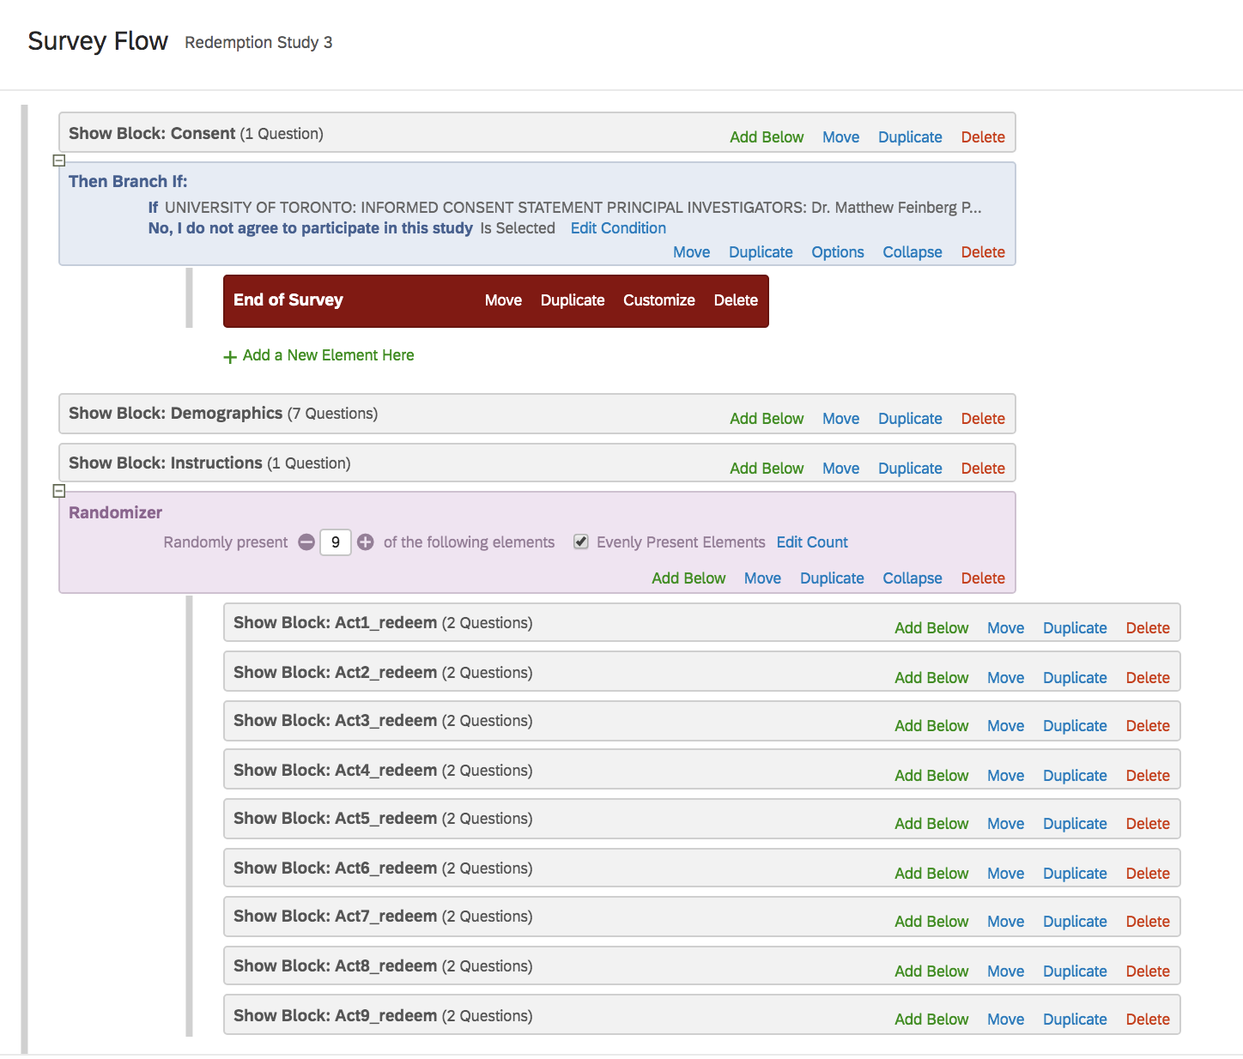

* Branching to theme matrix based off whether each act was redeemable or not

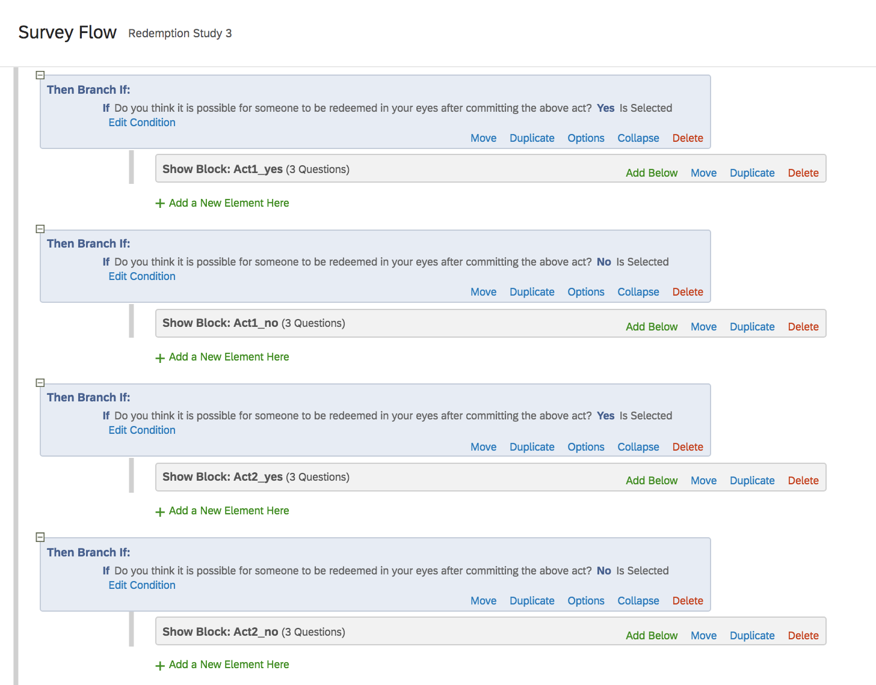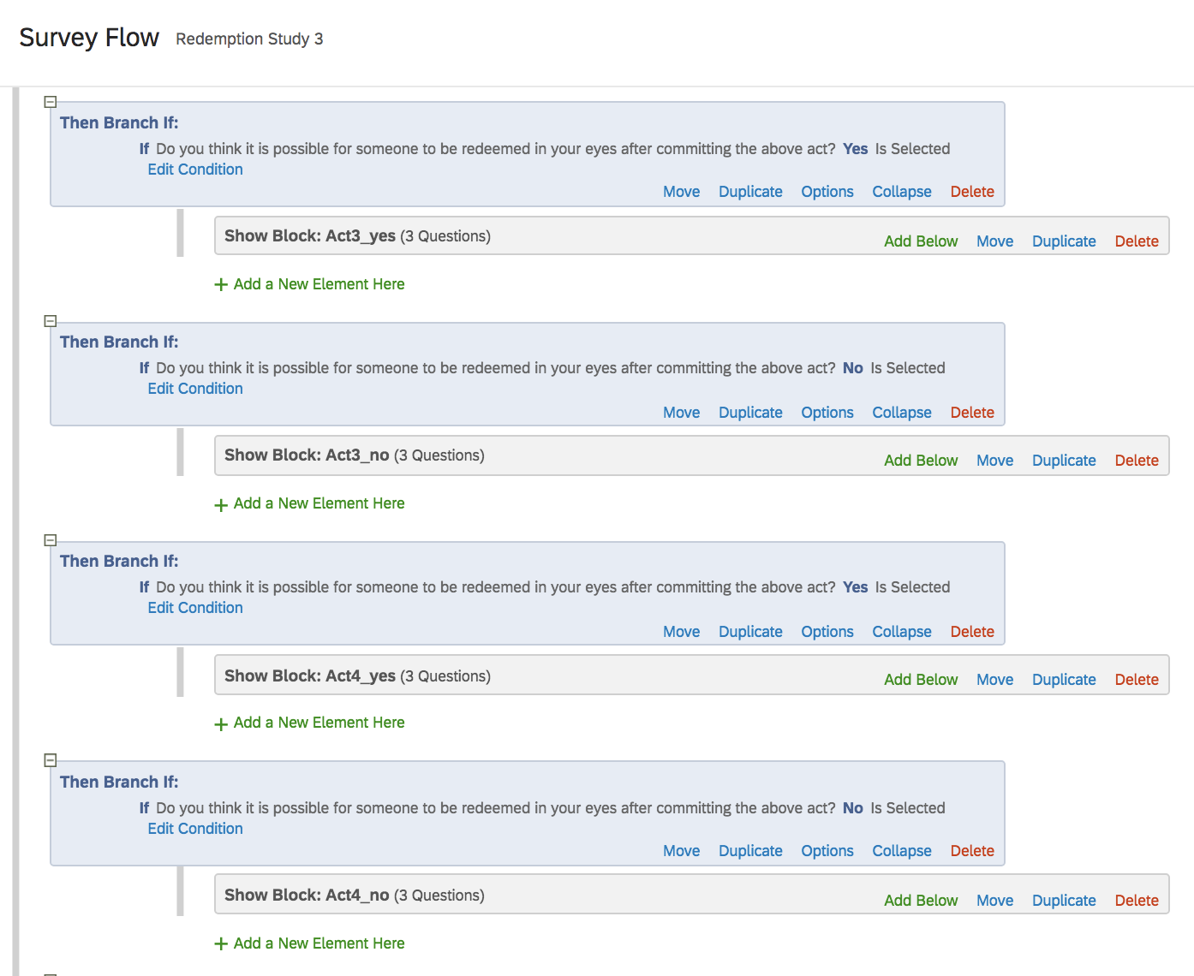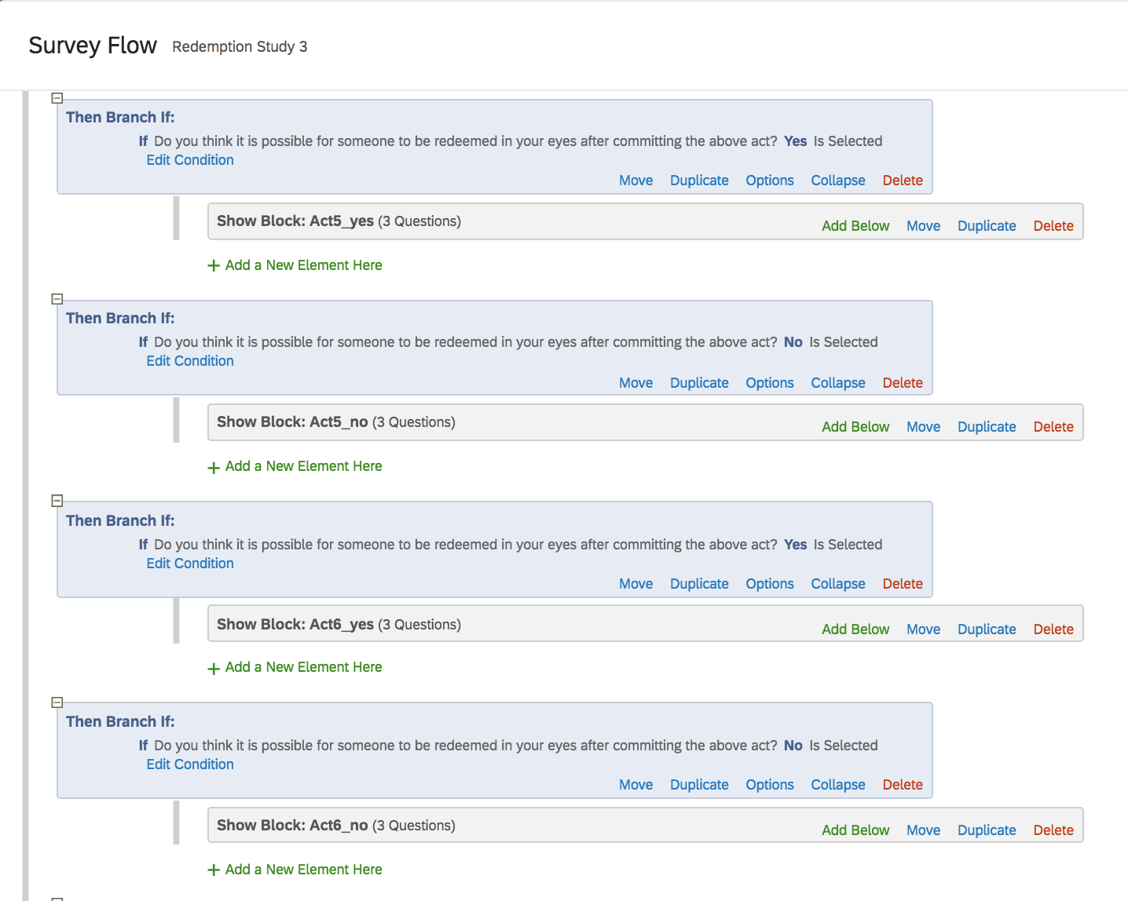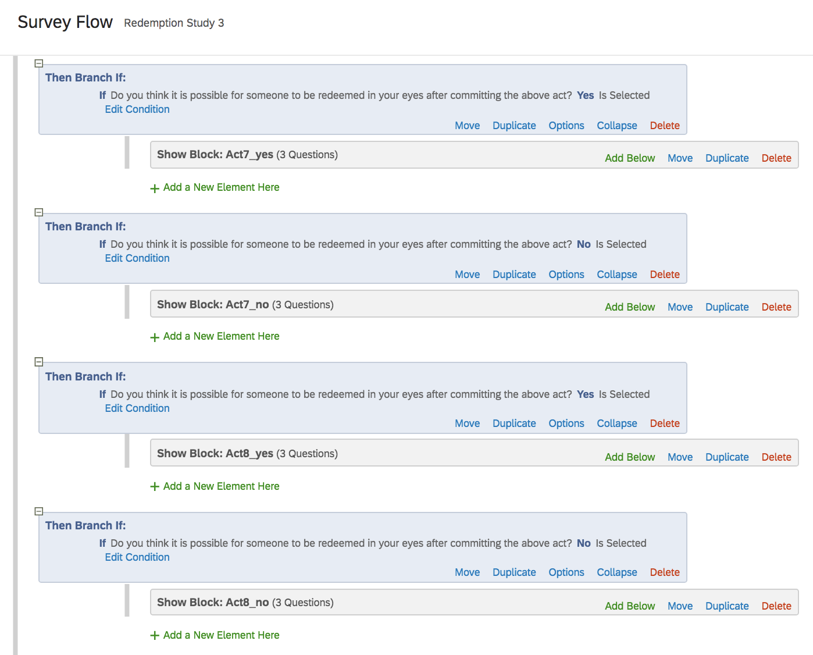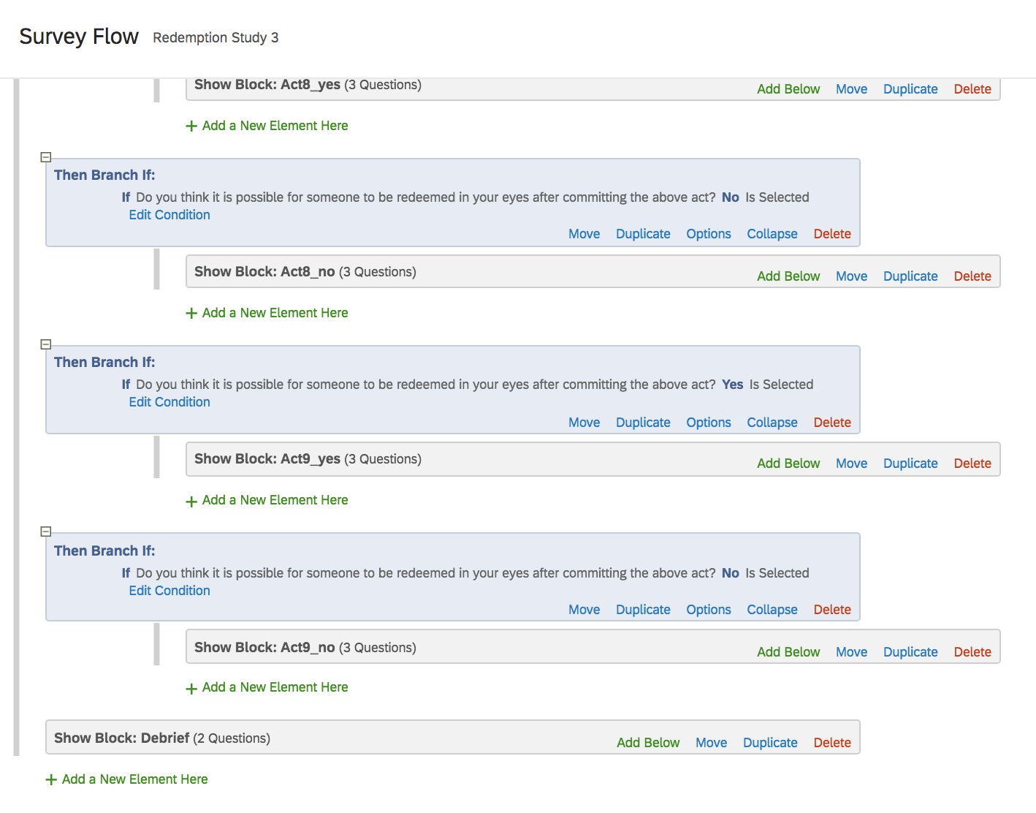

**Survey export:**

* I have also attached an exported .docx version of the survey in another document. The survey is exactly the same as the link provided above, but I attached the word version just in case it is useful “ForbesR_Assignment1_SurveyExport”.