***PS4: Effect of traffic density and non-driving task difficulty on driver performance***

*Joelle Girgis*

*Please Note:* Non-driving related task (NDRT) is a secondary task imbedded in a primary automated driving attentional task. More specifically, I am creating a simple smartphone GUI to mimic a texting interface which varies in difficulty (low and high) across 6 traffic density conditions. Because I don’t yet have access to the overarching driving simulator script, I can only provide an outline of how the GUI might function as a stand-alone data collection tool ( not how it fits into the bigger script)

High-level experiment outline

**SESSION**

-30 participants

-1 practice block (10 mins)

-1 experimental blocks (6 conditions/drives in total)

* Total time per block = 10 x 6 = 60 minutes

-At end of one trial, participant must click whenever ready to start new trial (self-administered breaks)

**BLOCK**

-6 conditions, randomized for each participant (low NDRT/low DRT, low ND task/medium D task, low ND task/high D task, high ND task/low D task, high ND task/medium D task, High ND task/high D task) 1

|  |  |  |
| --- | --- | --- |
|  | Lower difficulty NDRT | High Difficulty NDRT |
| Low difficulty DRT | x | x |
| Medium difficulty DRT | x | x |
| High difficulty DRT | x | x |

**TRIAL** (synonymous with the duration of one simulated driving scenario)

-each of the 6 conditions(DRT/NDRT combos) is manifested as one 10-minute trial

- Per trial/drive, participants will experience two take-over requests2 per drive that require their response (i.e., put both hands on steering wheel and take back primary control of vehicle)

*Within a trial, here’s what a code outline of the text input interface (NDRT) might look like….*

* At least 2 minutes into drive/trial, auditory stimulus will signal an incoming text message which requires a response
  + When participant clicks on “reply” button
  + Text on top of phone screen says “[input given text template]”
    - Trial can either have 30 character or 90 character strings (depending on difficulty- either high or low)
    - One word of string template will appear in 2 second intervals
  + When participant clicks on text field, universal keyboard appears (universal keyboard library)
  + Click Send = complete task (and terminate window)
  + Record: length of engagement in seconds up to termination, accuracy (string comparison function- e.g.,== and != operators), if task completed (“Send” clicked) versus incomplete
* New message appears 10 seconds after preceding task is terminated
  + When participant clicks on “reply” button …*repeat above loop but with new text message*

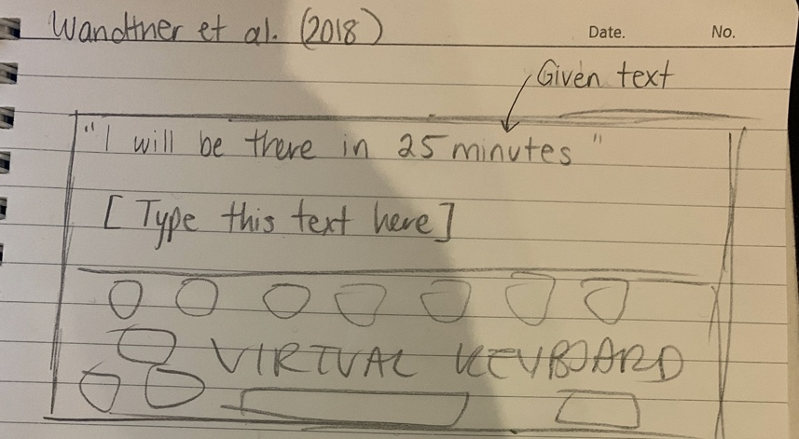

*iPad (or smartphone, preferably) display might look something like this ^

1. NDRT = non-driving related task (i.e. sending text message), DRT = driving-related task (monitoring automation under certain level of traffic density)

2. A takeover request (TOR) often entails a system warning or notification which advises the driver to take back primary control of driving the vehicle due to a limitation the automation is faced with (e.g. can’t detect lanes anymore due to wet road).