FreshFind — Project Documentation
Built by Infinityx Technologies
TechWiz7 · Web Innovation Unleashed · Version 1.0

1. Problem Definition
Farmers markets connect communities with local growers, but information about market locations, operating days and hours, and available produce is scattered across flyers, community boards, social media, and word of mouth. There is no single reliable source residents can check before planning a visit, which makes it difficult to know what is open, when, and what is likely to be in season. FreshFind addresses this by consolidating market and produce information into a single, responsive, browser-based platform.

2. Design Specifications

2.1 Architecture
FreshFind is built as a Single Page Application using HTML5, CSS3, and vanilla JavaScript (ES6 modules). There is no backend server or database; all content is served from static JSON files and rendered client-side using the Fetch API. Navigation between views is handled with hash-based routing.

2.2 Visual Design System
- Colour palette: deep green (#163D24) for header/footer/hero, mid green (#2C7A43) for actions and links, pale green (#EAF3E7) for section backgrounds, cream (#FAFAF7) as the base background.
- Typography: Poppins for headings and brand elements, Inter for body text.
- Components: rounded cards (14px radius) with a soft elevation shadow, pill-shaped status badges, circular icon buttons.
- Layout: centered container up to 1200px, responsive grid collapsing from 4 to 2 to 1 columns on smaller screens.

2.3 Feature-to-Requirement Mapping
Module | Requirement (per SRS) | Status
Home Page | Logo, nav, hero, featured content, chatbot launcher | Implemented
Market Directory | Catalog from JSON; filter by day/produce; sort A-Z, next open day | Implemented
Market Detail | Address, embedded map, schedule table, product grid | Implemented
Search | Global search across markets and produce | Implemented
Produce Guide | Browsable catalogue filterable by category | Implemented
AI Chatbot | Rule-based, pre-scripted JSON dataset, quick replies, fallback message | Implemented
Bookmarking | Save markets/produce, session-only notes, export as list | Implemented
Contact Us | Static info, embedded map, client-side form validation | Implemented
About Us | Static team/platform information | Implemented
Visitor Counter | Simulated using JavaScript + localStorage | Implemented
Real-Time Clock | Current date/time in header | Implemented
Geolocation | "Near me" sort using browser location | Implemented
Breadcrumb Navigation | Shown on directory/detail/guide pages | Implemented
Dummy Login/Signup | UI-only, non-authenticating buttons | Implemented

3. Diagrams

3.1 Site Map
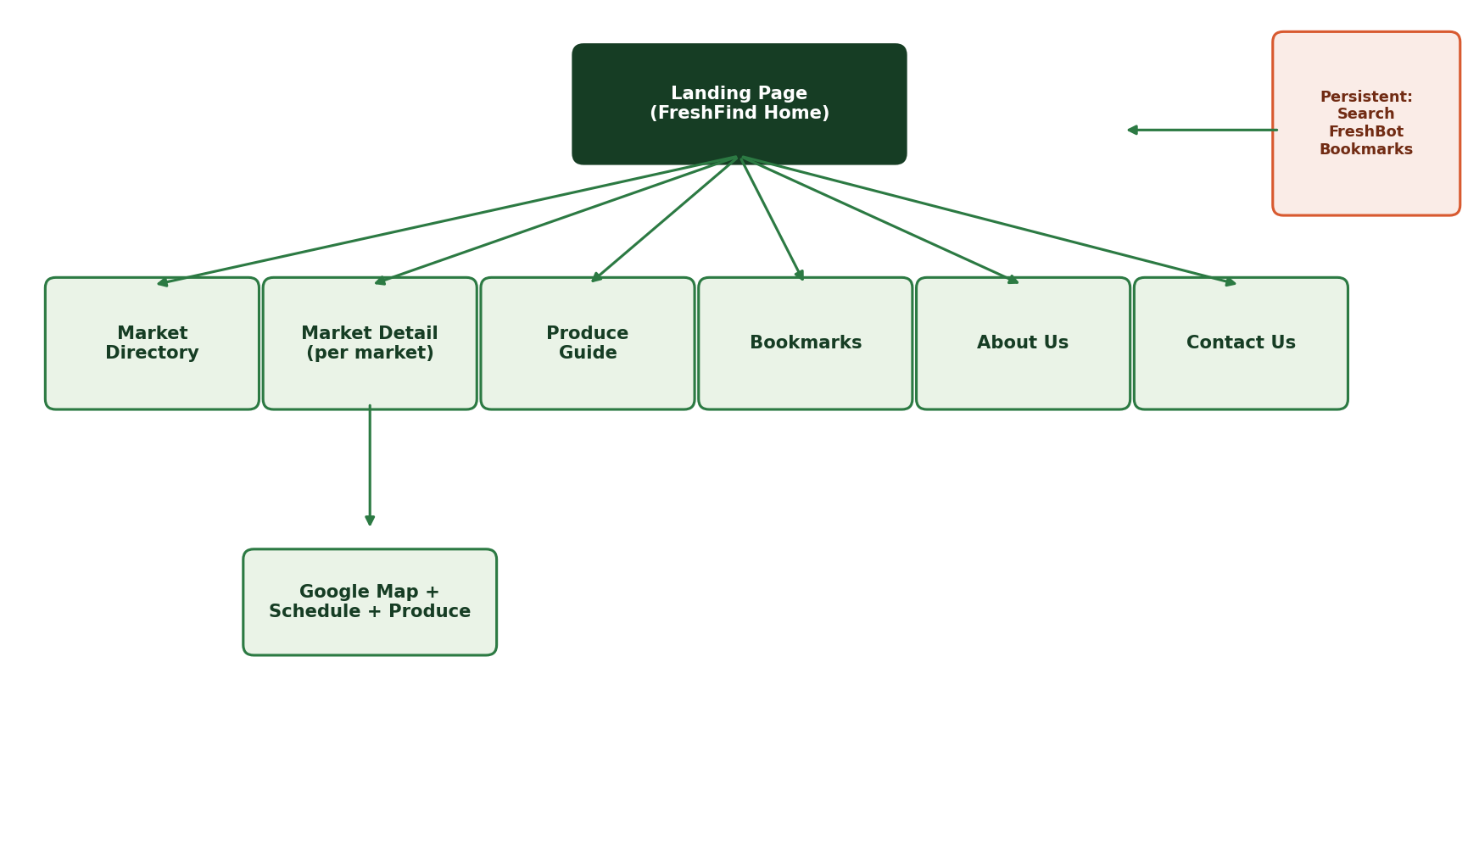
The Landing Page links to four core sections. Search, the FreshBot chatbot, and Bookmarks remain accessible from every page as persistent, cross-page features.

3.2 Data Flow Diagram (Level 0)
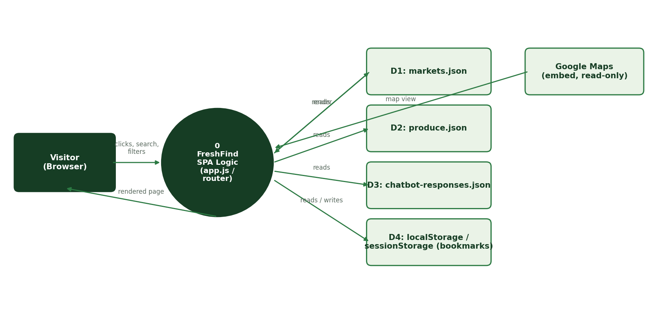
The visitor's browser is the only external entity. All logic runs client-side; the four data stores are static JSON files plus browser localStorage/sessionStorage. The only outbound call is a read-only Google Maps embed — no data is sent to any server.

4. Test Data Used in the Project
All test data is stored as pre-populated JSON files under /data. Sample structure:
File | Sample Record | Fields
markets.json | Riverside Farmers Market | id, name, area, address, lat/lng, days, hours, status, produce[], description
produce.json | Leafy Greens | id, name, category, season, tagline, description, markets[]
chatbot-responses.json | "near me" keyword group | keywords[], answer, link (optional)
Six sample markets and eight produce categories were used for development and demo purposes. Additional records can be appended to the JSON files without any code changes.

5. Project Installation Instructions
- 1. Unzip the submitted source code archive.
- 2. Open the folder and double-click index.html to run it directly in a browser, OR run a local server for full functionality: python -m http.server 8000, then visit http://localhost:8000
- 3. No build tools, package installation, or API keys are required.
- 4. For best results, use the latest version of Chrome, Firefox, Edge, or Safari, and allow location access if prompted to test the "Near me" feature.

6. Non-Functional Requirements Coverage
- Safe to use: no downloads are triggered anywhere in the site.
- Accessible: semantic HTML, visible focus states, alt text on meaningful images, reduced-motion support.
- User-friendly: persistent navigation, breadcrumbs, and a single consistent component language throughout.
- Performance: no build step or heavy framework; all assets are lightweight and CDN-cached.
- Compatibility: tested on the latest Chrome, Firefox, and Edge; responsive from mobile to desktop widths.
- Availability: static site with no server dependency, so uptime equals hosting uptime.

