Probability of 8/99 lottery

1.Introduction

The computations below describe the distribution and prove the fairness of a 8/99 lottery draw containing 3 different colors of winning balls. The game consists of a virtual customer selecting 6 yellow, 1 red and 1 orange number and receiving prizes depending on the amount of yellow balls hit, while getting his prizes multiplied by the red and orange numbers. This paper aims to offer a comprehensive and rigorous explanation of the mathematics behind the probability of hitting respective winning combinations and prove the fairness of the draw.

2.Calculations

3. Fair game

The idea of this game is to have no house edge, meaning that whatever the price is to participate should be the expected outcome. For every 25 euro in an account 1 ticket of entry is granted. With an estimated annual interest rate of 2% the weekly interest rate should be 0.02/365. Therefore the expected winnings every ticket should have weekly is:

$$E\left(T\right)=25*\frac{0.02}{365}=0.0096$$

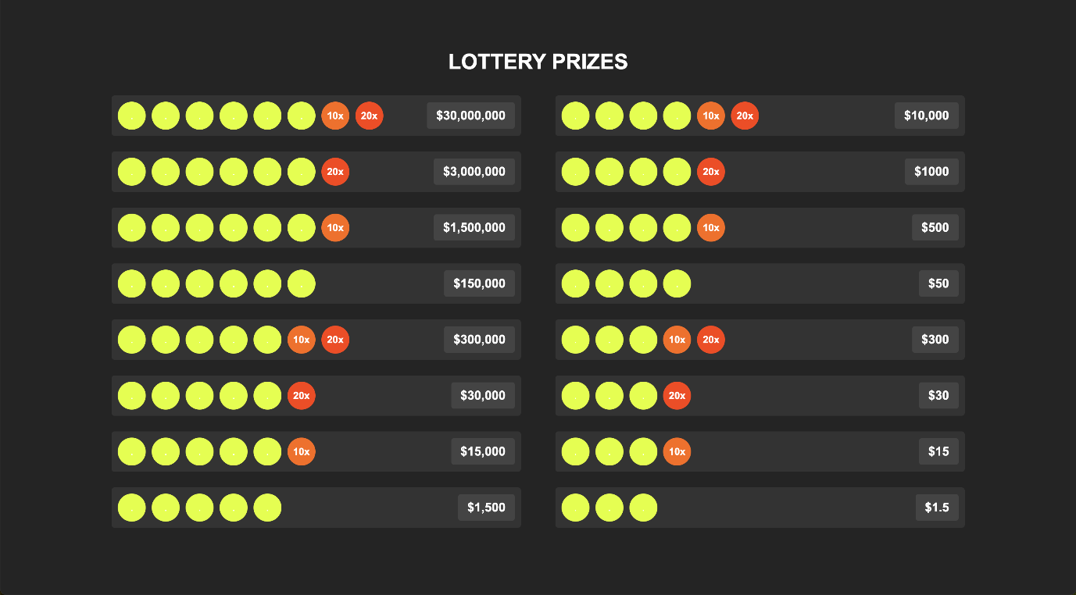

Expectation is calculated by multiplying the probabilities of every scenario by the payout of the respective winning set of numbers.

$$Let X be the winnings from every ticket. \\ Let x_{i} be the win from the event with probability p_{xi}$$

$$E\left(X\right)=\sum_{i=1}^{16}{x_{i}*p_{xi}}$$

$$E\left(X\right)=0.002266616*1.5+2.46342E-05*15+2.46342E-05*30+2.70705E-07*300+0.0000560*50+6.15633E-07*500+6.15633E-07*1000+6.84037E-09*10000+0.000000487*1500+5.35333E-09*15000+5.35333E-09*30000+5.94815E-11*300000+0.000000001*150000+9.59379E-12*1500000+9.59379E-12*300000+1.06598E-13*30000000=0.00954990$$

The difference of 0.00005 between the expectations is small enough for it to be disregarded as a edge.

4.Simulated output

The R code used to simulate these results is in the repository.

By simulating 10000000 runs the real return of a ticket equals to 0.0094052 which is within the expected scope given the low probability of the big prizes.

Here is a histogram showing the distribution of the annual payments expected to be received by a user with 300 tickets.

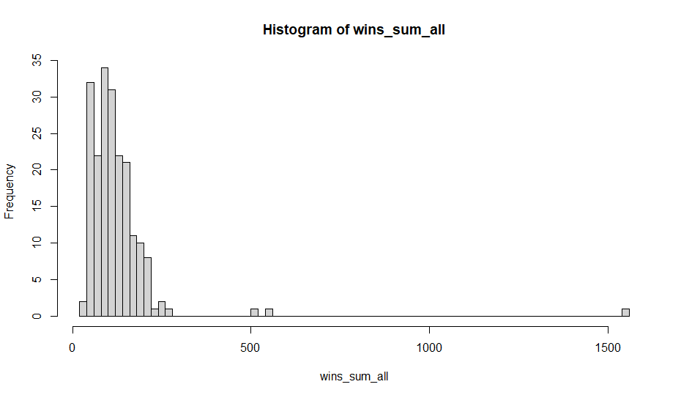

The mean of the simulation hovers around 140-150 which is aligned with what we should expect