An AI Agent for Rapid Evidence-Based Clinical
Research Support
Clinical researchers spend weeks manually reviewing hundreds of papers from databases like PubMed and ClinicalTrials.gov to synthesize evidence.
Challenges include:
- Large volume of unstructured medical literature
- Difficulty comparing trial outcomes
- Risk of overlooking contradictory findings
- Time-consuming systematic review preparation
There is a need for an intelligent system that can retrieve, extract, compare, and summarize evidence rapidly while ensuring citation grounding

We propose a Retrieval-Augmented AI Agent that:
- Accepts a clinical research query
- Performs semantic retrieval of relevant literature
- Extracts structured medical entities (Drug, Disease, Outcomes, PICO)
- Synthesises evidence across multiple trials
- Validates claims against source documents
- Generates structured evidence-based summaries.

The system begins with a clinical research query. The query is embedded using a transformer model and passed to a FAISS-based vector database for semantic retrieval. Retrieved documents undergo biomedical NLP extraction including NER and PICO identification. A retrieval-augmented AI agent synthesizes evidence across studies. A validation module ensures citation grounding before generating structured evidence-based outputs.

Flow Structure :
┌──────────────────────────────┐
│ 1. User Research Query ↓
┌──────────────────────────────┐
│ 2. Query Processing Layer
│ - Tokenization
│ - Transformer Embedding
│ - Intent Classification ↓
┌──────────────────────────────┐
│ 3. Semantic Retrieval Layer
│ - Query Embedding
│ - FAISS Vector Search
│ - Top-K Document Retrieval ↓
┌──────────────────────────────┐
│ 4. Information Extraction
│ - Named Entity Recognition
│ - PICO Extraction
│ - Relation Extraction ↓
┌──────────────────────────────┐
│ 5. AI Agent Reasoning Layer
│ - Retrieval-Augmented Gen
│ - Multi-step Comparison
│ - Evidence Synthesis ↓
┌──────────────────────────────┐
│ 6. Validation Layer
│ - Citation Grounding
│ - Similarity Check
│ - Confidence Scoring ↓
┌──────────────────────────────┐
│ 7. Output Generation
│ - Structured Summary
│ - Evidence Table
│ - Statistical Highlights
└──────────────────────────────┘
Data Flow with Algorithms :
User Query
↓
Encoder(Q) → Q_vector
↓
FAISS Search(Q_vector)
↓
Top-K Documents
↓
BioBERT NER + PICO Extraction
↓
Context Construction
↓
LLM(Q + Context)
↓
Claim Verification
↓
Evidence-Based Output
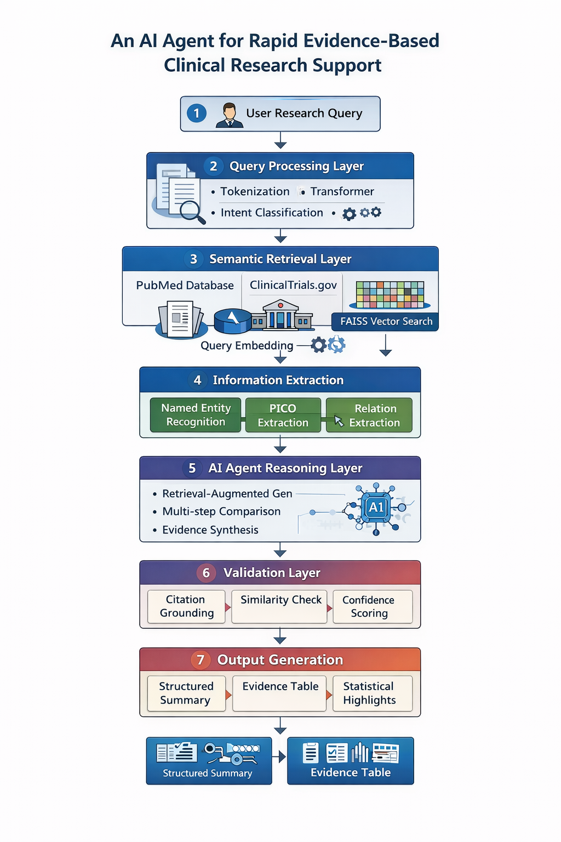

Start
↓
User Research Query
↓
Query Processing (NLP Understanding)
↓
Literature Retrieval
(PubMed / ClinicalTrials.gov)
↓
Vector Embedding + FAISS Search
↓
Top-K Relevant Papers Retrieved
↓
Information Extraction
- NER
- PICO Extraction
- Relation Extraction
↓
Multi-step AI Agent Reasoning
↓
Evidence Comparison & Synthesis
↓
Validation Layer (Citation Check)
↓
Structured Output Generation
- Summary
- Tables
- Key Findings
↓
End

1. Embedding / Retrieval Models
These convert text into vectors for semantic search (FAISS).

Model | Type | Pros | When to Use
all-MiniLM-L6-v2 | SentenceTransformer (384-dim) | Fast / lightweight | CPU / low GPU
BioSentVec / BioBERT embeddings | Biomedical embedding | Domain-specific | When semantic accuracy matters
SciBERT | Biomedical BERT | Better medical semantics | Medium GPU available
PubMedBERT | Domain-specific | Excellent for clinical text | Best for research corpora
Recommended starter: all-MiniLM-L6-v2 (fast, low-resource)

2. Retrieval Index

Library | Purpose | Notes
FAISS (FlatIP / HNSW) | Vector similarity search | Works CPU & GPU
Annoy / HNSW-lib | Approximate search | Useful if FAISS isn’t available

3. Information Extraction Models
These extract structured information like entities, PICO elements, and relations.
— Named Entity Recognition (NER)

Model | Purpose | Notes
dslim/bert-base-NER | General NER | Baseline entity extraction
biobert-v1.1 | Biomedical NER | Better for medical entities
scibert_scivocab_uncased (fine-tuned NER) | Domain-specific | Best if fine-tuned

— PICO / Relation Extraction

Approach | Pros | When to Use
Rule-based (regex + patterns) | Fast | Quick PICO extraction
Transformer Classifier (BioBERT) | Accurate | When precision matters
Sequence Labeling (Conditional Random Field) | High quality | Custom trained for clinical text

4. Reasoning / Generation Models
This is the heart of your AI agent — generating answers, summaries, comparisons.
A. Lightweight (Low GPU / CPU)
Model | Params | Notes
google/flan-t5-small | ~80M | Very low resource
mistralai/Mistral-7B (GGUF CPU) | 7B | CPU inference via llama.cpp
OpenAssistant-oasst-tiny-LM-123B | ~124M | Tiny LM light tasks

B. Mid-Level (Better Reasoning)

Model | Params | Notes
google/flan-t5-base | ~220M | Balanced capability
facebook/opt-6.7b | 6.7B | Good general reasoning
mistralai/Mistral-7B-Instruct | 7B | Decoder-only instruct tuned
C. High-Performance (Advanced)

Model | Params | Notes
google/flan-t5-large/xl/xxl | 770M - 11B | Great reasoning & summarization
mixtral-8x7b (Mistral MoE) | ~46B | Stronger multi-task reasoning
GPT-based APIs (OpenAI) | Varies | Best overall but external API

Algorithm: Rapid Evidence-Based Clinical Research AI Agent
Input: Clinical research query Q Output: Structured evidence-based summary S
- Query Processing
1.1 Tokenize Q
1.2 Generate embedding: Q_vec = Encoder(Q)
1.3 Normalize vector: Q_vec = Q_vec / ||Q_vec||
- Semantic Retrieval
2.1 For each document Di in corpus:
Di_vec = Encoder(Di)
2.2 Store Di_vec in FAISS index
2.3 Compute similarity:
sim_i = Q_vec · Di_vec
2.4 Retrieve Top-K documents:
D_top = argmax_k(sim_i)
- Information Extraction
For each document Dj in D_top:
3.1 Named Entity Recognition:
Entities = BERT_CRF(Dj)
3.2 PICO Extraction:
PICO_labels = SeqLabelModel(Dj)
3.3 Relation Extraction:
R = RelationClassifier(Entities)
- Context Construction
Context C = Concatenate(D_top + Extracted_structured_data)
- AI Agent Reasoning (RAG)
A_raw = LLM(Q + C)
- Evidence Aggregation
For each study:
Extract effect size θ_i
Compute weight w_i = 1 / variance_i
Combined effect: θ_combined = Σ(w_i * θ_i) / Σ(w_i)
- Validation Layer For each claim c in A_raw:
If similarity(c, D_top) < threshold:
Mark as unsupported
Compute confidence score
- Output Generation Format structured summary S:
- Key findings
- Comparison table
- Statistical highlights
Return S

