C++ Functions

The function in C++ language is also known as procedure or subroutine in other programming languages.

To perform any task, we can create function. A function can be called many times. It provides modularity and code reusability.

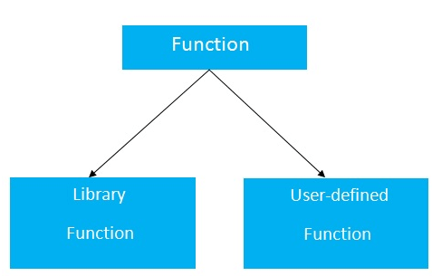

# Call by value and call by reference in C++

There are two ways to pass value or data to function in C++ language: call by value and call by reference. Original value is not modified in call by value but it is modified in call by reference.

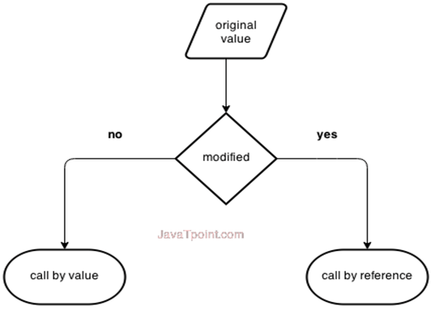

## **Call by value in C++**

In call by value, **original value is not modified.**

In call by value, value being passed to the function is locally stored by the function parameter in stack memory location. If you change the value of function parameter, it is changed for the current function only. It will not change the value of variable inside the caller method such as main().

## **Call by reference in C++**

In call by reference, original value is modified because we pass reference (address).

Here, address of the value is passed in the function, so actual and formal arguments share the same address space. Hence, value changed inside the function, is reflected inside as well as outside the function.

# C++ Arrays

Like other programming languages, array in C++ is a group of similar types of elements that have contiguous memory location.

## **C++ Array Types**

There are 2 types of arrays in C++ programming:

1. Single Dimensional Array
2. Multidimensional Array

# C++ Multidimensional Arrays

The multidimensional array is also known as rectangular arrays in C++. It can be two dimensional or three dimensional. The data is stored in tabular form (row ∗ column) which is also known as matrix.