# How to get input from user in Java

## **Java Scanner Class**

Java **Scanner class** allows the user to take input from the console. It belongs to **java.util** package. It is used to read the input of primitive types like int, double, long, short, float, and byte. It is the easiest way to read input in Java program.

# Method in Java

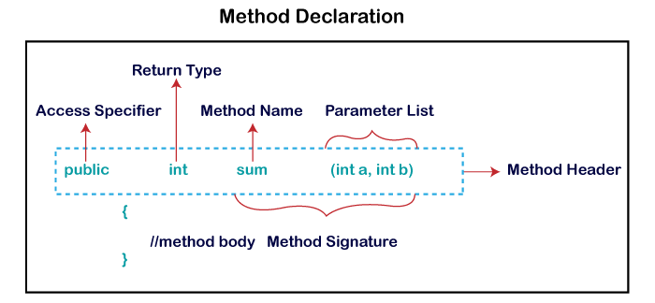

Java Arrays

Normally, an array is a collection of similar type of elements which has contiguous memory location.

**Java array** is an object which contains elements of a similar data type. Additionally, The elements of an array are stored in a contiguous memory location. It is a data structure where we store similar elements. We can store only a fixed set of elements in a Java array.

Array in Java is index-based, the first element of the array is stored at the 0th index, 2nd element is stored on 1st index and so on.

### **Types of Array in java**

There are two types of array.

* Single Dimensional Array
* Multidimensional Array

## **Single Dimensional Array in Java**

**Syntax to Declare an Array in Java**

1. dataType[] arr; (or)
2. dataType []arr; (or)
3. dataType arr[];

# Collections in Java

The **Collection in Java** is a framework that provides an architecture to store and manipulate the group of objects.

Java Collections can achieve all the operations that you perform on a data such as searching, sorting, insertion, manipulation, and deletion.

Java Collection means a single unit of objects. Java Collection framework provides many interfaces (Set, List, Queue, Deque) and classes ([ArrayList](https://www.javatpoint.com/java-arraylist), Vector, [LinkedList](https://www.javatpoint.com/java-linkedlist), [PriorityQueue](https://www.javatpoint.com/java-priorityqueue), HashSet, LinkedHashSet, TreeSet).

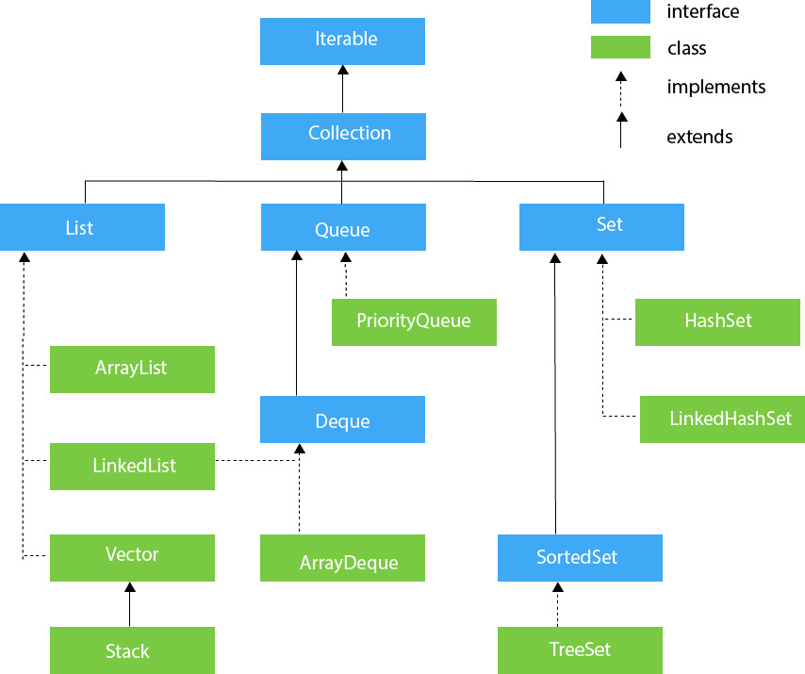

## **List Interface**

List interface is the child interface of Collection interface. It inhibits a list type data structure in which we can store the ordered collection of objects. It can have duplicate values.

List interface is implemented by the classes ArrayList, LinkedList, Vector, and Stack.

1. List <data-type> list1= **new** ArrayList();
2. List <data-type> list2 = **new** LinkedList();
3. List <data-type> list3 = **new** Vector();
4. List <data-type> list4 = **new** Stack();

## **ArrayList**

The ArrayList class implements the List interface. It uses a dynamic array to store the duplicate element of different data types.

## **LinkedList**

LinkedList implements the Collection interface. It uses a doubly linked list internally to store the elements. It can store the duplicate elements.

## **Vector**

Vector uses a dynamic array to store the data elements. It is similar to ArrayList.

## **Stack**

The stack is the subclass of Vector. It implements the last-in-first-out data structure, i.e., Stack. The stack contains all of the methods of Vector class and also provides its methods like boolean push(), boolean peek(), boolean push(object o), which defines its properties.

## **Queue Interface**

Queue interface maintains the first-in-first-out order. It can be defined as an ordered list that is used to hold the elements which are about to be processed. There are various classes like PriorityQueue, Deque, and ArrayDeque which implements the Queue interface.

## **PriorityQueue**

The PriorityQueue class implements the Queue interface. It holds the elements or objects which are to be processed by their priorities. PriorityQueue doesn't allow null values to be stored in the queue.

## **Deque Interface**

Deque interface extends the Queue interface. In Deque, we can remove and add the elements from both the side. Deque stands for a double-ended queue which enables us to perform the operations at both the ends.

## **ArrayDeque**

ArrayDeque class implements the Deque interface. It facilitates us to use the Deque. Unlike queue, we can add or delete the elements from both the ends.

## **Set Interface**

Set Interface in Java is present in java.util package. It extends the Collection interface. It represents the unordered set of elements which doesn't allow us to store the duplicate items.

## **HashSet**

HashSet class implements Set Interface. It represents the collection that uses a hash table for storage. Hashing is used to store the elements in the HashSet. It contains unique items.

## **LinkedHashSet**

LinkedHashSet class represents the LinkedList implementation of Set Interface. It extends the HashSet class and implements Set interface. Like HashSet, It also contains unique elements. It maintains the insertion order and permits null elements.

## **SortedSet Interface**

SortedSet is the alternate of Set interface that provides a total ordering on its elements. The elements of the SortedSet are arranged in the increasing (ascending) order. The SortedSet provides the additional methods that inhibit the natural ordering of the elements.

## **TreeSet**

Java TreeSet class implements the Set interface that uses a tree for storage. Like HashSet, TreeSet also contains unique elements. However, the access and retrieval time of TreeSet is quite fast. The elements in TreeSet stored in ascending order

# Exception Handling in Java

The **Exception Handling in Java** is one of the powerful mechanism to handle the runtime errors so that the normal flow of the application can be maintained.

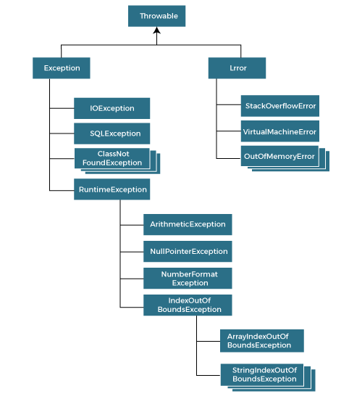

### **Types of Java Exceptions**

There are mainly two types of exceptions: checked and unchecked. An error is considered as the unchecked exception. However, according to Oracle, there are three types of exceptions namely:

1. Checked Exception
2. Unchecked Exception
3. Error

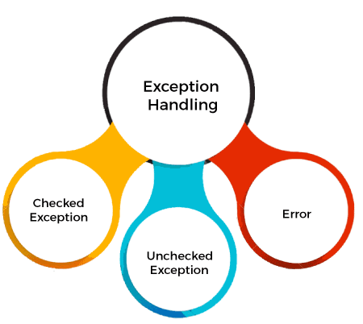

### **1) Checked Exception**

The classes that directly inherit the Throwable class except RuntimeException and Error are known as checked exceptions. For example, IOException, SQLException, etc. Checked exceptions are checked at compile-time.

### **2) Unchecked Exception**

The classes that inherit the RuntimeException are known as unchecked exceptions. For example, ArithmeticException, NullPointerException, ArrayIndexOutOfBoundsException, etc. Unchecked exceptions are not checked at compile-time, but they are checked at runtime.

### **3) Error**

Error is irrecoverable. Some example of errors are OutOfMemoryError, VirtualMachineError, AssertionError etc.