**ML ASSIGNMENT- 07**

B YAKSHITHA

21BDA60

1) What is Stride, Padding and Pooling? Explain with an example?

PADDING:

* Every time after convolution operation, original image size getting shrinks, as we have seen in above example six by six down to four by four and in image classification task there are multiple convolution layers so after multiple convolution operation, our original image will really get small but we don’t want the image to shrink every time.
* When the kernel moves over original images, it touches the edge of the images less number of times and touches the middle of the image more number of times and it overlaps also in the middle. So, the corner features of any image or on the edges aren’t used much in the output.

So, in order to solve these two issues, a new concept is introduced called padding. It preserves the size of the original image.

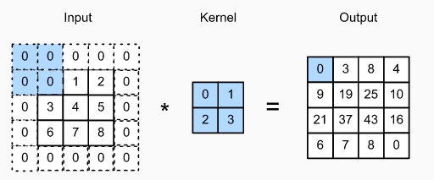

So, if n*n matrix is convolved with an ff matrix with a padding p, then the size of the output image will be:

(n+2p-f+1)^2

STRIDES:

When the array is created, the pixels are shifted over to the input matrix. The number of pixels turning to the input matrix is known as the strides. When the number of strides is 1, we move the filters to 1 pixel at a time. Similarly, when the number of strides is 2, we carry the filters to pixels and so on. They are essential because they control the convolution of the filter against the input i.e strides are responsible for regulating the features that could be missed while flattening the image.

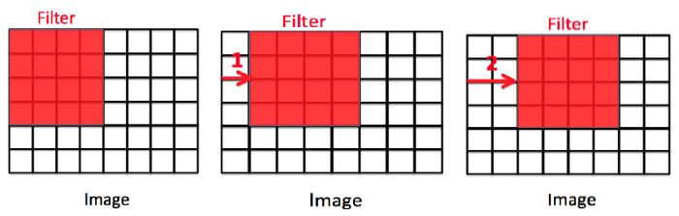

In the first matrix, the stride=0, second image the stride=2 and the third image the stride=2. The size of the output image is calculated by:

[{(n+2p-f+1)/s}+1]*[{(n+2p-f+1)/s}

POOLING:

The pooling layer is another building block of a CNN and plays a vital role I pre-processing an image. In the pre-process, the image size shrinks by reducing the number of parameters if the image is too large. When the picture is shrunk, the pixel density is also reduced, the downscaled image is obtained from the previous layers. Basically, its function is to progressively reduce the spatial size of the image to reduce the network complexity and computational cost.

There are three types of pooling:

1. Max pooling

It is a rule to take the maximum of a region and help to proceed with the most crucial features from the image. It is a sample-based process that transfers continuous functions into discrete counterparts.

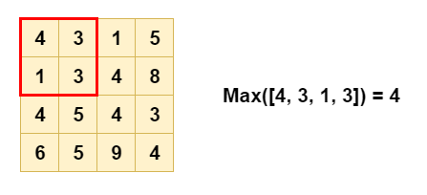

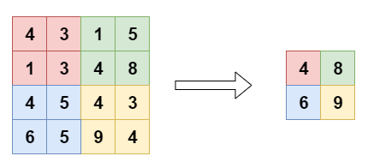

1. Average pooling

It is different from max pooling: it retains information about the lesser essential features.

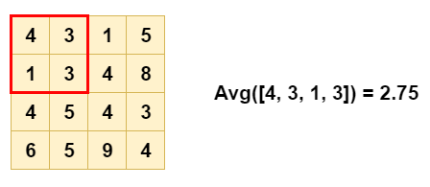

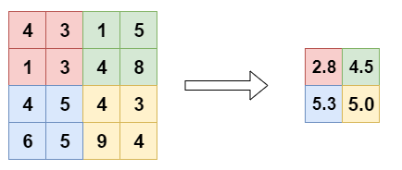

1. Sum pooling

It is similar to max pooling, but instead of calculating the maximum value, we calculate the mean of each sub-region.

2) What is overfitting? How to overcome overfitting in ML model?

A statistical model is said to be overfitted when the model does not make accurate predictions on testing data. When a model gets trained with so much data, it starts learning from the noise and inaccurate data entries in our dataset and when testing with test data results in high variance. Then, the model does not categorize the data correctly, because too many details and noise. The causes of overfitting are the non parametric and non linear methods because these types of machine learning algorithms have more freedom in building model based on the dataset and therefore they can build unrealistic models.

Reasons are:

* High variance and low bias
* Model is too complex
* The size of the training data

Techniques to overcome overfitting:

* Increase training data
* Reduce model complexity
* Cross-validation
* Remove features
* Regularization: ridge regularization and lasso regularization
* Use dropout for neural networks to tackle overfitting.