**Name: UPAS NATH**

**Roll No:47**

**Batch:B**

**Date:08/04/2022**

**ADVANCED DBMS LAB**

**Experiment No.: 1**

**Aim**

To familiarize with selecting data from single table

**QUESTION**

**PROCEDURE**

1. **List all data from table deposite**

select * from deposit;

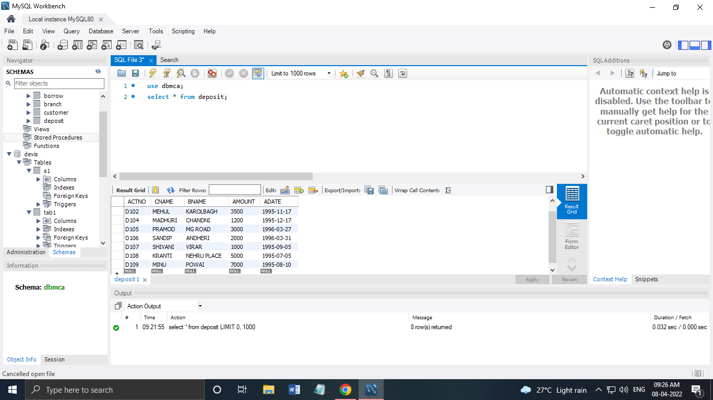

1. **List all data from borrow**

select * from borrow;

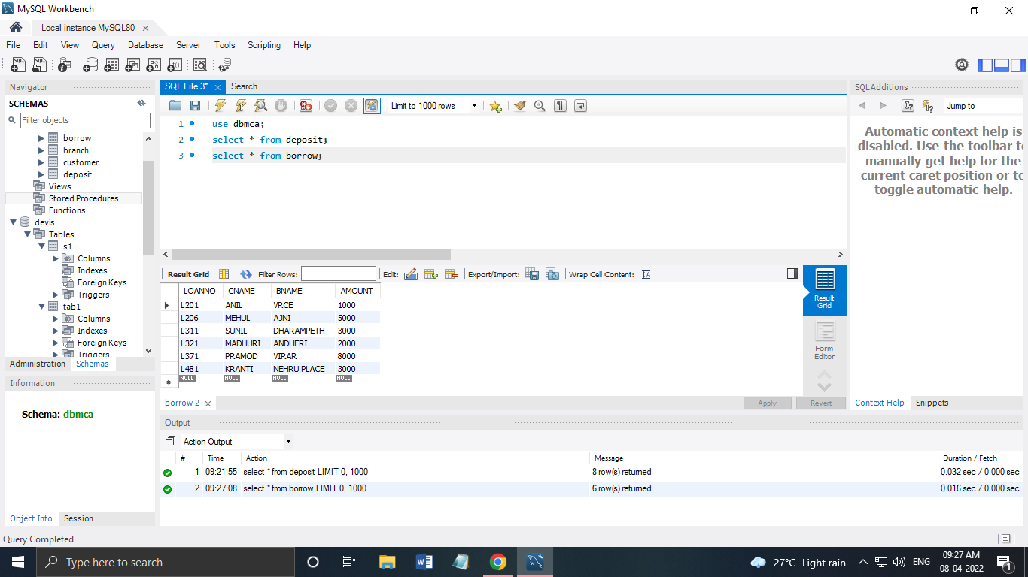

**3. List all data from customer**

select * from customer;

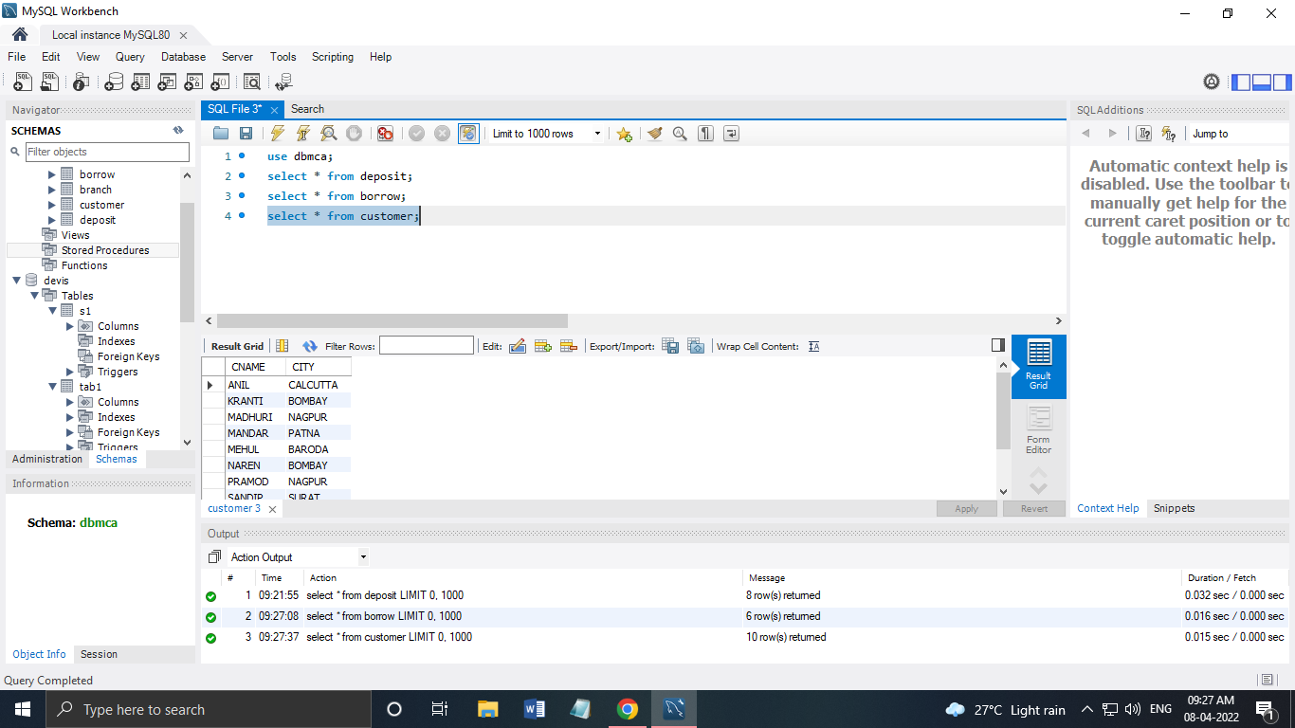

**4.List all data from branch**

select * from branch;

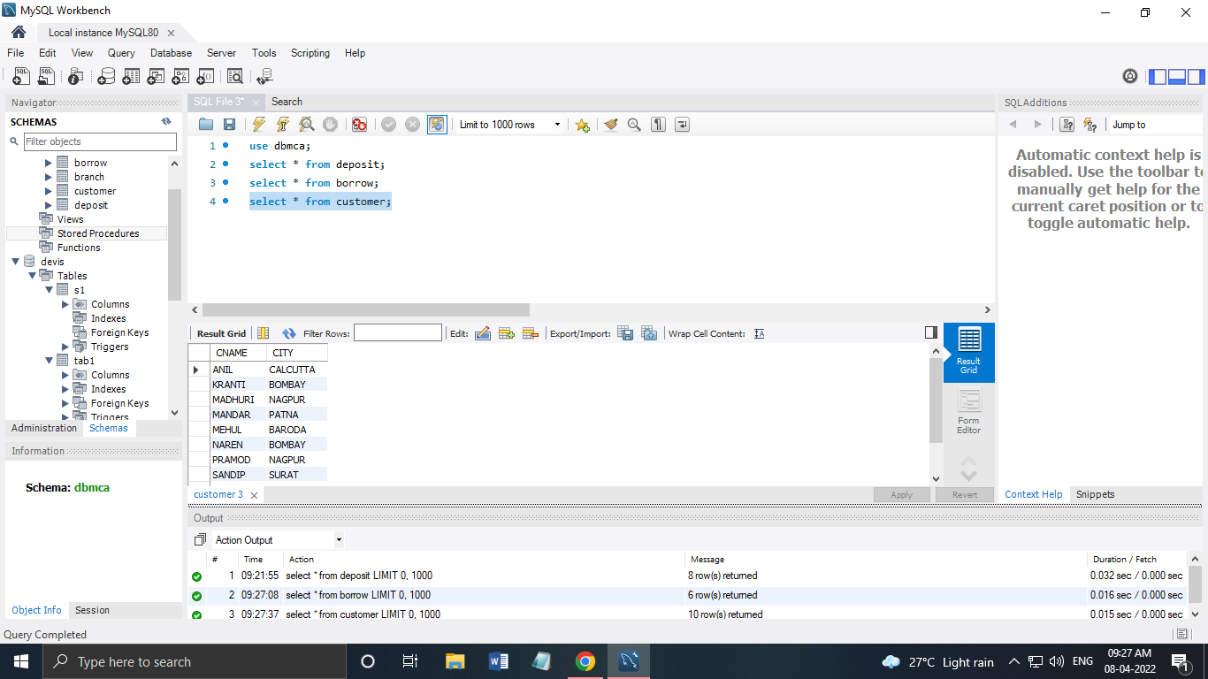

**5. Give account no and amount of deposite**

SELECT ACTNO,AMOUNT FROM DEPOSIT;

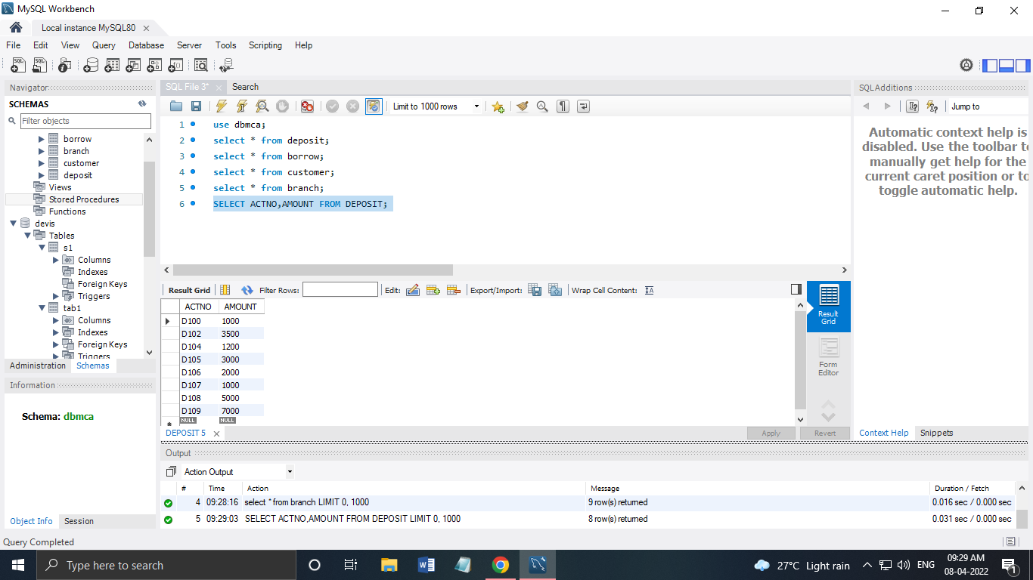

**6. Give customer name and account no of depositors**

SELECT CNAME,ACTNO FROM DEPOSIT;

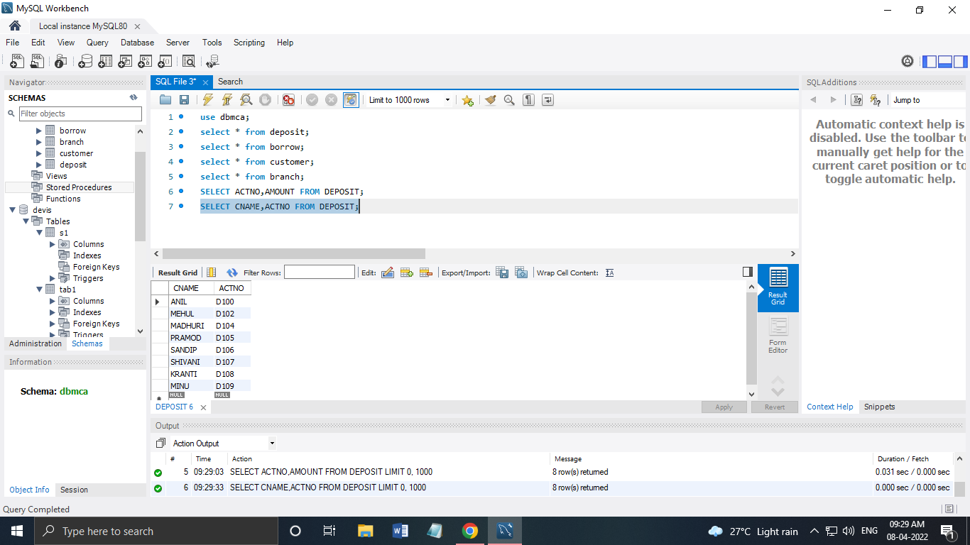

**7. Give name of customers**

SELECT CNAME FROM CUSTOMER;

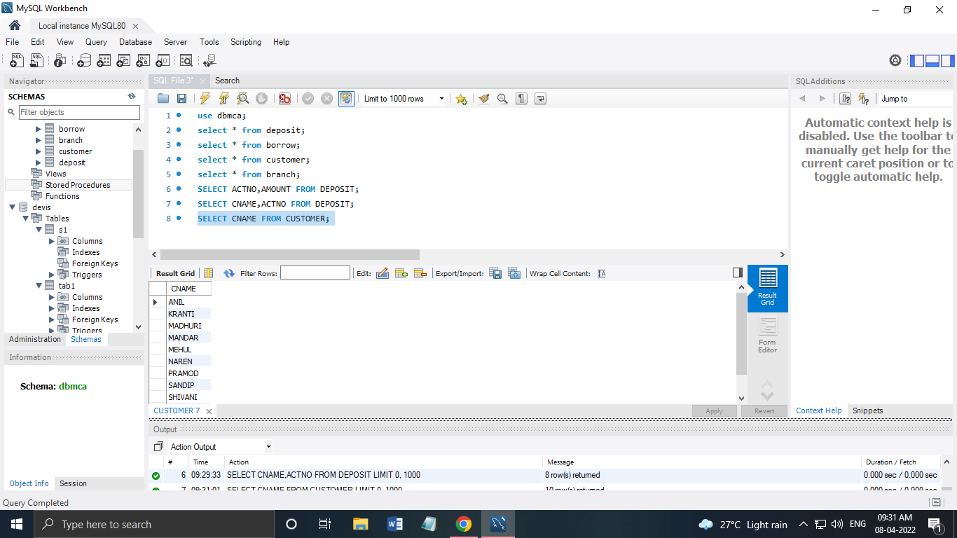

**8. Give name of branches**

SELECT BNAME FROM BRANCH;

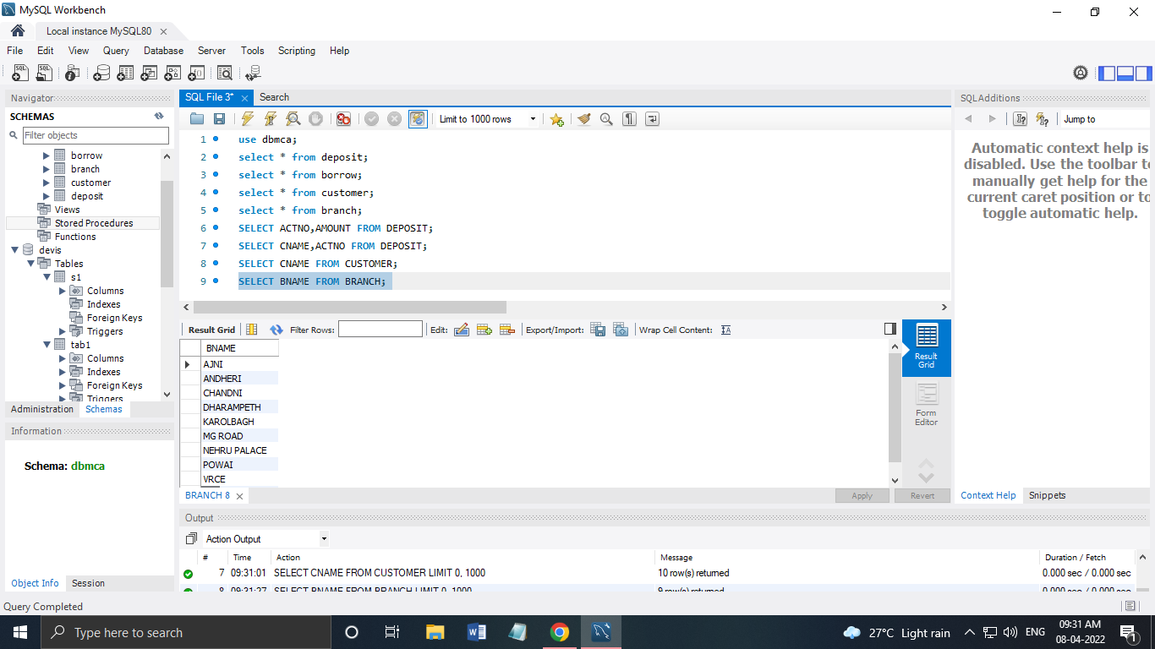

**9. Give name of borrows**

SELECT CNAME FROM BORROW;

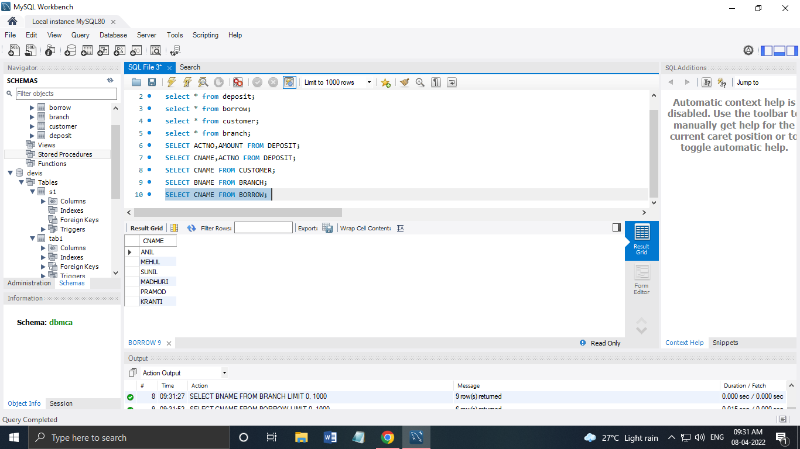

**10. Give names of customer living in city Nagpur**

SELECT CNAME FROM CUSTOMER WHERE CITY='NAGPUR';

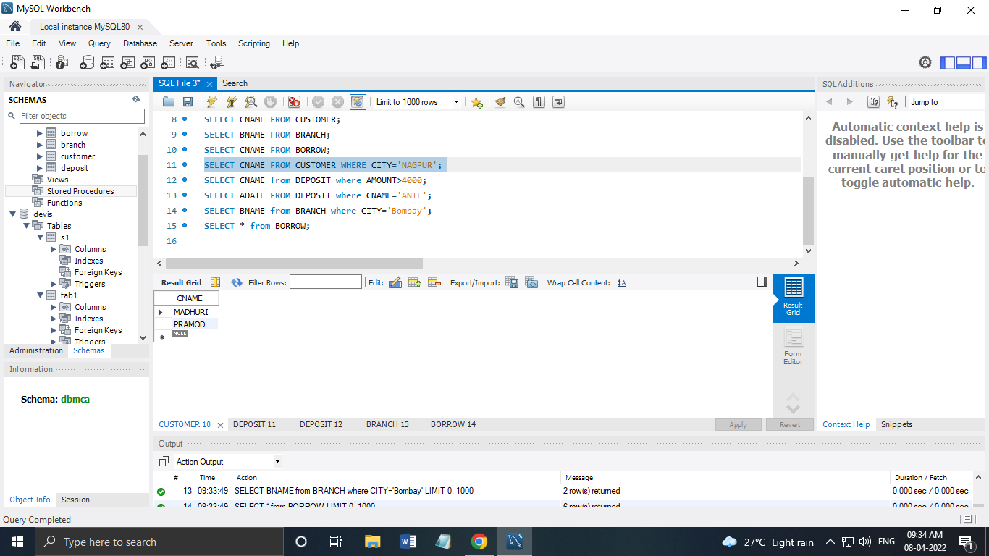

**11. Give names of depositors having amount greater than 4000**

SELECT CNAME from DEPOSIT where AMOUNT>4000;

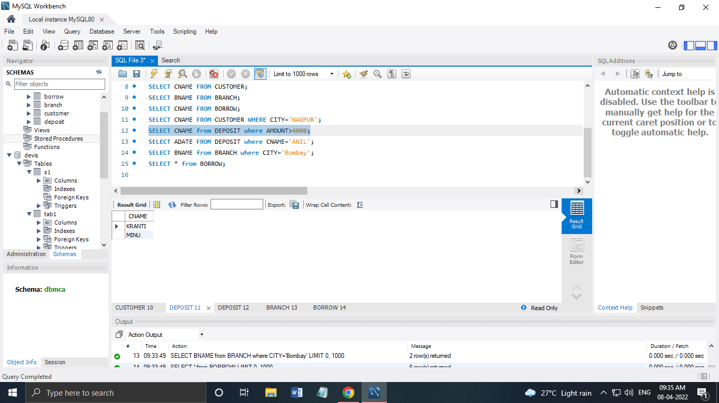

**12. Give account date of Anil**

SELECT ADATE FROM DEPOSIT where CNAME='ANIL';

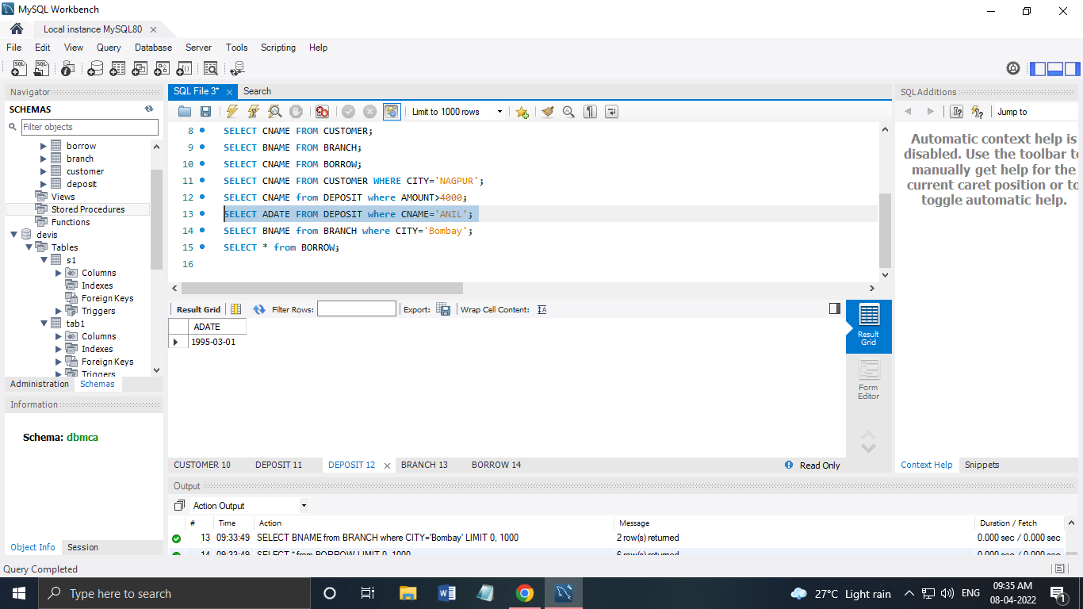

**13. Give name of all branches located in Bombay**

SELECT BNAME from BRANCH where CITY='Bombay';

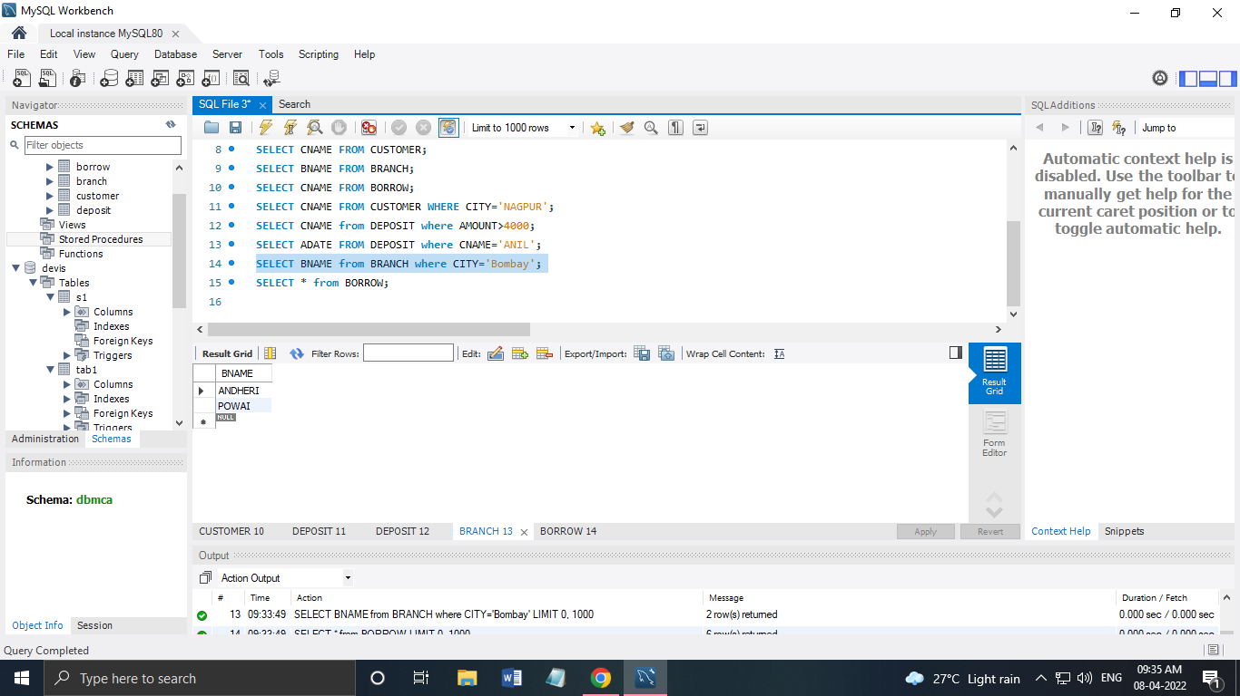

**14. Give name of borrower having loan number l205**

SELECT CNAME from BORROW where LOANNO='L205';

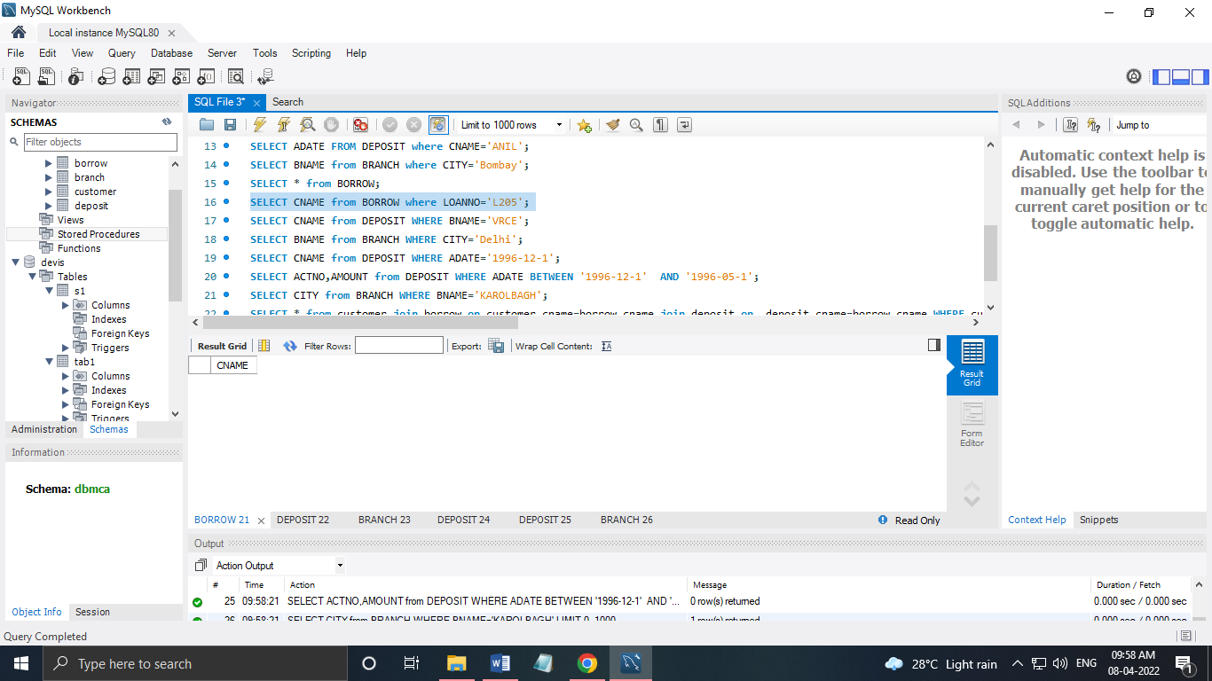

**15. Give names of depositors having account at VRCE**

SELECT CNAME from DEPOSIT WHERE BNAME='VRCE';

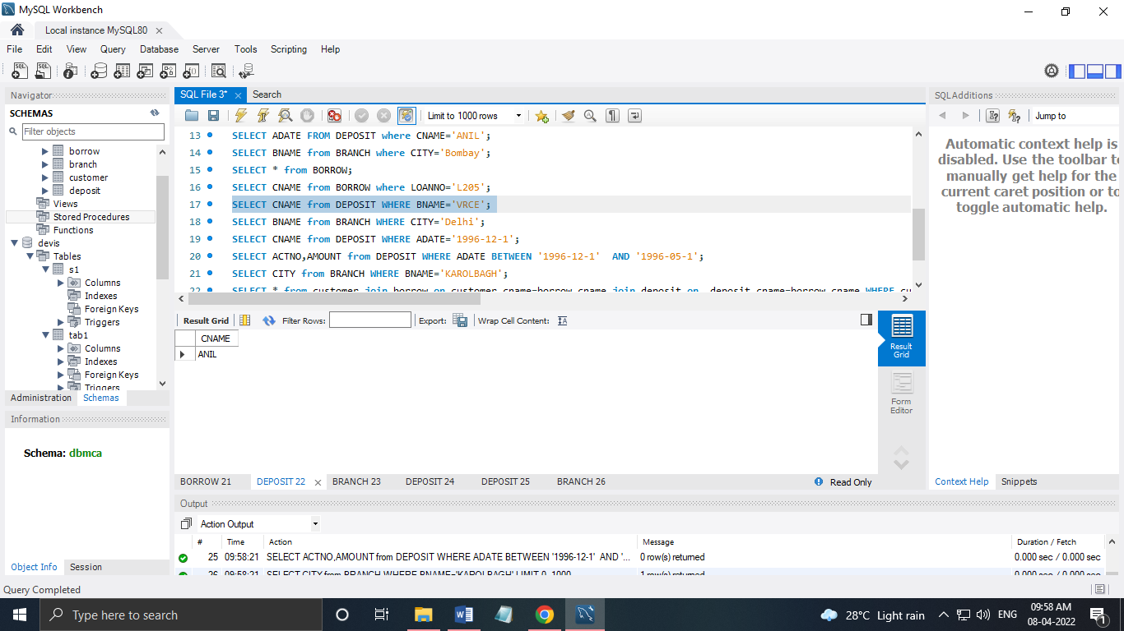

**16. Give names of all branched located in city Delhi**

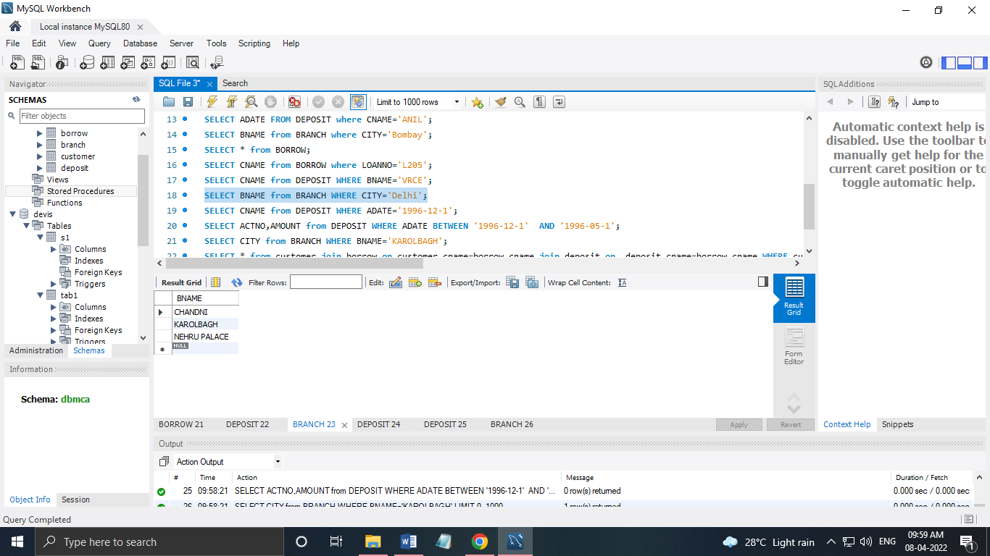

**17. Give name of the customers who opened account date ‘1-12-96’**

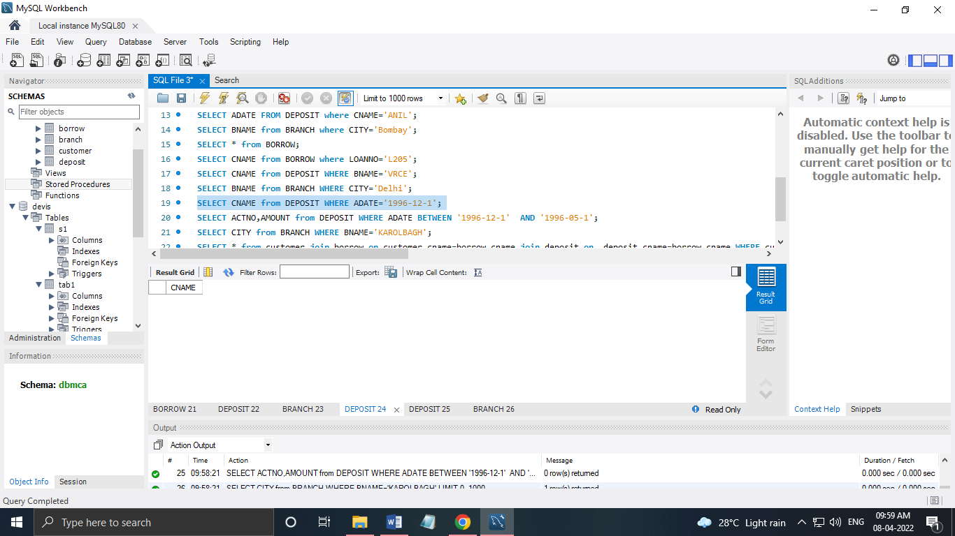

**18. Give account no and deposit amount of customers having account opened between dates  ‘1-12-96’ and ‘1-5-96’**

SELECT ACTNO,AMOUNT from DEPOSIT WHERE ADATE BETWEEN '27-3-1996' AND '1996-05-1';

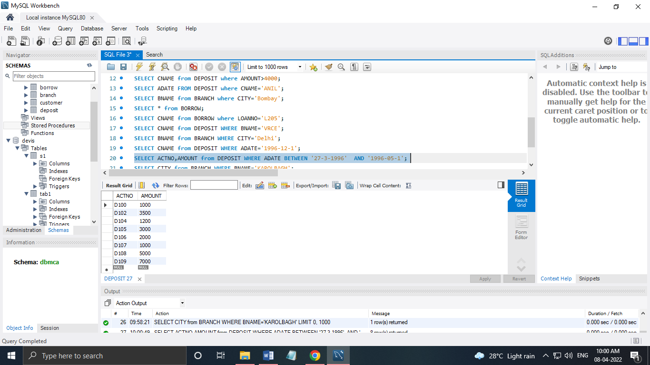

**19. Give name of the city where branch KAROLBAGH is located**

SELECT CITY from BRANCH WHERE BNAME='KAROLBAGH';

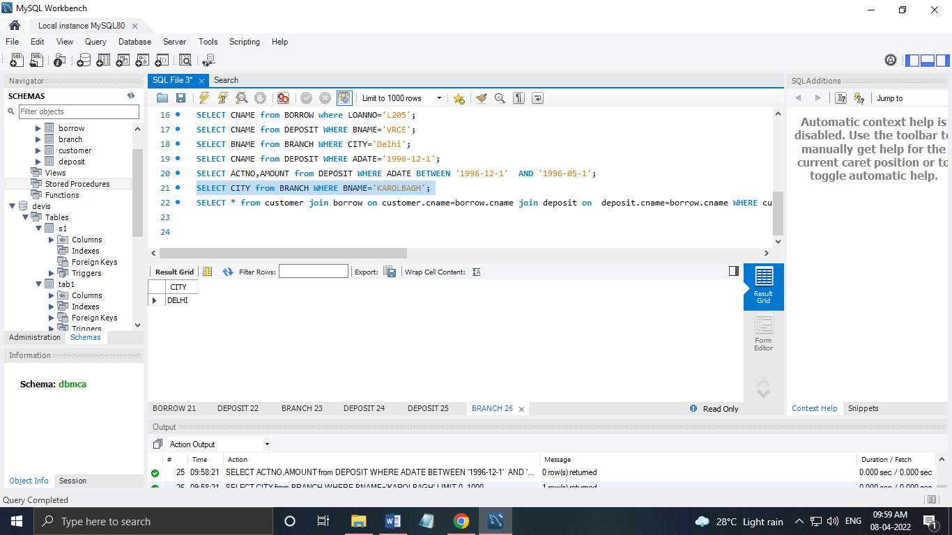

**20. Give details of customer ANIL**

SELECT * from customer join borrow on customer.cname=borrow.cname join deposit on deposit.cname=borrow.cname WHERE customer.cname='ANIL';

