**Name: UPAS NATH**

**Roll No: 47**

**Batch: B**

**Date: 06-05-2022**

**ADVANCED DBMS LAB**

**Experiment No.: 6**

**AIM**

To familiarize with join or cartesian product.

**QUESTION**

1. **Give name of customers having living city BOMBAY and branch city NAGPUR.**

SELECT D1.c_name, D1.b_name, C1.c_name, C1.city, B1.city, B1.b_name FROM DEPOSIT D1, CUSTOMER C1, BRANCH B1 WHERE C1.city = 'BOMBAY' AND B1.city = 'NAGPUR' AND D1.c_name = C1.c_name AND D1.b_name = B1.b_name;

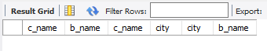

1. **Give names of customers having the same living city as their branch city.**

SELECT distinct(customer.c_name), BRANCH.city FROM BRANCH, customer WHERE BRANCH.city = customer.city;

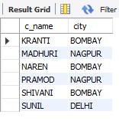

1. **Give names of customers who are borrowers as well as depositors and having city NAGPUR.**

SELECT C1.c_name FROM CUSTOMER C1,DEPOSIT D1,BORROW B1 WHERE C1.city='NAGPUR' AND C1.c_name=D1.c_name AND D1.c_name = B1.c_name;

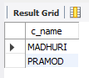

1. **Give names of borrowers having deposit amount greater than 1000 and loan amount greater than 2000.**

SELECT BR1.c_name, BR1.amount, D1.c_name, D1.amount FROM BORROW BR1,DEPOSIT D1 WHERE D1.c_name = BR1.c_name AND D1.amount > 1000 AND BR1.amount > 2000;

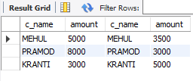

1. **Give names of depositors having the same branch as the branch of Sunil.**

SELECT D1.c_name FROM DEPOSIT D1 WHERE D1.b_name IN (SELECT D2.b_name FROM DEPOSIT D2 WHERE D2.c_name = 'SUNIL');

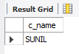

1. **Give names of borrowers having loan amount greater than the loan amount of Pramod.**

SELECT BR1.c_name,BR1.amount FROM BORROW BR1 WHERE BR1.amount > ALL (SELECT BR2.amount FROM BORROW BR2 WHERE BR2.c_name = 'PRAMOD');



1. **Give the name of the customer living in the city where branch of depositor Sunil is located.**

SELECT C.c_name FROM CUSTOMER C WHERE C.city IN (SELECT B.city FROM BRANCH B WHERE B.b_name IN (SELECT D.b_name FROM DEPOSIT D WHERE D.c_name='SUNIL'));



1. **Give branch city and living city of Pramod.**

SELECT B1.city , C1.city FROM BRANCH B1,CUSTOMER C1, DEPOSIT D1 WHERE C1.c_name = 'PRAMOD' AND C1.c_name = D1.c_name AND D1.b_name = B1.b_name;

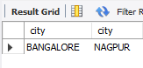

1. **Give branch city of Sunil and branch city of Anil.**

SELECT B1.city FROM DEPOSIT D1, BRANCH B1 WHERE D1.b_name = B1.b_name AND D1.c_name IN ('SUNIL' ,'ANIL');

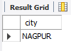

1. **Give the living city of Anil and the living city of Sunil.**

SELECT C1.c_name, C1.city FROM CUSTOMER C1 WHERE C1.c_name = 'ANIL' OR C1.c_name = 'SUNIL';

